# Generated QA Summary

--- Entry for custom_id: d5c4b87e0dba11ecb1e81171463288e9 ---

Image Source 1 -



Caption for image source 1: Frangipani flowers Frangipani (Plumeria) flowers in Perth, Western Australia.

Example Question - "What color is the center part of a Frangipani flower?"

Example Answer - "The center part of a Frangipani flower is yellow."

Additional Text Source 1 - One of the heavenly damsels in the frescoes of the fifth-century rock fortress Sigiriya holds a 5-petalled flower in her right hand that is indistinguishable from plumeria. In Eastern Africa, frangipani are sometimes referred to in Swahili love poems. (from: Plumeria)

Generated Question - How does the cultural significance of the Frangipani flower in Eastern Africa relate to its depiction in ancient Sigiriya frescoes?

Generated Answer - Both show the Frangipani flower as a symbol of beauty and love in cultural art and poetry.

--- Entry for custom_id: d5bf37a00dba11ecb1e81171463288e9 ---

Image Source 1 -

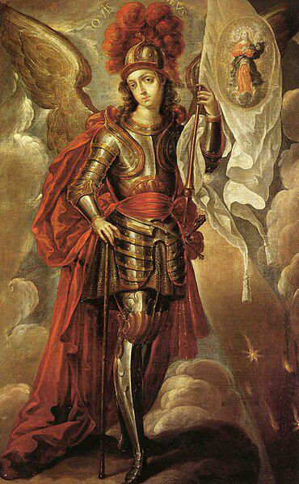

Caption for image source 1: San Miguel Arcángel - Cristóbal de Villalpando Saint Michael the Archangel.

Image Source 2 -

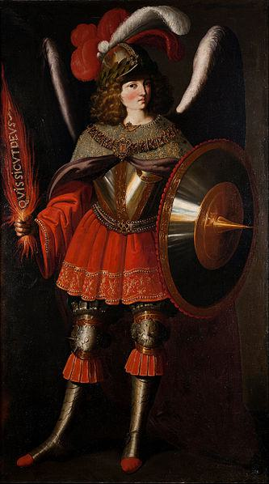

Caption for image source 2: Francisco de Zurbarán and Studio - The Archangel Michael - Google Art Project.

Example Question - "Saint Michael the Archangel's helmet had longer plumage on which painting: The Archangel Michael or Saint Michael the Archangel?"

Example Answer - "The Archangel Michael had longer plumage."

Additional Text Source 1 - In the 4th century, Saint Basil the Great's homily (De Angelis) placed Saint Michael over all the angels. He was called "Archangel" because he heralds other angels, the title Ἀρχαγγέλος (archangelos) being used of him in Jude 1:9. (from: Michael (archangel))

Generated Question - Considering Saint Michael's role as "Archangel," which painting shows him holding a banner that might symbolize his leadership?

Generated Answer - Saint Michael the Archangel by Cristóbal de Villalpando holds a banner, symbolizing his leadership.

--- Entry for custom_id: d5cc89be0dba11ecb1e81171463288e9 ---

Image Source 1 -

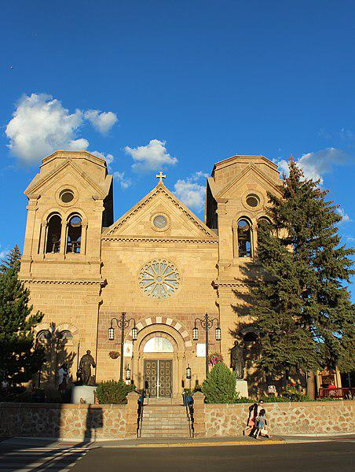

Caption for image source 1: Santa Fe, New Mexico, USA - Cathedral Basilica of St. Francis of Assisi - panoramio.

Image Source 2 -

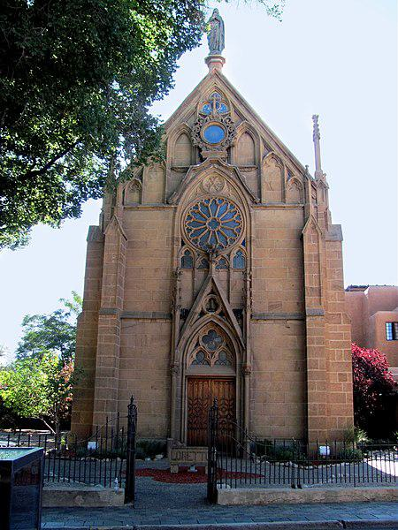

Caption for image source 2: Santa Fe, New Mexico, USA - Loretto Chapel - panoramio (1).

Example Question - "When it comes to the form of window on their facades, what do the Loretto Chapel and the Cathedral Basilica of St. Francis of Assisi have in common?"

Example Answer - "When it comes to the form of window on their facades, the Loretto Chapel and the Cathedral Basilica of St. Francis of Assisi have rose windows in common."

Additional Text Source 1 - In 1986, Pope John Paul II recited the prayer in bidding farewell to the global religious leaders he hosted for the first "World Day of Prayer for Peace", in Assisi at the Basilica of St. Francis. (from: Prayer of Saint Francis)

Generated Question - Which building is connected to the prayer recited by Pope John Paul II during the first "World Day of Prayer for Peace"?

Generated Answer - The Cathedral Basilica of St. Francis of Assisi is connected to the prayer recited by Pope John Paul II.

--- Entry for custom_id: d5cb1d860dba11ecb1e81171463288e9 ---

Image Source 1 -

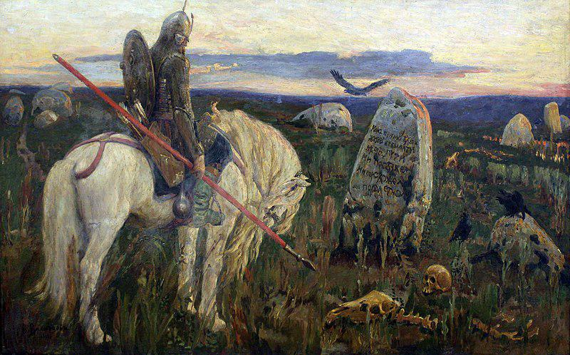

Caption for image source 1: 1919 Vasnetsov Ritter an der Kreuzung anagoria Viktor Mikhailovich Vasnetsov A knight at the crossroads.

Example Question - "What kind of weapon does the horse rider have in his hand in A Knight at the Crossroads?"

Example Answer - "The horse rider has a spear in his hand."

Additional Text Source 1 - Daredevil, who has been possessed by The Hand, hires Profile to take down Moon Knight. During an assault on the Shadowland fortress with Iron Fist, Ghost Rider, Spider-Man, Luke Cage, and Elektra, Daredevil almost kills Moon Knight, but Khonshu appears and asks him to spare his life. (from: Moon Knight)

Generated Question - Does the knight in "A Knight at the Crossroads" hold a weapon similar to those used by the heroes in the Moon Knight story?

Generated Answer - No, the knight holds a spear, unlike the modern weapons used by Moon Knight and others.

--- Entry for custom_id: d5ca078e0dba11ecb1e81171463288e9 ---

Image Source 1 -



Caption for image source 1: Spaltblättlinge.

Example Question - "Is the Spaltblättlinge shaped as a shell?"

Example Answer - "Yes, the Spaltblättlinge is shell-shaped."

Generated Question - Do the Spaltblättlinge mushrooms grow on wood and have a fan-like shape?

Generated Answer - Yes, they grow on wood and have a fan-like shape.

--- Entry for custom_id: d5c605800dba11ecb1e81171463288e9 ---

Image Source 1 -

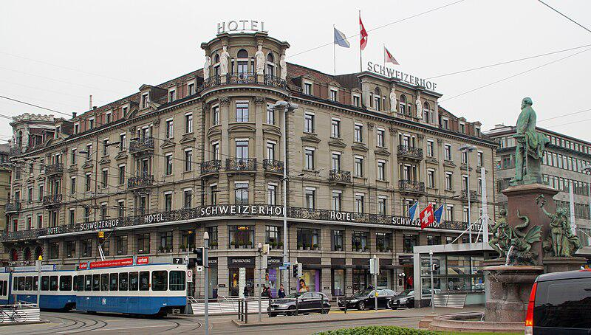

Caption for image source 1: 2015-03-25 Bahnhofplatz7 This photo was taken by Robert Kropf (User:TheRunnerUp) and released under the license CC BY-SA 4.0..

Example Question - "How many statues are on the Schweizerhof Hotel in Bahnhofplatz?"

Example Answer - "There are 6 statues on the roof of the Schweizerhof Hotel in Bahnhofplatz."

Additional Text Source 1 - It was awarded as the "historical hotel of the year" in 2012 by ICOMOS. He also designed the Cresta Palace Hotel in Celerina (St. Moritz), the Schweizerhof Hotel in Como and the former Hotel Reber au Lac in Locarno. (from: Jost Franz Huwyler-Boller)

Generated Question - Is the Schweizerhof Hotel in Bahnhofplatz recognized for its historical significance like the other hotels designed by Jost Franz Huwyler-Boller?

Generated Answer - Yes, the Schweizerhof Hotel in Bahnhofplatz was awarded "historical hotel of the year" in 2012.

--- Entry for custom_id: d5c44d440dba11ecb1e81171463288e9 ---

Image Source 1 -

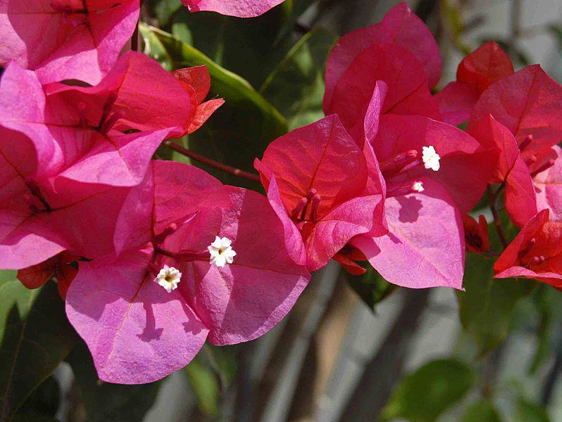

Caption for image source 1: Nyctaginaceae - Bougainvillea buttiana Flower surrended by bracts of Bougainvillea buttiana.

Image Source 2 -

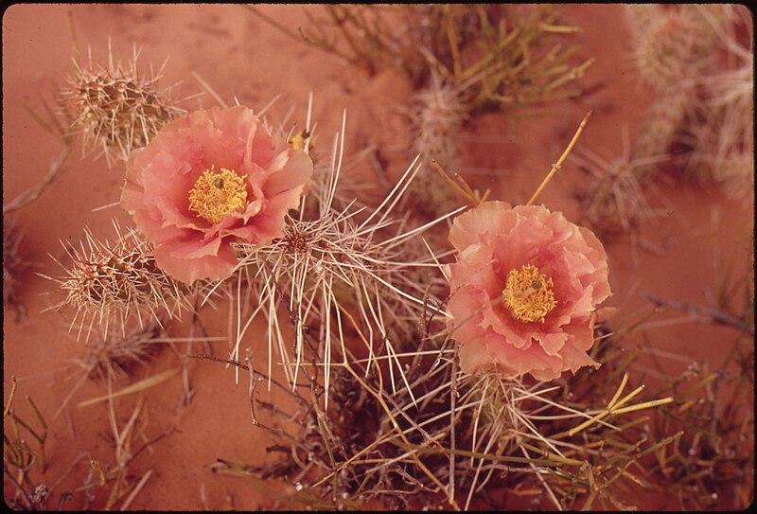

Caption for image source 2: ORANGE MALLOW, SHOWY DESERT FLOWER - NARA - 544877.

Example Question - "Is the Orange Globe Mallow and the Nyctaginaceae filamnet both pink?"

Example Answer - "No, the Orange Globe Mallow and the Nyctaginaceae filamnet are not both pink."

Generated Question - Are the flowers of Bougainvillea buttiana and the Orange Mallow surrounded by spines or bracts?

Generated Answer - The Bougainvillea buttiana flowers are surrounded by bracts, while the Orange Mallow flowers are surrounded by spines.

--- Entry for custom_id: d5da60840dba11ecb1e81171463288e9 ---

Example Question - What elements are used to create the explosive forces used by the technology that's currently being explored as a higher velocity alternative to conventional artillery?

Example Answer - Hydrogen and oxygen.

Image Source 1 -



Generated Question - How does the propellant used in modern 155 mm artillery ammunition differ from the gases used in combustion light-gas guns to achieve projectile acceleration?

Generated Answer - Modern 155 mm artillery uses solid nitrocellulose-based propellants, while combustion light-gas guns use hydrogen and oxygen gases.

--- Entry for custom_id: d5c385620dba11ecb1e81171463288e9 ---

Image Source 1 -

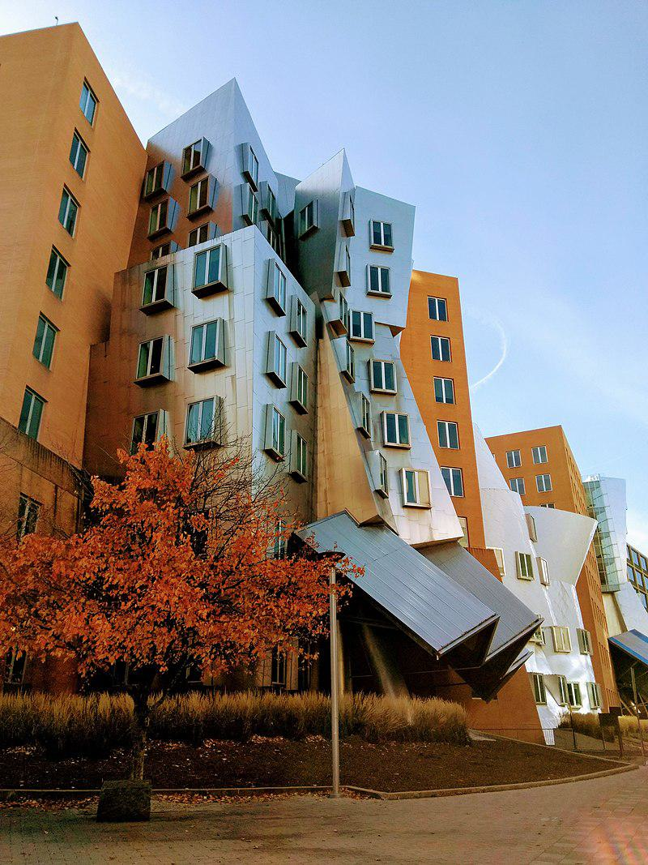

Caption for image source 1: Stata Center -MIT photo by Linda Fletcher.

Image Source 2 -

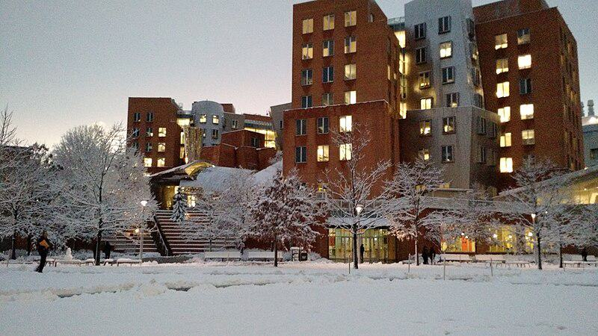

Caption for image source 2: Stata Center snow 2016 The Stata Center on the MIT Campus in snow, February 2016.

Example Question - "Are the buildings of the Stata Center uniform height?"

Example Answer - "The buildings of the Stata Center are not of uniform height."

Additional Text Source 1 - The wall and trees provide a uniform background for the chapel, and isolate the site from the noise and bustle of adjacent buildings. (from: MIT Chapel)

Generated Question - Does the Stata Center maintain a uniform appearance in both autumn and winter seasons despite the changing surroundings?

Generated Answer - No, the Stata Center's appearance contrasts with the autumn foliage and winter snow, showing different surroundings.

--- Entry for custom_id: d5dd1d740dba11ecb1e81171463288e9 ---

Example Question - Which person gave the island into which Somes Sound runs its name?

Example Answer - Samuel de Champlain gave Mount Desert Island, the island into which Somes Sound runs, its name.

Image Source 1 -

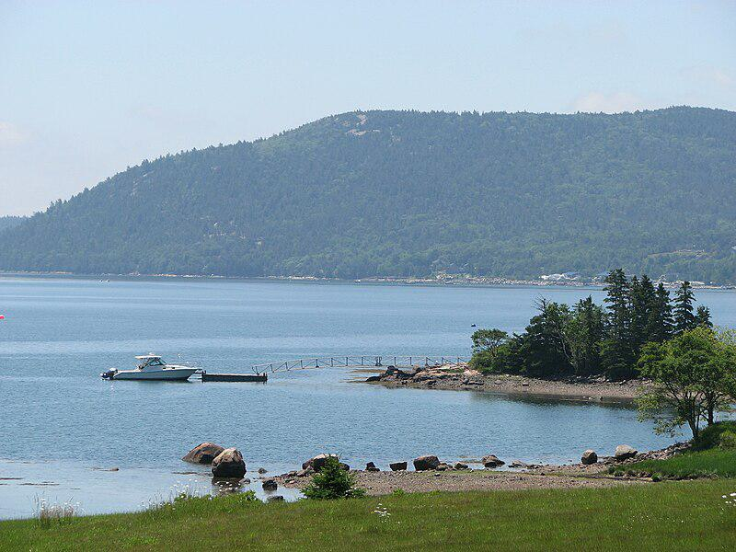

Generated Question - How deep is Somes Sound, the fjard visible from Mount Desert Island, and what is the island's significance?

Generated Answer - Somes Sound is about 175 feet deep, and Mount Desert Island is the largest island off Maine's coast.

--- Entry for custom_id: d5bfd3400dba11ecb1e81171463288e9 ---

Image Source 1 -

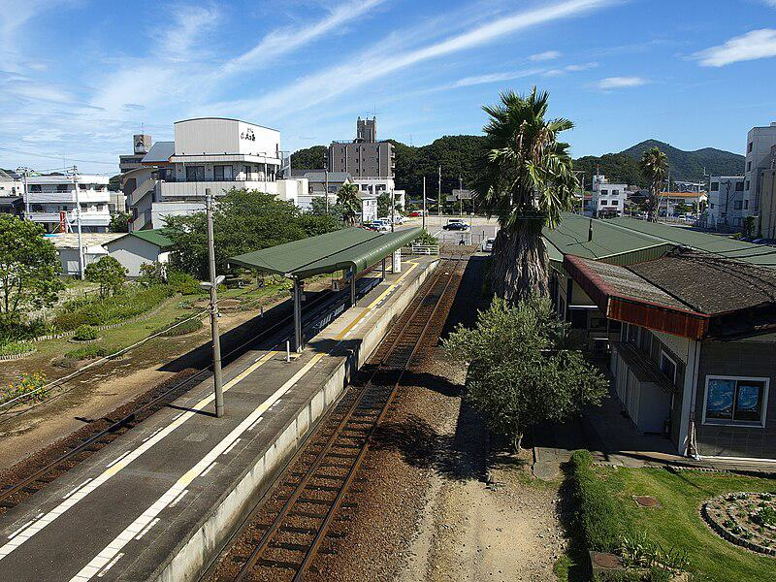

Caption for image source 1: Naruto railway station (overview) Naruto railway station overview ,Tokushima, Japan..

Example Question - "How many railway tracks appear at the Naruto railway station in Tokushima, Japan?"

Example Answer - "There are two railway tracks at the Naruto Railway Station in Tokushima, Japan."

Additional Text Source 1 - Konpiramae Station (金比羅前駅, Konpiramae-eki) is a railway station on the Naruto Line in Naruto, Tokushima Prefecture, Japan. It is operated by JR Shikoku and has the station number "N06". (from: Konpiramae Station)

Generated Question - Are Naruto railway station and Konpiramae Station both located in Naruto, Tokushima Prefecture, Japan?

Generated Answer - Yes, both stations are located in Naruto, Tokushima Prefecture, Japan.

--- Entry for custom_id: d5bfa64a0dba11ecb1e81171463288e9 ---

Image Source 1 -

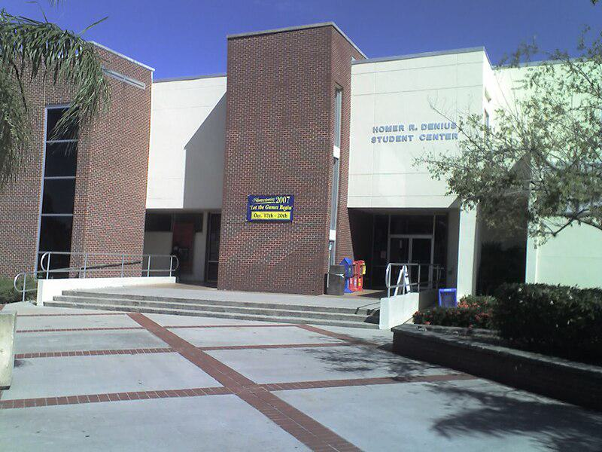

Caption for image source 1: FlTechSUB Florida Institute of Technology's Homer Denius Student Union Building, home to the campus bookstore, university mail annex, SUB Cafe, Office of Student Life, the John and Martha Hartley Room, as well as several student organizational offices..

Example Question - "Are there railings at the Florida Institute of Technology's Homer Denius Student Union Building?"

Example Answer - "Yes, there are railings."

Additional Text Source 1 - Florida Institute of Technology has 132 active student organizations on campus. The university-sponsored student organizations, such as Student Government Association, Campus Activities Board, the Homecoming Committee, FITV (CCTV Channel 99 on campus), and The Crimson (student-run university newspaper) operate in primary university funding. (from: Florida Institute of Technology)

Generated Question - Does the Florida Institute of Technology's Homer Denius Student Union Building likely support the activities of its 132 active student organizations?

Generated Answer - Yes, the building houses offices and spaces that support student organizations and activities.

--- Entry for custom_id: d5c3e5160dba11ecb1e81171463288e9 ---

Image Source 1 -



Caption for image source 1: The Rat (Graffiti in London) Banksy rat graffiti on City Road, London, United Kingdom..

Image Source 2 -



Caption for image source 2: Graffiti 47 on legal wall of PBS (2009) in Třebíč, Třebíč District Graffiti on legal wall of PBS factory in Trebic-Jejkov, Czech Republic..

Example Question - "What colors were used in the cartoon character in the Graffiti on legal wall of PBS factory that were not used in Banksy rat graffiti on City Road in London?"

Example Answer - "Red, blue, and yellow were used in the graffiti at the legal wall of PBS."

Additional Text Source 1 - Banksy no longer sells photographs or reproductions of his street graffiti, but his public "installations" are regularly resold, often even by removing the wall they were painted on. A small number of Banksy's works are officially, non-publicly, sold through an agency created by Banksy named Pest Control. (from: Banksy)

Generated Question - Can Banksy's rat graffiti on City Road be officially sold like the graffiti on the legal wall of PBS factory?

Generated Answer - No, Banksy's graffiti is rarely officially sold, unlike legal wall graffiti.

--- Entry for custom_id: d5c9d2460dba11ecb1e81171463288e9 ---

Image Source 1 -

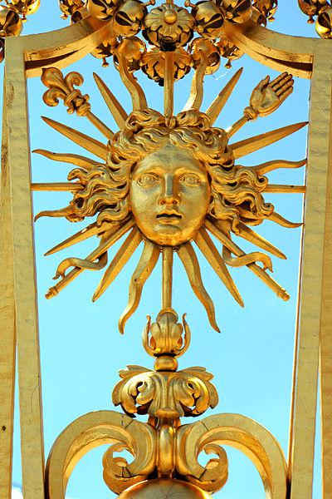

Caption for image source 1: Palace of Versailles - Louis XIV, 22 June 2014.

Example Question - "What human body part can be found on one of the spikes around the head on the Grille royale of Versailles, France?"

Example Answer - "A hand can be found on one of the spikes around the head on the Grille Royale of Versailles, France."

Additional Text Source 1 - The circulatory system consists of the heart and blood vessels (arteries, veins and capillaries). The heart propels the circulation of the blood, which serves as a "transportation system" to transfer oxygen, fuel, nutrients, waste products, immune cells and signalling molecules (i.e. hormones) from one part of the body to another. (from: Human body)

Generated Question - How does the heart in the circulatory system relate to the symbolic sun face in the Palace of Versailles grille?

Generated Answer - The heart circulates life like the sun face symbolizes life and energy.

--- Entry for custom_id: d5ca8bfa0dba11ecb1e81171463288e9 ---

Image Source 1 -



Caption for image source 1: Marissa Castelli Simon Shnapir 2013 U.S. Figure Skating Pairs Champions Marissa Castelli and Simon Shnapir stand atop the podium after becoming the 2013 U.S. Figure Skating Pairs Champions.

Example Question - "What color did Marissa Castelli wear after becoming the 2013 U.S. Figure Skating Pairs Champion?"

Example Answer - "Marissa Castelli wore the color red after becoming the 2013 U.S. Figure Skating Pairs Champion."

Additional Text Source 1 - None of the top three partnerships from 2012 competed in the pairs event, Denney / Coughlin being absent due to Coughlin's surgery and the other two pairs having split. Longtime pair Marissa Castelli / Simon Shnapir won the short program ahead of relatively new teams Felicia Zhang / Nathan Bartholomay and Alexa Scimeca / Christopher Knierim. (from: 2013 U.S. Figure Skating Championships)

Generated Question - Did Marissa Castelli and Simon Shnapir win the 2013 U.S. Figure Skating Pairs Championship despite the absence of the top three pairs from 2012?

Generated Answer - Yes, they won despite the absence of the top three pairs from 2012.

--- Entry for custom_id: d5d868b00dba11ecb1e81171463288e9 ---

Example Question - The public use Falcon Field and the state-owned facility located west of Adak in Alaska are both types of what?

Example Answer - Airports.

Image Source 1 -



Generated Question - Are both the Atlanta Regional Airport and Adak Airport used for public air travel and served by commercial airlines like Alaska Airlines?

Generated Answer - Yes, both airports are public use and served by commercial airlines.

--- Entry for custom_id: d5ddccba0dba11ecb1e81171463288e9 ---

Example Question - What type of armor and weapons would Spartacus have likely worn as a gladiator?

Example Answer - He would have probably worn a small rectangular, square or circular shield and a very short sword with a slightly curved blade.

Image Source 1 -

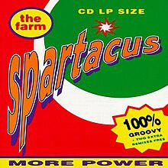

Generated Question - How does the image of the "Spartacus" album cover relate to the historical figure Spartacus and his gladiator weapons?

Generated Answer - The album cover name references Spartacus, who likely used a small shield and short curved sword as a Thracian gladiator.

--- Entry for custom_id: d5bf5dd40dba11ecb1e81171463288e9 ---

Image Source 1 -

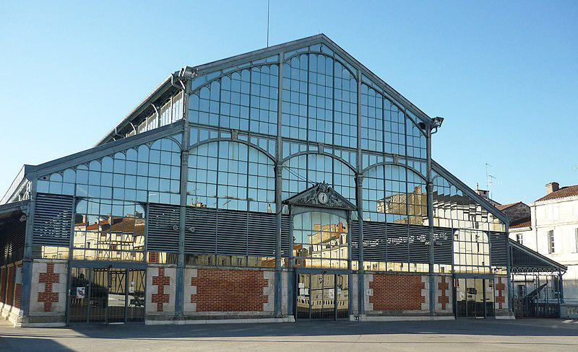

Caption for image source 1: Halles de Niort.

Example Question - "How many people are around the clock in the sculpture over the door of the Halles de Niort?"

Example Answer - "There are 4 people around the clock."

Additional Text Source 1 - There are no airports with scheduled airline service within the département, although Niort-Souche Airport is used for private movements. The nearest commercial airports are at Poitiers (Poitiers - Biard Airport), La Rochelle (La Rochelle - Île de Ré Airport) and Nantes (Nantes Atlantique Airport). (from: Deux-Sèvres)

Generated Question - Is the Halles de Niort located near any commercial airports mentioned in the Deux-Sèvres département text?

Generated Answer - Yes, it is near commercial airports at Poitiers, La Rochelle, and Nantes.

--- Entry for custom_id: d5db3c160dba11ecb1e81171463288e9 ---

Example Question - In Arthurian legend, the father of Lancelot and Hector de Maris takes which king's sister-in-law to be his wife?

Example Answer - Ban marries the sister to King Bors's wife.

Image Source 1 -

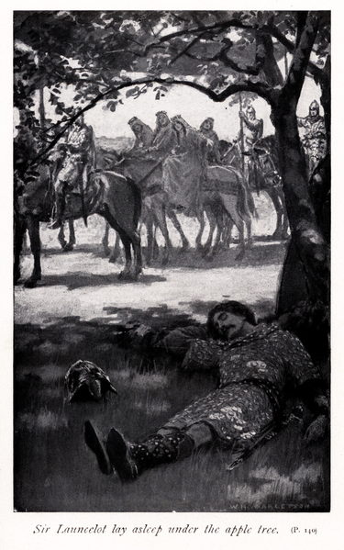

Generated Question - How is the sleeping figure under the apple tree in the illustration related to King Ban and his wife Elaine?

Generated Answer - The sleeping figure is Lancelot, son of King Ban and Elaine.

--- Entry for custom_id: d5da5b7a0dba11ecb1e81171463288e9 ---

Example Question - How big is the diameter of the smooth cap in the mycorrhizal organism that lives in symbiosis with the trees?

Example Answer - About 4–10 cm.

Image Source 1 -



--- Entry for custom_id: d5d416340dba11ecb1e81171463288e9 ---

Example Question - Did Ron McLarty or Peter Thomas live to a longer age?

Example Answer - Peter Thomas lived to a longer age.

Image Source 1 -

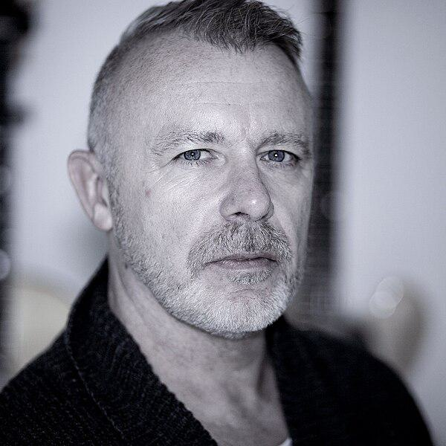

Generated Question - Based on their careers and the image, is Peter James Thomas likely the same person as Peter Addenbrooke Thomas, the announcer?

Generated Answer - Yes, Peter James Thomas is likely the same person as Peter Addenbrooke Thomas, the announcer.

--- Entry for custom_id: d5c9e6f00dba11ecb1e81171463288e9 ---

Image Source 1 -

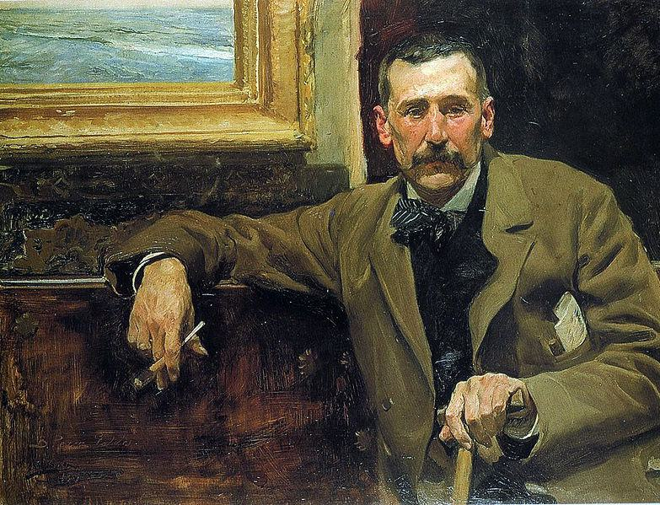

Caption for image source 1: Perez galdos.

Image Source 2 -

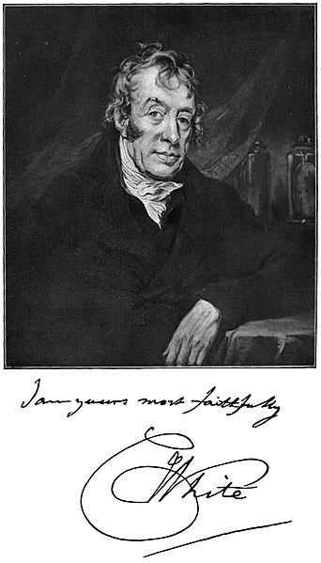

Caption for image source 2: White Charles physician Picture of Charles White, the physician.

Example Question - "Are the men in Joaquín Sorolla's "Portrait of Benito Pérez Galdós" and photograph of "Picture of Charles White, the physician" (taken in 1904) sitting down?"

Example Answer - "The men in Joaquín Sorolla's "Portrait of Benito Pérez Galdós" and photograph of "Picture of Charles White, the physician" (taken in 1904) are sitting down."

Additional Text Source 1 - Portrait of Benito Pérez Galdós (Spanish: Retrato de Benito Pérez Galdós is an oil portrait painting by Joaquín Sorolla in 1894. It represents the Spanish writer Benito Pérez Galdós at aged 51.In 1973 it was acquired by the grandsons of Galdós for the Cabildo Insular de Gran Canaria. (from: Portrait of Benito Pérez Galdós)

--- Entry for custom_id: d5d589ba0dba11ecb1e81171463288e9 ---

Example Question - Who were the parents of the god in Norse mythology projected as the husband of the goddes Frigg?

Example Answer - Odin is the son of Bestla and Borr

Image Source 1 -

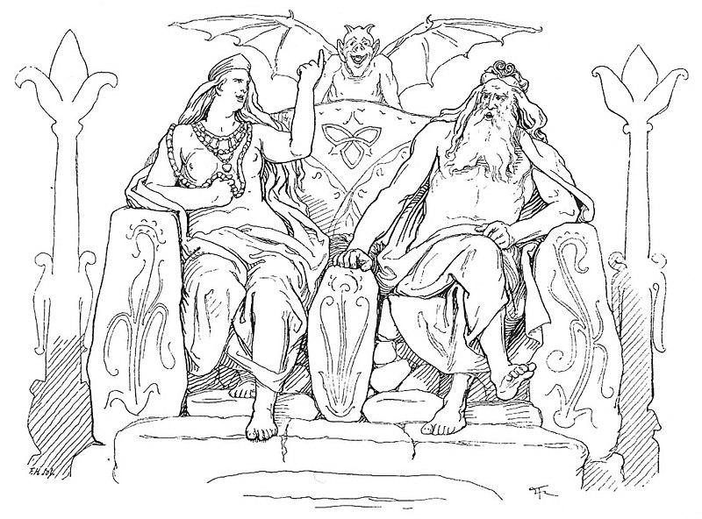

Generated Question - Which god, son of Bestla and Borr, is depicted sitting with the goddess Frigg and associated with wisdom and war?

Generated Answer - Odin is the son of Bestla and Borr, depicted with Frigg and associated with wisdom and war.

--- Entry for custom_id: d5dd0c9e0dba11ecb1e81171463288e9 ---

Example Question - What color are the bill and feet of the bar-tailed trogon and the belly of the male black-throated trogon?

Example Answer - yellow

Image Source 1 -

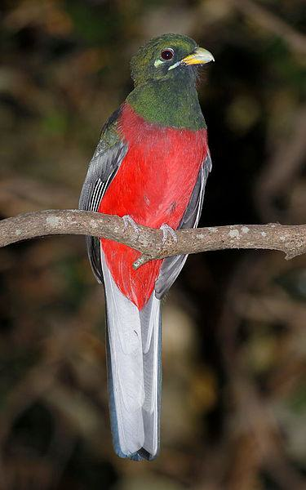

Generated Question - Which trogon species mentioned has a blue-black head with bronze iridescence, and which has a green head and golden yellow belly?

Generated Answer - The bar-tailed trogon has a blue-black head with bronze iridescence, and the black-throated trogon has a green head and golden yellow belly.

--- Entry for custom_id: d5ccb01a0dba11ecb1e81171463288e9 ---

Image Source 1 -

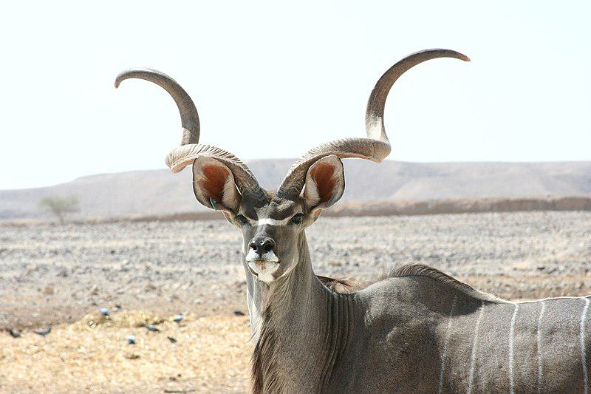

Caption for image source 1: Kudu antelope Kudu at antelpe ranch, Israel.

Example Question - "What shape are the horns of a Kudu Antelope?"

Example Answer - "The horns of the Kudu Antelope are spiral shaped."

Additional Text Source 1 - The alternative name "Strepsicerotini" was published by another British zoologist John Edward Gray as "Strepsiceriae" earlier in 1846. It comes from Greek with στρεπτός (streptós) meaning "twisted" and κέρατος (kératos) meaning "horn", referring to the shape of this group's horns. (from: Tragelaphini)

Generated Question - Does the name "Strepsicerotini" relate to the twisted shape of the Kudu antelope's horns?

Generated Answer - Yes, "Strepsicerotini" means twisted horn, describing the Kudu's spiral horns.

--- Entry for custom_id: d5bca3140dba11ecb1e81171463288e9 ---

Image Source 1 -

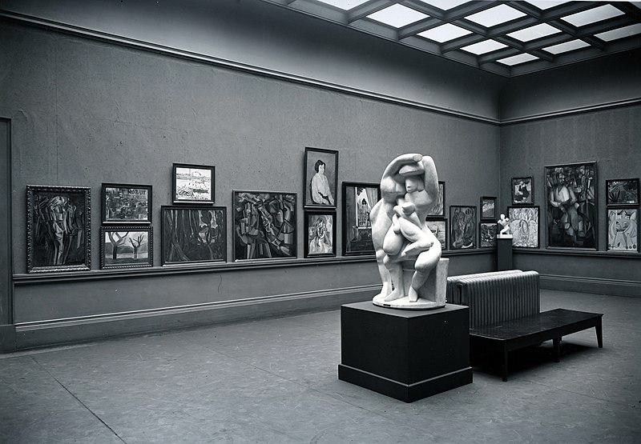

Caption for image source 1: Armory Show, International Exhibition of Modern Art, Chicago, 1913. The Cubist room.

Example Question - "How many sculptures are on display in the Cubist Room at the Armory Show International Exhibition of Modern Art?"

Example Answer - "There are two sculptures on display in the Cubist Room at the Armory Show International Exhibition of Modern Art."

Additional Text Source 1 - The DePaul Art Museum in Chicago, Illinois presented For and Against Modern Art: The Armory Show +100, from April 4 to June 16, 2013. The International Print Center in New York held an exhibition, "1913 Armory Show Revisited: the Artists and their Prints," of prints from the show or by artists whose work in other media was included. (from: Armory Show)

Generated Question - Did the Armory Show's Cubist Room in 1913 include both paintings and sculptures in its display?

Generated Answer - Yes, the Cubist Room displayed both paintings and sculptures.

--- Entry for custom_id: d5c704120dba11ecb1e81171463288e9 ---

Image Source 1 -



Caption for image source 1: Mycena parsonsiae 44171.

Image Source 2 -



Caption for image source 2: Mycena leaiana 58075.

Example Question - "What kind of surface can Mycena leaiana and Mycena parsonsiae grow on?"

Example Answer - "They can grow on a rock surface."

Additional Text Source 1 - Mycena galopus, commonly known as the milking bonnet or the milk-drop mycena, is an inedible species of fungus in the family Mycenaceae of the order Agaricales. It produces small mushrooms that have grayish-brown, bell-shaped, radially-grooved caps up to 2.5 cm (1 in) wide. (from: Mycena galopus)

Generated Question - Are Mycena parsonsiae and Mycena leaiana similar in cap shape despite their different colors and sizes?

Generated Answer - Yes, both have bell-shaped caps with radial grooves.

--- Entry for custom_id: d5d43e3e0dba11ecb1e81171463288e9 ---

Example Question - Did Adrien Brody win his Academy Award for Best Actor for The Pianist in the same year that Bill Murray won a Golden Globe award for Lost in Translation?

Example Answer - no

Image Source 1 -

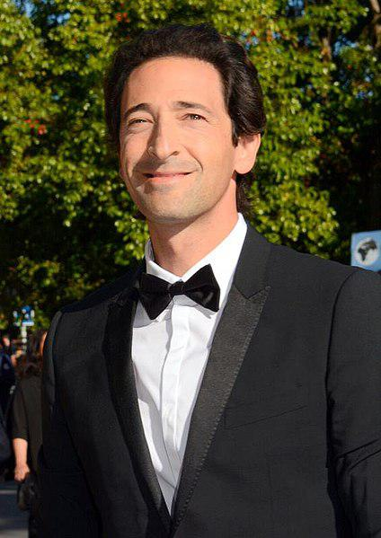

Generated Question - Did Adrien Brody become the youngest actor to win an Academy Award for Best Actor before Bill Murray received his Oscar nomination for Lost in Translation?

Generated Answer - Yes, Adrien Brody won the Academy Award before Bill Murray's nomination.

--- Entry for custom_id: d5cfe1680dba11ecb1e81171463288e9 ---

Example Question - How many vase painters have been identified by people who sometimes studied disjecta membra?

Example Answer - Over 2800 painters have been identified.

Image Source 1 -

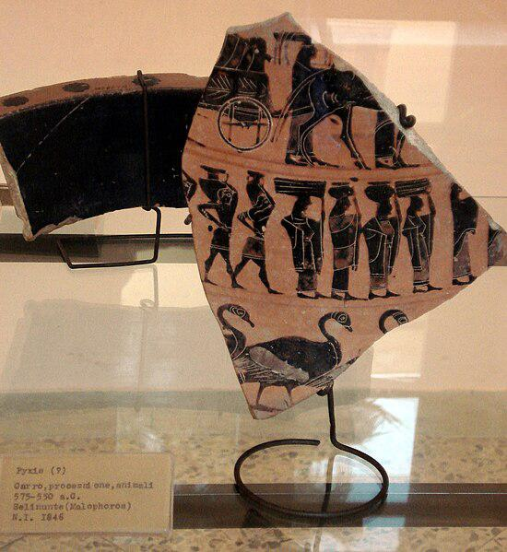

Generated Question - How do scholars identify individual ancient Greek vase painters using fragments like the one shown in the image?

Generated Answer - Scholars attribute painted fragments, called disjecta membra, to individual artists by studying their style.

--- Entry for custom_id: d5ccabc40dba11ecb1e81171463288e9 ---

Image Source 1 -

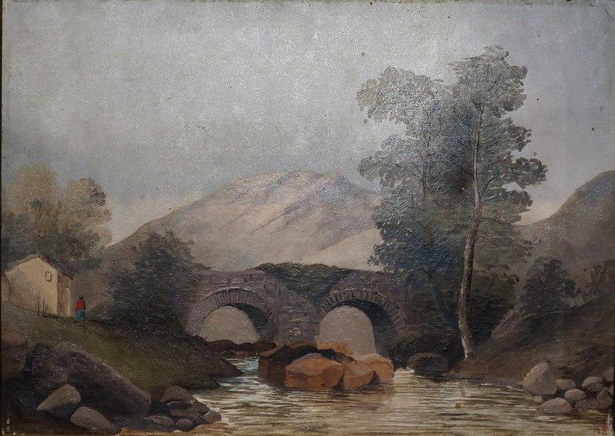

Caption for image source 1: Scottish Landscape, oil on canvas painting by Princess Victoria Kaiulani, c. 1891, Bishop Museum Scottish Landscape, oil on canvas painting by Princess Victoria Kaiulani, c. 1891, Bishop Museum.

Image Source 2 -

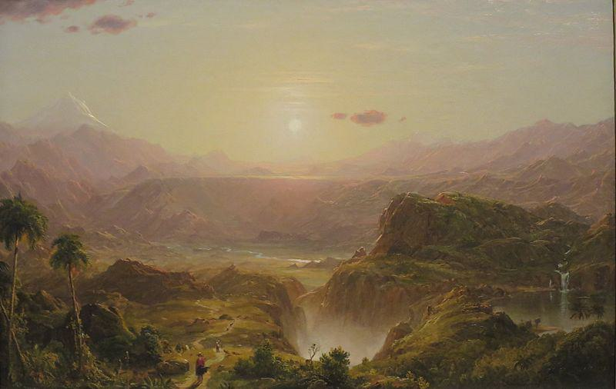

Caption for image source 2: 'The Andes of Ecuador', oil on canvas painting by Frederic Adwin Church, 1855, HAA The Andes of Ecuador oil on canvas painting by Frederic Edwin Church, 1855, Honolulu Museum of Art accession 56221.

Example Question - "In which painting is the sun visible: The Andes of Ecuador by Frederic Adwin Church or Scottish Landscape by by Princess Victoria Kaiulani?"

Example Answer - "The sun visible in the painting The Andes of Ecuador by Frederic Adwin Church."

Additional Text Source 1 - He later wrote to his friend Will Hicok Low, "If you want to cease to be Republican, see my little Kaiulani, as she goes through [the United States]." Historian A. Grove Day noted, "Of all his island friendships, the platonic affair with the half-Scottish princess has most persisted in the imagination of lovers of Hawaiiana." (from: Kaʻiulani)

Generated Question - Considering the landscapes and the historical connection, which painting likely reflects the heritage of Princess Victoria Kaiulani?

Generated Answer - The Scottish Landscape likely reflects Princess Victoria Kaiulani's heritage due to her half-Scottish background.

--- Entry for custom_id: d5c6d0aa0dba11ecb1e81171463288e9 ---

Image Source 1 -

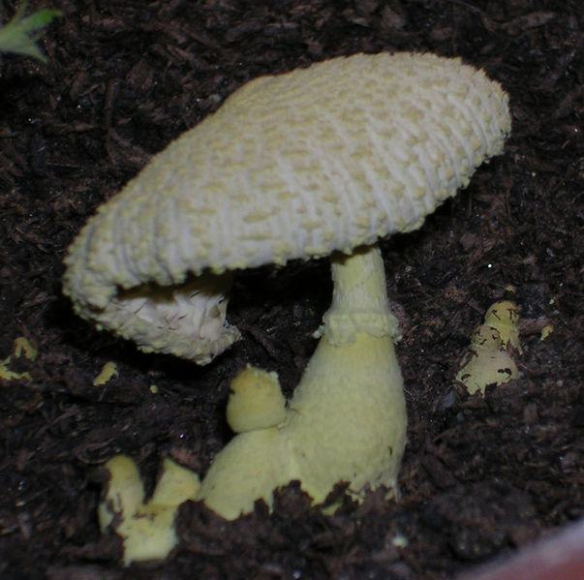

Caption for image source 1: Leucocoprinus birnbaumii.

Image Source 2 -



Caption for image source 2: Laccaria amethysteo-occidentalis (32942930552).

Example Question - "Which fungus top looks most like it was knit; Leucocoprinus birnbaumii or Laccaria amethysteo-occidentalis?"

Example Answer - "The Leucocoprinus birnbaumii fungus top looks most like it was knit."

Additional Text Source 1 - In the UK, Leucocoprinus birnbaumii has been given the recommended common name of "plantpot dapperling". In North America, it has also been called the "yellow parasol", "flowerpot parasol", "yellow houseplant mushroom", "lemon-yellow lepiota", or "yellow pleated parasol". (from: Leucocoprinus birnbaumii)

Generated Question - Considering their common names, which fungus is more associated with indoor plants, Leucocoprinus birnbaumii or Laccaria amethysteo-occidentalis?

Generated Answer - Leucocoprinus birnbaumii is more associated with indoor plants.

--- Entry for custom_id: d5c9a97e0dba11ecb1e81171463288e9 ---

Image Source 1 -

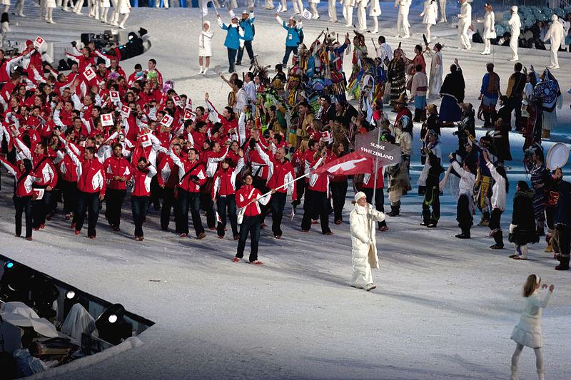

Caption for image source 1: 2010 Opening Ceremony - Switzerland entering.

Image Source 2 -

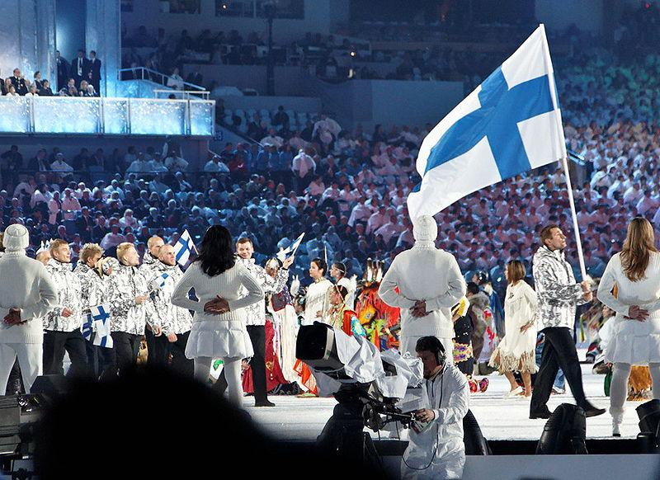

Caption for image source 2: 2010 Olympic Winter Games Opening Ceremony - Finland entering cropped.

Example Question - "Which nation in the 2010 Winter Olympics opening ceremony had more white in their uniforms: Finland or Switzerland?"

Example Answer - "Finland had more white in their uniforms than Switzerland."

Additional Text Source 1 - A soundtrack, Sounds of Vancouver 2010: Opening Ceremony Commemorative Album (French: Musique de Vancouver 2010 : L'album commémoratif de la cérémonie d'ouverture des Jeux), was released through the iTunes Store on February 12, 2010, containing many studio recordings of the performances from the opening ceremony. (from: 2010 Winter Olympics opening ceremony)

Generated Question - Did the 2010 Winter Olympics opening ceremony feature both Switzerland and Finland teams entering with their national flags?

Generated Answer - Yes, both Switzerland and Finland teams entered carrying their national flags.

--- Entry for custom_id: d5cfb54e0dba11ecb1e81171463288e9 ---

Example Question - What was the name of the home arena to the Texas Stars of the American Hockey League when WrestleMania 29 took place?

Example Answer - Cedar Park Center

Image Source 1 -



Generated Question - Did Aristobulus negotiate with Pompey at a mountain fortress while WrestleMania 29 took place in the arena originally named Cedar Park Center?

Generated Answer - Yes, Aristobulus negotiated at a mountain fortress, and WrestleMania 29 took place at Cedar Park Center.

--- Entry for custom_id: d5c449c00dba11ecb1e81171463288e9 ---

Image Source 1 -

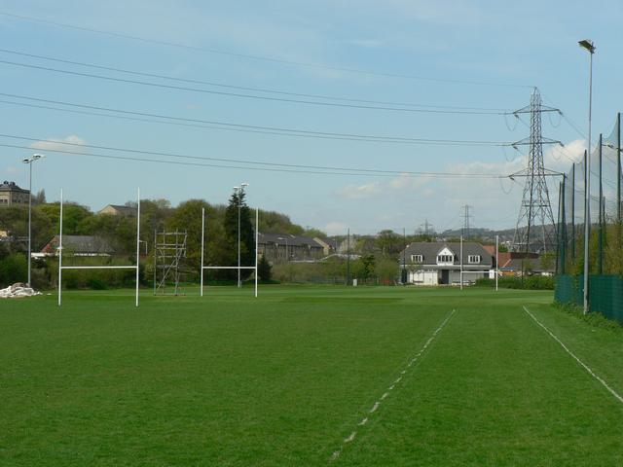

Caption for image source 1: Leeds Rugby Academy, Kirkstall - geograph.org.uk - 165339 Leeds Rugby Academy, Kirkstall. Looking along the fence on the east side adjacent to Morrisons..

Image Source 2 -

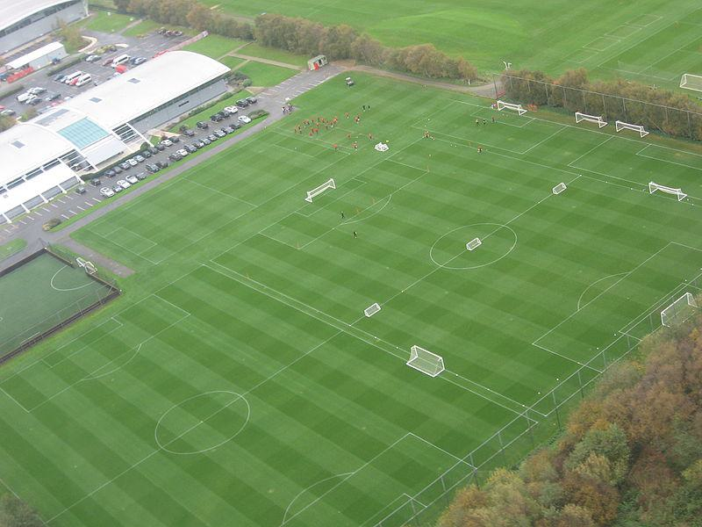

Caption for image source 2: MUFC training ground Carrington.

Example Question - "Are there light posts next to the field at both Leeds rugby Academy in kirkstall and the MUFC training ground in Carrington?"

Example Answer - "No, there are no light posts next to the field at Leeds rugby Academy in Kirkstall or the MUFC training ground in Carrington."

Additional Text Source 1 - The Under-16s and Under-18s typically play their academy league games at 11am on Saturday mornings at Carrington, while Youth Cup games are generally played at either Altrincham's Moss Lane ground (where the under-23s play their home games) or the club's 76,000-capacity Old Trafford home, in order to cater for the greater number of supporters these fixtures attract. (from: Manchester United F.C. Reserves and Academy)

Generated Question - Do both Leeds Rugby Academy and MUFC training ground Carrington host youth games on weekends?

Generated Answer - Only MUFC training ground Carrington hosts youth games on Saturday mornings.

--- Entry for custom_id: d5c3d3960dba11ecb1e81171463288e9 ---

Image Source 1 -

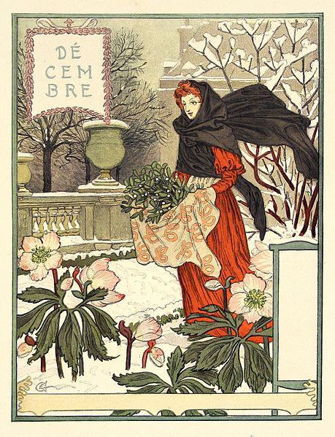

Caption for image source 1: Grasset-decembre.

Image Source 2 -

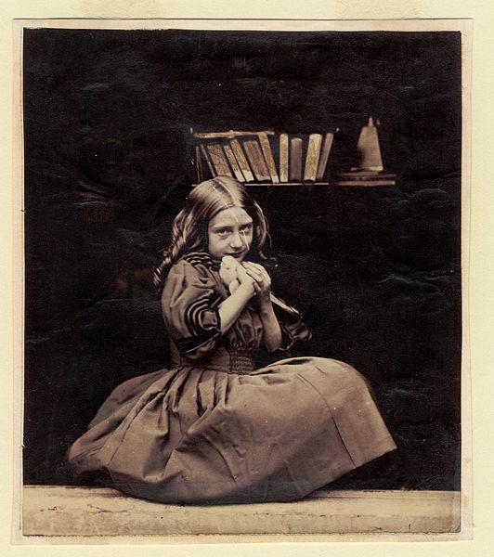

Caption for image source 2: Rejlander045 No title.

Example Question - "Which painting is more colorful, the "Decembre" by Eugène Grasset or the "Girl with dove" by Oscar Gustave Rejlander?"

Example Answer - "Decembre is more colorful than Girl with dove."

Additional Text Source 1 - Hugues Lebailly has endeavoured to set Dodgson's child photography within the "Victorian Child Cult", which perceived child nudity as essentially an expression of innocence. Lebailly claims that studies of child nudes were mainstream and fashionable in Dodgson's time and that most photographers made them as a matter of course, including Oscar Gustave Rejlander and Julia Margaret Cameron. (from: Lewis Carroll)

Generated Question - Considering the Victorian Child Cult context, which image likely reflects the era's innocence ideal more, the colorful "Decembre" or the black-and-white "Girl with dove"?

Generated Answer - The black-and-white "Girl with dove" likely reflects the Victorian innocence ideal more.

--- Entry for custom_id: d5d1f1060dba11ecb1e81171463288e9 ---

Example Question - What is the weight range for squids that are part of the Cephalopod molluscs phylum?

Example Answer - They can range in weight between 0.1 kg to 495 kg.

Image Source 1 -

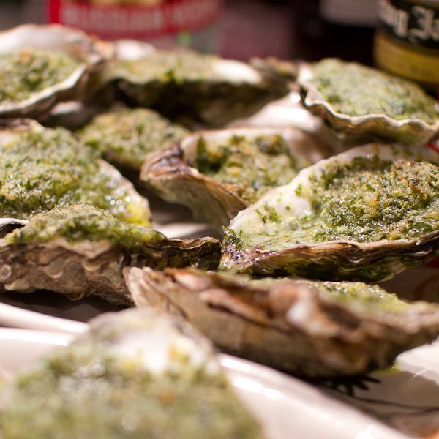

Generated Question - How do the weights of colossal squids compare to the edible molluscs used in dishes like Oysters Rockefeller?

Generated Answer - Colossal squids weigh up to 495 kg, much heavier than typical edible molluscs like oysters.

--- Entry for custom_id: d5c40a8c0dba11ecb1e81171463288e9 ---

Image Source 1 -

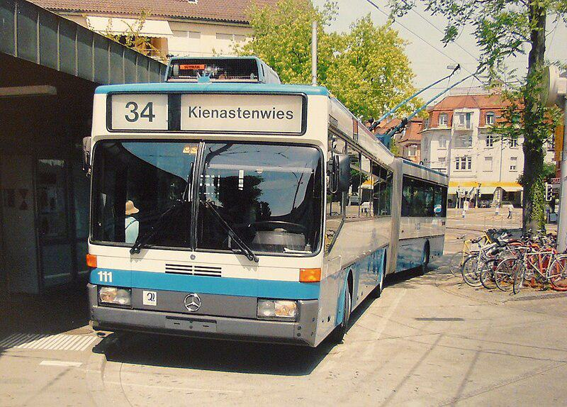

Caption for image source 1: Klausplatz Zurich trolleybus Mercedes-Benz trolleybus (#111) at Klusplatz in Zurich, Switzerland..

Example Question - "What brand of buses are used at Klusplatz in Zurich, Switzerland?"

Example Answer - "The buses at Klusplatz in Zurich, Switzerland are Mercedes Benz."

Additional Text Source 1 - In 1970 the PFLP obtained the release of the three terrorists convicted in Switzerland and other comrades-in-arms imprisoned abroad through coordinated hijackings. Flights affected were SR 100 (Zurich-New York), TWA flight TW741, Pan Am flight PA93 and BOAC flight BA775. (from: Zurich Airport)

Generated Question - Is the Mercedes-Benz trolleybus at Klausplatz in Zurich related to the 1970 hijackings involving flights from Zurich Airport?

Generated Answer - No, the trolleybus and the 1970 hijackings at Zurich Airport are unrelated.

--- Entry for custom_id: d5d0f5c60dba11ecb1e81171463288e9 ---

Example Question - On what highway in California were there cars overturned during the outbreak of weak tornadoes in Santa Barbara and Orange Counties between January 19 and January 21, 2010?

Example Answer - The cars were overturned on the Pacific Coast Highway.

Image Source 1 -

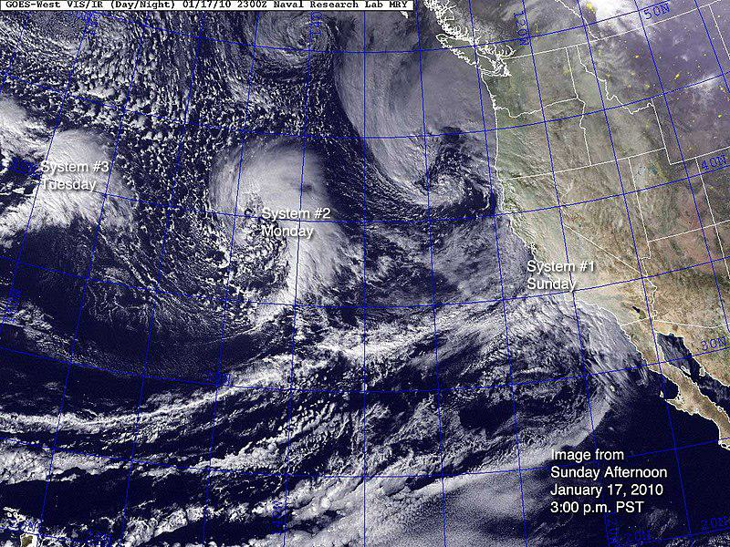

Generated Question - How many storm systems were visible off the California coast on January 17, 2010, before the tornado outbreak in Santa Barbara and Orange Counties?

Generated Answer - Three storm systems were visible off the California coast on January 17, 2010.

--- Entry for custom_id: d5d0210a0dba11ecb1e81171463288e9 ---

Example Question - What title can the older youth of the Sea Scouts elect a youth leader to that is also a member of a U.S. Navy gun crew?

Example Answer - They can be given the title 'boatswain".

Image Source 1 -

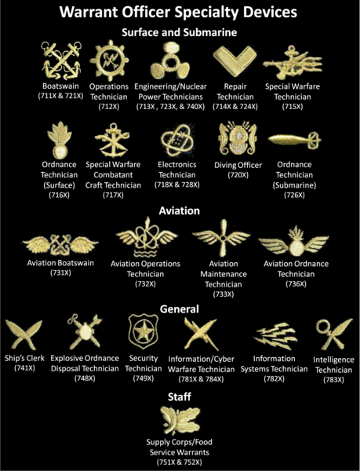

--- Entry for custom_id: d5dde1d20dba11ecb1e81171463288e9 ---

Example Question - Egbert Benson and John Jay had descent from what people whose colonization of the Americas began with the establishment of trading posts and plantations?

Example Answer - Dutch

Image Source 1 -

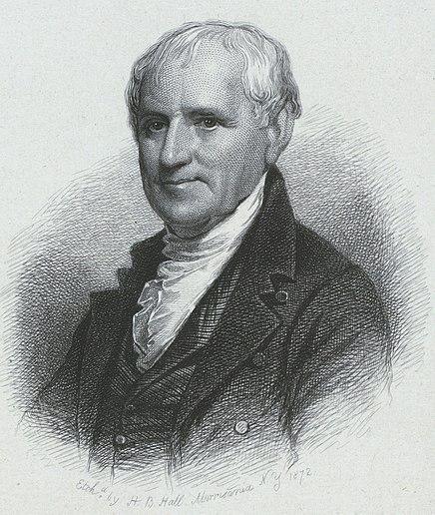

Generated Question - Which colonizing people, known for early trading posts in the Americas, were ancestors of Egbert Benson shown in the image?

Generated Answer - Dutch

--- Entry for custom_id: d5cc0cc80dba11ecb1e81171463288e9 ---

Image Source 1 -

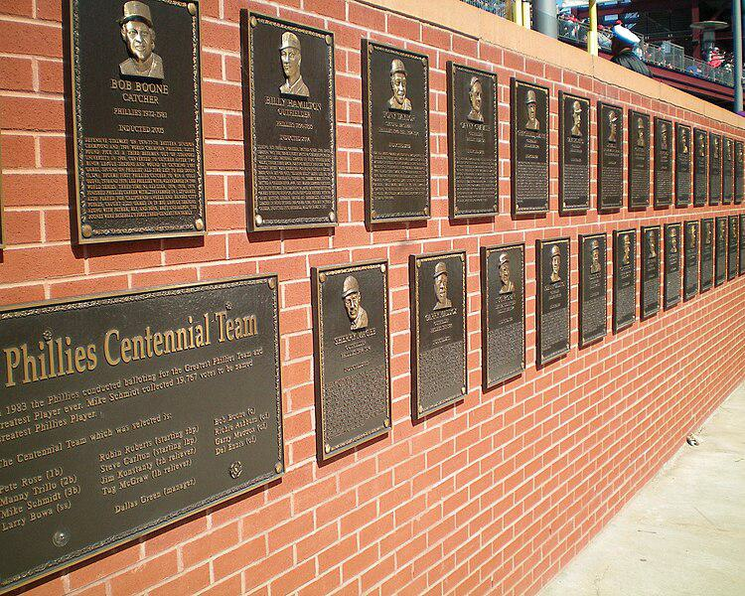

Caption for image source 1: PhilliesWallofFame This is the Phillies Wall of Fame at Citizens Bank Park, Philadelphia, PA..

Example Question - "What kind of wall holds the Phillies Wall of Fame at Citizens Bank Park, Philadelphia, PA?"

Example Answer - "A brick wall holds the Phillies Wall of Fame at Citizens Bank Park, Philadelphia, PA."

Additional Text Source 1 - In addition to Tropicana Field in St. Petersburg, Citizens Bank Park (Philadelphia Phillies), Truist Park (Atlanta Braves), Yankee Stadium (New York Yankees), and Globe Life Field (Texas Rangers) are the only current venues that have not yet hosted an All-Star Game. (from: List of Major League Baseball All-Star Games)

Generated Question - Is the Phillies Wall of Fame located in a stadium that has hosted an All-Star Game?

Generated Answer - No, Citizens Bank Park has not yet hosted an All-Star Game.

--- Entry for custom_id: d5c0f2f20dba11ecb1e81171463288e9 ---

Image Source 1 -

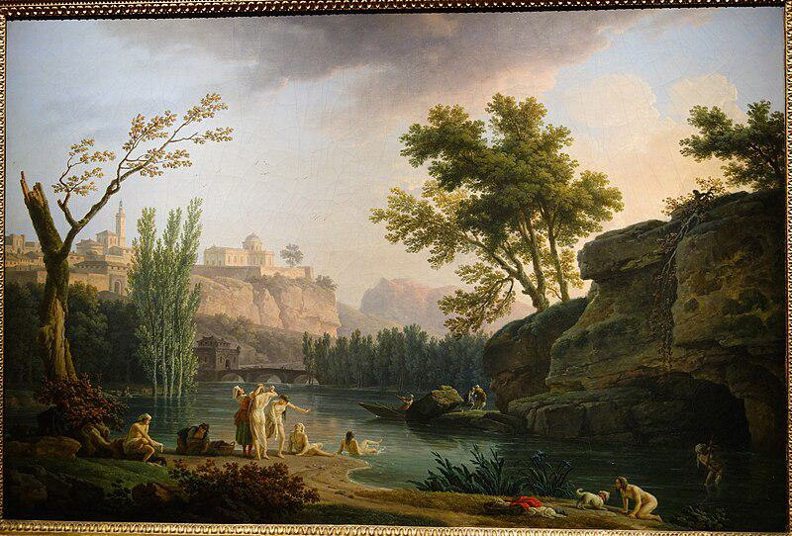

Caption for image source 1: Summer Evening, Landscape in Italy, view 2, by Joseph Vernet, 1773, oil on canvas - National Museum of Western Art, Tokyo - DSC08554 Painting in the National Museum of Western Art, Tokyo, Japan. This artwork is in the public domain because the artist died more than 70 years ago. Photography was permitted in the museum without restriction..

Image Source 2 -

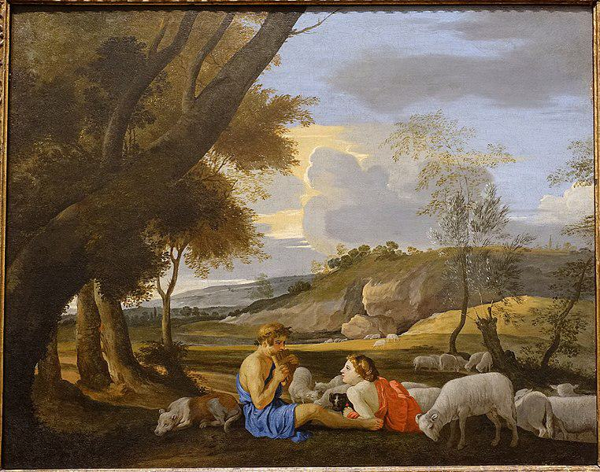

Caption for image source 2: Arcadian Landscape, by the circle of Nicolas Poussin, c. 1627-1628, oil on canvas - Blanton Museum of Art - Austin, Texas - DSC07880 Arcadian Landscape.

Example Question - "Is there a dog in Joseph Vernet's "Summer Evening, Landscape in Italy" and "Arcadian Landscape, by the circle of Nicolas Poussin"?"

Example Answer - "There is a dog in both Joseph Vernet's "Summer Evening, Landscape in Italy" and "Arcadian Landscape, by the circle of Nicolas Poussin"."

Additional Text Source 1 - Et in Arcadia ego (also known as Les bergers d'Arcadie or The Arcadian Shepherds) is a 1637–38 painting by Nicolas Poussin (1594–1665), the leading painter of the classical French Baroque style. It depicts a pastoral scene with idealized shepherds from classical antiquity, and a woman, possibly a shepherdess, gathered around an austere tomb. (from: Et in Arcadia ego)

Generated Question - Do both paintings depict natural landscapes with human figures interacting with animals?

Generated Answer - Yes, both paintings show natural landscapes with humans and animals interacting.

--- Entry for custom_id: d5d60a980dba11ecb1e81171463288e9 ---

Example Question - According to legend, Dangun founded the first kingdom in what place where monarchy existed until the end of the Japanese occupation?

Example Answer - Korea

Image Source 1 -



Generated Question - Where is the legendary birthplace of Korea's first kingdom located, as shown by the lake where Dangun's father descended from heaven?

Generated Answer - Baekdu Mountain at Heaven Lake.

--- Entry for custom_id: d5d9ed700dba11ecb1e81171463288e9 ---

Example Question - The high peak called Golden Hinde can be found in what area that the twin summits the Lions Gate Bridge was named in their honor are in?

Example Answer - Vancouver.

Image Source 1 -

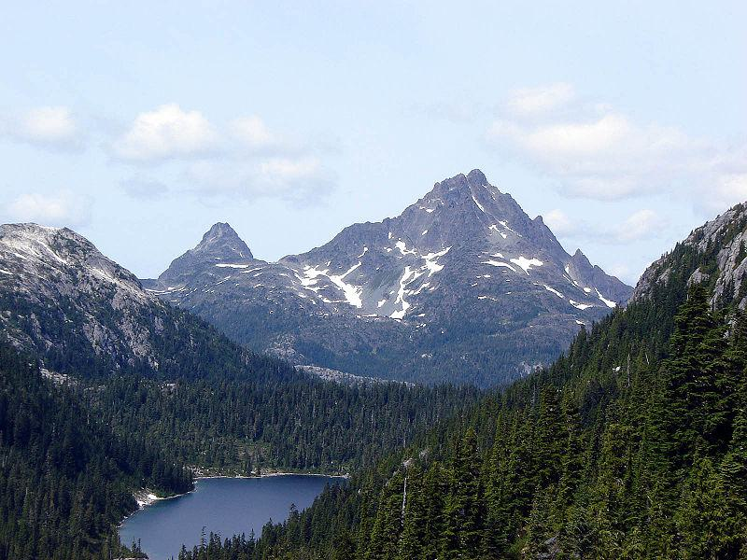

Generated Question - Are the Golden Hinde and the Lions peaks located on the same island or mainland area near Vancouver?

Generated Answer - No, Golden Hinde is on Vancouver Island, while the Lions peaks are near mainland Vancouver.

--- Entry for custom_id: d5c555a40dba11ecb1e81171463288e9 ---

Image Source 1 -

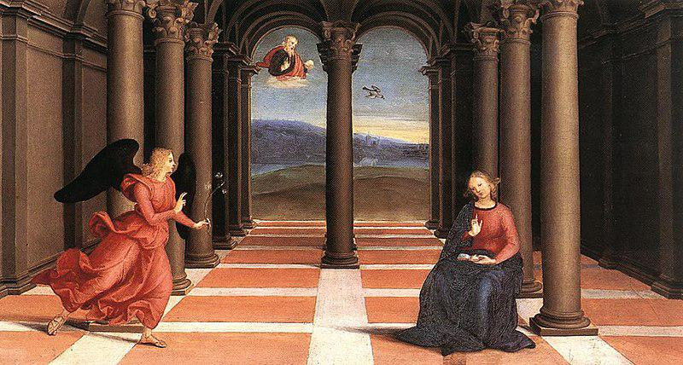

Caption for image source 1: Raphael - The Annunciation (Oddi altar).

Example Question - "What is the angel in The Annunciation Oddi altar holding in her hand?"

Example Answer - "The angel in The Annunciation Oddi Alter is holding an olive branch."

--- Entry for custom_id: d5d1e0e40dba11ecb1e81171463288e9 ---

Example Question - Does relation of ideas impact relational theory?

Example Answer - It does not.

Image Source 1 -



--- Entry for custom_id: d5c31f1e0dba11ecb1e81171463288e9 ---

Image Source 1 -

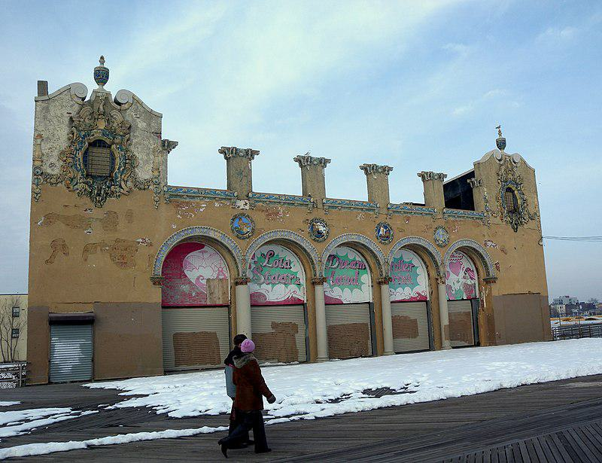

Caption for image source 1: Childs Restaurant CI jeh Looking north at former Childs Restaurant on a cloudy New Years Day after the Polar Bear plunge..

Image Source 2 -

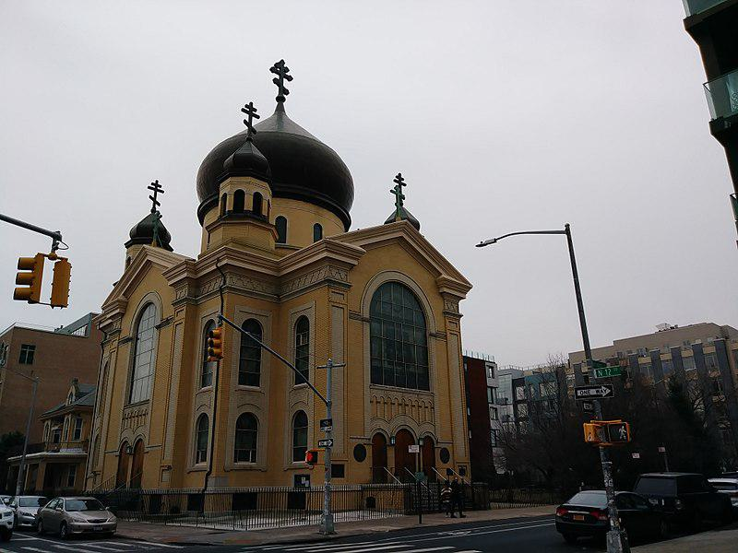

Caption for image source 2: Cathedral of the Transfiguration of Our Lord (28407618089).

Example Question - "What color is both the Cathedral of the Transfiguration of Our Lord Building and the Child's Restaurant Building?"

Example Answer - "The Cathedral of the Transfiguration of Our Lord building and the Child's Restaurant building are both brown."

Additional Text Source 1 - The Cathedral of the Transfiguration of Our Lord (Russian: Собор Преображения Господня) also called Catholic Cathedral of Atyrau is a religious building affiliated with the Catholic Church which is in the Avangard street of the city of Atyrau, 2 in Eurasian country of Kazakhstan, and which serves as the seat of the apostolic administration of Atyrau. (from: Cathedral of the Transfiguration of Our Lord, Atyrau)

Generated Question - Are the Cathedral of the Transfiguration of Our Lord in Kazakhstan and the Childs Restaurant building both used for religious purposes?

Generated Answer - No, only the Cathedral of the Transfiguration of Our Lord is used for religious purposes.

--- Entry for custom_id: d5dacd620dba11ecb1e81171463288e9 ---

Example Question - What type of rimless bottlenecked rifle cartridge was developed in the 1950's that the general purpose machine gun designated the General Support Machine Gun (GSMG) is chambered for?

Example Answer - 7.62x51mm NATO

Image Source 1 -

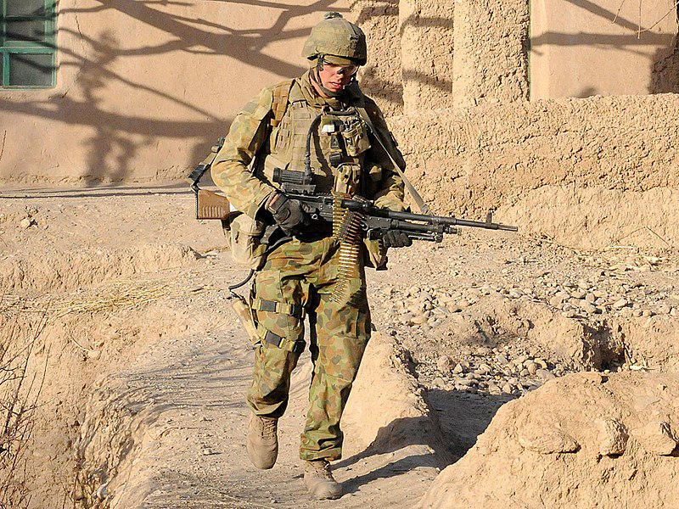

Generated Question - What general-purpose machine gun chambered for 7.62×51mm NATO replaced the M60 and is shown in the image with the soldier?

Generated Answer - The FN MAG 58, designated the General Support Machine Gun (GSMG).

--- Entry for custom_id: d5cd7d420dba11ecb1e81171463288e9 ---

Image Source 1 -

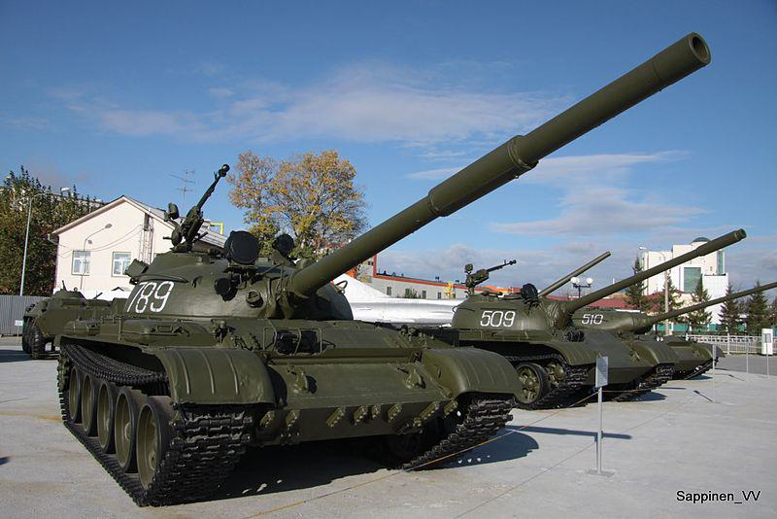

Caption for image source 1: Verkhnyaya Pyshma Tank Museum 2012 0071 Verkhnyaya Pyshma Tank Museum 2012.

Example Question - "What are some numbers of the tanks at the Verkhnyaya Pyshma Tank Museum?"

Example Answer - "The numbers of the tanks at the Verkhnyaya Pyshma Tank Museum are 789, 509 and 510."

Additional Text Source 1 - The UMMC Museum Complex (Russian: Музейный комплекс УГМК), officially the UMMC Museum of Military and Automotive Equipment, is a museum complex located in Verkhnyaya Pyshma, Sverdlovsk Oblast, Russia. The private museum is dedicated to the mechanical and military history of the Ural Federal District. (from: UMMC Museum of Military and Automotive Equipment)

Generated Question - Are the tanks numbered 789, 509, and 510 at the Verkhnyaya Pyshma Tank Museum part of the UMMC Museum of Military and Automotive Equipment?

Generated Answer - Yes, these tanks are part of the UMMC Museum of Military and Automotive Equipment in Verkhnyaya Pyshma.

--- Entry for custom_id: d5df50b20dba11ecb1e81171463288e9 ---

Example Question - Merlangius merlangus and Coregonus clupeaformis are both types of what?

Example Answer - Fish

Image Source 1 -

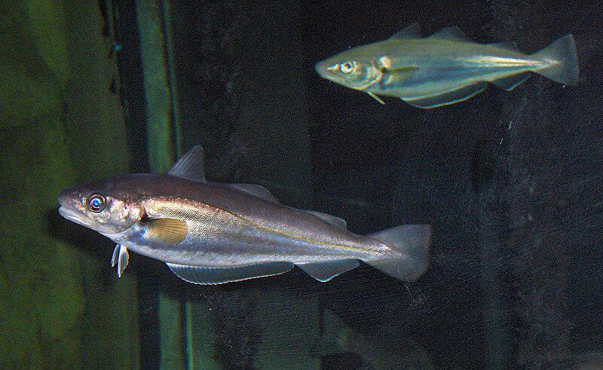

Generated Question - Are Merlangius merlangus and Coregonus clupeaformis closely related despite both being fish?

Generated Answer - No, they are different species and not closely related.

--- Entry for custom_id: d5ded43e0dba11ecb1e81171463288e9 ---

Example Question - The nobility of what country that party sponsored exploratory voyages can be traced back to Alfonso VI of Leon?

Example Answer - Portugal.

Image Source 1 -

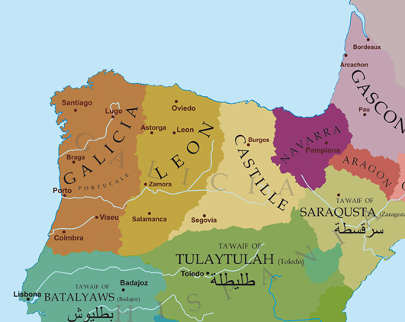

Generated Question - Which kingdom's nobility, linked to Alfonso VI of Leon, controlled the region between the Minho and Douro rivers shown on the map?

Generated Answer - The kingdom of León.

--- Entry for custom_id: d5d115100dba11ecb1e81171463288e9 ---

Example Question - Which more clearly defines a belief that just about anything has a spirit; Religion or Animism?

Example Answer - Animism

Image Source 1 -



Generated Question - How does animism differ from general religion in its view of spiritual essence in objects and creatures?

Generated Answer - Animism uniquely believes all objects and creatures possess a distinct spiritual essence, unlike general religion.

--- Entry for custom_id: d5dc26bc0dba11ecb1e81171463288e9 ---

Example Question - What is the more common form of hermaphroditism of producing reproductive cells at different life stages, where a born female changes into a male some time?

Example Answer - Protogynous hermaphrodites.

Image Source 1 -

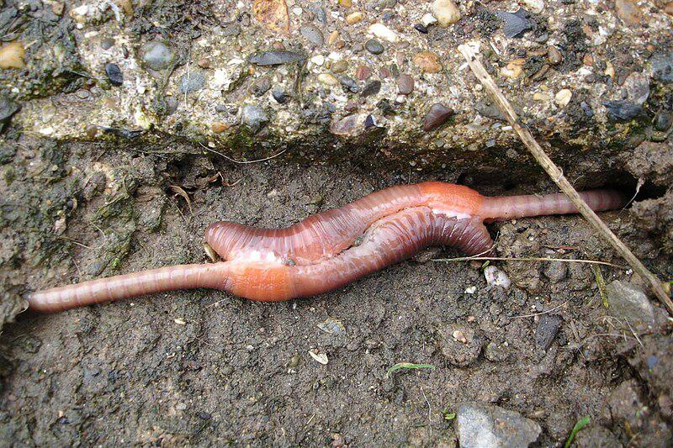

Generated Question - How do earthworms differ from protogynous hermaphrodites in their reproductive organ development?

Generated Answer - Earthworms are simultaneous hermaphrodites with both organs at once, while protogynous hermaphrodites change from female to male.

--- Entry for custom_id: d5c88f760dba11ecb1e81171463288e9 ---

Image Source 1 -

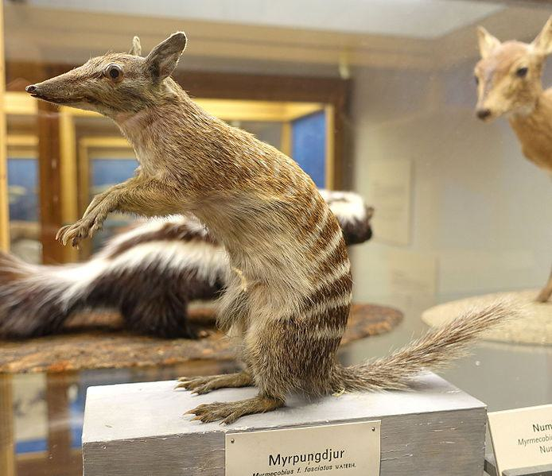

Caption for image source 1: Myrmecobius fasciatus - Swedish Museum of Natural History - Stockholm, Sweden - DSC00656 Exhibit in the Swedish Museum of Natural History - Stockholm, Sweden. Photography was permitted in the museum without restriction..

Image Source 2 -



Caption for image source 2: Siberian Chipmunk (Tamias sibiricus), Parc du Rouge-Cloître, Forêt de Soignes, Brussels (26040359560).

Example Question - "Is the snout of the Siberian Chipmunk longer relative to its body than the snout of the Myrmecobius Fasciatus?"

Example Answer - "No, the snout of the Siberian Chipmunk is not longer relative to its body than the snout of the Myrmecobius Fasciatus."

Additional Text Source 1 - Two subspecies have been described, but one of these—the rusty coloured Myrmecobius fasciatus rufus Finlayson, 1933,—has been extinct since at least the 1960s, and only the nominate subspecies (M. fasciatus fasciatus) remains alive today. The population described by Finlayson occurred in the arid central regions of South Australia, and he thought they had once extended to the coast. (from: Numbat)

Generated Question - Considering the extinction of one subspecies, does the Myrmecobius fasciatus in the museum exhibit represent the currently surviving subspecies?

Generated Answer - Yes, the museum exhibit represents the surviving nominate subspecies of Myrmecobius fasciatus.

--- Entry for custom_id: d5c2ab420dba11ecb1e81171463288e9 ---

Image Source 1 -



Caption for image source 1: WardenT&T T & T at Warden Centre in Markham.

Example Question - "What colors are used for the lettering sign on the front of the T&T Supermarket building in Markham?"

Example Answer - "The lettering on the sign for the T&T Supermarket in Markham is red, white, and green."

Additional Text Source 1 - The company's supermarket brands are Lianhua Supermarket and Hualian Supermarket (S: 华联超市, T: 華聯超市, P: Huálián Chāoshì). Its convenience store brand is Lianhua Quik (C: 快客便利, P: Kuàikè Biànlì). (from: Lianhua Supermarket)

Generated Question - Are the T&T Supermarket in Markham and the Lianhua Supermarket brands likely to share similar signage colors based on the image and text sources?

Generated Answer - No, the T&T Supermarket uses green, red, and white, while Lianhua Supermarket's colors are not specified.

--- Entry for custom_id: d5c11ab60dba11ecb1e81171463288e9 ---

Image Source 1 -



Caption for image source 1: NNC-US-1796-G$2½-Turban Head (no stars) 1796 G$2 Turban Head (or Capped Bust) (no stars)Gold (fineness 0.9160), 20mm, 4.37g, designed by Robert ScotJN2015-6714-15.

Example Question - "Does the head on the Turban Head coin have long or short hair?"

Example Answer - "The head on the Turban Head coin has long hair."

Additional Text Source 1 - Arousal by head hair may arise from seeing or touching very long or short hair, wet hair, a certain color of hair or a particular hairstyle. Others may find the attraction of literally "having sex with somebody's hair" as a fantasy or fetish. (from: Hair fetishism)

Generated Question - Does the Turban Head coin depict long hair that could be associated with hair attraction or fetishism?

Generated Answer - Yes, the Turban Head coin depicts long hair that could be linked to hair attraction.

--- Entry for custom_id: d5cd57d60dba11ecb1e81171463288e9 ---

Image Source 1 -

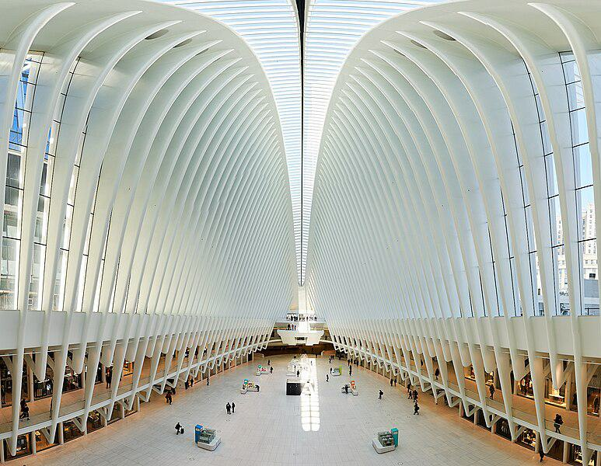

Caption for image source 1: Westfield Mall The Westfield Mall in One World Trade Center in New York CIty..

Example Question - "Are all the white ribs in the Westfield Mall in One World Trade Center in New York City the same length?"

Example Answer - "No, all of the white ribs in the Westfield Mall in the One World Trade Center in New York City do not have the same length."

Additional Text Source 1 - One World Trade Center (also known as One World Trade, One WTC, and formerly Freedom Tower) is the main building of the rebuilt World Trade Center complex in Lower Manhattan, New York City. One WTC is the tallest building in the United States, the tallest building in the Western Hemisphere, and the sixth-tallest in the world. (from: One World Trade Center)

Generated Question - Is the Westfield Mall located inside the tallest building in the United States?

Generated Answer - Yes, the Westfield Mall is inside One World Trade Center, the tallest building in the United States.

--- Entry for custom_id: d5ca8dda0dba11ecb1e81171463288e9 ---

Image Source 1 -

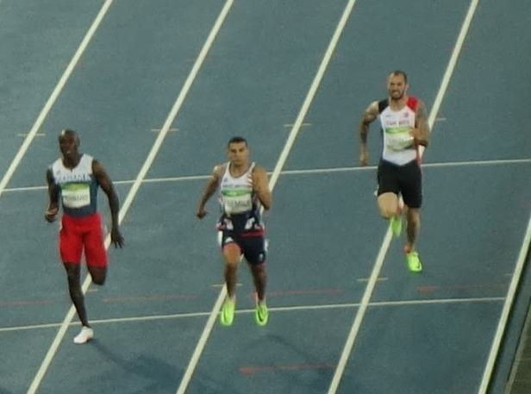

Caption for image source 1: Men's 200 metres event at the 2016 Summer Olympics, Olympic Stadium (Engenhão), Rio de Janeiro, Brazil (cropped) Men's 200 metres event at the 2016 Summer Olympics, Olympic Stadium (Engenhao), Rio de Janeiro, Brazil..

Image Source 2 -

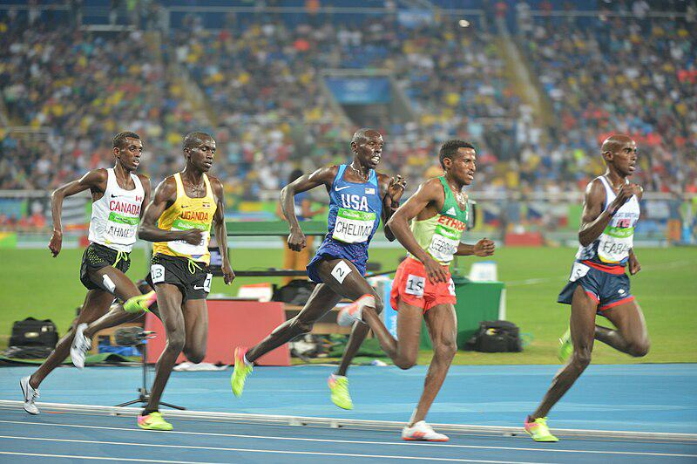

Caption for image source 2: Spc. Paul Chelimo wins silver medal in 5,000 meters at Rio Olympic Games photos by Tim Hipps, IMCOM Public Affairs (29090421706).

Example Question - "In the 5,000 and 200 meters events at the Rio Olympic Games, did the athletes wear their country's name across their chest?"

Example Answer - "Yes, they wore their country's name across their chest."

Additional Text Source 1 - He previously participated in two other Olympic games and three events (The men's 400 meters and men's 4 x 400 meters relay in Sydney, and the men's 400 meters hurdles in Athens), winning silver medals in the Sydney relay and the Athens hurdles race. During the August 15 qualifications, McFarlane participated in the second heat against five other athletes. (from: Jamaica at the 2008 Summer Olympics)

Generated Question - Did athletes in both the 200 meters and 5,000 meters events at the Rio Olympics wear bib numbers on their uniforms?

Generated Answer - Yes, athletes in both events wore bib numbers on their uniforms.

--- Entry for custom_id: d5c43bec0dba11ecb1e81171463288e9 ---

Image Source 1 -

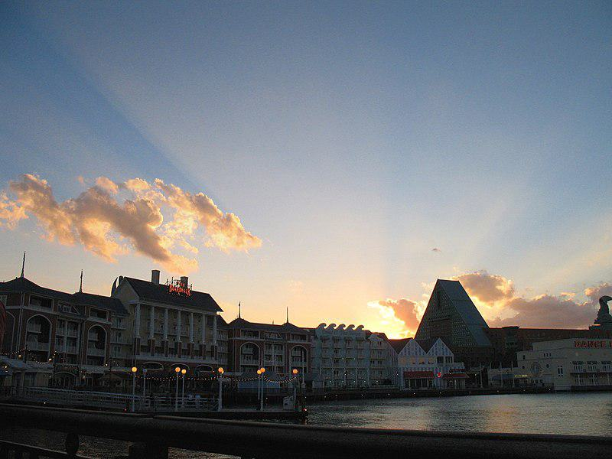

Caption for image source 1: DISNEYWORLD BOARDWALK RESORT - panoramio.

Image Source 2 -

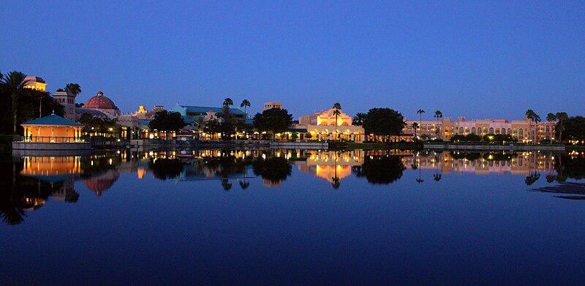

Caption for image source 2: Coronado Blue (33706136420).

Example Question - "Are Disney's Coronado Springs Resort and Disneyworld's Boardwalk Resort both located on the water?"

Example Answer - "Yes, Disney's Coronado Springs Resort and Disneyworld's Boardwalk Resort are both located on the water."

Additional Text Source 1 - About two years after the initial release, The Walt Disney World Explorer – Second Edition was released with updated information on new attractions, parks, and resorts (e.g. Buzz Lightyear's Space Ranger Spin, Disney's Animal Kingdom, and Disney's Coronado Springs Resort). The application is narrated by Hettie Lynne Hurtes and Corey Burton. (from: The Walt Disney World Explorer)

Generated Question - Are both Disney's Coronado Springs Resort and Disneyworld's Boardwalk Resort featured in The Walt Disney World Explorer's updated edition?

Generated Answer - Yes, both resorts are featured in The Walt Disney World Explorer's updated edition.

--- Entry for custom_id: d5d1f34a0dba11ecb1e81171463288e9 ---

Example Question - What literature has a number of Germanic gods mentioned in it that can include Týr and Ullr?

Example Answer - Old Norse.

Image Source 1 -

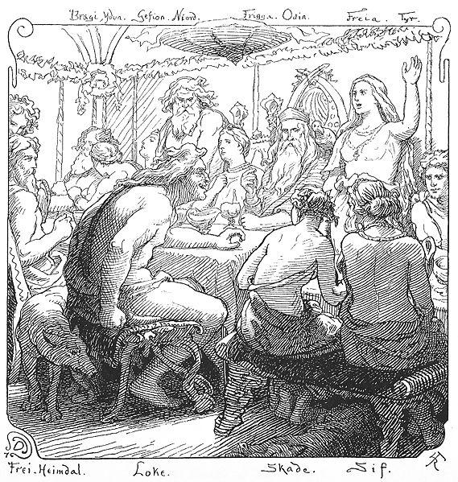

Generated Question - Which group of Germanic gods, including Týr, is primarily associated with war and mentioned in Old Norse literature?

Generated Answer - The Æsir are primarily associated with war and include Týr in Old Norse literature.

--- Entry for custom_id: d5ccad4a0dba11ecb1e81171463288e9 ---

Image Source 1 -

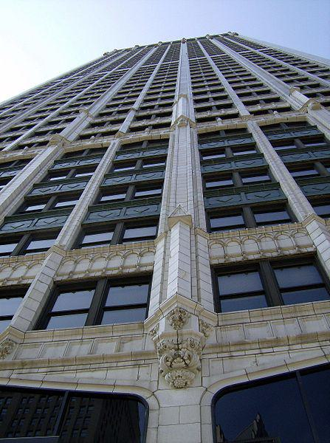

Caption for image source 1: CadillaclookingupDetroit Cadillac Tower in Detroit, Michigan, United States..

Image Source 2 -

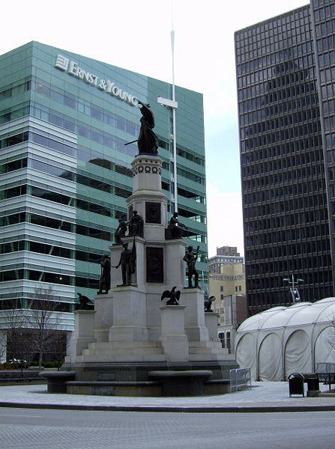

Caption for image source 2: MichiganSoldiersSailors.

Example Question - "Is the Stone on the Michigan Soldiers & Sailors Monument the same Shade of Grey as the facade of the Cadillac building in Detroit?"

Example Answer - "No, the Stone on the Michigan Soldiers & Sailors Monument is not the same Shade of Grey as the facade of the Cadillac building in Detroit."

Additional Text Source 1 - Confederate Soldiers and Sailors Monument, Garfield Park, erected, according to its inscription, "to mark the burial place of 1616 Confederate soldiers and sailors who died here as prisoners of war and whose graves cannot now be identified. " Following protests of the murder of George Floyd in June 2020, the city announced plans to remove the monument. (from: List of Confederate monuments and memorials)

Generated Question - Are the Michigan Soldiers & Sailors Monument and the Confederate Soldiers and Sailors Monument both planned for removal due to protests?

Generated Answer - No, only the Confederate Soldiers and Sailors Monument is planned for removal.

--- Entry for custom_id: d5d5bade0dba11ecb1e81171463288e9 ---

Example Question - Libor which is calculated by the Intercontinental Exchange stands for what?

Example Answer - London Inter-bank Offered Rate

Image Source 1 -



Generated Question - Is the name Libor in Libor Šulák related to the financial term LIBOR calculated by the Intercontinental Exchange?

Generated Answer - No, Libor Šulák is a person's name and unrelated to the financial LIBOR index.

--- Entry for custom_id: d5dfa6d40dba11ecb1e81171463288e9 ---

Example Question - The method of modeling what, which in biology is the similarity due to shared ancestry between a pair of structures or genes in different taxa, is based on the observation that protein tertiary structure is better conserved than amino acid sequence?

Example Answer - homology

Image Source 1 -

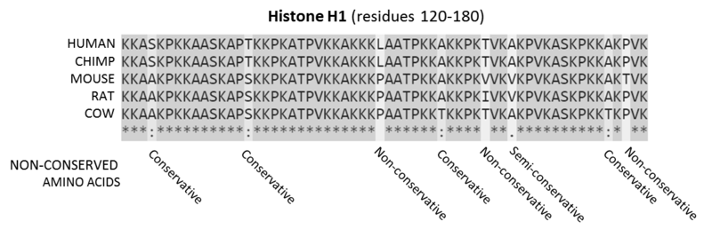

Generated Question - How does the sequence alignment of mammalian histone proteins illustrate the principle that protein tertiary structure is better conserved than amino acid sequence in homology modeling?

Generated Answer - The alignment shows conserved and mutated residues, indicating structural conservation despite sequence variation.

--- Entry for custom_id: d5d13d100dba11ecb1e81171463288e9 ---

Example Question - Which operated in a wider market: American Association of Professional Baseball or United League Baseball?

Example Answer - American Association of Professional Baseball operated in a wider market.

Image Source 1 -



Generated Question - Which baseball league operated earliest among United League Baseball, American Association of Professional Baseball, and the All-American Girls Professional Baseball League?

Generated Answer - The All-American Girls Professional Baseball League operated earliest, in 1948.

--- Entry for custom_id: d5c7276c0dba11ecb1e81171463288e9 ---

Image Source 1 -

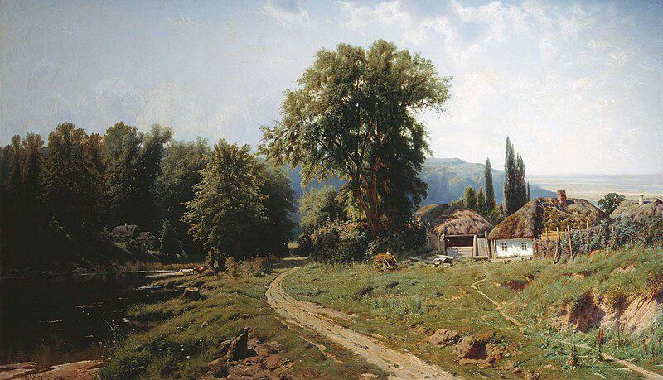

Caption for image source 1: KonstantinKryzhitsky HutorVMalorossii 1884 Khutir (or hamlet) in Little Russia, 1884.

Example Question - "What material is the roof of the house in Constantin Kryjitski's "Khutir (or hamlet) in Little Russia, 1884" made from?"

Example Answer - "The roof of the house is thatched in Constantin Kryjitski's "Khutir (or hamlet) in Little Russia, 1884."

Additional Text Source 1 - Prilepin said in an interview that the rationale behind the proposed state was that the separatists no longer could be called such because they were now supporting a unified state. On 9 August, Zakharchenko stated that the proposed state would not be named "Malorossiya" ("Little Russia") because "many feel repulsed by" the name. (from: Little Russia)

Generated Question - Does the name "Malorossiya" in the painting's title relate to the proposed state's name mentioned by Zakharchenko?

Generated Answer - No, Zakharchenko said the proposed state would not be named "Malorossiya" due to negative feelings.

--- Entry for custom_id: d5d17d980dba11ecb1e81171463288e9 ---

Example Question - Does the auriculotemporal nerve run parallel to the superficial iliac circumflex artery?

Example Answer - No, the superficial iliac circumflex artery is in the leg and the auriculotemporal nerve is in the head.

Image Source 1 -

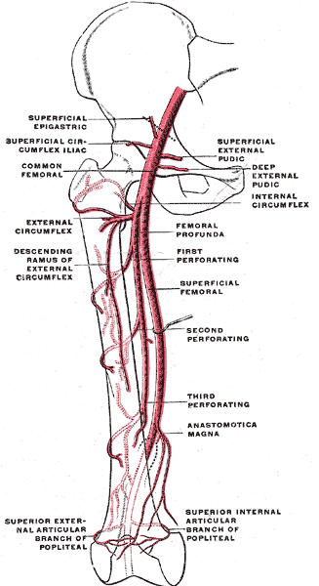

Generated Question - Are the superficial circumflex iliac artery and the auriculotemporal nerve both branches of arteries in the thigh region?

Generated Answer - No, the superficial circumflex iliac artery is in the thigh, but the auriculotemporal nerve is in the head.

--- Entry for custom_id: d5d0c7220dba11ecb1e81171463288e9 ---

Example Question - What is the basic difference between the reflectivity on individual PPI angles and composite reflectivity?

Example Answer - The reflectivity on individual PPI angles show the precipitation intensity at that specific angle above the horizon while the composite reflectivity is the maximum dBZ reflectivity from any of the reflectivity angles of the NEXRAD weather radar

Image Source 1 -

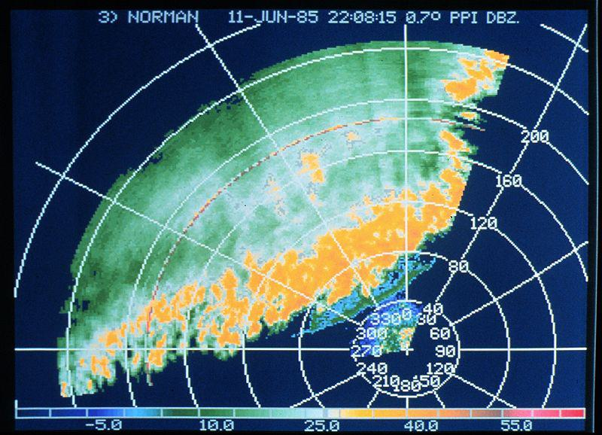

Generated Question - How does the reflectivity shown in the thunderstorm line image relate to the individual PPI angles described in the text?

Generated Answer - The image shows precipitation intensity at a specific PPI angle, reflecting the concept of individual PPI angle reflectivity.

--- Entry for custom_id: d5c95f6e0dba11ecb1e81171463288e9 ---

Image Source 1 -

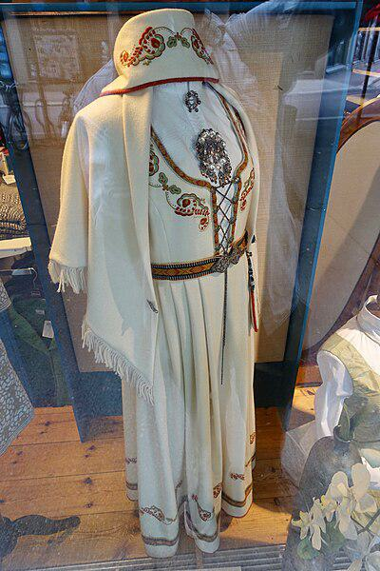

Caption for image source 1: Vestfoldbunad Den broderte Segerbrandt-bunaden For sale at Vestfold-Stua in Tønsberg, Norway (reconstructed traditional folk costume of Vestfold county with embroidery) 2019-08-27 5281 Brodert vestfoldbunad / Segerbrandt-bunaden; Norwegian bunad (reconstructed traditional/folk costume) of Vestfold County, model with embroidery designed by Petrine Segerbrandt (born 1880), for sale at Vestfold-Stua women's clothing store in Tnsberg, Norway..

Image Source 2 -



Caption for image source 2: Amerindian woman in her traditional clothes.png photo of an amerindian woman in her traditional clothes.

Example Question - "Can floral designs be found in both the traditional folk costume of Vestfold county, Norway and traditional Amerindian women clothing?"

Example Answer - "Yes, floral designs can be found in both the traditional folk costume of Vestfold county, Norway and traditional Amerindian women clothing."

Additional Text Source 1 - Some speakers make a sharp break between traditional folk costume (tracht) and the "dirndl", a word which they use only for modern designs. For instance, tracht scholar Thekla Weissengruber distinguishes between renewed tracht (based closely upon historical designs) and Trachtenbekleidung (tracht clothing), including dirndls and lederhosen. (from: Dirndl)

Generated Question - Do both the Vestfoldbunad and traditional Amerindian clothing represent renewed traditional designs rather than modern fashion adaptations?

Generated Answer - Yes, both represent renewed traditional designs rooted in cultural heritage.

--- Entry for custom_id: d5cc2ab40dba11ecb1e81171463288e9 ---

Image Source 1 -

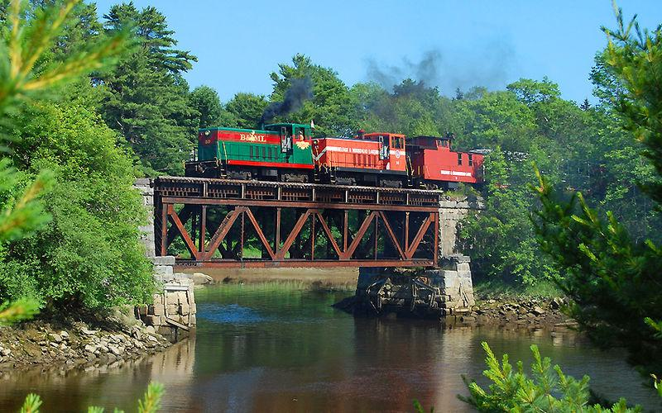

Caption for image source 1: BMLRR City Point Trestle (MP 2.0) BML#50 and BML#53, a pair of late 1940's GE 70-ton diesel electric locomotives, crossing the BML's City Point Trestle (MP 2.0) at the "Head of Tide" heading inland from Belfast, Maine, on the 33-mile Belfast and Moosehead Lake Railroad main line to Burnham Junction..

Example Question - "What runs under the train tracks on the BML's City Point Trestle?"

Example Answer - "Water runs under the train tracks on the BML's City Point Trestle."

Additional Text Source 1 - He cites a book called "Senro wa tsuzuku" (The Tracks Go On And On), a book loved by his son, for inspiring the inclusion of a train. He discusses how in the book, children construct railroad tracks, also doing things such as creating tunnels or bridges when they find mountains or rivers. (from: The Legend of Zelda: Spirit Tracks)

Generated Question - How does the BML's City Point Trestle relate to the idea of building bridges over water as inspired by the book mentioned?

Generated Answer - The BML's City Point Trestle is a bridge over water, similar to how children build bridges over rivers in the book.

--- Entry for custom_id: d5c2c5640dba11ecb1e81171463288e9 ---

Image Source 1 -

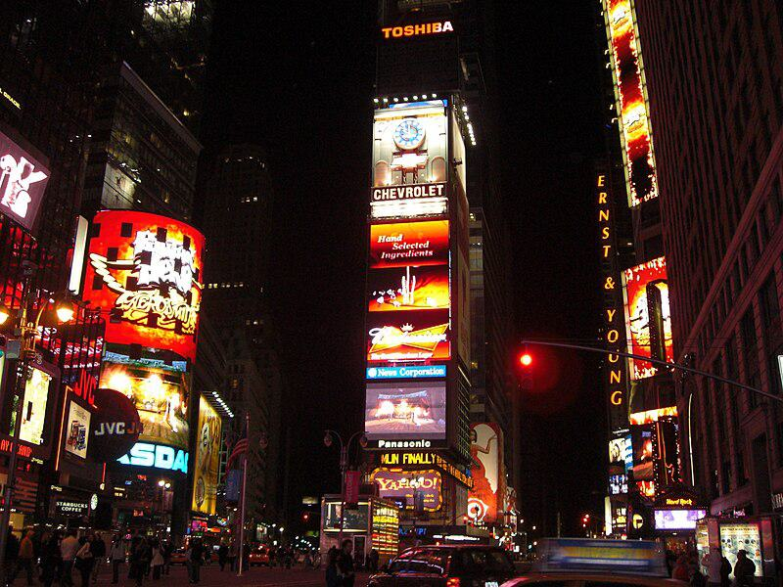

Caption for image source 1: Times Square, New York, USA1 Times Square, New York, USA.

Example Question - "Does Times Square feature ads from Chevrolet?"

Example Answer - "Chevrolet ads are featured in Times Square."

Additional Text Source 1 - The tower was originally built to serve as the headquarters of The New York Times, which moved into the tower in January 1904. The paper's owner persuaded the city to re-name the area "Times Square". (from: One Times Square)

Generated Question - Is the name "Times Square" related to the original purpose of the tower shown in the image?

Generated Answer - Yes, the tower was the New York Times headquarters, inspiring the name "Times Square".

--- Entry for custom_id: d5de28a40dba11ecb1e81171463288e9 ---

Example Question - For the individual who discovered the law of gravitation, what did his writings suggest towards the main goals of alchemy?

Example Answer - Discovery of the philosopher's stone and Elixir of Life.

Image Source 1 -

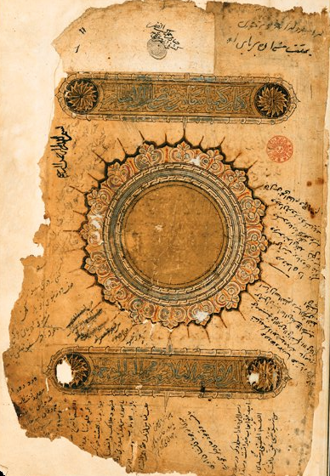

--- Entry for custom_id: d5c789820dba11ecb1e81171463288e9 ---

Image Source 1 -

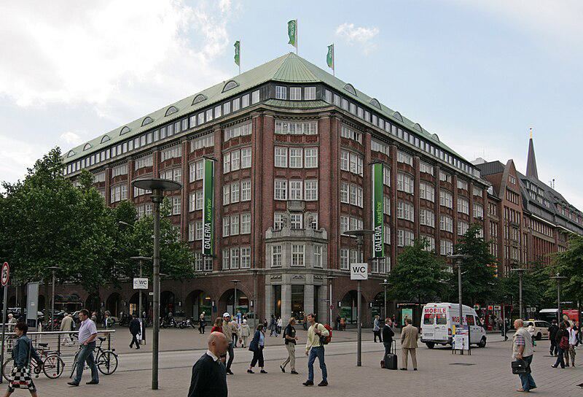

Caption for image source 1: Galeria Kaufhof Hamburg Galeria Kaufhof im Klopperhaus an der Monckebergstrae in Hamburg-Altstadt..

Example Question - "How many flags are atop the Galeria Kaufhof Hamburg?"

Example Answer - "There are three flags atop the Galeria Kaufhof Hamburg."

Additional Text Source 1 - Jewish-owned department stores were confiscated from their owners during the Nazi regime. Next to some smaller, independent department stores like Breuninger in Stuttgart these are Karstadt (in 2010 taken over by Nicolas Berggruen, also operating the KaDeWe and the Kaufhof at Alexanderplatz in Berlin, the Alsterhaus in Hamburg and the Oberpollinger Oberpollinger in Munich, and Galeria Kaufhof. (from: Department stores by country)

Generated Question - Is the Galeria Kaufhof in Hamburg part of a group of department stores that includes Karstadt and Alsterhaus?

Generated Answer - Yes, Galeria Kaufhof in Hamburg is part of the group that includes Karstadt and Alsterhaus.

--- Entry for custom_id: d5d9d22c0dba11ecb1e81171463288e9 ---

Example Question - What were the Messerschmitt Bf 109 and 152 air aces from Canada involved in?

Example Answer - World War II.

Image Source 1 -



Generated Question - Were the Messerschmitt Bf 109 and the Canadian and Chinese fighter aces all involved in the same war?

Generated Answer - Yes, they were all involved in World War II.

--- Entry for custom_id: d5cb1c8c0dba11ecb1e81171463288e9 ---

Image Source 1 -



Caption for image source 1: 2011-06-15 Mycena sanguinolenta (Alb. & Schwein.) P. Kumm 151560.

Example Question - "Do the caps on the Mycena sanguinolenta have bumps?"

Example Answer - "The caps on the Mycena sanguinolenta have bumps."

Additional Text Source 1 - The other "bleeding Mycena" (M. haematopus) is readily distinguished from M. sanguinolenta by its larger size, different color, growth on rotting wood, and presence of a sterile band of tissue on the margin of the cap. Further, M. sanguinolenta consistently has red-edged gills, while the gill edges of M. haematopus are more variable. (from: Mycena sanguinolenta)

Generated Question - Can Mycena sanguinolenta be identified by its size and growth on rotting wood compared to Mycena haematopus?

Generated Answer - No, Mycena sanguinolenta is smaller and does not grow on rotting wood like Mycena haematopus.

--- Entry for custom_id: d5c72fb40dba11ecb1e81171463288e9 ---

Image Source 1 -

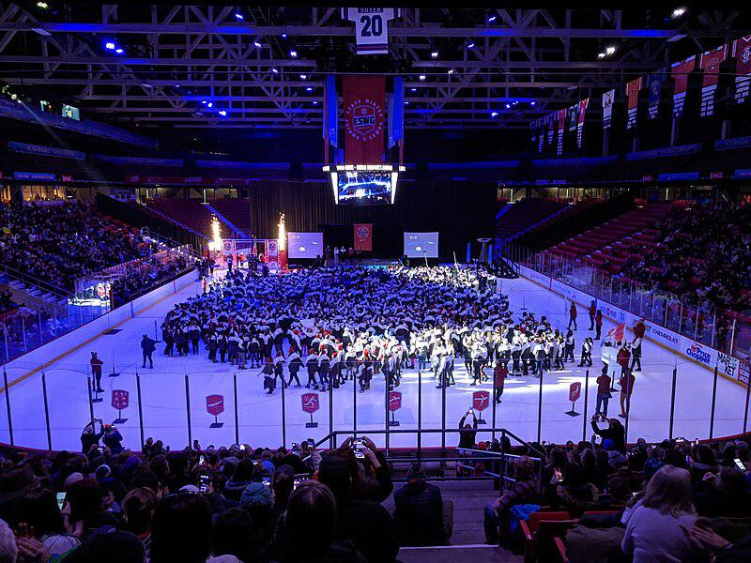

Caption for image source 1: EmpireStateWinterGames2020OpeningCeremony Opening ceremony for the 2020 Empire State Winter Games in the Olympic Center.

Example Question - "How many big screens surround the stage on the ice rink at the 2020 Empire State Winter Games opening ceremony?"

Example Answer - "There were three big screens surrounding the stage on the ice rink at the 2020 Empire State Winter Games opening ceremony."

Additional Text Source 1 - " Writing in The Observer, Jackie Kay commented that "it seemed that Boyle had invented a new kind of opening ceremony, a concept ceremony, one that embraces big ideas as passionately as it does technical flamboyancy". The Stage said that "Danny Boyle's spectacular and moving Olympics Opening Ceremony was undoubtedly the theatrical highlight of 2012". (from: 2012 Summer Olympics opening ceremony)

Generated Question - How does the 2020 Empire State Winter Games opening ceremony on ice compare to Danny Boyle's 2012 Olympics opening ceremony in terms of embracing big ideas and technical flamboyance?

Generated Answer - The 2020 Empire State Winter Games opening ceremony is a large, organized event on ice, while Danny Boyle's 2012 ceremony was praised for its big ideas and technical flamboyance.

--- Entry for custom_id: d5d62f3c0dba11ecb1e81171463288e9 ---

Example Question - The sticky emu bush was first formally described in what year?

Example Answer - Eremophila glutinosa was first formally described by Robert Chinnock in 1979.

Image Source 1 -

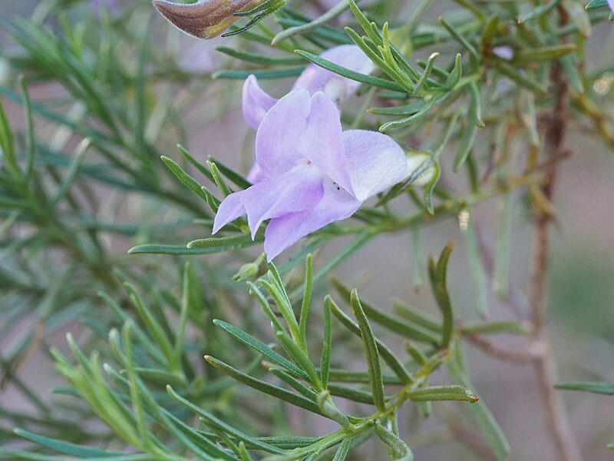

Generated Question - Does the sticky emu bush have resinous leaves and where is it typically found growing?

Generated Answer - Yes, it has sticky resinous leaves and grows on rocky hills and granite outcrops in Western Australia.

--- Entry for custom_id: d5d1eb660dba11ecb1e81171463288e9 ---

Example Question - Was the NASCAR Winston Cup Series or the NASCAR Busch Series longer in 1992?

Example Answer - The Winston Cup was longer than the Busch Series.

Image Source 1 -



Generated Question - Did the 1992 NASCAR Winston Cup Series or the Winston West Series, where Kevin Harvick drove in 1997, start earlier in the year?

Generated Answer - The 1992 NASCAR Winston Cup Series started earlier in the year than the 1997 Winston West Series.

--- Entry for custom_id: d5cc4d500dba11ecb1e81171463288e9 ---

Image Source 1 -

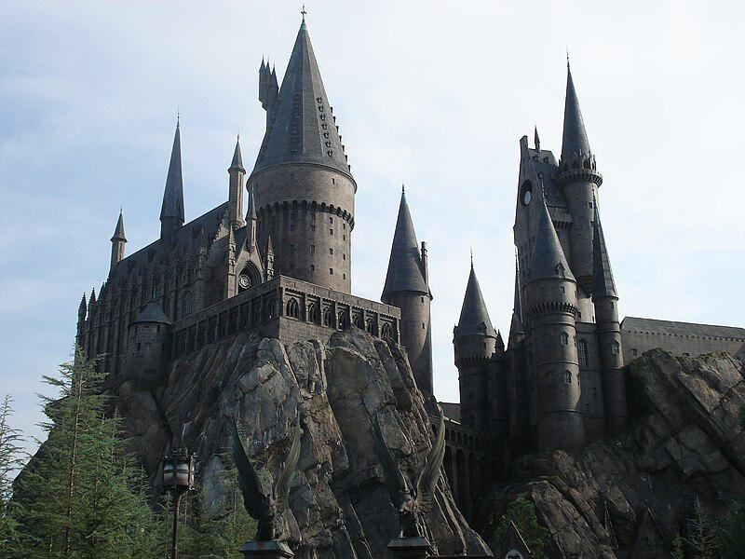

Caption for image source 1: Hogwarts's replica in Universal Studio, Orlando Hogwarts's replica in Universal Studio, Orlando.

Example Question - "What shape is the base of the tallest tower in Hogwarts's replica castle at Universal Studio?"

Example Answer - "It is a circle."

Additional Text Source 1 - The CN Tower was surpassed in 2009 by the Canton Tower in Guangzhou, China, which stands at 604 metres (1,982 ft) tall, as the world's tallest tower; which in turn was surpassed by the Tokyo Skytree in 2011, which currently is the tallest tower at 634.0 metres (2,080.1 ft) in height. (from: CN Tower)

Generated Question - Is the tallest tower in Hogwarts's replica castle taller or shorter than the CN Tower?

Generated Answer - The tallest tower in Hogwarts's replica castle is much shorter than the CN Tower.

--- Entry for custom_id: d5db09da0dba11ecb1e81171463288e9 ---

Example Question - Eel and South Fork American are both names of what?

Example Answer - Rivers

Image Source 1 -

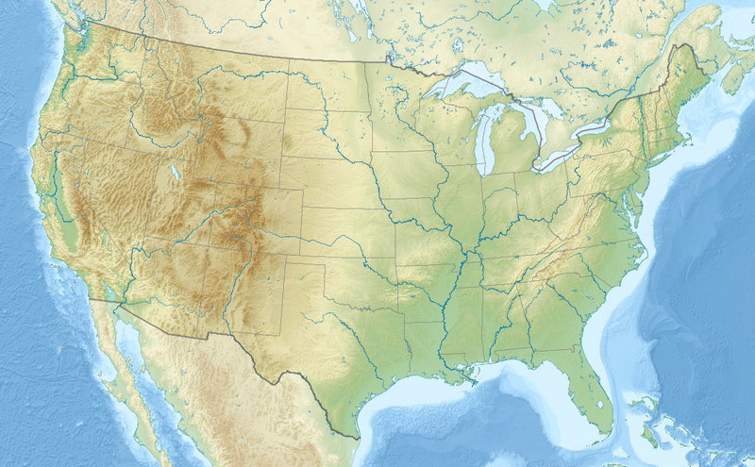

Generated Question - Which South Fork river flows through a wilderness area shown on the map, and which one flows through the Sierra Nevada foothills?

Generated Answer - South Fork Eel River flows through wilderness shown on the map; South Fork American River flows through Sierra Nevada foothills.

--- Entry for custom_id: d5c9dd7c0dba11ecb1e81171463288e9 ---

Image Source 1 -

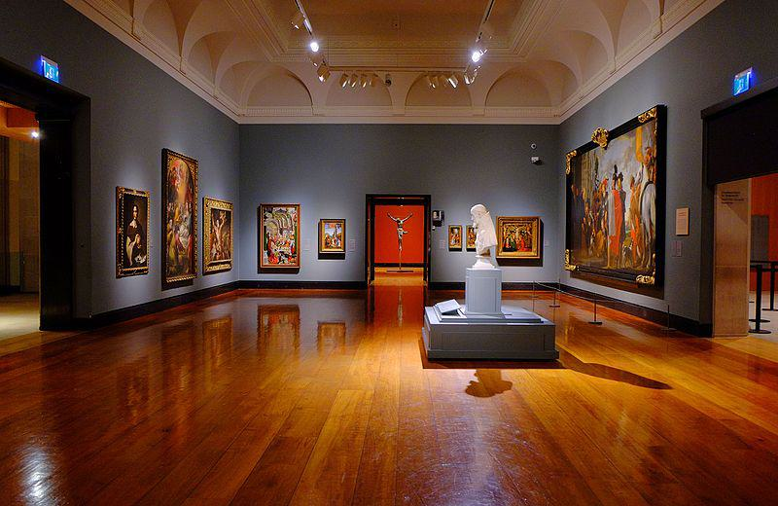

Caption for image source 1: Art Gallery of Ontario (23782351913).

Example Question - "What kind of lighting can be found in the Ontario Art Gallery?"

Example Answer - "Ceiling track lighting can be found in the Ontario Art Gallery."

Additional Text Source 1 - True North Gallery (also known as The Music Gallery of Fine Art), founded in 2016 by Geoff and Brooke Kulawick, is an art museum and gallery in downtown Waterdown, Ontario, Canada. Dedicated to showcasing visual art by professional musicians, it claims to be the only art gallery of its kind. (from: True North Gallery)

Generated Question - How does the Art Gallery of Ontario's lighting compare to the typical setting of the True North Gallery in Ontario?

Generated Answer - The Art Gallery of Ontario uses ceiling track lighting, while the True North Gallery focuses on visual art by musicians without specified lighting.

--- Entry for custom_id: d5cf130a0dba11ecb1e81171463288e9 ---

Image Source 1 -



Caption for image source 1: University Club, Virginia Tech The University Club at Virginia Tech in Blacksburg, Virginia.

Example Question - "What color are the awnings over the entryway into the University Club at Virginia Tech?"

Example Answer - "The awnings over the entryway into the University Club at Virginia Tech are green."

Additional Text Source 1 - University of Waterloo sociology professor Kenneth Westhues criticized both the university's response to the shootings and the Massengill Report. Westhues identified the cause of the shootings as a mobbing Cho had experienced in the Virginia Tech English department and suggested that the explanation for Cho's actions should go beyond what he calls the "defective character" explanation: (from: Virginia Tech shooting)

Generated Question - How does the additional text source relate to the University Club at Virginia Tech shown in the image?

Generated Answer - The text discusses a shooting incident linked to Virginia Tech, where the University Club is located.

--- Entry for custom_id: d5c1bd900dba11ecb1e81171463288e9 ---

Image Source 1 -

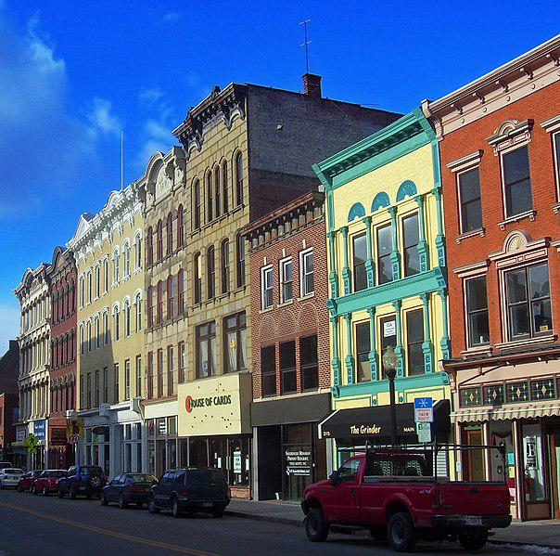

Caption for image source 1: Main Mall Row, Poughkeepsie, NY.

Image Source 2 -

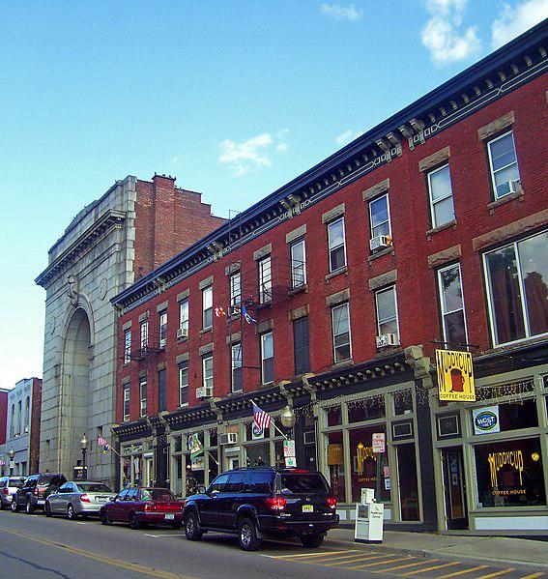

Caption for image source 2: Lower Main Street, Beacon, NY.

Example Question - "Does the Main Mall Row in Poughkeepsie, NY or the Lower Main Street building complex in Beacon, NY have a more colorful facade?"

Example Answer - "The Main Mall Row in Poughkeepsie, NY has a more colorful facade."

Additional Text Source 1 - Lafuente had a plan to revitalize the City of Poughkeepsie by a process that would replace blighted areas with new housing and businesses. A native to the area, Lafuente had an intention to plant the seeds that would return Main Street to its prominence and such a plan would involve the elimination of the Main Mall. (from: Main Mall)

Generated Question - Considering Lafuente's plan to revitalize Poughkeepsie, which area between Main Mall Row and Lower Main Street is more likely targeted for redevelopment due to its current appearance?

Generated Answer - Main Mall Row is more likely targeted for redevelopment due to its colorful but older facade.

--- Entry for custom_id: d5ca4bf40dba11ecb1e81171463288e9 ---

Image Source 1 -

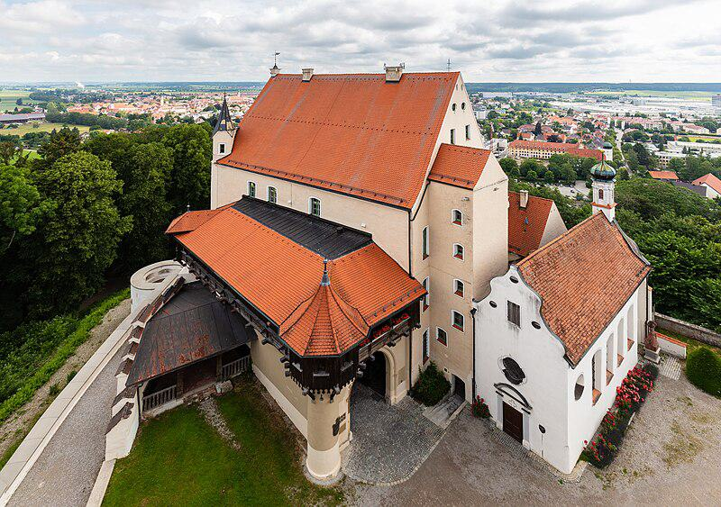

Caption for image source 1: Castillo Mindelburg, Mindelheim, Alemania, 2019-06-21, DD 31 Mindelburg Castle, Mindelheim, Germany.

Image Source 2 -

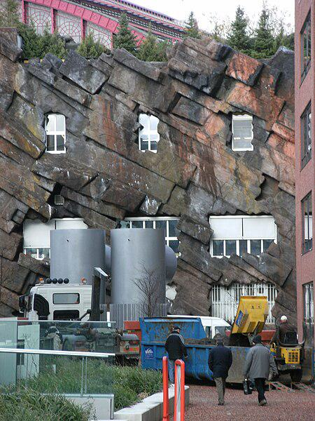

Caption for image source 2: Strange building with fake rock formations Antwerpen Strange building with fake rock formations Antwerpen..

Example Question - "What grows near both a Strange building with fake rock formations in Antwerpen and Mindelburg Castle?"

Example Answer - "Grass grows near both a Strange building with fake rock formations in Antwerpen and Mindelburg Castle."

Additional Text Source 1 - Last month he tweeted about "fake books," "the fake dossier," "fake CNN," and he added a new claim—that Google search results are "RIGGED" to mostly show only negative stories about him. " They graphed his expanding use in columns labeled: "Fake news", "Fake (other) and "Phony". (from: Fake news)

Generated Question - How do the concepts of "fake" in the additional text relate to the physical "fake" elements seen near the buildings in the images?

Generated Answer - Both involve artificial or deceptive elements—fake news in text and fake rock formations near the buildings.

--- Entry for custom_id: d5bfd9760dba11ecb1e81171463288e9 ---

Image Source 1 -

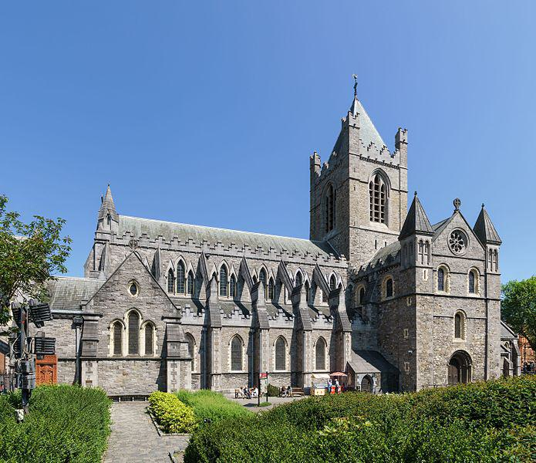

Caption for image source 1: Christ Church Cathedral, Dublin, 2016-06-03 Christ Church Cathedral.

Image Source 2 -

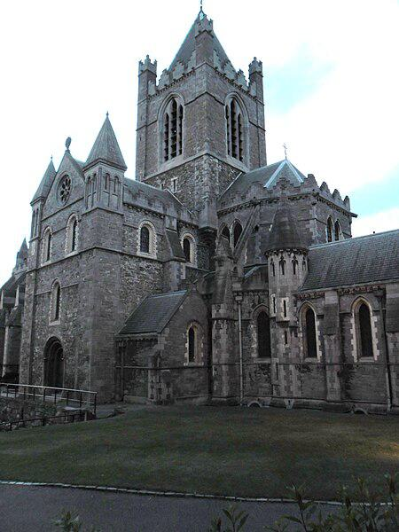

Caption for image source 2: Christ Church Cathedral, Dublin - panoramio.

Example Question - "Does Christ Church Cathedral, Dublin have taller greenery in front or on the sides?"

Example Answer - "The Christ Church Cathedral, Dublin has taller greenery on the sides than in front."

Additional Text Source 1 - In 1971, the general synod, following prior discussions, created the "Christ Church Cathedral Group of Parishes", uniting what were then four parishes with the cathedral, whose dean is their rector: (from: Christ Church Cathedral, Dublin)

Generated Question - Does the Christ Church Cathedral in Dublin have more visible greenery in front or on the sides based on the images and its parish grouping context?

Generated Answer - The Christ Church Cathedral in Dublin has more visible greenery on the sides than in front.

--- Entry for custom_id: d5ce91f00dba11ecb1e81171463288e9 ---

Image Source 1 -

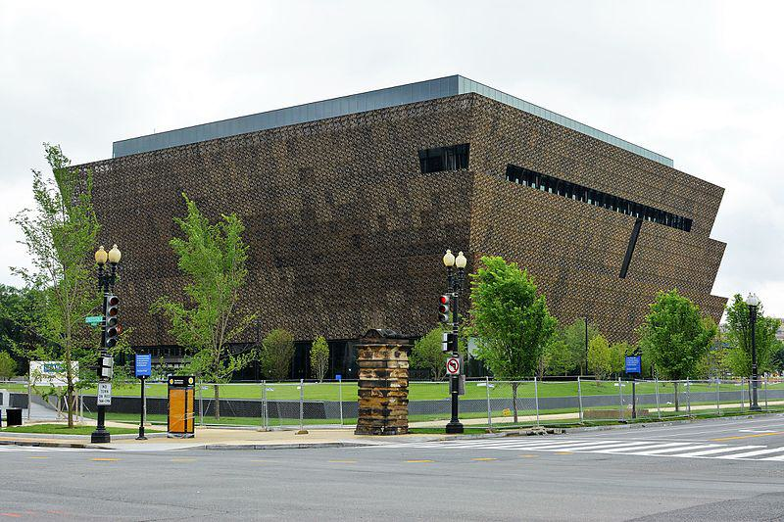

Caption for image source 1: National Museum of African American History and Culture.

Image Source 2 -

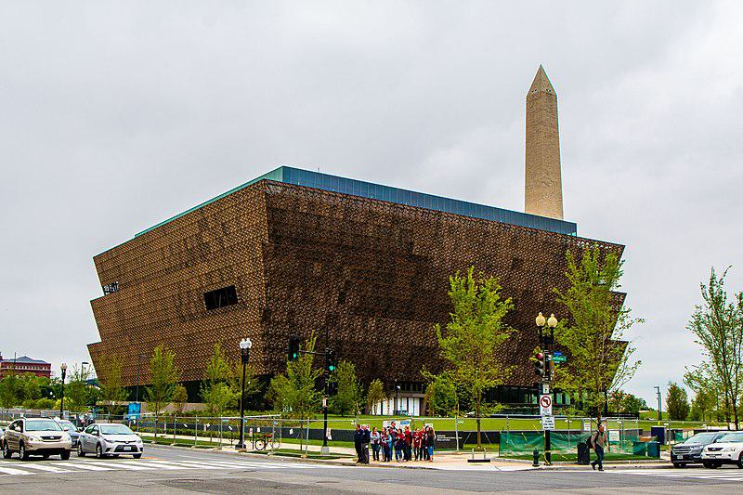

Caption for image source 2: African American Museum Washington, DC The African-American History Museum in Washington, DC.

Example Question - "Are there trees surrounding the African-American History Museum in Washington, DC?"

Example Answer - "Yes, there are trees surrounding the African-American History Museum in Washington, DC."

Additional Text Source 1 - "Field to Factory" encouraged Mack to continue pursuing a museum. In 1987 and 1988, NCEED began lining up support among black members of Congress for legislation that would establish an independent African-American national history museum in Washington, D.C. (from: National Museum of African American History and Culture)

Generated Question - Did the support from black members of Congress in the 1980s contribute to the establishment of the museum surrounded by trees in Washington, D.C.?

Generated Answer - Yes, their support helped establish the National Museum of African American History and Culture surrounded by trees.

--- Entry for custom_id: d5d2efd40dba11ecb1e81171463288e9 ---

Example Question - Which person, who purportedly created abthainries for his brother King Edgar, was called the abbot of Dunkeld?

Example Answer - Ethelred

Image Source 1 -

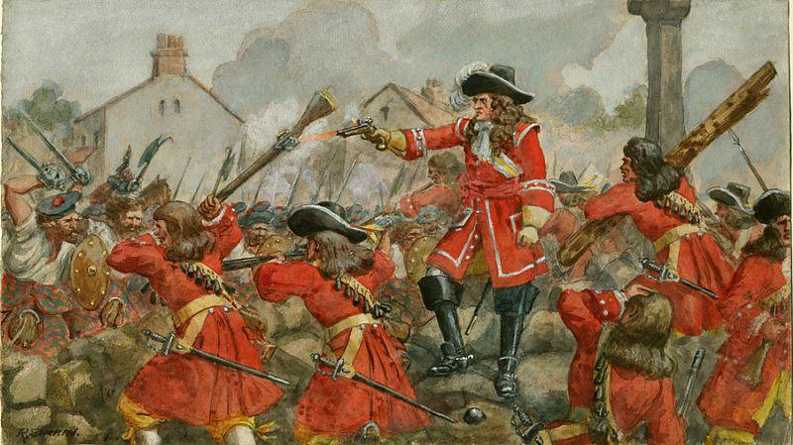

Generated Question - Was Ethelred, who was called abbot of Dunkeld, necessarily a churchman during the time of the Battle of Dunkeld?

Generated Answer - No, Ethelred was not necessarily a churchman but often a layman holding abbacies.

--- Entry for custom_id: d5cc33560dba11ecb1e81171463288e9 ---

Image Source 1 -

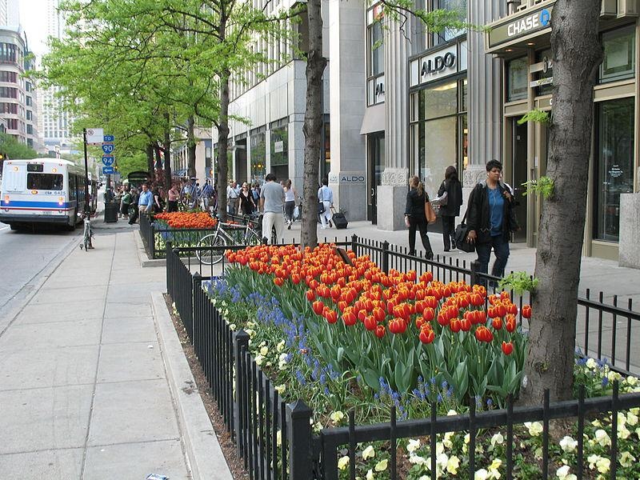

Caption for image source 1: 20070509 Tulip Days 2007 Tulip Days on The Magnificent Mile with CTA bus in view..

Image Source 2 -

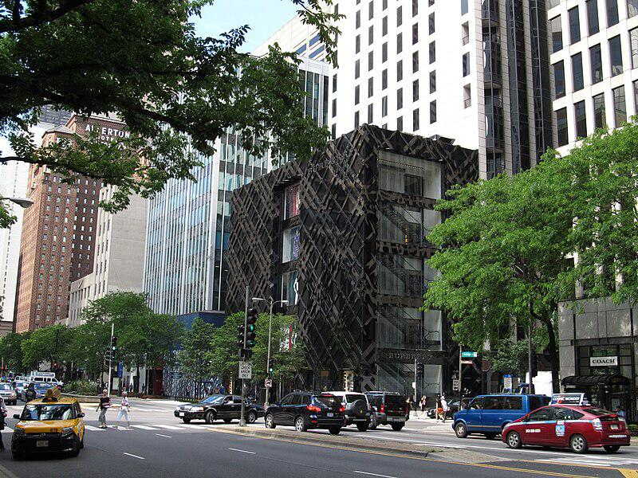

Caption for image source 2: The Magnificent Mile, Michigan Avenue, Chicago, Illinois (9181676490) The Magnificent Mile, sometimes referred to as The Mag Mile, is a prestigious section of Chicago's Michigan Avenue, running from the Chicago River to Oak Street in the Near North Side..

Example Question - "On The Magnificent Mile, what types of transportation service vehicles can be seen?"

Example Answer - "Taxis and buses can be seen on The Magnificent Mile."

Additional Text Source 1 - In 2008, a public art installation of kinetic sculptures designed by local and international architects was placed in the garden beds. During the summer, the "Gardens of The Magnificent Mile" festival event occurs. (from: Magnificent Mile)

Generated Question - Are the flower gardens on The Magnificent Mile decorated with kinetic sculptures during the summer festival?

Generated Answer - Yes, kinetic sculptures are placed in the gardens during the summer festival.

--- Entry for custom_id: d5c283060dba11ecb1e81171463288e9 ---

Image Source 1 -



Caption for image source 1: Jeison Angulo USA-Columbia, FIFA U20 World Cup (18679461162) (cropped).

Image Source 2 -



Caption for image source 2: Philipp Lahm, Germany national football team (06) Philipp Lahm (FC Bayern Munich), german national football team This photograph was taken by user Steindy and released under the license(s) stated below..

Example Question - "Do both FC Bayern Munich and Colombia's national football team wear adidas jerseys?"

Example Answer - "Both the FC Bayern Munich and Colombia's national football team wear Adidas jerseys."

Additional Text Source 1 - Bayern Chairman Karl-Heinz Rummenigge stated, "Of course, Bayern Munich are very angry" with the Royal Dutch Football Association (KNVB), and would be seeking compensation from them, continuing, "Once again we must pay the bill as a club after a player is seriously injured playing for a national team. (from: 2010–11 FC Bayern Munich season)

Generated Question - Do both the Colombia national team player and the Bayern Munich player wear Adidas kits, and does Bayern Munich face issues when their players get injured playing for national teams?

Generated Answer - Yes, both wear Adidas kits, and Bayern Munich is upset about injuries to their players during national team matches.

--- Entry for custom_id: d5c9722e0dba11ecb1e81171463288e9 ---

Image Source 1 -

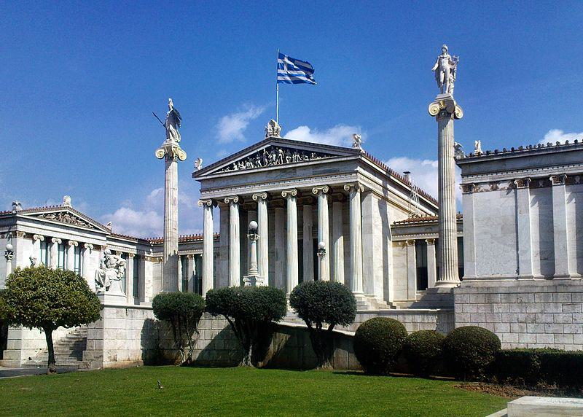

Caption for image source 1: Athens academy Academy of Athens.

Example Question - "At the Academy of Athens how many columns have a statue depicting a human on top of them?"

Example Answer - "Two columns have a statue depicting a human on top of them at the Academy of Athens."

Additional Text Source 1 - Later in the mid and late 19th century, Theophil Freiherr von Hansen and Ernst Ziller took part in the construction of many neoclassical buildings such as the Athens Academy and the Zappeion Hall. Ziller also designed many private mansions in the centre of Athens which gradually became public, usually through donations, such as Schliemann's Iliou Melathron. (from: Athens)

Generated Question - Were the statues on top of the columns at the Academy of Athens likely influenced by neoclassical architects like Theophil Hansen and Ernst Ziller?

Generated Answer - Yes, the statues on the columns reflect the neoclassical style promoted by Hansen and Ziller.

--- Entry for custom_id: d5dbab1a0dba11ecb1e81171463288e9 ---

Example Question - How many years after the death of Ptolemy IV was Arsinoë's defeat by Julius Caesar?

Example Answer - 156 years

Image Source 1 -

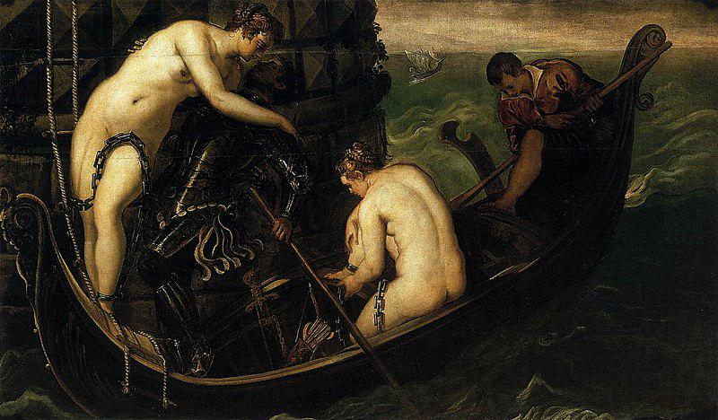

Generated Question - Considering Arsinoë IV's birth range and Ptolemy IV's death, how old was Arsinoë when Ptolemy IV died?

Generated Answer - Arsinoë was not yet born or was an infant when Ptolemy IV died in 204 BC.

--- Entry for custom_id: d5ce857a0dba11ecb1e81171463288e9 ---

Image Source 1 -

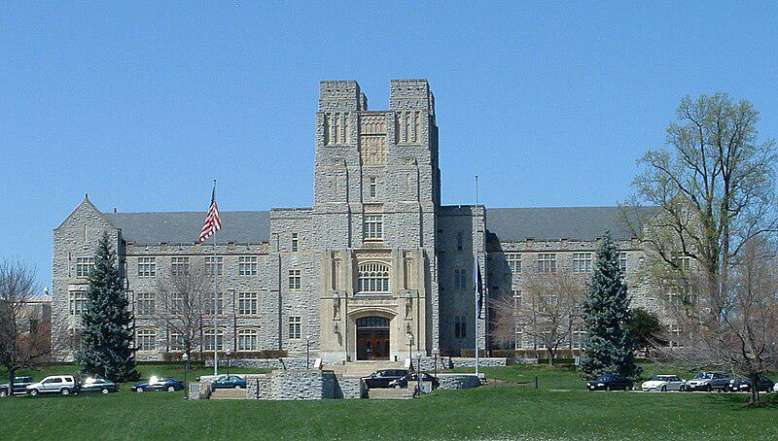

Caption for image source 1: Virginiatech-burrusshall-fromdrillfield Virginia Tech's Burruss Hall taken from the drillfield.

Example Question - "Is Virginia Tech's Burruss Hall symmetrical or asymmetrical?"

Example Answer - "Virginia Tech's Burruss Hall is symmetrical."

Additional Text Source 1 - Opened in August 2012, Turner Place at Lavery Hall is the newest dining hall at Virginia Tech. It features: Atomic Pizzeria, Jamba Juice, 1872 Fire Grill, Qdoba Mexican Grill, Origami (a hibachi grill), Soup Garden, Dolci e Caffe, and Bruegger's Bagels. (from: Campus of Virginia Tech)

Generated Question - Is Burruss Hall's traditional architecture similar to the modern dining options available at Turner Place in Lavery Hall?

Generated Answer - No, Burruss Hall has traditional architecture, while Turner Place offers modern dining options.

--- Entry for custom_id: d5c987960dba11ecb1e81171463288e9 ---

Image Source 1 -

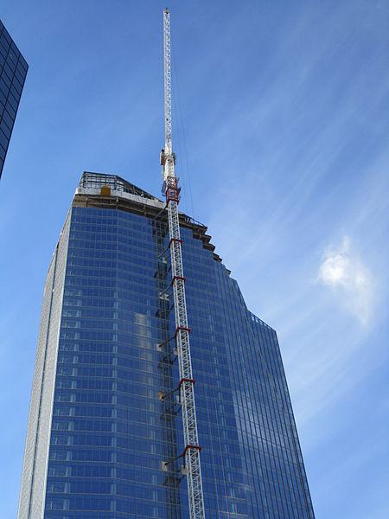

Caption for image source 1: Eighth Avenue Place - East Tower, 2010-09-29.

Image Source 2 -

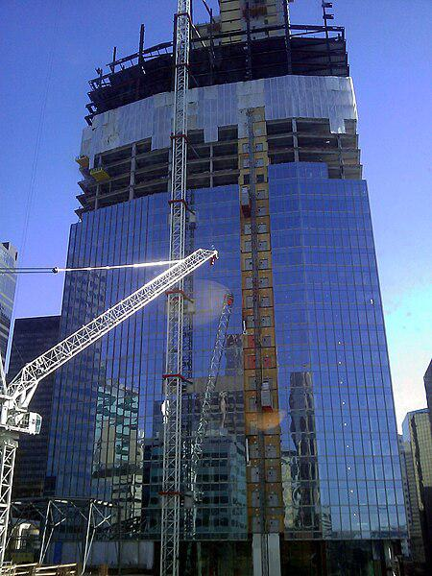

Caption for image source 2: Penny Lane Towers construction Construction of 8th Avenue place (Penny Lane Towers) in April 2010. Calgary, Alberta, Canada.

Example Question - "From which direction were the glass windows installed on the Penny Lane Towers?"

Example Answer - "The glass windows on the Penny Lane Towers were installed from the bottom up."

Additional Text Source 1 - The complex is housed on the site of the former Penny Lane Mall, originally intending to keep the historic name as "Penny Lane Towers", the project has since been renamed. (from: Eighth Avenue Place)

Generated Question - Are the glass windows on Eighth Avenue Place installed in a similar bottom-up manner as seen during Penny Lane Towers construction?

Generated Answer - Yes, the glass windows on Eighth Avenue Place were installed from the bottom up, similar to Penny Lane Towers.

--- Entry for custom_id: d5d8173e0dba11ecb1e81171463288e9 ---

Example Question - Of Gaius Julius Caesar and Trajan, which would have existed further after the death of Jesus?

Example Answer - Trajan would have existed further after.

Image Source 1 -

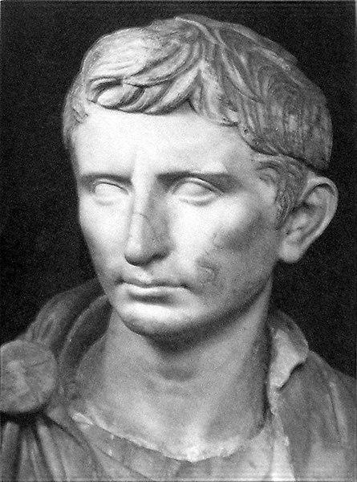

Generated Question - Which Roman leader incorporated the region into Italy first, Gaius Julius Caesar or Trajan?

Generated Answer - Gaius Julius Caesar incorporated the region into Italy first.

--- Entry for custom_id: d5d2aa380dba11ecb1e81171463288e9 ---

Example Question - In the history of Lincolnshire and Lancashire counties, which county was recorded in the Domesday Book?

Example Answer - Lincolnshire was recorded in the Domesday Book as Lindsey, while Lancashire did not exist as a county in the Domesday Book.

Image Source 1 -

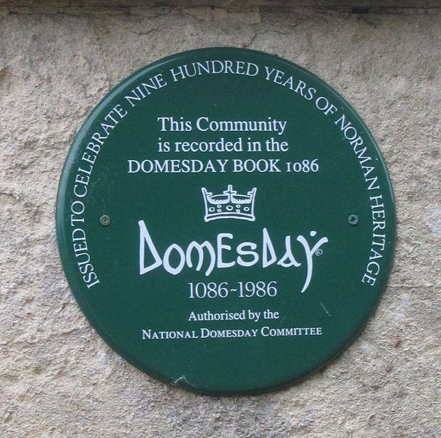

Generated Question - Which county's communities could have memorial plaques like the one shown, based on their recording in the Domesday Book?

Generated Answer - Communities in Lincolnshire (Lindsey) could have such plaques, as it was recorded in the Domesday Book, unlike Lancashire.

--- Entry for custom_id: d5d5ff6c0dba11ecb1e81171463288e9 ---

Example Question - Darling River and Goulburn River are both located where?

Example Answer - New South Wales, Australia

Image Source 1 -

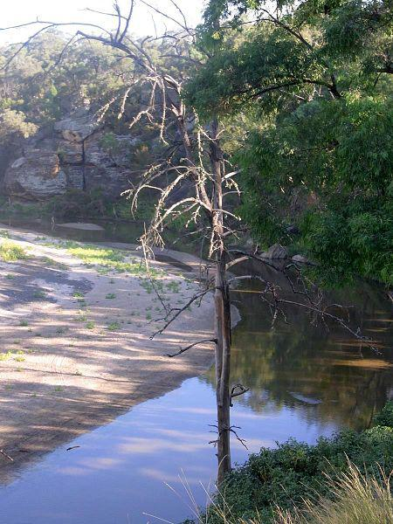

Generated Question - Do the Darling River and Goulburn River both flow within the same Australian state and contribute to different river systems?

Generated Answer - Yes, both flow in New South Wales but belong to different river catchments.

--- Entry for custom_id: d5c6342e0dba11ecb1e81171463288e9 ---

Image Source 1 -



Caption for image source 1: Vauxhall Velox PA estate ca 1959 Vauxhall Velox PA estate / wagon at Classic Car Show in Hertfordshire.

Image Source 2 -

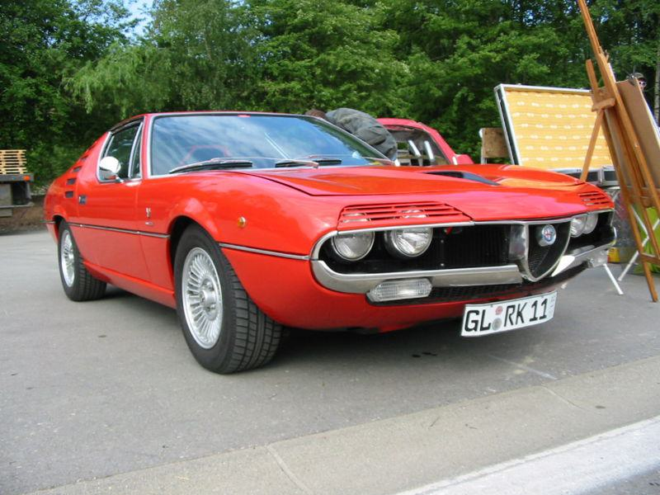

Caption for image source 2: Alfa Romeo Montreal.

Example Question - "Are the headlights on the Vauxhall Velox PA estate a different shape than the headlights on the Alfa Romeo Montreal?"

Example Answer - "No, the headlights on the Vauxhall Velox PA estate are not a different shape than the headlights on the Alfa Romeo Montreal."

Additional Text Source 1 - In its day, its best-known configuration was the Vauxhall Velox (velox, veloc- being Latin for "swift"/"fleet" and the source of English velocity) standard 4-seater with open tourer body. Vauxhall's own description was the 30–98 hp Vauxhall-Velox sporting car. (from: Vauxhall 30-98)

Generated Question - Considering the Vauxhall Velox PA estate and the Alfa Romeo Montreal, which car is more likely named to emphasize speed?

Generated Answer - The Vauxhall Velox PA estate is named to emphasize speed, as "Velox" means swift or fleet.

--- Entry for custom_id: d5cc11aa0dba11ecb1e81171463288e9 ---

Image Source 1 -

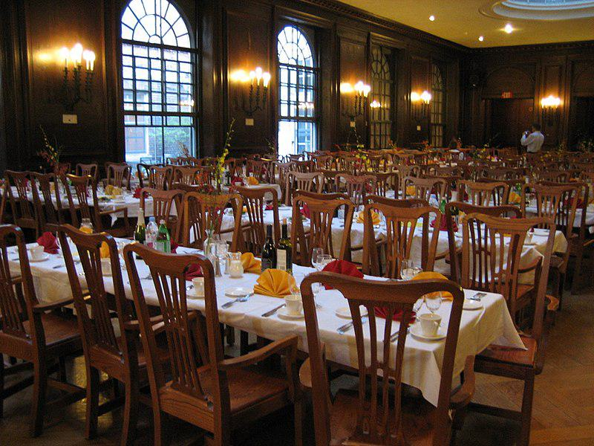

Caption for image source 1: Adams House Dining Hall.

Example Question - "What is the color of the table cloth in the Adams House Dining hall?"

Example Answer - "At the Adams House Dining hall, the table cloth is white."

Additional Text Source 1 - An Adams win would result in a return of the gong, continued use of "Pfadams House" with Pfoho becoming "Orzheimer House", though Adams generously offered to supply the rival library with a copy of "Hooked on Phonics." An Adams win would also grant the Pfoho "colonists" dining hall privileges at Adams House. (from: Pforzheimer House)

Generated Question - Would a win by Adams allow Pforzheimer House residents to dine in the Adams House Dining Hall shown in the image?

Generated Answer - Yes, an Adams win would grant Pforzheimer House residents dining privileges at Adams House.

--- Entry for custom_id: d5c606980dba11ecb1e81171463288e9 ---

Image Source 1 -

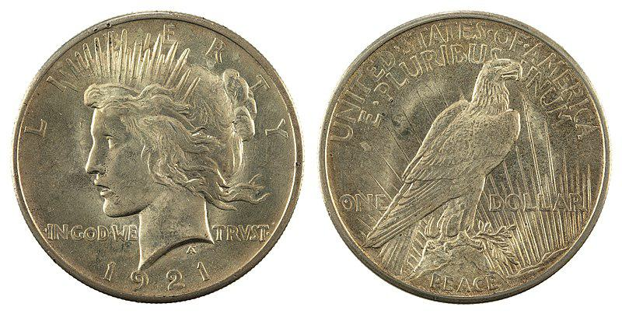

Caption for image source 1: NNC-US-1921-1$-Peace dollar JN2015-6706-07.

Image Source 2 -



Caption for image source 2: 1879S Morgan Dollar NGC MS67plus Reverse.png The reverse of the Morgan silver dollar..

Example Question - "What is different about the "In God We Trust" on the 1921 Peace dollar and the 1879 Morgan silver dollar?"

Example Answer - "In God We Trust on the 1921 Peace dollar and the 1879 Morgan silver dollar are in different fonts."

Additional Text Source 1 - The Peace dollar's lettering tended to strike indistinctly, and Burdette suggests that the new chief engraver, John R. Sinnock (who succeeded Morgan after his death in 1925), may have begun work in the middle of the motto "In God We Trust", and for reasons unknown, only the one word was boldened. (from: Peace dollar)

Generated Question - How does the placement of "In God We Trust" differ between the 1921 Peace dollar and the 1879 Morgan silver dollar?

Generated Answer - On the Peace dollar, it is split on the front, while on the Morgan dollar, it is centered on the back.

--- Entry for custom_id: d5cb32440dba11ecb1e81171463288e9 ---

Image Source 1 -

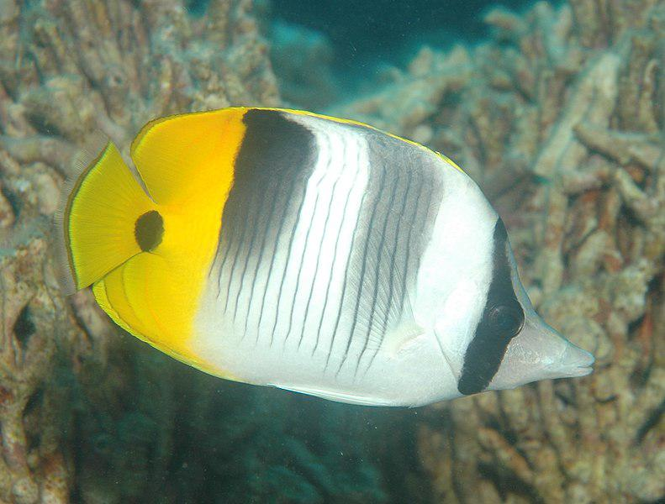

Caption for image source 1: Chaetodon ulietensis.

Image Source 2 -

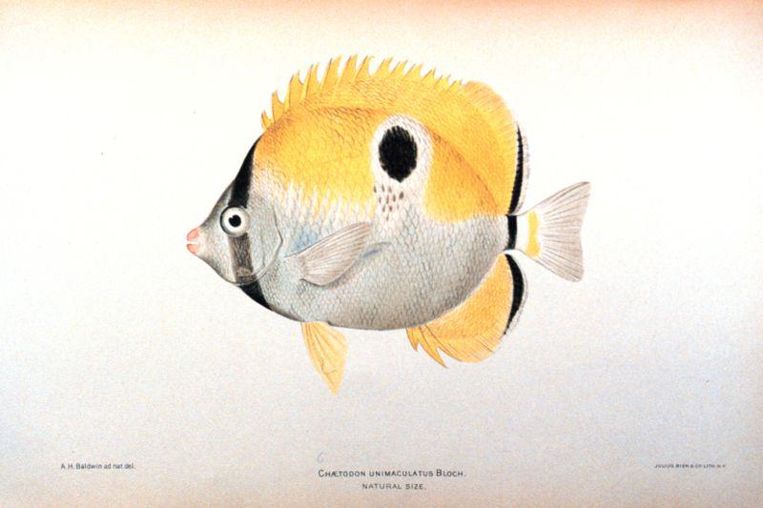

Caption for image source 2: Chaetodon unimaculatus.

Example Question - "What do both the Chaetodon unimaculatus and the Chaetodon ulietensis have running vertically across their eye?"

Example Answer - "Both fish have a black stripe running vertically across their eyes."

Additional Text Source 1 - Chaetodon ulietensis is often found singly or in pairs on coral-rich reef systems, foraging on sessile invertebrates and algae. It is not a territorial species that freely grazes throughout a wide range within reefs, lagoons and harbors, and every now and then large groups congregate at rich feeding spots. (from: Chaetodon ulietensis)

Generated Question - Do both Chaetodon ulietensis and Chaetodon unimaculatus exhibit solitary or group behavior while feeding?

Generated Answer - Chaetodon ulietensis can be solitary or in groups, while Chaetodon unimaculatus behavior is not specified.

--- Entry for custom_id: d5db3df60dba11ecb1e81171463288e9 ---

Example Question - The photoelectric effect is the what, a variety of which are called secondary electrons, when electromagnetic radiation, such as light, hits a material?

Example Answer - Emission of electrons

Image Source 1 -

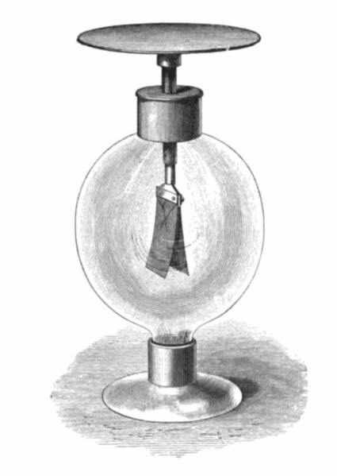

Generated Question - How does the gold leaf electroscope demonstrate the emission of electrons in the photoelectric effect compared to secondary electron emission?

Generated Answer - The electroscope discharges by electron emission when high-frequency light hits it, unlike secondary emission caused by charged particles.

--- Entry for custom_id: d5da0f080dba11ecb1e81171463288e9 ---

Example Question - Who is the representative for the 2nd congressional district in the U.S. state containing a largely suburban county called Johnson?

Example Answer - Republican Steve Watkins.

Image Source 1 -

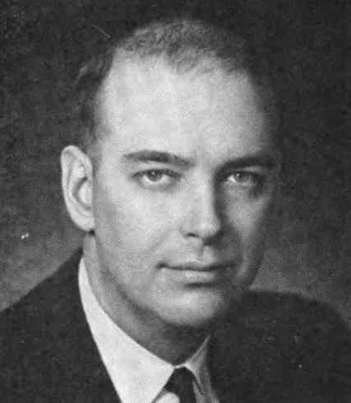

Generated Question - Was Robert F. Ellsworth a Republican representative from the same Kansas district that includes Lawrence before being redistricted?

Generated Answer - Yes, he was a Republican representative from that district before redistricting.

--- Entry for custom_id: d5cbf6340dba11ecb1e81171463288e9 ---

Image Source 1 -



Caption for image source 1: Prosole Beauty Products Inspiring sole "PROSOLE".

Example Question - "What colors does the packaging for Prosole beauty products come in?"

Example Answer - "The packaging for Prosole beauty products comes in red, pink, black, purple, and gray."

Additional Text Source 1 - K-Beauty products are presented using sophisticated ingredients and appealing packaging. Products use ingredients ranging from more natural sources such as green tea leaves, orchid, soybean to snail slime, morphing masks, bee venom (an anti-inflammatory “faux-tox” alleged to relax facial muscles), moisturizing starfish extract, and pig collagen. (from: K-Beauty)

Generated Question - How does the packaging variety of Prosole beauty products compare to the sophisticated presentation of K-Beauty products?

Generated Answer - Prosole uses colorful packaging, while K-Beauty emphasizes sophisticated ingredients and appealing design.

--- Entry for custom_id: d5dcb2da0dba11ecb1e81171463288e9 ---

Example Question - The genus of carnivorous plants indigenous to the eastern seaboard of the United States, Texas, the Great Lakes area and southeastern Canada has what 2 closely allied genera in its family?

Example Answer - Darlingtonia and Heliamphora.

Image Source 1 -



Generated Question - Which species of the Sarracenia genus is found in cold-temperate regions like the Great Lakes and Canada?

Generated Answer - Sarracenia purpurea.

--- Entry for custom_id: d5d4890c0dba11ecb1e81171463288e9 ---

Example Question - What bodies of water bounds Kent (county) on the north and what determines the major geographical features of the county?

Example Answer - Kent is bounded on the north by the River Thames and the North Sea and the major geographical features of the county are determined by a series of ridges running from west to east across the county.

Image Source 1 -

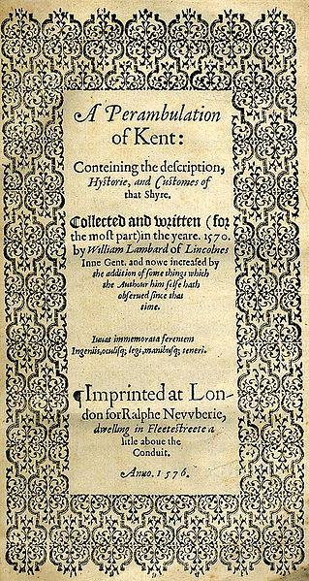

--- Entry for custom_id: d5dc9f160dba11ecb1e81171463288e9 ---

Example Question - There are some more generally recognized genres and categorizations of what thing of which Hebrew is a type?

Example Answer - The Bible

Image Source 1 -



Generated Question - How is the Hebrew alphabet related to the original language of most content shared with the Septuagint and the Christian Old Testament?

Generated Answer - The Hebrew alphabet represents the original language of most content shared with the Septuagint and the Christian Old Testament.

--- Entry for custom_id: d5d2d7060dba11ecb1e81171463288e9 ---

Example Question - How many years of difference is there between the war of bucket and the year Bologna played their first ever game?

Example Answer - 734 years.

Image Source 1 -

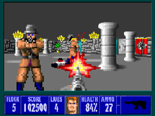

Generated Question - How many years after Bologna's first football game was Wolfenstein 3D, a pioneering first-person shooter, released?

Generated Answer - Wolfenstein 3D was released 81 years after Bologna's first game in 1910.

--- Entry for custom_id: d5d119e80dba11ecb1e81171463288e9 ---

Example Question - Are antiporters an example of passive transport?

Example Answer - No they are not.

Image Source 1 -



Generated Question - Does the antiporter use energy from one molecule moving down its gradient to move another molecule against its gradient?

Generated Answer - Yes, it uses energy from one molecule moving down its gradient to move another against its gradient.

--- Entry for custom_id: d5c9d9da0dba11ecb1e81171463288e9 ---

Image Source 1 -

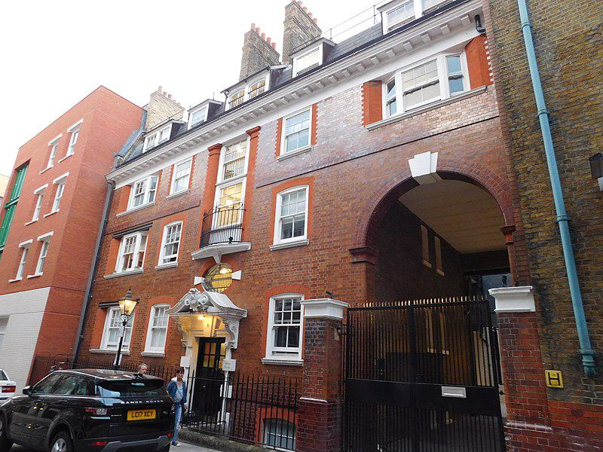

Caption for image source 1: 8 Mercer Street, London 1 6 And 8, Mercer Street Wc2 Wikidata has entry Q27083430 with data related to this item. 8 Mercer Street, London. The "Mercers' Maiden" figure above the door indicates this is or was a building owned by the Mercers' Company (a City of London livery company)..

Example Question - "What color is the keystone on the arch of the Mercers' Company building's outdoor entrance?"

Example Answer - "The keystone on the arch of the Mercers' Company building's outdoor entrance is white."

Additional Text Source 1 - Sydney is home to Australia's first building by renowned Canadian-American architect Frank Gehry, the Dr Chau Chak Wing Building (2015), based on the design of a tree house. An entrance from The Goods Line–a pedestrian pathway and former railway line–is located on the eastern border of the site. (from: Sydney)

Generated Question - Does the Mercers' Company building in London have a traditional entrance like the Dr Chau Chak Wing Building in Sydney?

Generated Answer - Yes, the Mercers' Company building has a traditional entrance, unlike the modern design of the Dr Chau Chak Wing Building.

--- Entry for custom_id: d5c5f7f20dba11ecb1e81171463288e9 ---

Image Source 1 -

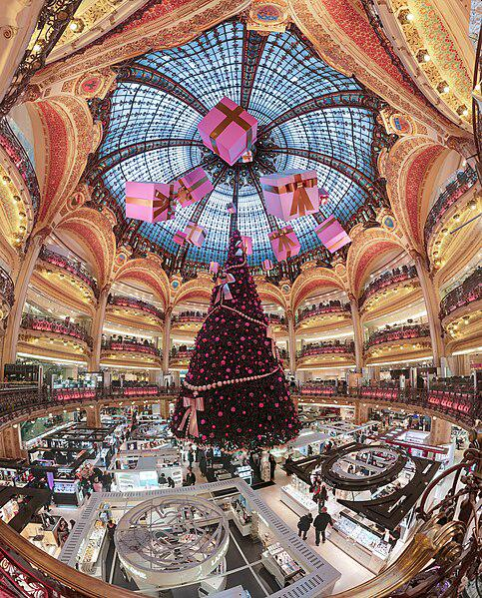

Caption for image source 1: Galerie Lafayette Haussmann Dome Dome and balconies of Galeries Lafayette store, lady section, in boulevard Haussmann, Paris, with Christmas decorations. This picture has a 170 field of view. Dome and balconies of Galeries Lafayette store, lady section, in boulevard Haussmann, Paris, with Christmas decorations..

Image Source 2 -

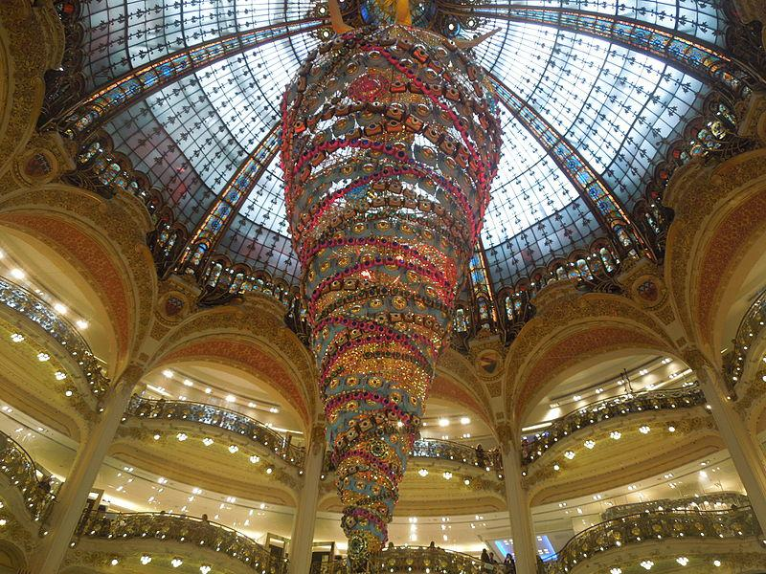

Caption for image source 2: Christmas Decoration in Galeries Lafayette Paris France Christmas decorations in Galeries Lafayette, Paris, France..

Example Question - "In which orientations has the Galeries Lafayette in Paris displayed their annual Christmas tree?"

Example Answer - "Galeries Lafayette in Paris displayed their annual Christmas tree both right-side up and upside down."

Additional Text Source 1 - Galeries Lafayette Paris Haussmann has a suspended Christmas tree every year, the first of which was hung from the dome in 1976. (from: Galeries Lafayette)

Generated Question - How does the suspended Christmas tree decoration in Galeries Lafayette Paris relate to the dome structure shown in the images?

Generated Answer - The suspended Christmas tree hangs from the dome's center, integrating with the dome's architecture.

--- Entry for custom_id: d5d89ace0dba11ecb1e81171463288e9 ---

Example Question - The black or brown dragonfly with pale markings that lives in North Queensland, Australia, is named after the local Aboriginal word meaning what?

Example Answer - 'Eungella' is believed to be a local Aboriginal word for 'mountain of the mist' or 'land of cloud', and is part of the name of the Eungella darner, a dragonfly.

Image Source 1 -

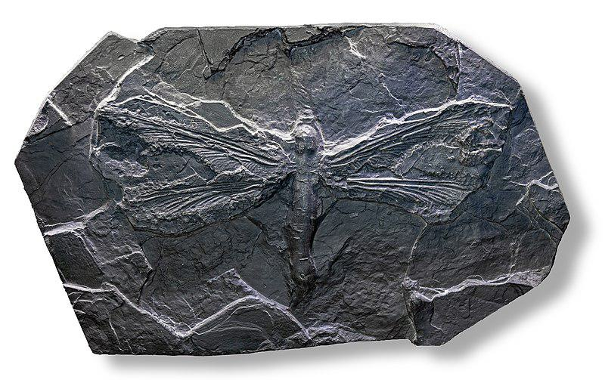

Generated Question - How does the wingspan of the ancient Meganeura compare to the size of the modern Eungella darner dragonfly found in North Queensland?

Generated Answer - Meganeura had a much larger wingspan, around 680 mm, compared to the much smaller modern Eungella darner.

--- Entry for custom_id: d5d7b9380dba11ecb1e81171463288e9 ---

Example Question - Which country can you find whipbirds and Cinclosoma castanotum?

Example Answer - Whipbirds and Cinclosoma castanotum can both be found in Australia.

Image Source 1 -

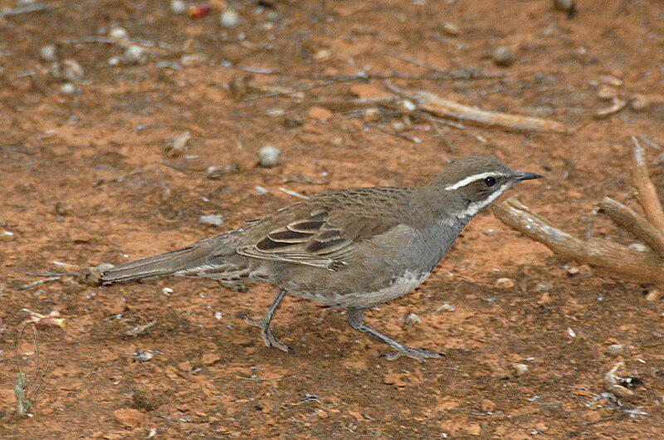

Generated Question - Are both the whipbirds and the chestnut-backed quail-thrush found in similar Australian habitats?

Generated Answer - Yes, both are found in Australian habitats ranging from rainforest to arid scrub.

--- Entry for custom_id: d5c3b9240dba11ecb1e81171463288e9 ---

Image Source 1 -

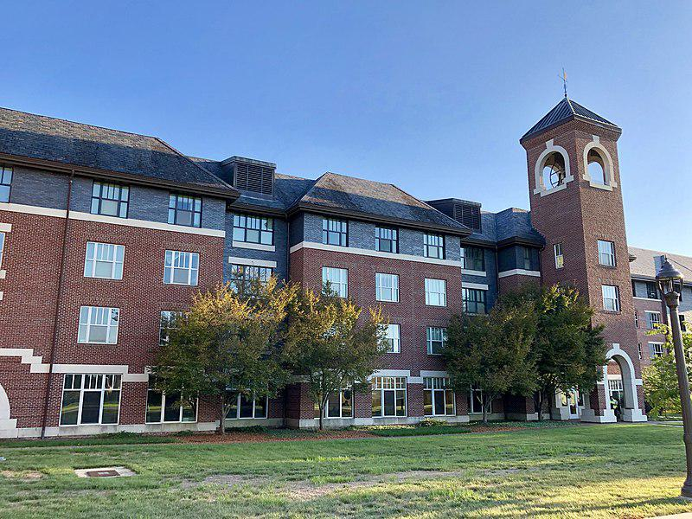

Caption for image source 1: Belltower Hall, East Campus, Duke University, Durham, NC (48961180032).

Example Question - "What architectural structures are at the top of the tower at Belltower Hall at Duke University?"

Example Answer - "Arches are at the top of the tower at Belltower Hall at Duke University."

Additional Text Source 1 - East Campus, 1.5 miles (2.4 kilometers) away, home to all first-years, contains Georgian-style architecture. The university administers two concurrent schools in Asia, Duke-NUS Medical School in Singapore (established in 2005) and Duke Kunshan University in Kunshan, China (established in 2013).Duke is ranked among the top universities in the United States. (from: Duke University)

Generated Question - Does Belltower Hall on Duke University's East Campus reflect the Georgian-style architecture typical of the campus?

Generated Answer - Yes, Belltower Hall reflects the Georgian-style architecture typical of Duke's East Campus.

--- Entry for custom_id: d5c12ed40dba11ecb1e81171463288e9 ---

Image Source 1 -

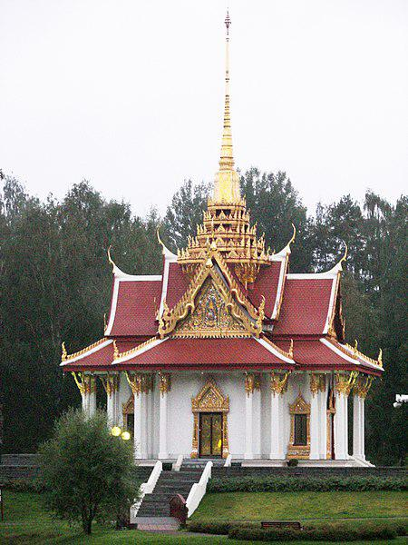

Caption for image source 1: Chulalongkorns paviljong The pavilion of Chulalongkorn south of Bispgarden, Sweden.

Example Question - "What leads up to the doorway of the pavilion of Chulalongkorn south of Bispgården, Sweden?"

Example Answer - "Stairs lead up to the doorway of the pavilion of Chulalongkorn south of Bispgården, Sweden."

Additional Text Source 1 - Designed as a Thai royal pavilion, the only one of its kind outside Thailand, it was raised in 1997 in commemoration of King Chulalongkorn's visit there a century earlier. (from: Ragunda Municipality)

Generated Question - Is the pavilion of Chulalongkorn in Sweden unique in its architectural style compared to typical buildings in Sweden?

Generated Answer - Yes, it is a Thai royal pavilion, the only one of its kind outside Thailand.

--- Entry for custom_id: d5c4a2f80dba11ecb1e81171463288e9 ---

Image Source 1 -

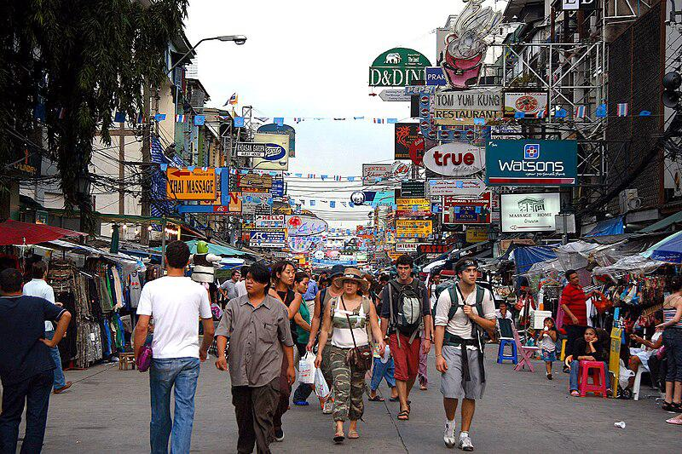

Caption for image source 1: Khaosan road Khaosan road.

Image Source 2 -



Caption for image source 2: Khaosan Road at night in 2012 View of the Khaosan Road at night.

Example Question - "The the road paved with the same material in front of Center Point Plaza and in front of Grand Guest House?"

Example Answer - "No the road is not paved with the same material in front of Center Point Plaza and in front of Grand Guest House."

Additional Text Source 1 - The Taipei Guest House (Chinese: 臺北賓館; pinyin: Táiběi Bīnguǎn) is the historical building located at 1 Ketagalan Boulevard, Bo'ai Special Zone, Zhongzheng District, Taipei, Taiwan. It is owned by the Government of the Republic of China and used as a state guest house for receiving state guests or celebration activities. (from: Taipei Guest House)

Generated Question - Are the streets on Khaosan Road during the day and night shown in the images equally crowded with pedestrians?

Generated Answer - No, the street during the day appears more crowded with pedestrians than at night.

--- Entry for custom_id: d5c6ae720dba11ecb1e81171463288e9 ---

Image Source 1 -

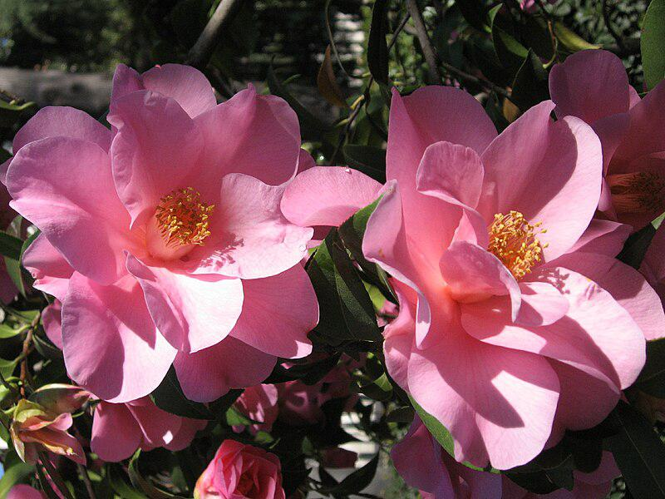

Caption for image source 1: Camellia x williamsii 'Brigadoon'.

Example Question - "Are the petals of Camellia x williamsii flower the same color as its pistil?"

Example Answer - "Camellia x williamsii's petals are not the same color as its pistil."

Additional Text Source 1 - C. japonica 'Alba Plena' is nicknamed the "Bourbon Camellia". Captain Connor of the East Indiaman Carnatic, brought the flower to England in 1792. (from: Camellia japonica)

Generated Question - Are the petals of Camellia x williamsii 'Brigadoon' the same color as the petals of C. japonica 'Alba Plena'?

Generated Answer - No, Camellia x williamsii 'Brigadoon' petals are pink, while C. japonica 'Alba Plena' petals are white.

--- Entry for custom_id: d5df42020dba11ecb1e81171463288e9 ---

Example Question - What enzyme is replaced in the treatment of EPI, and is used in the treatment of CP for pain reduction?

Example Answer - Pancreatic enzymes.

Image Source 1 -



Generated Question - How does pancreatic enzyme replacement therapy relate to treatment options for chronic pancreatitis and pancreatic cancer symptoms?

Generated Answer - It is used to treat chronic pancreatitis pain and enzyme insufficiency but does not address pancreatic cancer symptoms.

--- Entry for custom_id: d5c707b40dba11ecb1e81171463288e9 ---

Image Source 1 -



Caption for image source 1: Iran and Portugal match at the FIFA World Cup 2018 3.

Example Question - "Are professional soccer players' socks always the same color as their uniforms?"

Example Answer - "No, professional soccer players' socks can be a different color from their uniforms."

Additional Text Source 1 - Branimir "Branko" Šegota (born June 8, 1961) is a Canadian former professional soccer forward, starring in the original Major Indoor Soccer League (MISL), the North American Soccer League (NASL), the Continental Indoor Soccer League (CISL), the National Professional Soccer League, and the Canadian Soccer League. (from: Branko Šegota)

Generated Question - Do the players in the Iran and Portugal match wear socks matching their uniform colors like Branko Šegota did in his leagues?

Generated Answer - Yes, the players wear socks matching their uniform colors, unlike Branko Šegota who played in various leagues.

--- Entry for custom_id: d5d4383a0dba11ecb1e81171463288e9 ---

Example Question - To what country does the Northwest Territories' Acasta Gneiss and the Innuitian Region's Queen Elizabeth Islands belong to?

Example Answer - They are from Canada.

Image Source 1 -

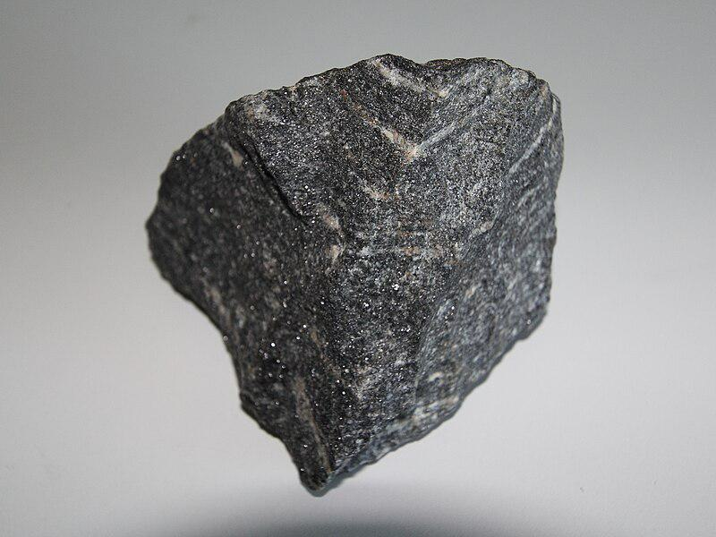

Generated Question - Are both the Innuitian Region's Queen Elizabeth Islands and the Acasta Gneiss located within the same country in Canada?

Generated Answer - Yes, both are located in Canada.

--- Entry for custom_id: d5dd7a800dba11ecb1e81171463288e9 ---

Example Question - Cognition of what, systems of which exist in order to motivate employees to work towards achieving strategic goals which are set by entities, serves to increase the likelihood of survival and reproduction by causing associative learning?

Example Answer - Rewards

Image Source 1 -

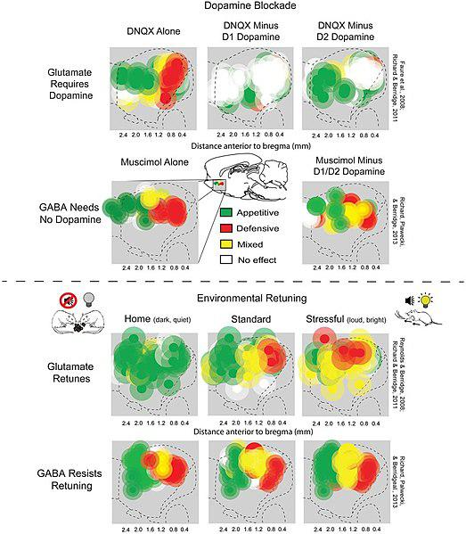

--- Entry for custom_id: d5c251ec0dba11ecb1e81171463288e9 ---

Image Source 1 -



Caption for image source 1: Convergent Lady Beetle - Hippodamia convergens, along Route 50 in western Utah Convergent Lady Beetle - Hippodamia convergens, along Route 50 in western Utah..

Image Source 2 -

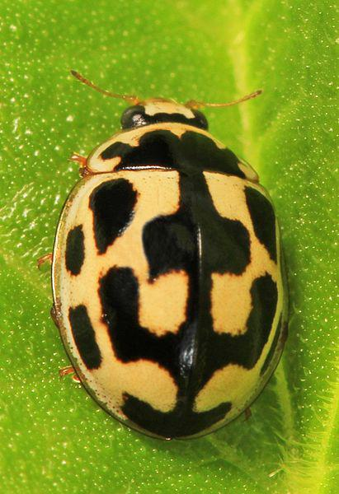

Caption for image source 2: Fourteen-spotted Lady Beetle - Propylea quatuordecimpunctata, Woodbridge, Virginia Fourteen-spotted Lady Beetle - Propylea quatuordecimpunctata, Woodbridge, Virginia..

Example Question - "Which is a darker color: the convergent lady beetle or the fourteen spotted lady beetle?"

Example Answer - "The convergent lady beetle is darker in color than the fourteen spotted lady beetle, which is mostly white."

Additional Text Source 1 - The specific name comes from quatuordecim, the Latin for "fourteen" and guttata, the Latin for "spotted". This ladybird is also sometimes known as the cream-spotted ladybird, polkadot ladybird or eighteen spot ladybird and may be confused with another beetle also known as the eighteen-spot ladybird (Myrrha octodecimguttata). (from: Cream-spot ladybird)

Generated Question - How do the spot patterns differ between the convergent lady beetle and the fourteen-spotted lady beetle?

Generated Answer - The convergent lady beetle has fewer, distinct black spots on orange, while the fourteen-spotted lady beetle has many irregular black spots on a cream background.

--- Entry for custom_id: d5d22bda0dba11ecb1e81171463288e9 ---

Example Question - What is the name of a railway part that contains railroad ties and can also have an electrification system for electric trains?

Example Answer - The tracks.

Image Source 1 -



Generated Question - What railway structure includes rails, ties, ballast, and may have an electrification system indicated by a high voltage sign?

Generated Answer - The track or permanent way.

--- Entry for custom_id: d5d206280dba11ecb1e81171463288e9 ---

Example Question - A game that is similar to a video game save that there is audible and tactile feedback but not visual might be created using what software?

Example Answer - Audio editing software

Image Source 1 -

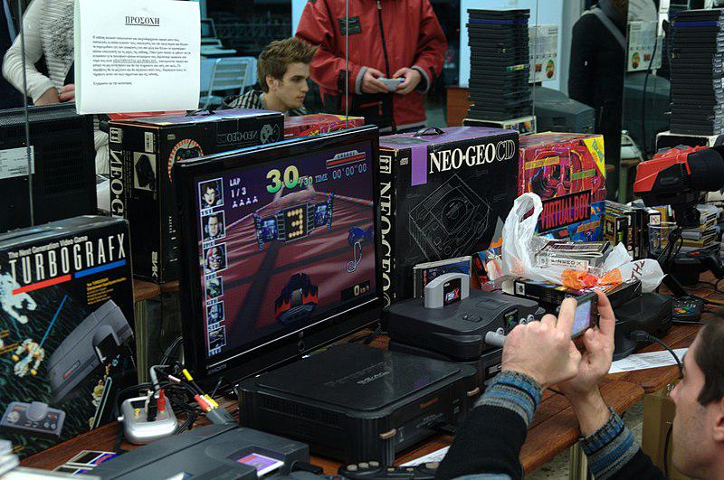

Generated Question - Could an audio game be played on any of the classic video game consoles shown at the game show?

Generated Answer - No, audio games require devices with audible and tactile feedback, not just classic video game consoles.

--- Entry for custom_id: d5dd72380dba11ecb1e81171463288e9 ---

Example Question - Who was shot in the calcaneus bone?

Example Answer - Achilles.

Image Source 1 -

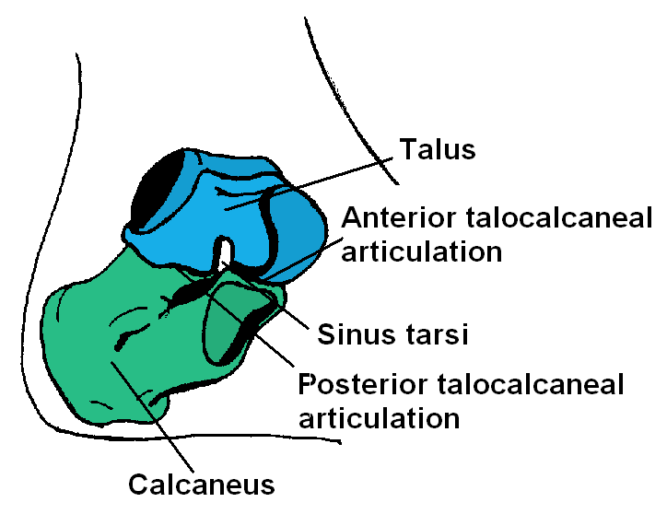

Generated Question - Which bone, shown in the image, is connected to muscles via the Achilles tendon and was pierced in the legend of Achilles' death?

Generated Answer - The calcaneus bone.

--- Entry for custom_id: d5d67a1e0dba11ecb1e81171463288e9 ---

Example Question - What are three threats to the 'ua'u?

Example Answer - Feral cats, small Asian mongooses, and rats are all threats.

Image Source 1 -

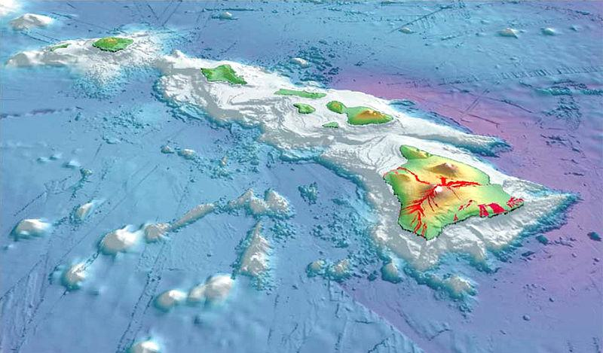

Generated Question - Considering the Hawaiian petrel is endemic to Hawaiʻi, how might the volcanic landscape shown affect its habitat and threats?

Generated Answer - The volcanic landscape creates unique habitats but also limits safe nesting areas, increasing vulnerability to predators like cats and mongooses.

--- Entry for custom_id: d5cb6eb20dba11ecb1e81171463288e9 ---

Image Source 1 -

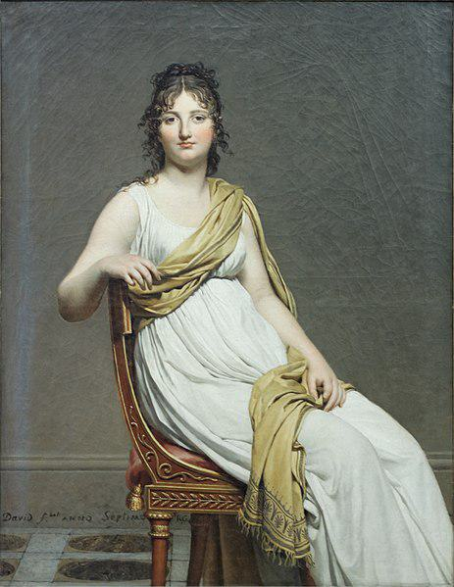

Caption for image source 1: Portrait de madame de Verninac by David Louvre RF1942-16 n2.

Example Question - "Is the subject in the painting Portrait of Madame Raymond de Verninac indoors or outdoors?"

Example Answer - "The subject of the painting "Portrait of Madame Raymond de Verninac" is indoors."

Additional Text Source 1 - In 1897 Gautreau posed yet again for a standing portrait, for what would be her favorite version, by Antonio de La Gándara. In 1960, Cuban-American fashion designer Luis Estévez created an iconic black dress based on the John Singer Sargent painting Portrait of Madame X (1884). (from: Portrait of Madame X)

--- Entry for custom_id: d5dadc080dba11ecb1e81171463288e9 ---

Example Question - A regular pentagon has how many more equal angles than squares in non-Euclidean geometry do?

Example Answer - 1

Image Source 1 -

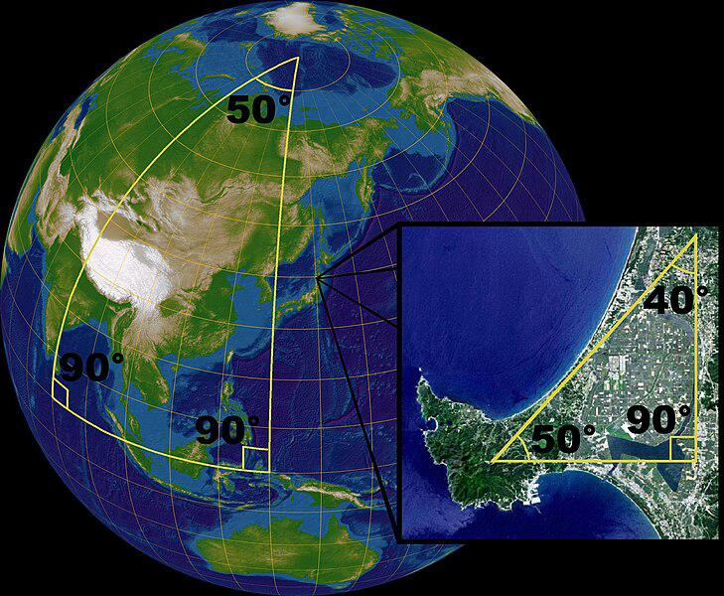

Generated Question - How does the sum of angles in a spherical triangle compare to the sum of angles in a regular pentagon and a non-Euclidean square?

Generated Answer - The spherical triangle's angles sum to more than 180°, unlike the fixed angles in a regular pentagon and non-Euclidean square.

--- Entry for custom_id: d5bd7c3a0dba11ecb1e81171463288e9 ---

Image Source 1 -

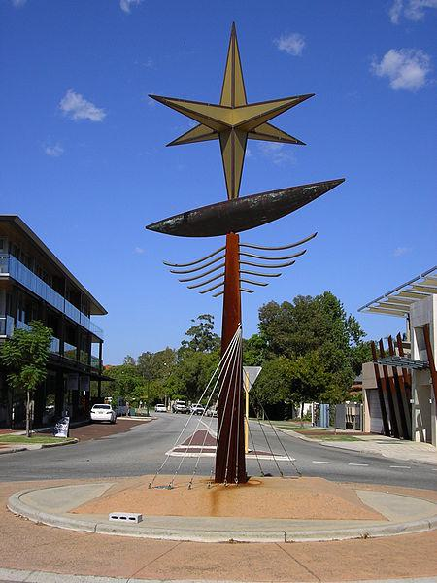

Caption for image source 1: Public Art-Asteroids, Nedlands 009 Public Art-Asteroid, Nedlands, Western Australia..

Example Question - "How many pointed edges does the star on the Public Art "Asteroid" in (Nedlands, Western_Australia) have?"

Example Answer - "The star on the Public Art "Asteroid" in (Nedlands, Western_Australia) has six pointed edges."

Additional Text Source 1 - The symbol is known in Arabic as Khātem Sulaymān (Seal of Solomon; خاتم سليمان) or Najmat Dāwūd (Star of David; نجمة داوود). The "Seal of Solomon" may also be represented by a five-pointed star or pentagram. (from: Hexagram)

Generated Question - Does the star on the Public Art "Asteroid" in Nedlands resemble the Seal of Solomon or the Star of David based on its points?

Generated Answer - The star has six points, resembling the Star of David or Seal of Solomon.

--- Entry for custom_id: d5c4e0560dba11ecb1e81171463288e9 ---

Image Source 1 -

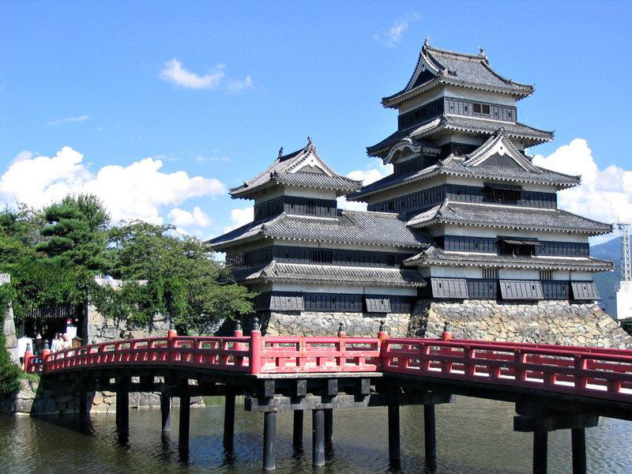

Caption for image source 1: Matsumoto Castle far3 0504.

Image Source 2 -



Caption for image source 2: Chuurei-tou Fujiyoshida 17025277650 c59733d6ba o Churei-to pagoda and Mount Fuji with cherry blossoms in the Arakurayama Sengen Park, Fujiyoshida, Yamanashi, central Japan..

Example Question - "Which structure is more dully colored, gray; Chūrei-tōpagoda or Matsumoto Castle?"

Example Answer - "Matsumoto Castle is more dully colored than Chūrei-tōpagoda."

Additional Text Source 1 - However, with the assassination of Oda Nobunaga in 1582, the castle was seized by Ogasawara Dosetsuzai with the backing of Uesugi Kagekatsu. His nephew, Ogasawara Sadayoshi, later pledged fealty to Tokugawa Ieyasu, and renamed the castle "Matsumoto Castle". (from: Matsumoto Castle)

Generated Question - Did the renaming of Matsumoto Castle occur before or after the construction of the Chūrei-tō pagoda?

Generated Answer - The renaming of Matsumoto Castle occurred before the Chūrei-tō pagoda existed.

--- Entry for custom_id: d5d9f5680dba11ecb1e81171463288e9 ---

Example Question - Both the ACT Department of Education and Training and SACE Board of South Australia award what?

Example Answer - Certificates

Image Source 1 -

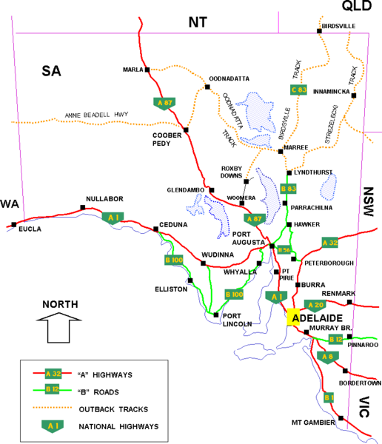

Generated Question - Do the South Australian Certificate of Education and the ACT Department of Education and Training both award certificates to students completing senior secondary schooling in regions connected by major highways shown in the map?

Generated Answer - Yes, both award certificates to students in regions connected by these highways.

--- Entry for custom_id: d5cc28ac0dba11ecb1e81171463288e9 ---

Image Source 1 -

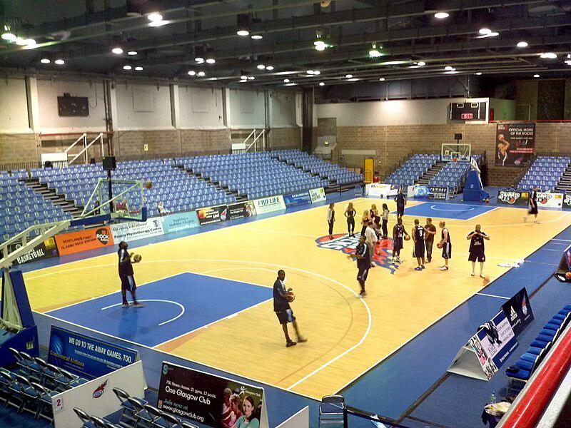

Caption for image source 1: KelvinHallBasketball Kelvin Hall International Sports Arena, basketball venue for Glasgow Rocks of the BBL.

Image Source 2 -

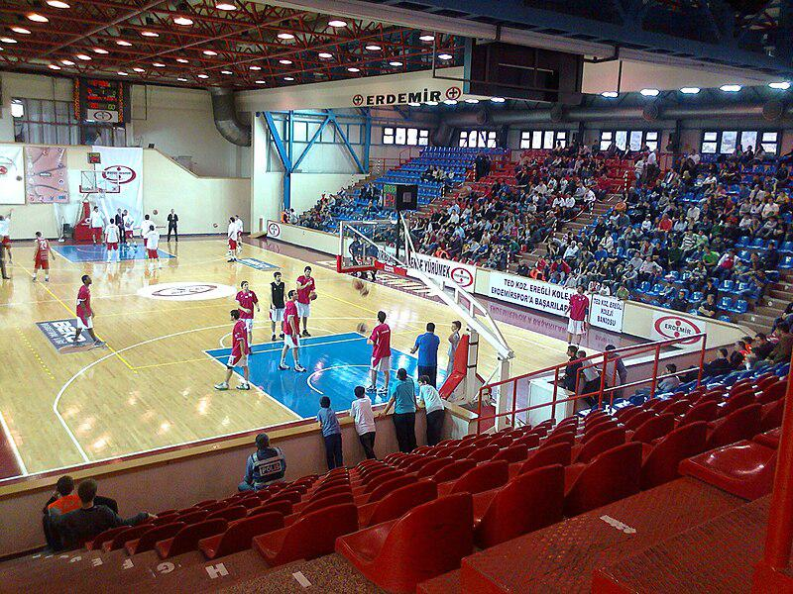

Caption for image source 2: Erdemir Spor Salonu iç görünüş.

Example Question - "Does the Erdemir Sport Hall have more blue seats than the Kelvin Hall International Sports Arena?"

Example Answer - "No, the Erdemir Sport Hall does not have more blue seats than the Kelvin Hall International Sports Arena."

Additional Text Source 1 - Erdemir Sport Hall (Turkish: Erdemir Spor Salonu) is a multi-purpose indoor sport venue that is located in the Karadeniz Ereğli town of Zonguldak Province, Turkey. The hall has a seating capacity of 2,000 spectators. (from: Erdemir Sport Hall)

Generated Question - Considering the seating colors and capacity, which venue likely accommodates more spectators, Kelvin Hall or Erdemir Sport Hall?

Generated Answer - Erdemir Sport Hall likely accommodates more spectators due to its 2,000 seating capacity despite fewer blue seats.

--- Entry for custom_id: d5cfe05a0dba11ecb1e81171463288e9 ---

Example Question - Which river has been at the center of conflicts between Virginia troops and Canadian-French troops?

Example Answer - Ohio River

Image Source 1 -

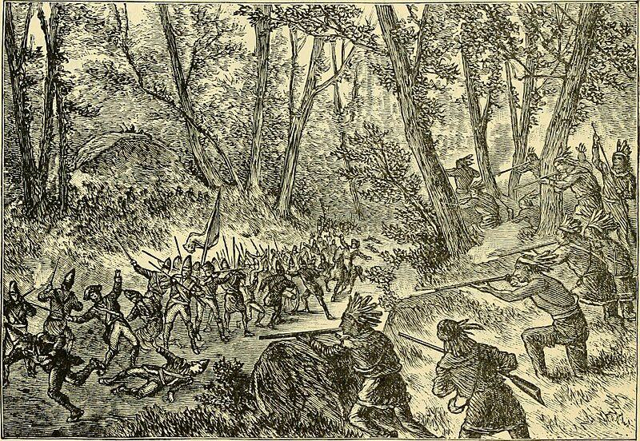

Generated Question - Who led the Canadian militia and French troops attacking British forces near the Ohio River valley?

Generated Answer - Claude-Pierre Pécaudy de Contrecœur led the Canadian militia and French troops.

--- Entry for custom_id: d5c4ba9a0dba11ecb1e81171463288e9 ---

Image Source 1 -



Caption for image source 1: 2018 USA Indoor Track and Field Championships (40313663152) 2018 USA Indoor Track and Field Championships.

Example Question - "For the runners in 2018 USA Indoor Track and Field Championships, are the Nike logos on their tops and bottoms on the same side of their body or on different sides?"

Example Answer - "The logos on their tops and bottoms are on the same side."

Additional Text Source 1 - Athletes who meet the "A" standard for entry into the previous Olympic Games or World Championships in Athletics receive automatic entry, as do any athletes who placed in the top three of their event at the 2018 USA Outdoor Track and Field Championships. (from: 2019 USA Outdoor Track and Field Championships)

Generated Question - Do the athletes in the 2018 USA Indoor Track and Field Championships automatically qualify for the 2019 USA Outdoor Track and Field Championships if they placed in the top three in 2018?

Generated Answer - Yes, top three finishers in 2018 automatically qualify for the 2019 championships.

--- Entry for custom_id: d5cd80620dba11ecb1e81171463288e9 ---

Image Source 1 -

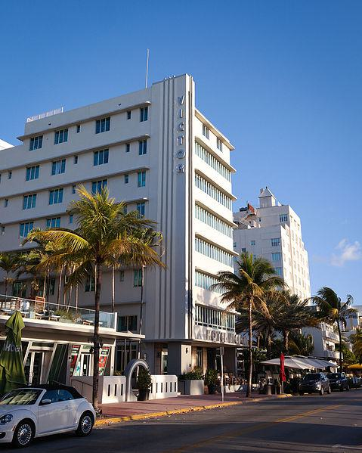

Caption for image source 1: Hotel Victor (Miami Beach) The Hotel Victor in Miami Beach, Florida.

Example Question - "What word appears vertically in blue letters on the side of the The Hotel Victor in Miami Beach, Florida?"

Example Answer - "On the side of The Hotel Victor in Miami Beach, "Victor" appears vertically in blue letters."

Additional Text Source 1 - The first "skyscraper" was the 18-story Lord Tarleton Hotel built in 1940 by Samuel Jacobs. The Jewish mobster Meyer Lansky, who ran some "carpet joints" (gambling operations) in Florida by 1936, and eventually controlled casinos in Cuba and Las Vegas, retired in Miami and died in Miami Beach. (from: Miami Beach, Florida)

Generated Question - Considering the Hotel Victor's height and the first skyscraper in Miami Beach, is the Hotel Victor taller than the Lord Tarleton Hotel built in 1940?

Generated Answer - No, the Hotel Victor is shorter than the 18-story Lord Tarleton Hotel.

--- Entry for custom_id: d5d4d6640dba11ecb1e81171463288e9 ---

Example Question - ANT and ATON are both what?

Example Answer - Aids to navigation.

Generated Question - Are the vessels TANB, BUSL, ATON, and ANB used by the Coast Guard primarily for maintaining aids to navigation?

Generated Answer - Yes, they are used by the Coast Guard for aids to navigation tasks.

--- Entry for custom_id: d5c6f2240dba11ecb1e81171463288e9 ---

Image Source 1 -

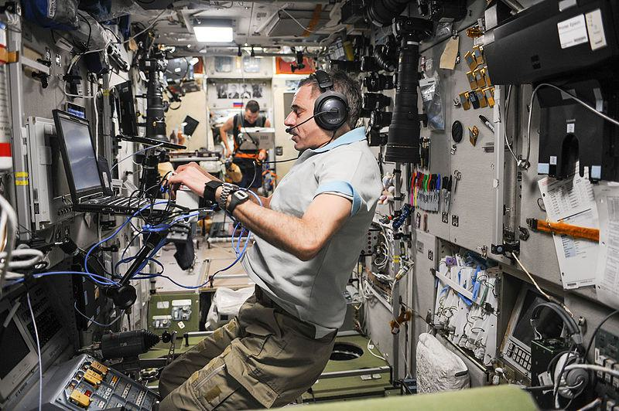

Caption for image source 1: ISS-45 Mikhail Kornienko inside the Zvezda Service Module Russian cosmonaut and one-year crew member Mikhail Kornienko conducts tests inside the Russian Service Module, Zvezda. In the background, Russian cosmonaut Oleg Kononenko can be seen running on one of the station's treadmill devices..

Example Question - "Can two astronauts be in the Zvezda Service Module at once?"

Example Answer - "Yes, there is room for two astronauts in the module at once."

Additional Text Source 1 - Zarya FGB [Russian: ФГБ - Функциональный Грузовой Блок, English: Functional (or Operational) Cargo Block (or Module)] holds 5,500 kg and the Zvezda Service module holds 860 kg, however, it is generally preferred to keep the main thrusters on Zarya and Zvezda in reserve, as they have finite lifespans. (from: ISS Propulsion Module)

Generated Question - Considering the weight capacities of Zarya and Zvezda modules, which module is likely to hold more equipment for astronauts like Mikhail Kornienko?

Generated Answer - The Zarya module likely holds more equipment since it has a higher weight capacity of 5,500 kg compared to Zvezda's 860 kg.

--- Entry for custom_id: d5d5bea80dba11ecb1e81171463288e9 ---

Example Question - What kind of cell would not need the structure to separate nucleoplasm from the rest of the cell?

Example Answer - Red blood cells do not have a cell nucleus so would not need a nuclear envelope to separate nucleoplasm from the rest of the cell.

Image Source 1 -



Generated Question - How does the size of the nucleus in the electron micrograph relate to the overall cell size and its function in protein synthesis?

Generated Answer - The nucleus size reflects about 8% of the cell volume, housing DNA and RNA essential for protein synthesis.

--- Entry for custom_id: d5bc16240dba11ecb1e81171463288e9 ---

Image Source 1 -

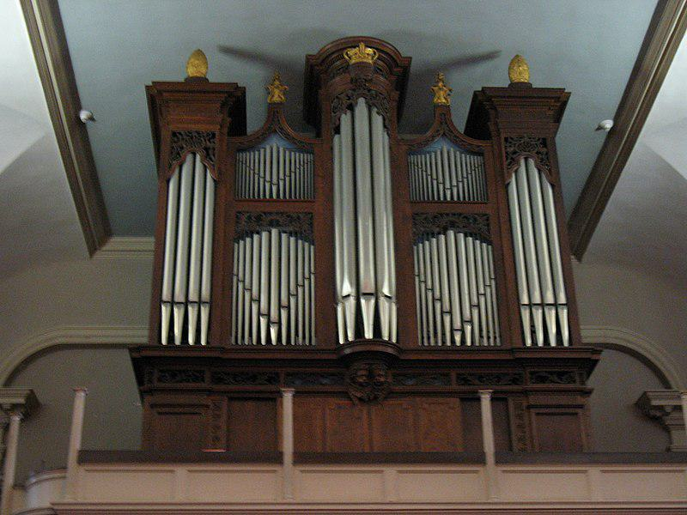

Caption for image source 1: Pipe organ King's Chapel The pipe organ of King's Chapel, Boston, MA..

Example Question - "Are the gold objects located at the top or the bottom of the pipe organ at King's Chapel in Boston?"

Example Answer - "The King's Chapel in Boston's pipe organ has gold objects found at the top."

Additional Text Source 1 - Some European king and queen's crowns were made of gold, and gold was used for the bridal crown since antiquity. An ancient Talmudic text circa 100 AD describes Rachel, wife of Rabbi Akiva, receiving a "Jerusalem of Gold" (diadem). (from: Gold)

Generated Question - Are the gold objects on the pipe organ at King's Chapel similar in placement to where a gold crown would be worn on a person?

Generated Answer - Yes, the gold objects are at the top, similar to where a crown is worn on a head.

--- Entry for custom_id: d5cbff9e0dba11ecb1e81171463288e9 ---

Image Source 1 -



Caption for image source 1: Abstraction with Reference to a Flowering Tree, by Paul Klee, 1925, oil on carton - National Museum of Modern Art, Tokyo - DSC06558 Exhibit in the National Museum of Modern Art, Tokyo (). This artwork is in the public domain because the artist died more than 70 years ago. Photography was permitted in the museum without restriction..

Image Source 2 -



Caption for image source 2: Mondrian, Compositie B.

Example Question - "What shape is found in both Mondrian's Compositie B and Klee's Abstraction with Reference to a Flowering Tree?"

Example Answer - "Squares and rectangles are found in both Mondrian's Compositie B and Klee's Abstraction with Reference to a Flowering Tree."

Additional Text Source 1 - This has been regularly done by many feminist writers. Like most folktales from around the world, A Flowering Tree synthesizes two discrete elements: first, an impossible narrative (a girl turns into a tree; a prince marries a peasant), and second, mythic archetypes which resonate deeply with all of us, no matter what our beliefs. (from: A Flowering Tree: A Woman's Tale)

Generated Question - How do the geometric shapes in Klee's painting relate to the symbolic transformation in the folktale "A Flowering Tree"?

Generated Answer - Klee's geometric shapes abstractly represent the transformation and mythic archetypes in the folktale.

--- Entry for custom_id: d5d82af80dba11ecb1e81171463288e9 ---

Example Question - CNS demyelinating autoimmune diseases are autoimmune diseases which primarily affect what nervous system of the body consisting primarily of the brain and spinal cord?

Example Answer - It affects the central nervous system.

Image Source 1 -

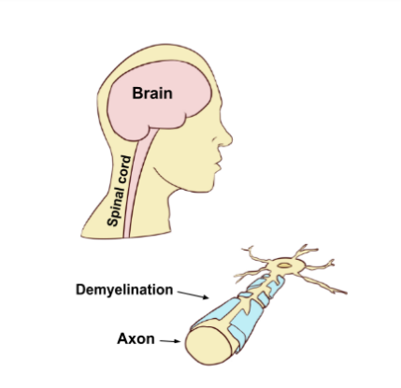

--- Entry for custom_id: d5c7dfea0dba11ecb1e81171463288e9 ---

Image Source 1 -

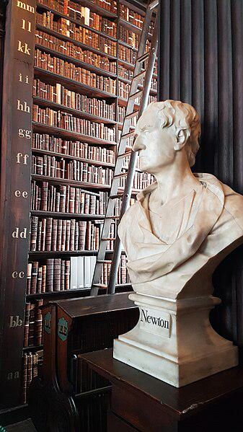

Caption for image source 1: The Old Library, Trinity College - Dublin 02 The Old Library, Trinity College - Dublin.

Image Source 2 -

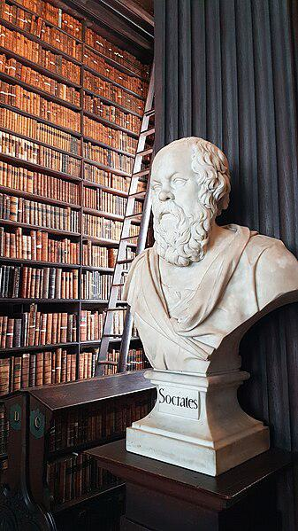

Caption for image source 2: The Old Library, Trinity College - Dublin 01 The Old Library, Trinity College - Dublin.

Example Question - "What item holds up the statues of Socrates and Newton at the the Old Library at Trinity College?"

Example Answer - "Wooden stands hold up the statues of Socrates and Newton at the the Old Library at Trinity College."

Additional Text Source 1 - The Library of Trinity College Dublin (Irish: Leabharlann Choláiste na Tríonóide) serves Trinity College and the University of Dublin. It is a legal deposit or "copyright library", which means that publishers in Ireland must deposit a copy of all their publications there, free of charge. (from: Library of Trinity College Dublin)

Generated Question - Are the statues of Newton and Socrates located in a library that legally requires publishers to deposit their works?

Generated Answer - Yes, both statues are in Trinity College Library, which is a legal deposit library.

--- Entry for custom_id: d5d883f40dba11ecb1e81171463288e9 ---

Example Question - To which river system does the major tributary of the Arkansas River and the sixth-longest river in the US belong to?

Example Answer - They belong to the Mississippi River system.

Image Source 1 -

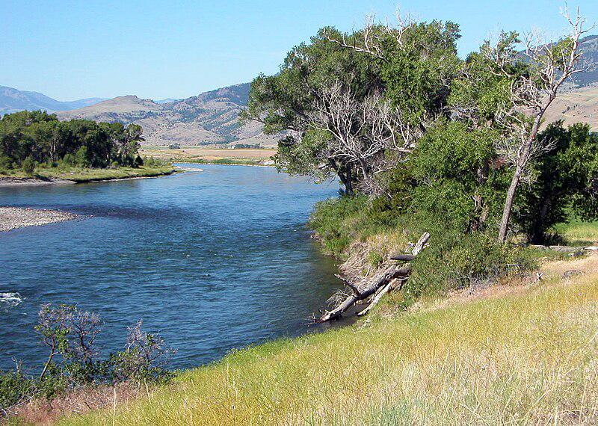

Generated Question - Which river system does the Yellowstone River, a major tributary of the Missouri, ultimately belong to along with the Arkansas River?

Generated Answer - Both belong to the Mississippi River system.

--- Entry for custom_id: d5c47c380dba11ecb1e81171463288e9 ---

Image Source 1 -

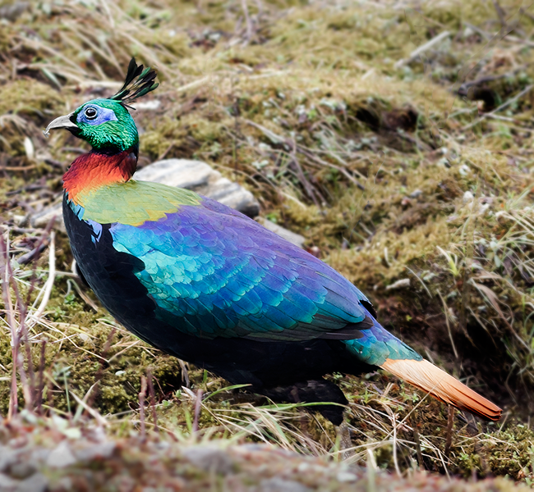

Caption for image source 1: Himalayan Monal Adult Male East Sikkim Sikkim India.png This bird species Himalayan Monal an adult male has been photographed at the district of East Sikkim in the state of Sikkim of India on 11th May 2014..

Example Question - "What is on the head of the Himalayan monal?"

Example Answer - "A plume is on the head of the Himalayan monal."

Additional Text Source 1 - The cheer pheasant (Catreus wallichi), crested argus (Rheinardia ocellata), the crested partridge (Rollulus roulroul) and the crested guineafowl (Guttera pucherani) are similar ecologically to the Himalayan monal in that they too forage in rotting wood for termites, ant and beetle larvae, molluscs, crustaceans and young rodents. (from: Galliformes)

Generated Question - Do the Himalayan monal and the crested guineafowl share similar foraging habits?

Generated Answer - Yes, both forage in rotting wood for insects and small animals.

--- Entry for custom_id: d5df26aa0dba11ecb1e81171463288e9 ---

Example Question - What geographical areas can you find Ameiurus melas?

Example Answer - Central US.

Image Source 1 -

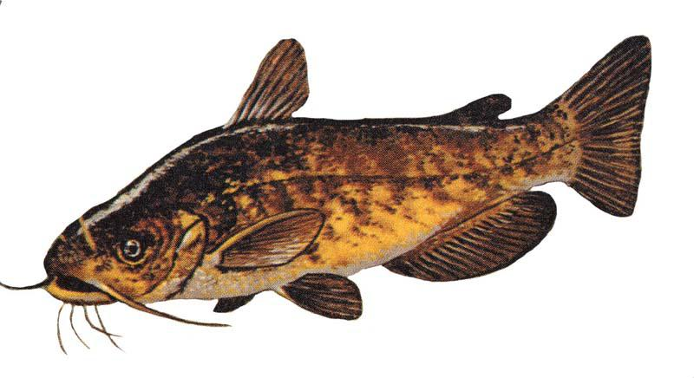

Generated Question - How do the habitats of black bullhead and brown bullhead catfish compare in terms of water conditions?

Generated Answer - Both thrive in low oxygen, warm, and muddy waters with soft bottoms.

--- Entry for custom_id: d5cdb0500dba11ecb1e81171463288e9 ---

Image Source 1 -



Caption for image source 1: PeaceLilyHousePlant.

Image Source 2 -

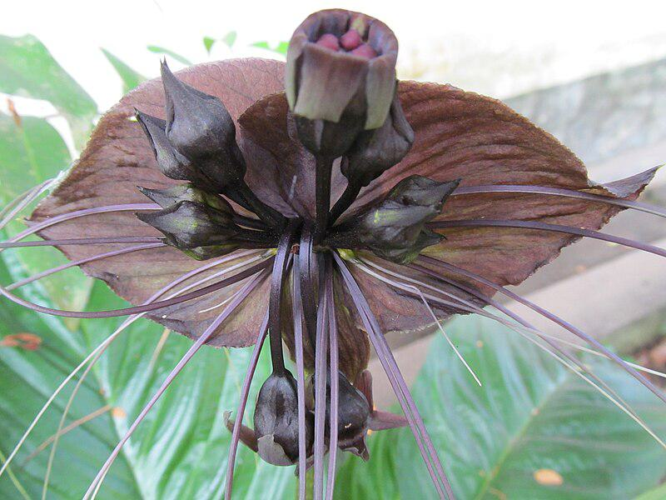

Caption for image source 2: Tacca chantrieri - Kerala -Vavvalpoovu -black bat flower 05.

Example Question - "Which flower is darker in color; Tacca_chantrieri or Peace Lily?"

Example Answer - "Tacca chantrieri is darker in color than the Peace Lily."

Additional Text Source 1 - Most resent accusations include Black Bat Flower (Tacca chantrieri), a Pelican Flower (Aristolochia gigantea), a Hanging Lobster Claw plants (Heliconia rostrata), and notorious for it odor Corpse Flower (Amorphophallus titanum), which bloom years apart. (from: Williams Conservatory)

Generated Question - Which flower among Peace Lily and Black Bat Flower is more likely to have a strong odor based on the additional text?

Generated Answer - Black Bat Flower is more likely to have a strong odor.

--- Entry for custom_id: d5d883c20dba11ecb1e81171463288e9 ---

Example Question - What are two species of trogon that are found in Africa?

Example Answer - The bar-tailed trogon and the Narina trogon.

Image Source 1 -

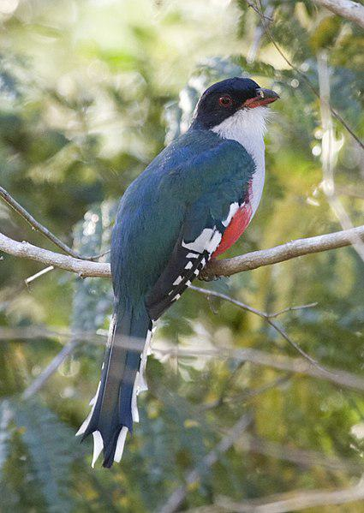

--- Entry for custom_id: d5de26ce0dba11ecb1e81171463288e9 ---

Example Question - What is the difference in how Jim Henson's Rowlf the dog and Gromit the dog in Wallace & Gromit were created?

Example Answer - Rowlf is a puppet and Gromit is made of clay.

Image Source 1 -



Generated Question - How do the creation methods of Jim Henson's Muppets and Wallace & Gromit's characters differ in terms of animation style?

Generated Answer - Muppets are puppets performed live, while Wallace & Gromit are stop-motion clay-animated characters.

--- Entry for custom_id: d5c8e0b60dba11ecb1e81171463288e9 ---

Image Source 1 -

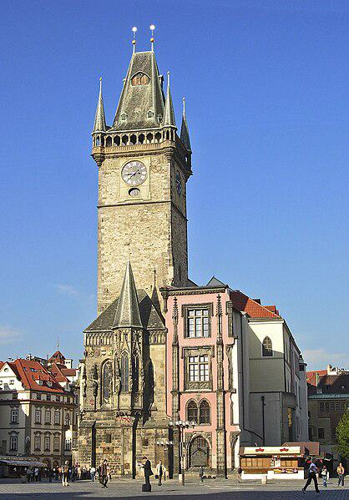

Caption for image source 1: Prag Altstaedter Ring rathaus Town Hall, Old Town Square, Prague, Czech Republic.

Image Source 2 -

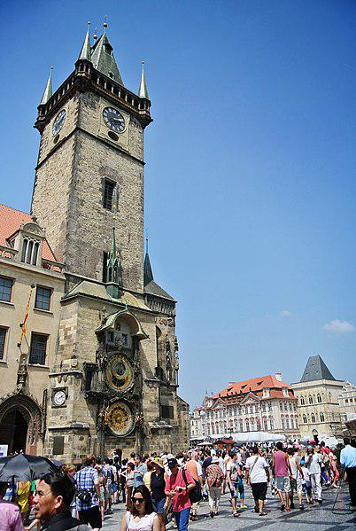

Caption for image source 2: Old Town, 110 00 Prague-Prague 1, Czech Republic - panoramio (113).

Example Question - "How many spires are on each corner of the Town Hall tower, Old Town Square, Prague?"

Example Answer - "Each corner of the Town Hall Tower in Old Town Square, Prague, has one spire."

Additional Text Source 1 - Proponents, led again by Dr John Deakin Heaton, wrote about the Continental associations of a grand and impressive town hall. He hoped that visitors would come to Leeds to see the Town Hall, and that a tower, at a few additional thousand pounds, would provide the building with beauty beyond "mere utilitarianism". (from: Leeds Town Hall)

Generated Question - Do the towers of the Prague Town Hall and Leeds Town Hall both aim to add beauty beyond utilitarian function?

Generated Answer - Yes, both towers are designed to add beauty beyond mere utilitarianism.

--- Entry for custom_id: d5d1aa480dba11ecb1e81171463288e9 ---

Example Question - Did Jason Worilds and Robin Cole attend the same high school?

Example Answer - no

Image Source 1 -



--- Entry for custom_id: d5c71a880dba11ecb1e81171463288e9 ---

Image Source 1 -

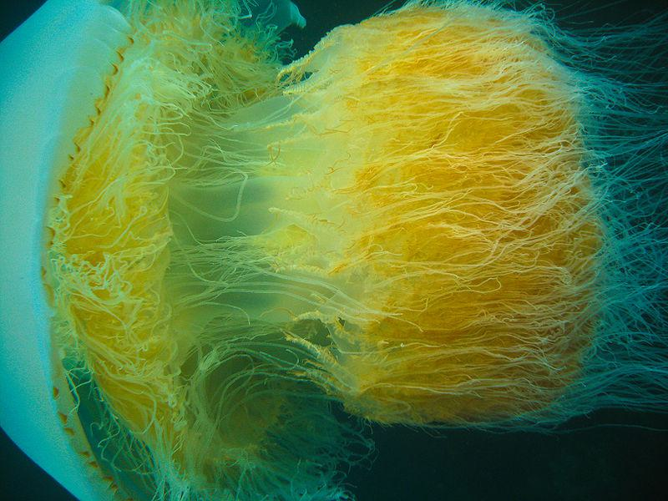

Caption for image source 1: Nomura jellyfish 2009 Korea a Nomura's jellyfish in Little Munsom island, Jeju-do, South Korea. This one got a bit cropped as I was dodging the stinging tentacles, so I'm not 100% happy with it. But I like the detail so decided it was worth uploading..

Image Source 2 -

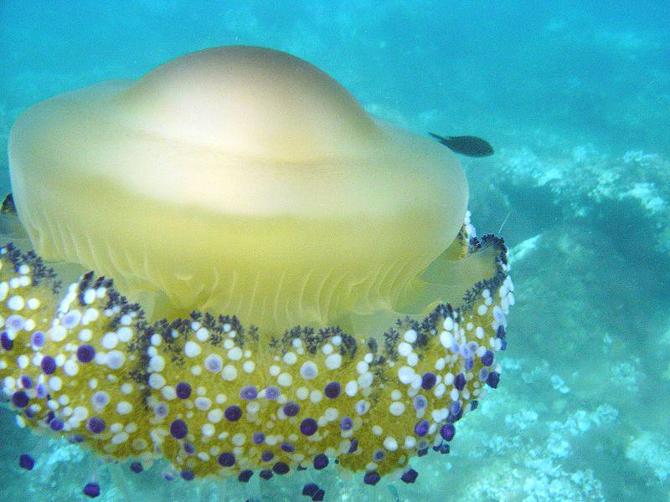

Caption for image source 2: Addaura 066 Cotylorhiza tuberculata.

Example Question - "What color is present on the bodies of both the Cotylorhiza Tuberculata jellyfish species and Nomura's Jellyfish?"

Example Answer - "Yellow is present the bodies of both jellyfish."

Additional Text Source 1 - Rhopilema esculentum and Rhopilema hispidum are edible jellyfish, and are the most common ones consumed in China, Japan and Korea. Additional edible jellyfish species include Aurelia aurita, Crambionella orsini, Chrysaora pacifica, Lobonema smithii, Lobonemoides gracilis and Nomura's jellyfish (Stomolophus nomuria). (from: Jellyfish as food)

Generated Question - Are Nomura's jellyfish and Cotylorhiza tuberculata both considered edible jellyfish species in East Asia?

Generated Answer - Only Nomura's jellyfish is considered edible in East Asia, not Cotylorhiza tuberculata.

--- Entry for custom_id: d5da13fe0dba11ecb1e81171463288e9 ---

Example Question - Is the Turpin Site north or south of the Crow Canyon Archaeological District?

Example Answer - It is north of it.

Image Source 1 -

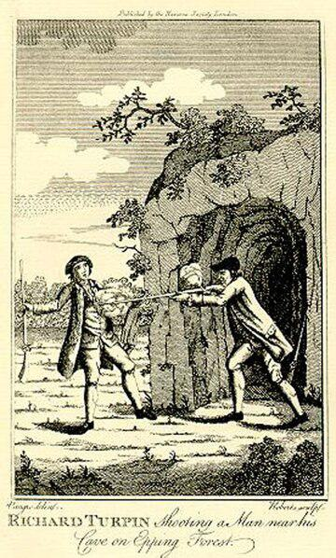

Generated Question - Is the Turpin Site related to the person depicted in the eighteenth-century image of Turpin shooting a man near his cave?

Generated Answer - No, the Turpin Site is an archaeological site in Ohio unrelated to the eighteenth-century Turpin.

--- Entry for custom_id: d5d9a28e0dba11ecb1e81171463288e9 ---

Example Question - What religion has early literature like the first four Pali Nikayas and had scriptures that were translated into Chinese?

Example Answer - Buddhism.

Image Source 1 -

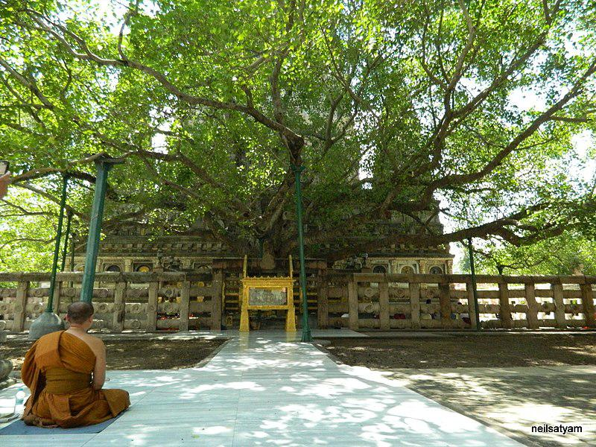

Generated Question - Which religion's early texts include the Pali Nikayas and encourage pilgrimage to Bodh Gaya where enlightenment was attained?

Generated Answer - Buddhism.

--- Entry for custom_id: d5bbd5b00dba11ecb1e81171463288e9 ---

Image Source 1 -

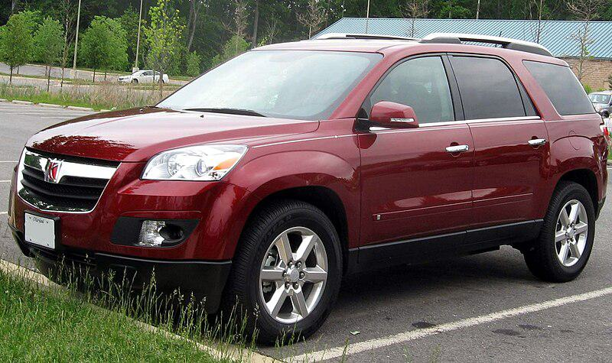

Caption for image source 1: 07-Saturn-Outlook-XR.

Example Question - "How many roof rails does a Saturn Outlook have?"

Example Answer - "The Saturn Outlook has 2 roof rails."

Additional Text Source 1 - In the UK, the Cossack model featured large body decals, roof rails, running boards, 15-in alloy wheels, and on some versions, a sunroof, steel bullbars, spotlights, a rear-mounted spare tyre, and semibucket seats. Other markets' importers made similar upgrades and many were also called Cossack. (from: Lada Niva)

Generated Question - Does the Saturn Outlook shown have the same number of roof rails as the Cossack model described in the additional text?

Generated Answer - No, the Saturn Outlook has 2 roof rails, while the Cossack model has roof rails but the exact number is not specified.

--- Entry for custom_id: d5dda4920dba11ecb1e81171463288e9 ---

Example Question - The term that is commonly applied to several unrelated fish, including the emerald notothen, is also used as an alternate name of which family of fish?

Example Answer - The thornyhead family (Sebastidae)

Image Source 1 -



Generated Question - How does the commercial importance of the emerald rockcod compare to the conservation status of the whale shark?

Generated Answer - The emerald rockcod is commercially important, while the whale shark is classified as vulnerable.

--- Entry for custom_id: d5cf108a0dba11ecb1e81171463288e9 ---

Image Source 1 -



Caption for image source 1: (Zephyranthes candida) White Ginger Lily at Marikavalasa (Zephyranthes candida) White Ginger Lily at Marikavalasa, Visakhapatnam.

Image Source 2 -



Caption for image source 2: Saguaro flower.

Example Question - "Which flower is more ruffled, less flat; Saguaro flower or Zephyranthes candida?"

Example Answer - "The saguaro flower is more ruffled and less flat."

Additional Text Source 1 - The generic name Zephyranthes literally means "flowers of the west wind", from Greek ζέφυρος (zéphuros, an Anemoi) and ἄνθος (anthos, 'flower'). Zephyrus, the Greek personification of the west wind, is also associated with rainfall. (from: Zephyranthes rosea)

Generated Question - Considering the meaning of Zephyranthes as "flowers of the west wind," which flower appears more influenced by wind in its shape, Zephyranthes candida or the Saguaro flower?

Generated Answer - The Zephyranthes candida appears more flat and less ruffled, suggesting less wind influence than the more ruffled Saguaro flower.

--- Entry for custom_id: d5d779320dba11ecb1e81171463288e9 ---

Example Question - Murom and Yekaterinburg are both what?

Example Answer - Cities.

Image Source 1 -

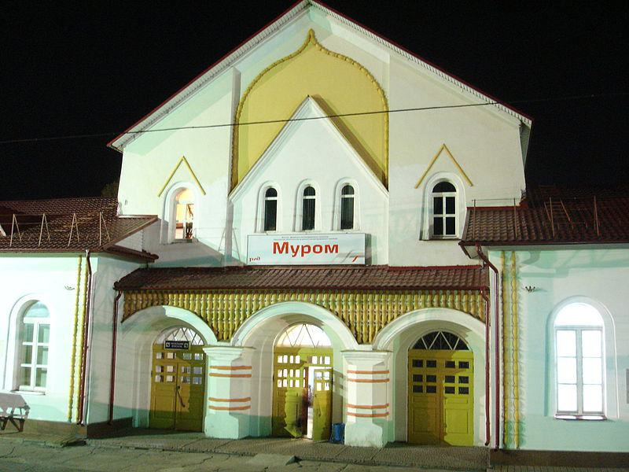

Generated Question - Are Murom and Novosibirsk both cities mentioned in the sources, and do they belong to the same historical or regional context?

Generated Answer - No, Murom is an ancient city of Kievan Rus', while Novosibirsk is a modern Siberian city.

--- Entry for custom_id: d5bea24a0dba11ecb1e81171463288e9 ---

Image Source 1 -

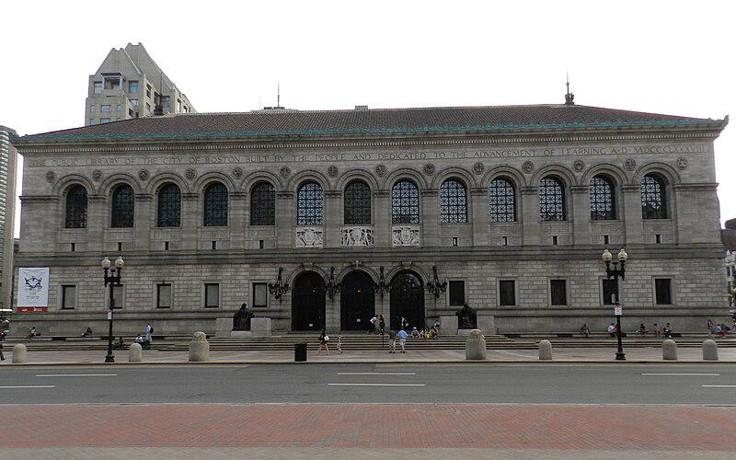

Caption for image source 1: Boston Library Boston Public Library, Copley Square.

Image Source 2 -

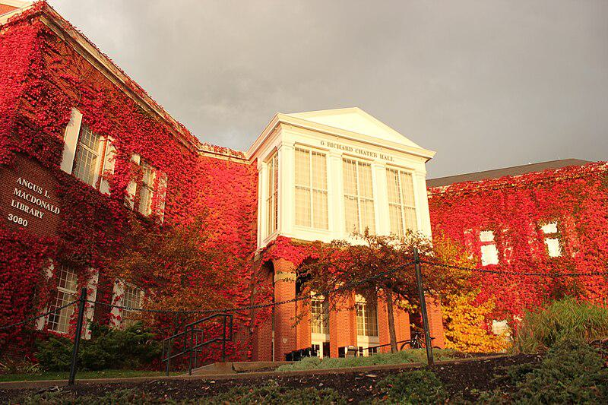

Caption for image source 2: StFX Library Angus L. MacDonald Library, St. Francis Xavier University..

Example Question - "Do both the Angus L. MacDonald Library at St. Francis Xavier University and the Boston Library have ivy growing on the front of them?"

Example Answer - "No, the Angus L. MacDonald Library at St. Francis Xavier University has ivy on it but the Boston Library does not."

Additional Text Source 1 - Four women were awarded university degrees in 1897.A metal plaque in the St. Francis Xavier University Chapel is dedicated to the thirty-three members of the college, now St. Francis Xavier University, who were killed in service during the First World War (1914–18).In February 1922, St. Francis Xavier University's War Memorial Rink, with a brick exterior and wooden interior, opened. (from: St. Francis Xavier University)

Generated Question - Considering the architectural styles and historical elements, which library likely has a more classical design, Boston Public Library or Angus L. MacDonald Library?

Generated Answer - Boston Public Library likely has a more classical design with its stone facade and arches.

--- Entry for custom_id: d5c4be6e0dba11ecb1e81171463288e9 ---

Image Source 1 -

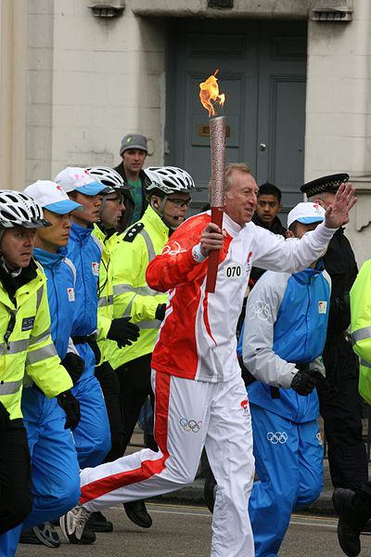

Caption for image source 1: 2008 Olympic Torch Relay, London AB2.

Example Question - "How many different colors was the 2008 Olympic torch?"

Example Answer - "The 2008 Olympic torch was two different colors."

Additional Text Source 1 - The design of the 2008 Olympic Torch was based on traditional scrolls and used a traditional Chinese design known as the "Propitious Clouds" (祥云). The torch was designed to remain lit in 65 km/h (40 mph) winds, and in rain of up to 50 mm (2 in) per hour. (from: 2008 Summer Olympics)

Generated Question - Did the 2008 Olympic torch design incorporate traditional Chinese elements and was it made to withstand strong wind and rain?

Generated Answer - Yes, it featured traditional Chinese "Propitious Clouds" and was made to stay lit in strong wind and rain.

--- Entry for custom_id: d5d1255a0dba11ecb1e81171463288e9 ---

Example Question - Harghita and The Colombian Massif are both what?

Example Answer - Mountain ranges

Image Source 1 -

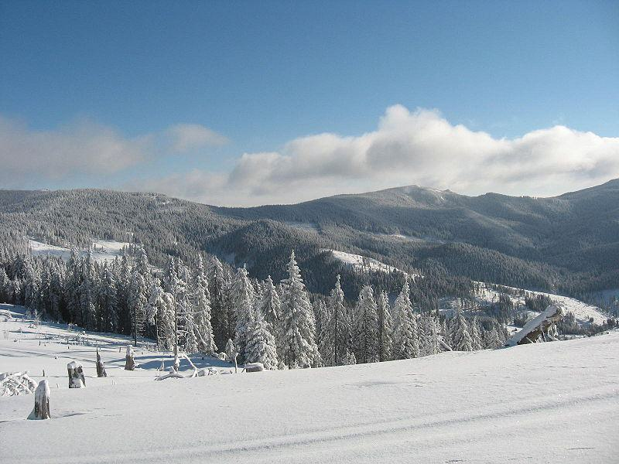

--- Entry for custom_id: d5ce11ee0dba11ecb1e81171463288e9 ---

Image Source 1 -



Caption for image source 1: Renoir - Country Lane, between 19th and early 20th century Country Lane.

Image Source 2 -

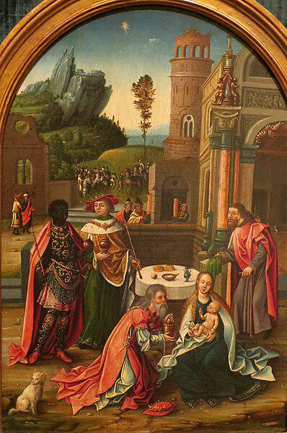

Caption for image source 2: 'Adoration of the Magi', Flemish school oil on wood painting, Antwerp, early 16th century Adoration of the Magi.

Example Question - "Between the works "Adoration of the Magi" and "Country Lane" which work is more clear in what it is expressing visually?"

Example Answer - ""Adoration of the Magi" is more clear in what it is expressing visually."

Additional Text Source 1 - National Geographic's coverage of the painting, after the restoration, offers this commentary:"Leonardo's Adoration of the Magi divulges brushstrokes, colors, and images long hidden under dirt and darkened varnish. The unfinished painting, commissioned in 1481, also shows evidence of the artist’s thought process, including modifications he made as he worked". (from: Adoration of the Magi (Leonardo))

Generated Question - Considering the clarity and visible details, how does the restored "Adoration of the Magi" compare to Renoir's "Country Lane"?

Generated Answer - The restored "Adoration of the Magi" reveals clearer details and artistic intent than Renoir's "Country Lane."

--- Entry for custom_id: d5cae1860dba11ecb1e81171463288e9 ---

Image Source 1 -

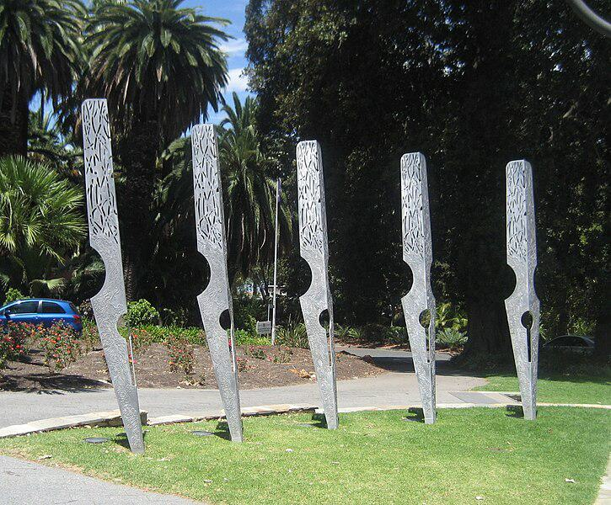

Caption for image source 1: Public art - Pen Nibs, Stirling Gardens, Perth.

Image Source 2 -

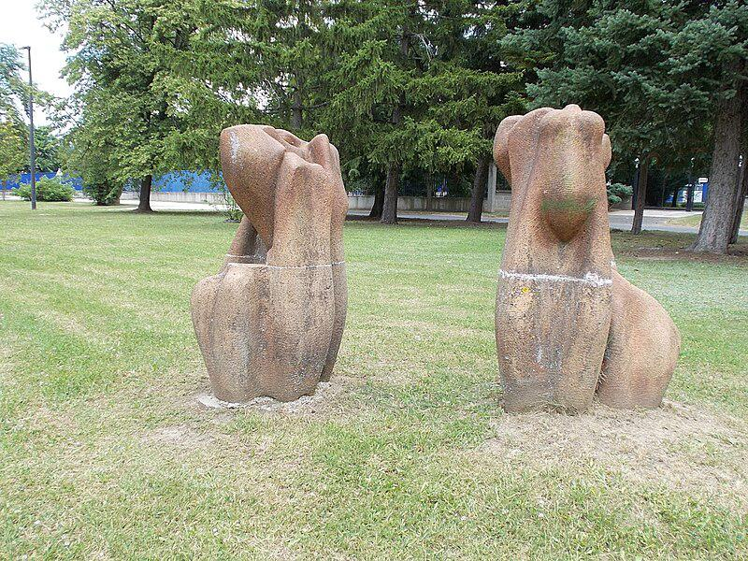

Caption for image source 2: Modern sculptures, Kálmán Imre Square, 2020 Nyergesújfalu Park, modern sculptures (circa 2nd half of the 20th century) - Kalman Imre Square, Nyergesujfalu, Komarom-Esztergom County, Hungary.

Example Question - "Which art display is made up of taller and more narrow items; Public art -Pen Nibs or Modern sculptures, Kálmán Imre Square?"

Example Answer - "The Public art- Pen Nibs is made up of taller and more narrow item."

Additional Text Source 1 - These more closely emulate the ballpoint pens most modern writers are experienced with. Despite being rigid and firm, the idea that steel nibs write "horribly" is a misconception. (from: Fountain pen)

Generated Question - Considering the shapes and materials, which art display better represents traditional writing tools, the Pen Nibs in Perth or the Modern sculptures in Kálmán Imre Square?

Generated Answer - The Pen Nibs in Perth better represent traditional writing tools as they resemble steel pen nibs.

--- Entry for custom_id: d5c1dc1c0dba11ecb1e81171463288e9 ---

Image Source 1 -

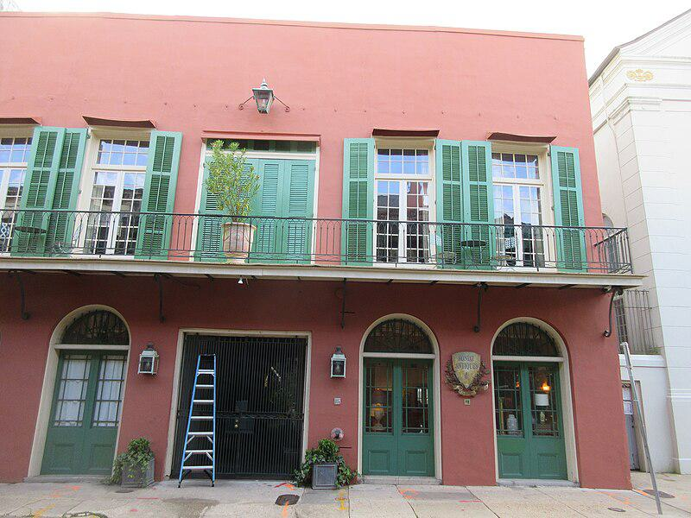

Caption for image source 1: Lower Chartres Street, French Quarter, New Orleans 8th April 2019 22 Chartres Street, French Quarter, New Orleans.

Image Source 2 -

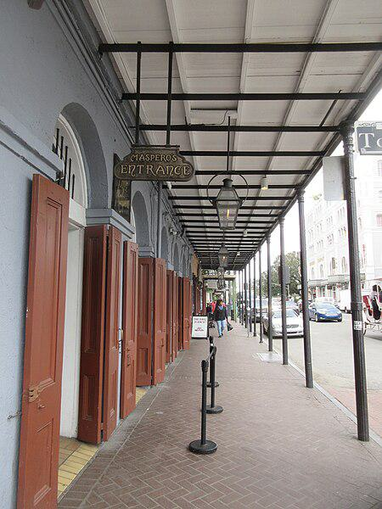

Caption for image source 2: Decatur Street, French Quarter, New Orleans 25th Feb 2019 53 Decatur Street, French Quarter, New Orleans.

Example Question - "What is seen in front of the arched windows at Maspero's and Soniat Antiques in the French Quarter?"

Example Answer - "Iron bars are present in front of the arched windows at Maspero's and Soniat Antiques in the French Quarter."

Additional Text Source 1 - In November 1880 Maspero went to Egypt as head of an archeological mission sent there by the French government, which ultimately developed into the well-equipped Institut français d'archéologie orientale. (from: Gaston Maspero)

Generated Question - Are the entrances at 22 Chartres Street and Maspero's in the French Quarter both protected by iron bars or gates?

Generated Answer - Only 22 Chartres Street has iron bars at the entrance; Maspero's entrance does not.

--- Entry for custom_id: d5caf28e0dba11ecb1e81171463288e9 ---

Image Source 1 -

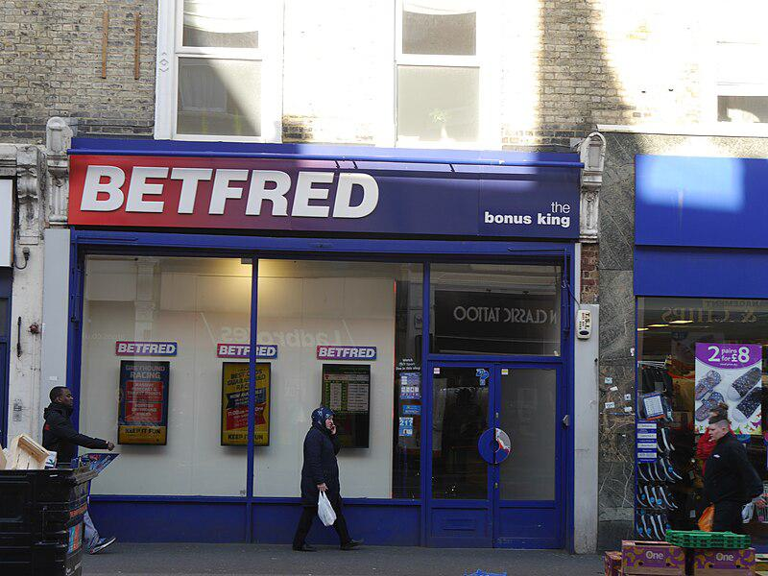

Caption for image source 1: Betfred, North End Road, Fulham, London 03 North End Road, Fulham, London.

Example Question - "Is the Betfred, North End Road, Fulham, London sign two distinct, separate colors or is there a gradient?"

Example Answer - "The sign is colored in a gradient."

Additional Text Source 1 - This encouraged the southern stretch of North End Road to become Fulham's unofficial "High street", almost a mile from the actual Fulham High Street, with its own department store, F.H. Barbers, along with Woolworth's, Marks & Spencer and Sainsbury's outlets, all long gone. (from: Fulham)

Generated Question - Is the Betfred shop located on North End Road part of the unofficial "High street" area in Fulham mentioned in the text?

Generated Answer - Yes, Betfred is located on North End Road, part of Fulham's unofficial "High street."

--- Entry for custom_id: d5dbad180dba11ecb1e81171463288e9 ---

Example Question - What is a reactive oxygen species and also a free radical that exhibits paramagnetism?

Example Answer - Superoxide anion

Image Source 1 -

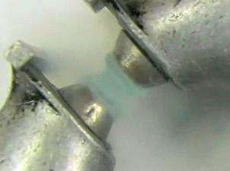

Generated Question - How does the paramagnetism of superoxide anion and liquid oxygen relate to their chemical behavior?

Generated Answer - Both exhibit paramagnetism due to unpaired electrons, influencing superoxide's reactivity and liquid oxygen's magnetic suspension.

--- Entry for custom_id: d5c31e600dba11ecb1e81171463288e9 ---

Image Source 1 -

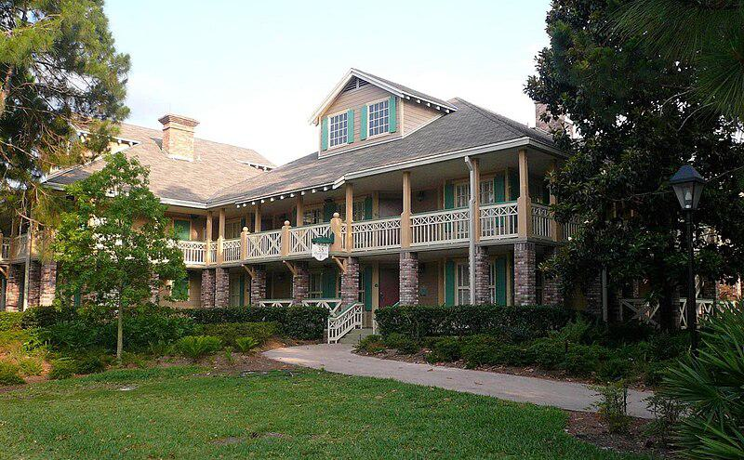

Caption for image source 1: Disney World - Port Orleans Riverside - by mrkathika - cropped Walt Disney World Port Orleans Hotel Riverside Hotel Room Complex.

Image Source 2 -

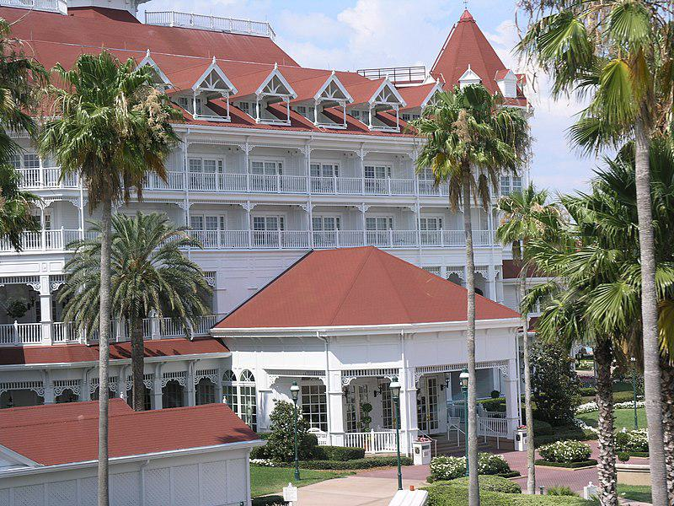

Caption for image source 2: Grand Floridian, Disney World - panoramio.

Example Question - "Do the Disney World Grand Floridian and the Disney World Riverside hotel room complex share the same exterior colors?"

Example Answer - "No, the Disney World Grand Floridian and the Disney World Riverside are not the same exterior color."

Additional Text Source 1 - At the start of The Magical World of Disney, former Disney CEO Michael Eisner talks about the special while enjoying tea with Fozzie Bear and his mother Emily at the Grand Floridian hotel. After Fozzie gets butter on Eisner’s sleeve, Gonzo turns up with a group of monsters and Frackles to take care of the mess. (from: The Muppets at Walt Disney World)

Generated Question - Are the Disney World Grand Floridian and Riverside hotels featured in the same Disney special involving Michael Eisner and Muppets?

Generated Answer - No, only the Grand Floridian is featured in the Disney special with Michael Eisner and the Muppets.

--- Entry for custom_id: d5c376e40dba11ecb1e81171463288e9 ---

Image Source 1 -

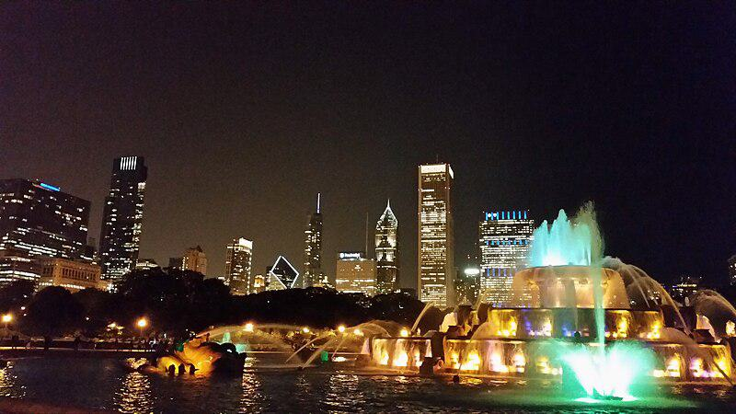

Caption for image source 1: Buckingham Fountain (14670643318).

Example Question - "Is the Aon Center visible when sitting at Buckingham Fountain?"

Example Answer - "The Aon Center is visible when sitting at Buckingham Fountain."

Additional Text Source 1 - Looking north from the fountain, viewers see some of the tallest buildings in the United States (Aon Center, Two Prudential Plaza, and One Prudential Plaza). (from: Crown Fountain)

Generated Question - Can you see the Two Prudential Plaza from Buckingham Fountain at night?

Generated Answer - Yes, the Two Prudential Plaza is visible from Buckingham Fountain at night.

--- Entry for custom_id: d5d758800dba11ecb1e81171463288e9 ---

Example Question - Norfolk is a rural type of area named by a term that is historically equivalent to what?

Example Answer - Shire

Image Source 1 -

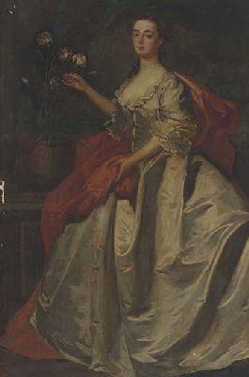

Generated Question - Is the rural county of Norfolk named after a person with a noble title shown in the image?

Generated Answer - Yes, Norfolk is named after Mary, Duchess of Norfolk.

--- Entry for custom_id: d5c2a6740dba11ecb1e81171463288e9 ---

Image Source 1 -

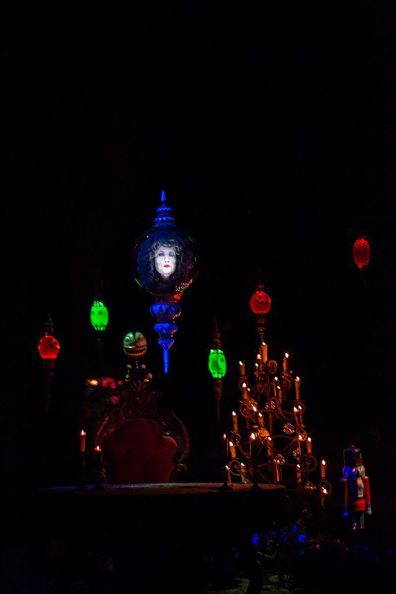

Caption for image source 1: Haunted Mansion Holiday (28279097855).

Image Source 2 -

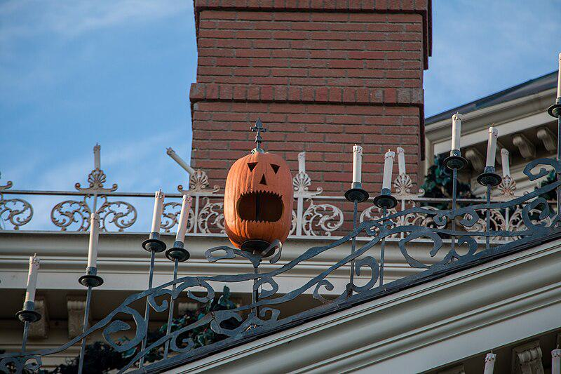

Caption for image source 2: Haunted Mansion Holiday (34399894066).

Example Question - "What type of decorative object is used to decorate both the interior and the exterior of the Haunted Mansion Holiday exhibit at Disneyland?"

Example Answer - "A candle is used to decorate both the interior and the exterior of the Haunted Mansion Holiday exhibit at Disneyland."

Additional Text Source 1 - In addition, The Hatbox Ghost was the official "spooksperson" for Disneyland Resort's 2009 O-pin House pin trading event and Haunted Holidays celebration. In July 2010, director Guillermo del Toro, participating in a panel discussion at Comic-Con, announced his involvement as cowriter and producer in a new film based on The Haunted Mansion attraction. (from: Hatbox Ghost)

Generated Question - Are candles and Halloween-themed decorations both used inside and outside the Haunted Mansion Holiday exhibit at Disneyland?

Generated Answer - Yes, candles and Halloween-themed decorations are used both inside and outside the exhibit.

--- Entry for custom_id: d5d9bf760dba11ecb1e81171463288e9 ---

Example Question - Where are the items that are used to create sets of melodies played at intervals upon a set of bells to mark the passage of time most commonly located?

Example Answer - The items that are used to play these sets are most commonly located in bell towers or grandfather clocks.

Image Source 1 -

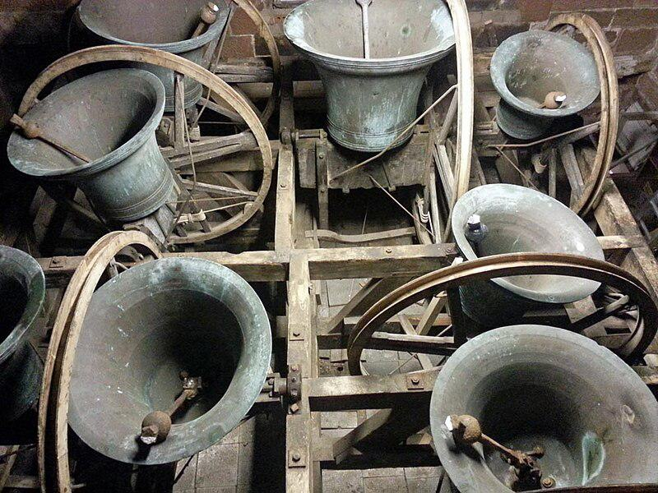

Generated Question - Are the bells shown in the image likely part of a clock chime set commonly found in bell towers?

Generated Answer - Yes, the bells in the image are likely part of a clock chime set commonly found in bell towers.

--- Entry for custom_id: d5c560b20dba11ecb1e81171463288e9 ---

Image Source 1 -

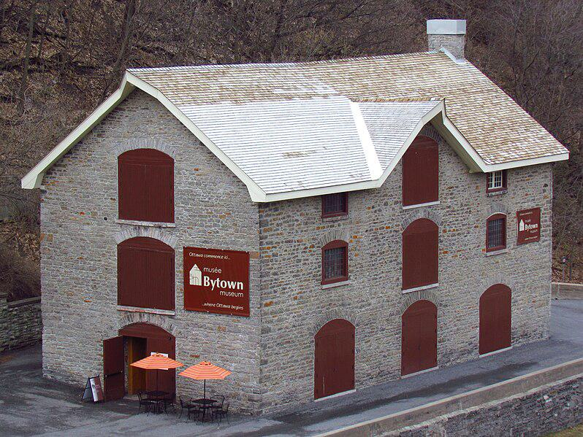

Caption for image source 1: Bytown Museum, 2011 Bytown Museum, Ottawa, Ontario, Canada.

Example Question - "Does the roof of the Bytown Museum in Ontario, Canada have a chimney on one end or both ends?"

Example Answer - "The Bytown Museum's roof in Ontario has a chimney on one end."

Additional Text Source 1 - CBC Radio One has stations in Sudbury (CBCS), with rebroadcasters throughout Northeastern Ontario, and in Thunder Bay (CBQT), with rebroadcasters in the Northwest. The French Ici Radio-Canada Première has a station in Sudbury (CBON), with rebroadcasters throughout Northern Ontario. (from: Northern Ontario)

Generated Question - Is the Bytown Museum located in the same region where CBC Radio One and Ici Radio-Canada Première have stations?

Generated Answer - No, the Bytown Museum is in Ontario, but CBC stations are in Northern and Northeastern Ontario, not Ottawa.

--- Entry for custom_id: d5c580ec0dba11ecb1e81171463288e9 ---

Image Source 1 -

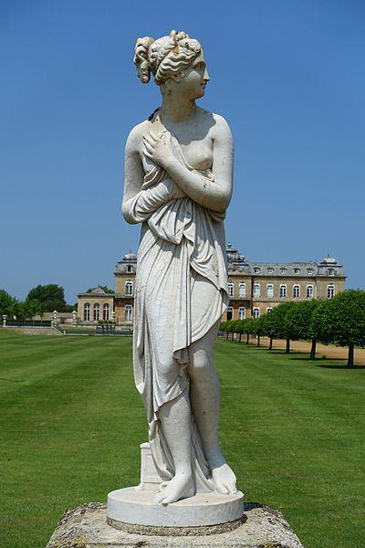

Caption for image source 1: Venus Italica by Antonio Canova (copy), early to mid 1800s, marble - Wrest Park - Bedfordshire, England - DSC08290 Statue in Wrest Park - Bedfordshire, England..

Image Source 2 -

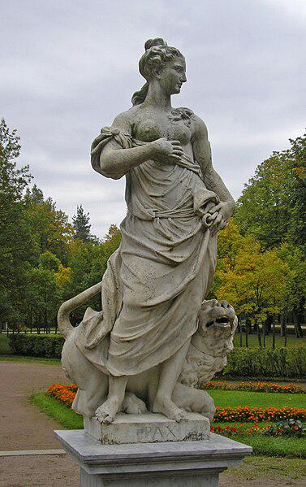

Caption for image source 2: Statue of the goddess Pax (Pavlovsk Garden, St Petersburg, Russia) Statue of Pax in Pavlovsk Garden. St Petersburg, Russia. Sculptor: Pietro Baratta. Miha Ulanov.

Example Question - "Do both the women portrayed in the works "Statue of the goddess Pax" and "Venus Italica" have both breasts exposed?"

Example Answer - "No, Venus Italica only has one breast exposed."

Additional Text Source 1 - She saw a way to express her empathy for these refugees in terms of the statue. The resulting sonnet, "The New Colossus", including the lines: "Give me your tired, your poor/Your huddled masses yearning to breathe free", is uniquely identified with the Statue of Liberty in American culture and is inscribed on a plaque in its museum. (from: Statue of Liberty)

Generated Question - Considering the empathy expressed in the Statue of Liberty's sonnet, which statue, Venus Italica or Pax, more likely symbolizes peace and refuge?

Generated Answer - The statue of Pax more likely symbolizes peace and refuge.

--- Entry for custom_id: d5d6d23e0dba11ecb1e81171463288e9 ---

Example Question - The neighborhood in Brooklyn is bounded by Prospect Park to the north was originally chartered as a Dutch colony town of what name?

Example Answer - Flatbush was originally chartered as the Dutch Nieuw Nederland colony town of Midwout.

Image Source 1 -

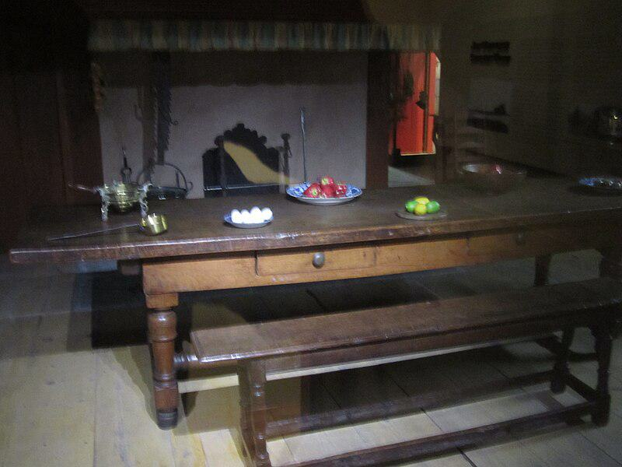

Generated Question - What Dutch colony town, now part of Brooklyn, would have had dining tables like the one shown from 1664?

Generated Answer - The Dutch colony town of Midwout, now Flatbush in Brooklyn, would have had such dining tables.

--- Entry for custom_id: d5daadb40dba11ecb1e81171463288e9 ---

Example Question - In inorganic nomenclature, the what, defined as is the loss of electrons or an increase in the oxidation state of an atom, state is represented by a Roman numeral placed after the element name inside the parenthesis or as a superscript after the element symbol?

Example Answer - Oxidation

Image Source 1 -



Generated Question - How is the oxidation state represented in inorganic nomenclature, similar to how Roman numerals are used on the clock face shown?

Generated Answer - The oxidation state is shown by Roman numerals after the element name or as a superscript.

--- Entry for custom_id: d5c7438c0dba11ecb1e81171463288e9 ---

Image Source 1 -

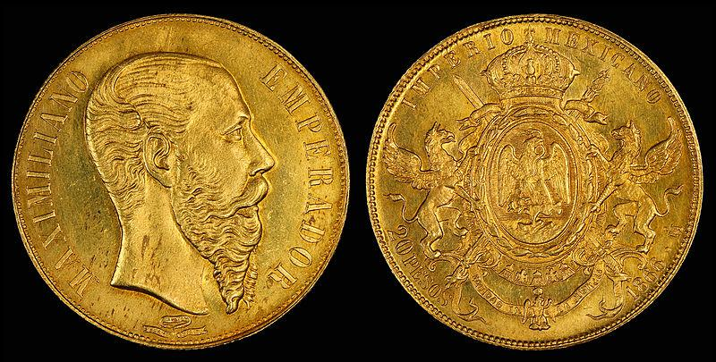

Caption for image source 1: Mexico 1866 20 Pesos Mexico 20 gold pesos (1866), depicting Maximilian I of Mexico.

Image Source 2 -

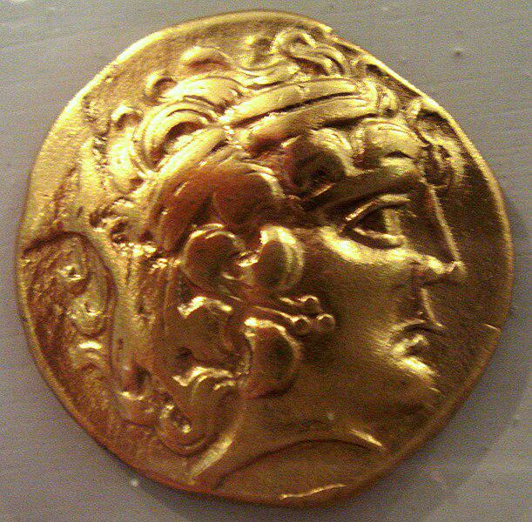

Caption for image source 2: Cenomani gold coin 5 to 1st century BCE French Gaul Cenomani gold coin 5 to 1st century BCE French Gaul.

Example Question - "Who has longer hair on their head, the head on the Cenomani gold coin to the head on the 1866 Mexican 20 gold peso?"

Example Answer - "The head on the Cenomani has longer hair."

Additional Text Source 1 - A limited-edition twenty-peso coin was struck, during 1866 only, comprising 87.5 percent gold and also featuring Maximilian on one side and the coat of arms on the other. The New Mexican republic continued to strike the 8 reales piece, but also began minting coins denominated in centavos and pesos. (from: Mexican peso)

Generated Question - Which coin features a crowned coat of arms, the 1866 Mexican 20 gold peso or the Cenomani gold coin?

Generated Answer - The 1866 Mexican 20 gold peso features a crowned coat of arms.

--- Entry for custom_id: d5cc138a0dba11ecb1e81171463288e9 ---

Image Source 1 -

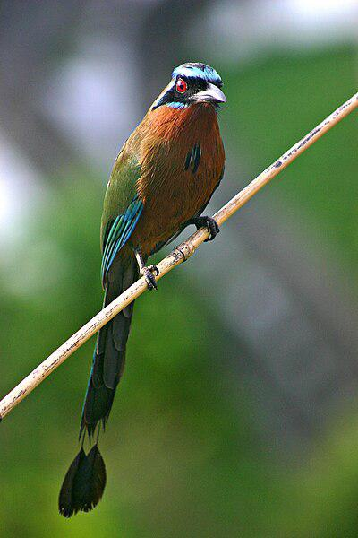

Caption for image source 1: Blue-crowned Motmot front 2.

Example Question - "Does the Blue-crowned Motmot have long or short back feathers?"

Example Answer - "The Blue-crowned Motmot has long back feathers."

Additional Text Source 1 - This species and the Lesson's Motmot, Whooping Motmot, Trinidad Motmot, Amazonian Motmot, and Andean Motmot were all considered conspecific. The IUCN uses blue-crowned as their identifier for this species, however it was also the name used for the prior species complex. (from: Blue-capped motmot)

Generated Question - Are the Blue-crowned Motmot and Lesson's Motmot considered the same species or different species according to the IUCN?

Generated Answer - They were once considered the same species but are now recognized as different species by the IUCN.

--- Entry for custom_id: d5d981be0dba11ecb1e81171463288e9 ---

Example Question - In the series based on The Southern Vampire Mysteries, what character along with Lafayette try to convince Tara to become a vampire in season 5?

Example Answer - Sookie.

Image Source 1 -

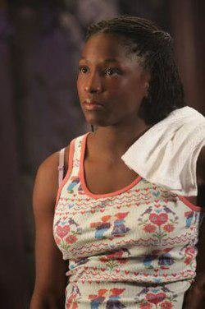

Generated Question - In the series based on The Southern Vampire Mysteries, who convinces Pam to turn Tara into a vampire despite Tara's hatred for vampires?

Generated Answer - Sookie and Lafayette.

--- Entry for custom_id: d5de06260dba11ecb1e81171463288e9 ---

Example Question - The Pont des Arts or Passerelle des Arts is a pedestrian bridge in Paris which links the central square of the Palais du Louvre and what French learned society, grouping five académies?

Example Answer - It links to the Institut de France.

Image Source 1 -

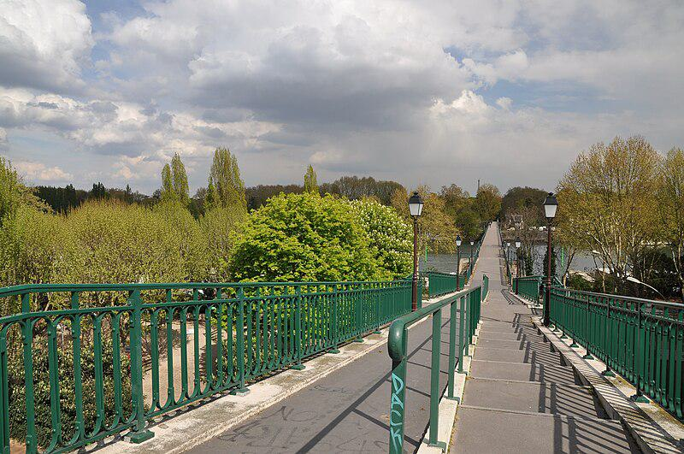

Generated Question - Which pedestrian bridge links the Institut de France and the Palais du Louvre, and which bridge marks Paris's westernmost point crossing the Seine?

Generated Answer - The Pont des Arts links the Institut de France and Palais du Louvre; the Passerelle de l'Avre is Paris's westernmost bridge.

--- Entry for custom_id: d5d4456e0dba11ecb1e81171463288e9 ---

Example Question - Who voices Pearl in the show which was nominated for a Primetime Emmy Award for Short-format Animation and was adapted as a best-selling children's book?

Example Answer - Magno-Hall

Image Source 1 -



--- Entry for custom_id: d5c97cec0dba11ecb1e81171463288e9 ---

Image Source 1 -

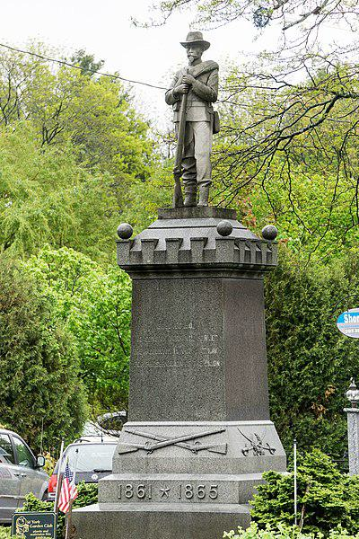

Caption for image source 1: Civil War Monument in York, Maine Granite Civil War monument in York, Maine. The base is enscribed with the following: ERECTED/1906/TO SONS OF YORK WHO SERVED/THEIR COUNTRY IN ARMY AND NAVY/FOR PRESERVATION OF THE UNION/1861-1865.

Image Source 2 -

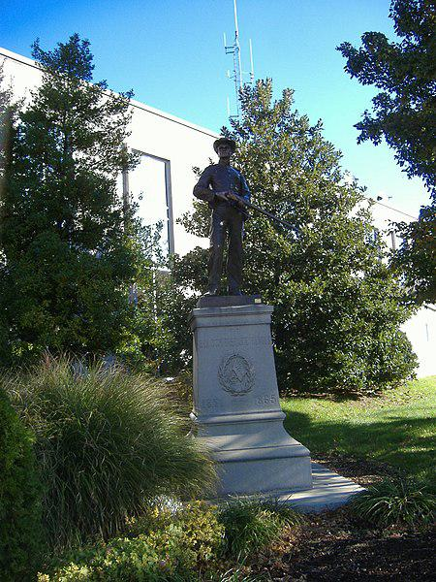

Caption for image source 2: Confederate Monument in Owensboro 2 Confederate Monument in Owensboro in Owensboro, Kentucky, sculpted by George Julian Zolnay and unveiled in 1900..

Example Question - "What is the head of the statues at the Civil War monument in Maine and the Confederate Monument in Kentucky covered with?"

Example Answer - "There are hats on the head of the statues at the Civil War monument in Maine and the Confederate Monument in Kentucky."

Additional Text Source 1 - The American Civil War (April 12, 1861 – May 9, 1865, also known by other names) was a civil war in the United States fought between northern and Pacific states ("the Union" or "the North") and southern states that voted to secede and form the Confederate States of America ("the Confederacy" or "the South"). (from: American Civil War)

Generated Question - Do the monuments in Maine and Kentucky commemorate soldiers from opposing sides of the American Civil War?

Generated Answer - Yes, the Maine monument honors Union soldiers, and the Kentucky monument honors Confederate soldiers.

--- Entry for custom_id: d5da12c80dba11ecb1e81171463288e9 ---

Example Question - Corneal abrasion and Cycloplegia both affect what?

Example Answer - The eye.

Image Source 1 -

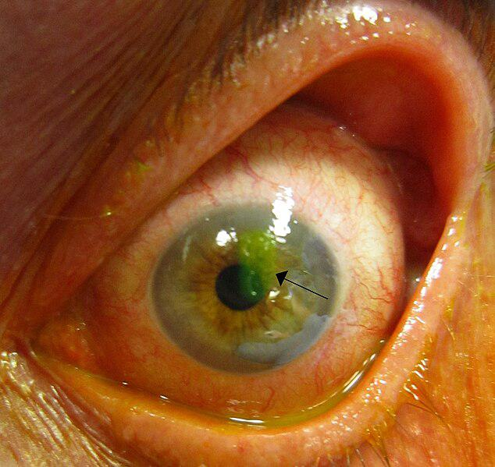

Generated Question - How does the green stain in the eye image relate to the symptoms of corneal abrasion described in the text?

Generated Answer - The green stain highlights the corneal abrasion causing pain, redness, and light sensitivity.

--- Entry for custom_id: d5c8fc360dba11ecb1e81171463288e9 ---

Image Source 1 -



Caption for image source 1: Jesús Manuel Corona, 2012 FIFA Club World Cup (cropped).

Example Question - "What brand of shorts is Jesús Manuel Corona wearing at the 2012 FIFA Club World Cup?"

Example Answer - "Nike is the brand of shorts worn by Jesús Manuel Corona at the 2012 FIFA Club World Cup."

Additional Text Source 1 - As a sponsor, the logo of another of its subsidiaries, Carta Blanca, was on the kits. During Monterrey's participation at the 2012 FIFA Club World Cup, with Carta Blanca as the sole kit sponsor, the name 'Corona' was not displayed, but instead 'Jesús C.' was printed on the kit. (from: Jesús Manuel Corona)

Generated Question - Why was the name "Jesús C." printed on Jesús Manuel Corona's kit instead of "Corona" during the 2012 FIFA Club World Cup?

Generated Answer - Because the kit sponsor was Carta Blanca, so "Corona" was not displayed, only "Jesús C."

--- Entry for custom_id: d5ce55140dba11ecb1e81171463288e9 ---

Image Source 1 -

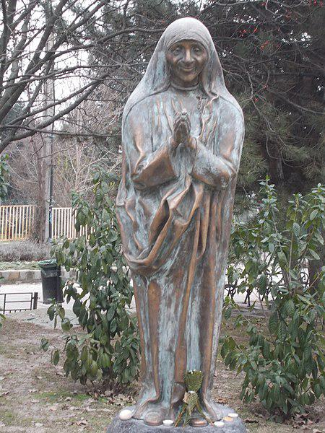

Caption for image source 1: Statue of Mother Teresa by Mihály Gábor, Mártonhegy, Hegyvidék, Budapest : Statue of Mother Teresa (Mihaly Gabor, 2014)..

Example Question - "Are the hands of the Statue of Mother Teresa by Mihály Gábor touching each other?"

Example Answer - "Yes, the hands of the Statue of Mother Teresa by Mihály Gábor are touching each other."

Additional Text Source 1 - After that Mihály Farkas stepped forward from behind the curtain and said: "the game is over". Gábor Péter's wife, Jolán Simon, who served as Rákosi's secretary, was also arrested. (from: Gábor Péter)

Generated Question - Is the statue of Mother Teresa by Mihály Gábor related to the historical figure Gábor Péter mentioned in the additional text?

Generated Answer - No, the statue of Mother Teresa by Mihály Gábor is unrelated to Gábor Péter.

--- Entry for custom_id: d5d2d22e0dba11ecb1e81171463288e9 ---

Example Question - What has the grouting technology offered by Mainmark won?

Example Answer - An award

--- Entry for custom_id: d5d1a3ae0dba11ecb1e81171463288e9 ---

Example Question - What was the Latin name of the state that included Terra Mariana and the Duchy of Estonia?

Example Answer - Civitas Ordinis Theutonici was the Latin name of the State of the Teutonic Order, the state that included Terra Mariana and the Duchy of Estonia.

Image Source 1 -

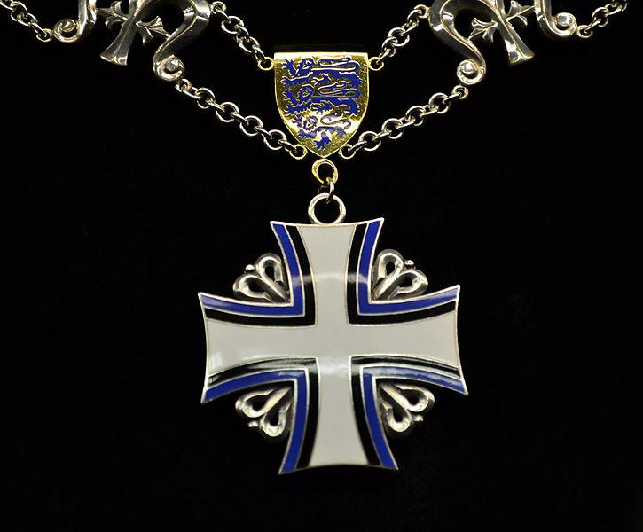

Generated Question - How is the Order of the Cross of Terra Mariana connected to the medieval state that included Terra Mariana and the Duchy of Estonia?

Generated Answer - The Order of the Cross of Terra Mariana is named after Terra Mariana, a region once part of the medieval State of the Teutonic Order.

--- Entry for custom_id: d5d4ffe00dba11ecb1e81171463288e9 ---

Example Question - The ruler of Caria from 377-353 BC is best known what structure that Antipater of Sidon listed as one of the Seven Wonders of the Ancient World?

Example Answer - Mausolus is best known for the Mausoleum at Halicarnassus, erected and named for him by order of his widow.

Image Source 1 -

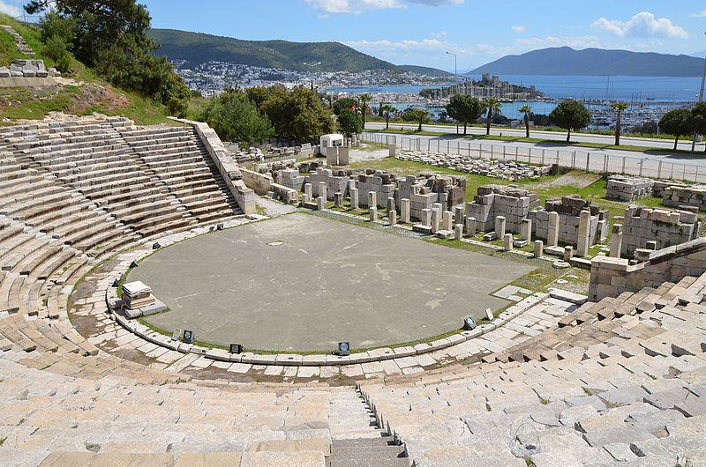

Generated Question - Besides the Mausoleum, what other significant structure did Mausolus build in Halicarnassus during the 4th century BC?

Generated Answer - Mausolus also built the Theatre at Halicarnassus in the 4th century BC.

--- Entry for custom_id: d5d901da0dba11ecb1e81171463288e9 ---

Example Question - Hebius vibakari is what type of snake, which has another variety called tiger?

Example Answer - Keelback

Image Source 1 -

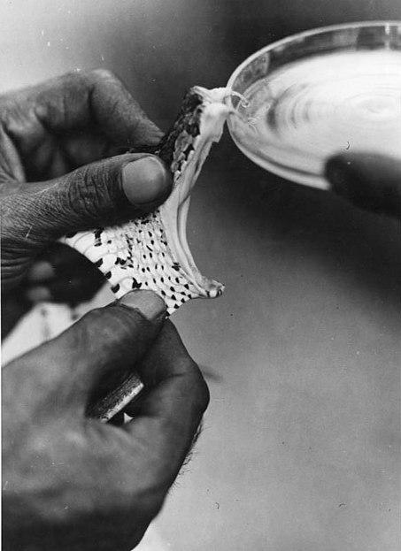

--- Entry for custom_id: d5d5a5300dba11ecb1e81171463288e9 ---

Example Question - The name Giannis which is a variation of John hails from what country's language that contains the fourth of the four canonical gospels?

Example Answer - Greece.

Image Source 1 -

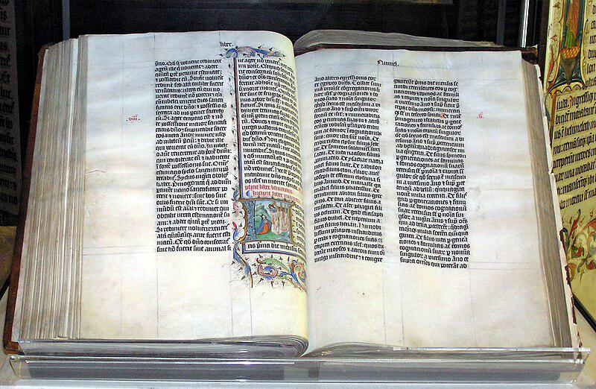

Generated Question - Which language's variant of the name John is connected to the fourth canonical gospel shown in the Christian Bible image?

Generated Answer - Greek.

--- Entry for custom_id: d5c52b380dba11ecb1e81171463288e9 ---

Image Source 1 -

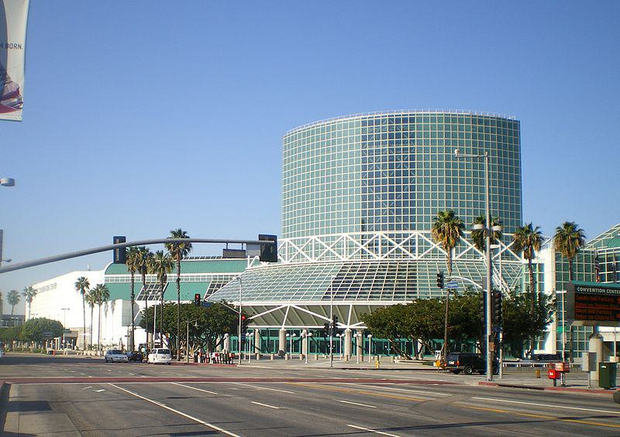

Caption for image source 1: Los Angeles Convention Center The Los Angeles Convention Center in southern Downtown Los Angeles, California. Glass facade seen at Pico & Figueroa..

Image Source 2 -

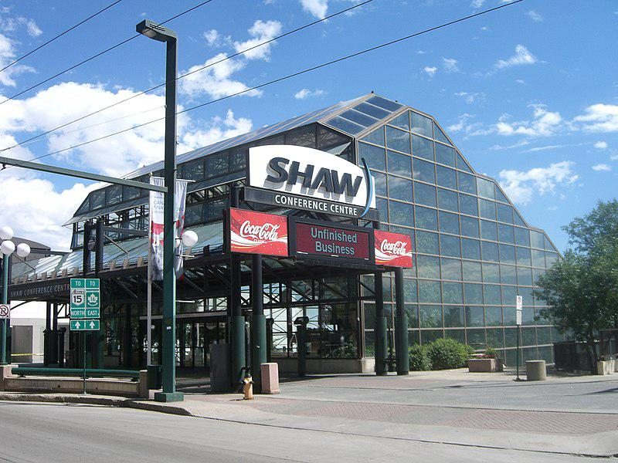

Caption for image source 2: Shaw3997 Photo taken downtown Edmonton, Alberta..

Example Question - "Is the glass facade of the Shaw Convention Center in Edmonton rounder than the glass facade of the Los Angeles Convention Center?"

Example Answer - "No the glass facade of the Shaw Convention Center in Edmonton is not rounded than the glass facade of the Los Angeles Convention Center."

Additional Text Source 1 - WonderCon relocated from Anaheim to Los Angeles in 2016, and is now called WonderCon Los Angeles and was held March 25–27, 2016 at the Los Angeles Convention Center. The 2017 edition of the convention returned to Anaheim and was held March 31 – April 2, 2017.The WonderCon logo was designed by Richard Bruning and Tim Zach. (from: WonderCon)

Generated Question - Has the Los Angeles Convention Center hosted WonderCon events since 2016?

Generated Answer - Yes, WonderCon was held at the Los Angeles Convention Center in 2016.

--- Entry for custom_id: d5cb416c0dba11ecb1e81171463288e9 ---

Image Source 1 -

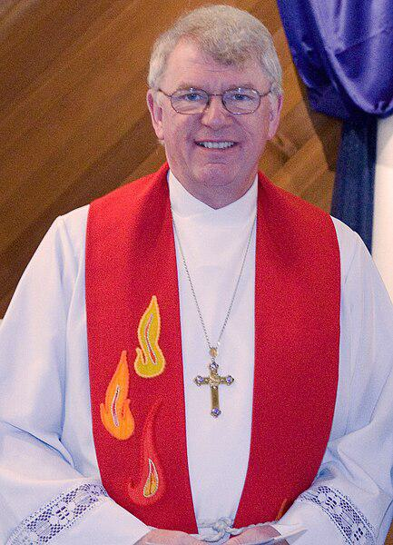

Caption for image source 1: Michael Ingham bishop Michael Ingham in 2009.

Example Question - "What did Michael Ingham have on his Bishop scarf in 2009?"

Example Answer - "Michael Ingham had flames on his Bishop scarf in 2009."

Additional Text Source 1 - And so they cut off a grandma in her international prime by the stocking tops, to borrow one of Denis's phrases, which Mrs Thatcher often used. "In a commentary in the Daily Express in April 2009, Ingham referred to Thatcher as "reckless" and a battler for Britain. (from: Bernard Ingham)

Generated Question - Did Michael Ingham wear his bishop scarf with flames while commenting on Mrs. Thatcher in 2009?

Generated Answer - Yes, Michael Ingham wore his bishop scarf with flames in 2009 when commenting on Mrs. Thatcher.

--- Entry for custom_id: d5ca18140dba11ecb1e81171463288e9 ---

Image Source 1 -

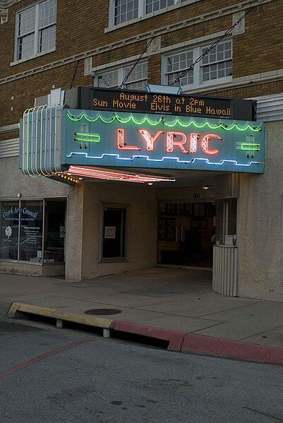

Caption for image source 1: Historic Lyric Theatre Harrison, Arkansas Historic Lyric Theatre in downtown Harrison, Arkansas. Hosts plays, concerts and the occasional film..

Image Source 2 -

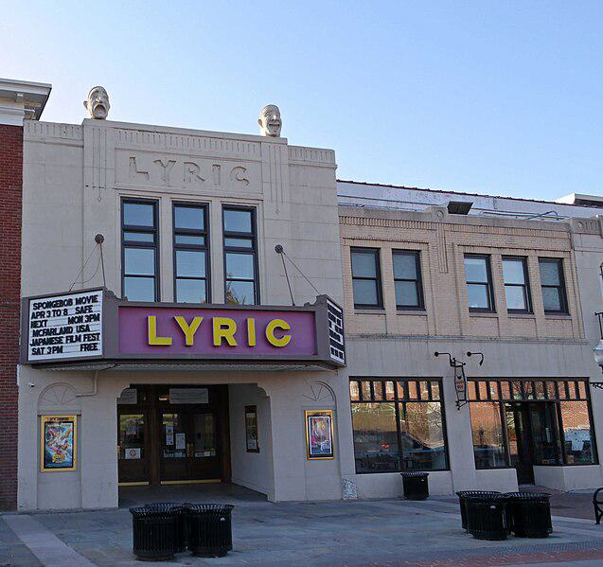

Caption for image source 2: Lyric Theater (Blacksburg, Virginia) A view of the 1930 Lyric Theater in Blacksburg, Virginia. designed by architect Louis Phillipe Smithey..

Example Question - "Which Lyric theatre has more neon lighting on its sign, the Historic Lyric Theatre Harrison, Arkansas or the Lyric Theater in Blacksburg, Virginia?"

Example Answer - "Historic Lyric Theatre in Harrison, Arkansas has more neon lighting."

Additional Text Source 1 - The Lyric Theater is a theater located on W. Rush Street in Harrison, Boone County, Arkansas. Designed and constructed by J. W. Bass of Detroit, the Lyric was built in 1929 and adorned with murals by J. W. Zelm (though mythology became prevalent in the area that they had been painted by an unknown hobo). (from: Lyric Theatre (Harrison, Arkansas))

Generated Question - Which Lyric Theatre is older, the one in Harrison, Arkansas or the one in Blacksburg, Virginia?

Generated Answer - The Lyric Theatre in Harrison, Arkansas is older, built in 1929.

--- Entry for custom_id: d5c25e4e0dba11ecb1e81171463288e9 ---

Image Source 1 -

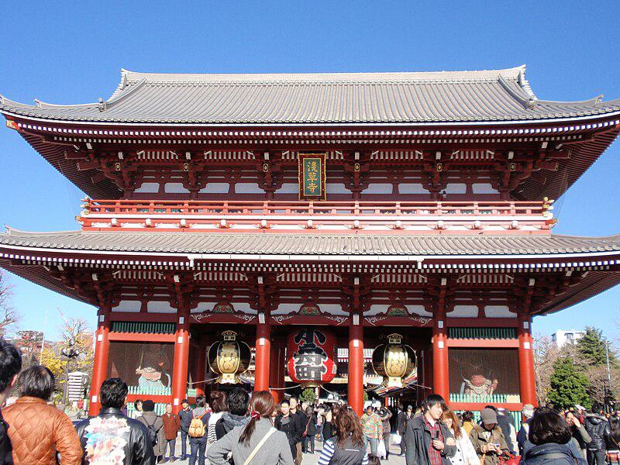

Caption for image source 1: Sensoji1 picture of Sensoji.

Example Question - "How many layers are in the roof of the Sensoji?"

Example Answer - "There are two layers in the roof."

Additional Text Source 1 - Adjacent to the temple is a five-story pagoda, the Asakusa Shinto shrine, as well as many shops with traditional goods in the Nakamise-dōri. The Sensoji Kannon temple is dedicated to Kannon Bosatsu, the Bodhisattva of compassion, and is the most widely visited spiritual site in the world with over 30 million visitors annually. (from: Sensō-ji)

Generated Question - Does the Sensoji temple have more than one roof layer like the adjacent five-story pagoda?

Generated Answer - No, the Sensoji temple has two roof layers, while the pagoda has five stories.

--- Entry for custom_id: d5cfc7500dba11ecb1e81171463288e9 ---

Example Question - What describes physical items used on Aircraft more fully; Ground support equipment or ATA 100?

Example Answer - Ground support Equipment

Image Source 1 -

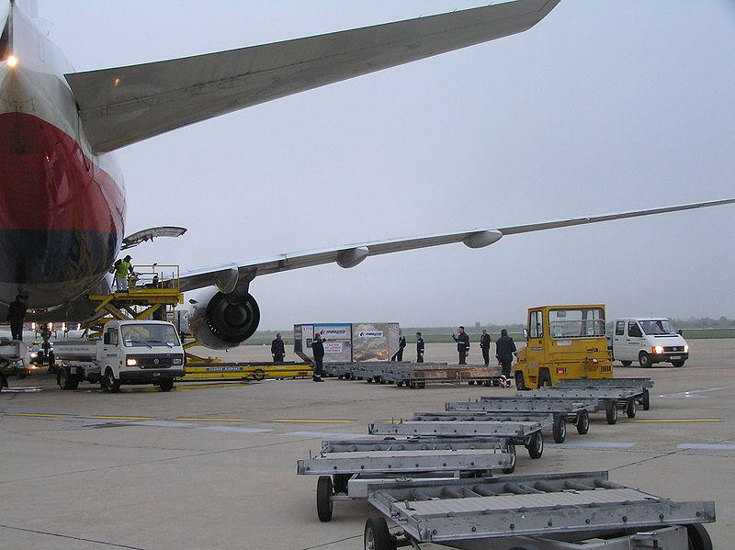

Generated Question - Does the image show equipment related to ground power operations, aircraft mobility, or ATA 100 documentation?

Generated Answer - The image shows ground support equipment related to ground power and aircraft mobility, not ATA 100 documentation.

--- Entry for custom_id: d5bed92c0dba11ecb1e81171463288e9 ---

Image Source 1 -

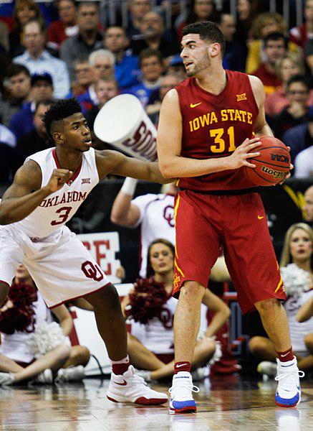

Caption for image source 1: Big 12 Championship - Georges Niang.

Example Question - "What color is incorporated in the uniforms of both the Oklahoma Sooners and Iowa State Cyclones?"

Example Answer - "Red is incorporated in the uniforms of both the Oklahoma Sooners and Iowa State Cyclones."

Additional Text Source 1 - After thrashing Kansas State, Iowa State, and Oklahoma State by a combined score of 91–17, the Sooners returned home. Inexplicably, a team that had run roughshod over equivalent teams, managed to suffer a 23–3 loss to unranked Kansas, a team that came into Norman with a 5–3 record. (from: 1975 Oklahoma Sooners football team)

Generated Question - Did the Oklahoma Sooners basketball team perform consistently well against all Big 12 teams like the Iowa State Cyclones did in the Big 12 Championship?

Generated Answer - No, the Oklahoma Sooners had inconsistent performance, losing unexpectedly to unranked Kansas.

--- Entry for custom_id: d5dcfb140dba11ecb1e81171463288e9 ---

Example Question - What is the former name of the square where the oldest royal foundation in Oxford is located?

Example Answer - Oriel Square, the square where Oriel College, the oldest royal foundation in Oxford is located, was formerly known as Canterbury Square.

Image Source 1 -

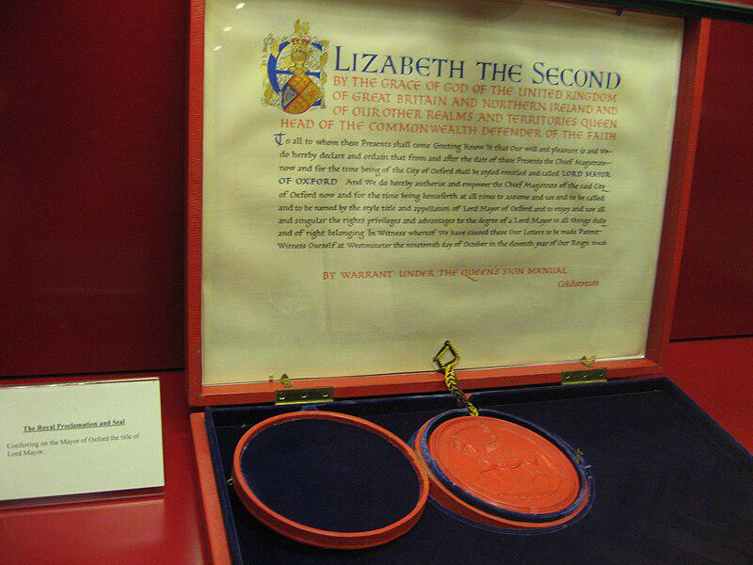

Generated Question - Which royal document shown in the image supports the historic royal status of Oxford, where Oriel College is located?

Generated Answer - The royal proclamation granting Lord Mayoralty to Oxford supports its historic royal status.

--- Entry for custom_id: d5dae4be0dba11ecb1e81171463288e9 ---

Example Question - What were Demeter and Gaia goddesses or "mothers" of?

Example Answer - Earth

Image Source 1 -

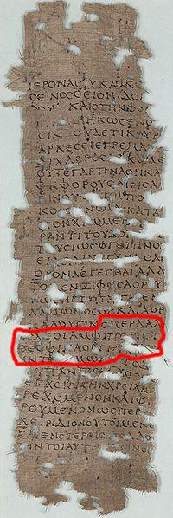

Generated Question - How do the Greek deities Gaia and Demeter relate to the earth and life according to mythology and ancient texts?

Generated Answer - Gaia is the primordial mother of all life and earth personified; Demeter is an earth and agricultural goddess.

--- Entry for custom_id: d5ca5d380dba11ecb1e81171463288e9 ---

Image Source 1 -

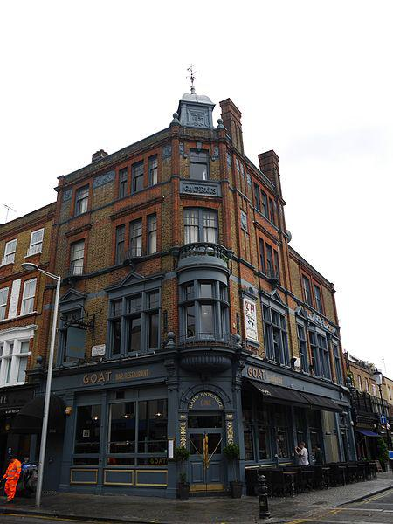

Caption for image source 1: Goat in Boots, Chelsea 02 The Goat in Boots is a pub at 333 Fulham Road in Chelsea, London, England.

Image Source 2 -

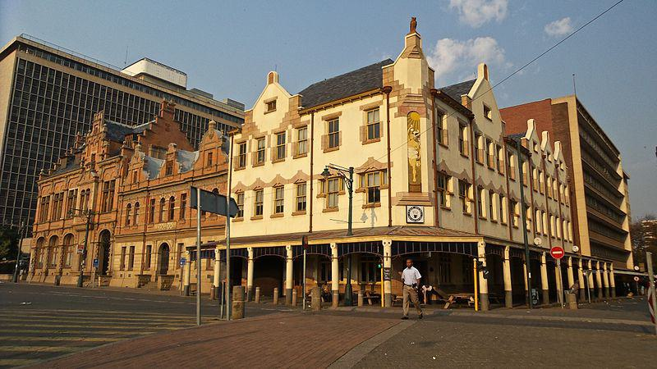

Caption for image source 2: Cafe Riche-002 Cafe Riche, Church Square, Pretoria.

Example Question - "Are the tops of the second story windows of both the Cafe Riche in Pretoria and the The Goat in Boots pub in London flat or pointed?"

Example Answer - "The tops of the second story windows are pointed."

Additional Text Source 1 - In folkloristics, Puss in Boots is classified as Aarne–Thompson–Uther ATU 545B, "Puss in Boots", a subtype of ATU 545, "The Cat as Helper". Folklorists Joseph Jacobs and Stith Thompson point that the Perrault's tale is the possible source of the Cat Helper story in later European folkloric traditions. (from: Puss in Boots)

Generated Question - Do the Goat in Boots pub and Cafe Riche have architectural features that reflect the fairy tale of Puss in Boots?

Generated Answer - Yes, both buildings have pointed window tops reminiscent of the fairy tale's style.

--- Entry for custom_id: d5dcfe020dba11ecb1e81171463288e9 ---

Example Question - What kind of B cells are affected by the type of NHL that can be treated with Rituximab?

Example Answer - This type of NHL affects lymphoplasmacytoid cells and plasma cells.

Image Source 1 -



Generated Question - How does Rituximab target the malignant B cells involved in Waldenström's macroglobulinemia?

Generated Answer - Rituximab binds to CD20 proteins on the surface of malignant B cells.

--- Entry for custom_id: d5c9e4a20dba11ecb1e81171463288e9 ---

Image Source 1 -

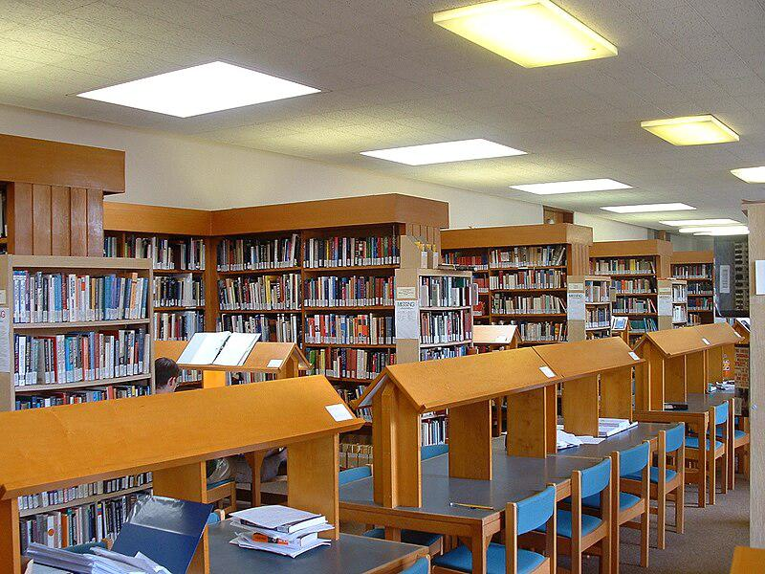

Caption for image source 1: Library of Fitzwilliam College, Cambridge.

Image Source 2 -



Caption for image source 2: Trinity College Library 05 Old library in the Trinity College, Dublin.

Example Question - "Does the Library of Fitzwilliam College in Cambridge have a higher ceiling than the Old Library of Trinity College in Dublin?"

Example Answer - "Yes, the Library of Fitzwilliam College in Cambridge has a higher ceiling than the Old Library of Trinity College in Dublin."

Additional Text Source 1 - The Library of Trinity College Dublin (Irish: Leabharlann Choláiste na Tríonóide) serves Trinity College and the University of Dublin. It is a legal deposit or "copyright library", which means that publishers in Ireland must deposit a copy of all their publications there, free of charge. (from: Library of Trinity College Dublin)

Generated Question - Which library, Fitzwilliam College or Trinity College Dublin, is more likely to have legal deposit books based on their described roles?

Generated Answer - Trinity College Dublin is more likely to have legal deposit books as it is a legal deposit library.

--- Entry for custom_id: d5bcbeee0dba11ecb1e81171463288e9 ---

Image Source 1 -



Caption for image source 1: 2015 01 Koh Lanta 30 littlr teeth (16423924129).

Image Source 2 -

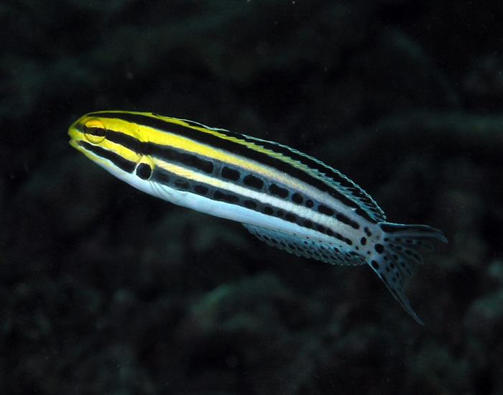

Caption for image source 2: Striped blenny Striped blenny.

Example Question - "Which fish has stripes that are oriented more vertically; Amphiprion clarkii or Striped blenny?"

Example Answer - "Amphiprion clarkii has stripes that are oriented more vertically."

Additional Text Source 1 - The ocellaris clownfish (Amphiprion ocellaris), also known as the false percula clownfish or common clownfish, is a marine fish belonging to the family Pomacentridae, which includes clownfishes and damselfishes. Amphiprion ocellaris are found in different colors, depending on where they are located. (from: Ocellaris clownfish)

Generated Question - Which fish has more distinct vertical white stripes, the Amphiprion clarkii or the Striped blenny?

Generated Answer - The Amphiprion clarkii has more distinct vertical white stripes.

--- Entry for custom_id: d5c2c0640dba11ecb1e81171463288e9 ---

Image Source 1 -

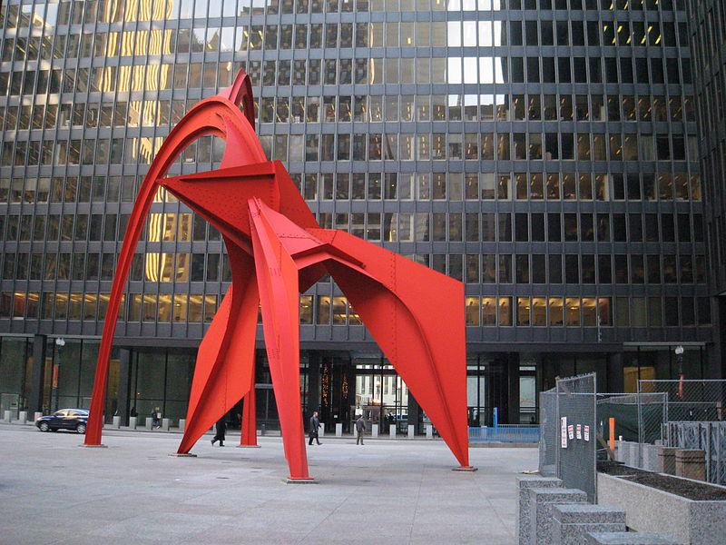

Caption for image source 1: Lascar Flamingo sculpture (4608071498).

Image Source 2 -

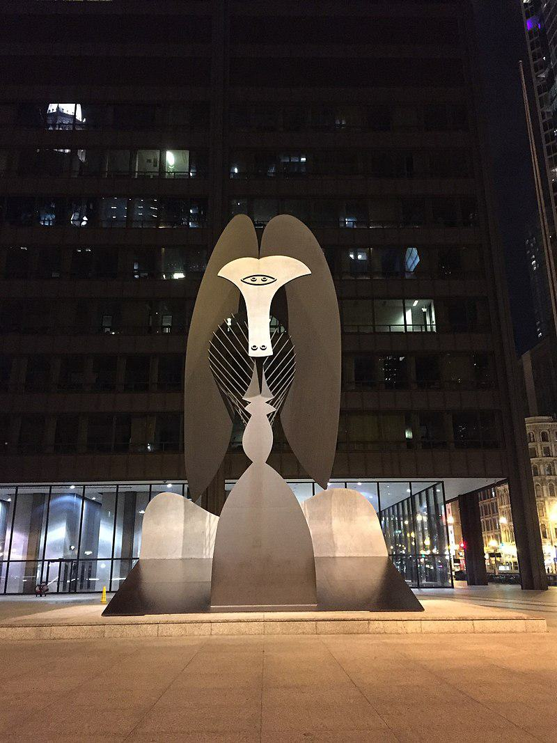

Caption for image source 2: Chicago Picasso Night The Picasso, Daley Plaza, Chicago, IL..

Example Question - "Is the The Picasso in Daley Plaza the same color as the Lascar flamingo sculpture?"

Example Answer - "The Picasso in Daley Plaza isn't the same color as the Lascar flamingo sculpture."

Additional Text Source 1 - But in fact, he was inspired by [Corbett]," Picasso's grandson Olivier Widmaier Picasso told the Chicago Sun-Times in 2004."I think the Chicago Sculpture was inspired by her," said the grandson, author of Picasso, the Real Family Story. Picasso made 40 works inspired by her, said the grandson, including The Girl Who Said (from: Chicago Picasso)

Generated Question - Are the Lascar Flamingo and The Picasso sculptures in Chicago inspired by the same person?

Generated Answer - No, only The Picasso sculpture was inspired by Corbett, according to Picasso's grandson.

--- Entry for custom_id: d5df6ef80dba11ecb1e81171463288e9 ---

Example Question - Why is the largest city in Courtland probably known as the "city where the wind is born?"

Example Answer - The city is probably known for this characteristic because of the constant sea breeze.

Image Source 1 -

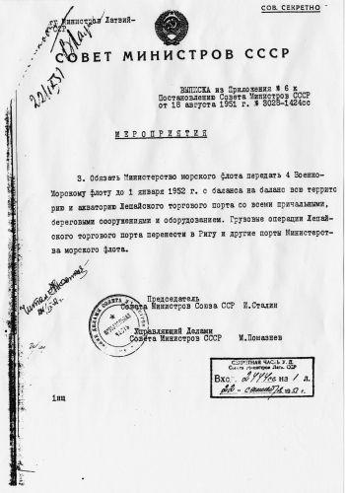

Generated Question - How does the USSR document about Liepāja relate to the city's coastal location and historical significance in Courland?

Generated Answer - The document shows Liepāja's strategic coastal importance, aligning with its location in Courland and its role as a military port.

--- Entry for custom_id: d5c1ebd00dba11ecb1e81171463288e9 ---

Image Source 1 -

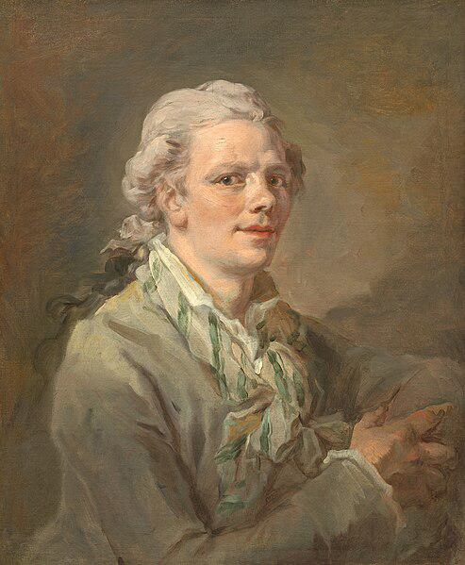

Caption for image source 1: Unknown French artist, Portrait of a Young Man (NGA, 1961.9.18).

Image Source 2 -

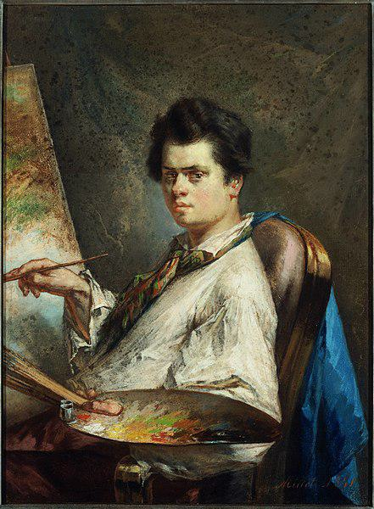

Caption for image source 2: 1841, Millet, Jean-François, Portrait of Louis-Alexandre Marolles Portrait of Louis-Alexandre Marolles Gift of Joseph F. McCrindle.

Example Question - "In the paintings and Portrait of Louis-Alexandre Marolles by Jean-François Millet and Portrait of a Young Man by an unknown French artist, are the men wearing the exact same style of shirt?"

Example Answer - "No, the men between these paintings are wearing different styles of shirts."

Additional Text Source 1 - Though Houbraken claimed that Millet had two sons who both became painters, the Dutch RKD only shows him influencing the painter Jean-François Millet (II) and Jean Coustel. Perhaps because of the confusion between this painter and later painters with the same name, most notably Jean-François Millet, Mark Twain later wrote a farcical play called (from: Francisque Millet)

Generated Question - Are the two men in the portraits by Jean-François Millet and the unknown French artist likely related based on the additional text about Millet's family?

Generated Answer - No, the text suggests only one painter son, so they are unlikely related.

--- Entry for custom_id: d5ca4ae60dba11ecb1e81171463288e9 ---

Image Source 1 -

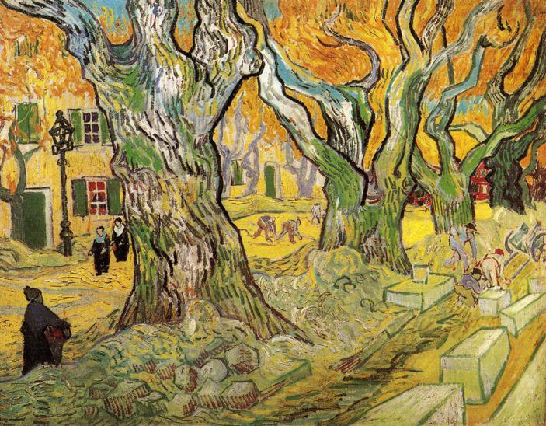

Caption for image source 1: Van Gogh The Road Menders-1889-Phillips.

Example Question - "What activity are people doing in the painting The Road Menders by Van Gogh?"

Example Answer - "People are walking on the street and fixing a road in the painting The Road Menders by Van Gogh."

Additional Text Source 1 - The Large Plane Trees, also called Road Menders at Saint-Rémy is an oil painting by Vincent van Gogh. Painted in 1889 in Saint-Rémy, France, the painting depicts roadwork underneath autumn trees with yellow leaves. (from: The Large Plane Trees)

Generated Question - Are the trees in Van Gogh's The Road Menders painting depicted with autumn colors and are people shown working on the road?

Generated Answer - Yes, the trees have autumn colors and people are shown working on the road.

--- Entry for custom_id: d5bfcb3e0dba11ecb1e81171463288e9 ---

Image Source 1 -

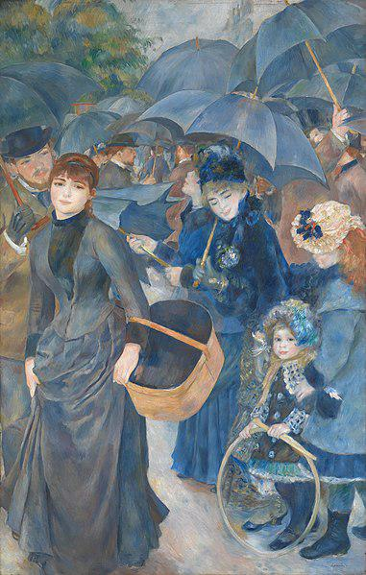

Caption for image source 1: Pierre-Auguste Renoir, The Umbrellas, ca. 1881-86 The Umbrellas.

Example Question - "Are there fewer than four open umbrellas in The Umbrellas?"

Example Answer - "No, there is not."

Additional Text Source 1 - The largest hand-portable umbrellas are golf umbrellas. Umbrellas can be divided into two categories: fully collapsible umbrellas, in which the metal pole supporting the canopy retracts, making the umbrella small enough to fit in a handbag, and non-collapsible umbrellas, in which the support pole cannot retract and only the canopy can be collapsed. (from: Umbrella)

Generated Question - Are the umbrellas in Renoir's The Umbrellas likely to be fully collapsible or non-collapsible based on their size and use?

Generated Answer - They are likely non-collapsible, as the umbrellas appear large and sturdy, typical of non-collapsible types.

--- Entry for custom_id: d5cf6a8a0dba11ecb1e81171463288e9 ---

Example Question - Is the real life counterpart of the animal associated with Tengu in Shinto mythology more or less likely to fly than the real life counterpart associated with the Golden Fleece in Greek mythology?

Example Answer - More likely

Image Source 1 -

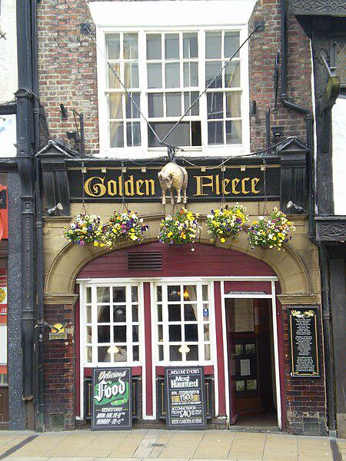

Generated Question - Considering the mythological origins, which animal associated with the Golden Fleece or Tengu is more likely to be depicted with wings?

Generated Answer - The animal associated with the Golden Fleece is more likely to be depicted with wings.

--- Entry for custom_id: d5c2bed40dba11ecb1e81171463288e9 ---

Image Source 1 -



Caption for image source 1: Race Through New York with Jimmy Fallon (32831664510) (cropped).

Example Question - "Is the Comcast building taller than the NBC building?"

Example Answer - "The Comcast building is taller than the NBC building."

Additional Text Source 1 - The GE Building would be officially known as the Comcast Building. Comcast planned to replace the neon GE lettering from the top of the building with a 10-foot (3.0 m) tall, LED-lit Comcast wordmark and NBC logo, and add a 17-foot (5.2 m) NBC logo on the building western's facade. (from: 30 Rockefeller Plaza)

Generated Question - Does the Comcast Building have larger and more prominent logos compared to the NBC building facade?

Generated Answer - Yes, the Comcast Building has larger and more prominent logos than the NBC building facade.

--- Entry for custom_id: d5d8d4a80dba11ecb1e81171463288e9 ---

Example Question - What kind of ancient material does the the Pine Canyon Formation in Utah and the sedimentary sequence formed approximately 530 million years ago preserve?

Example Answer - They preserve fossils.

Image Source 1 -

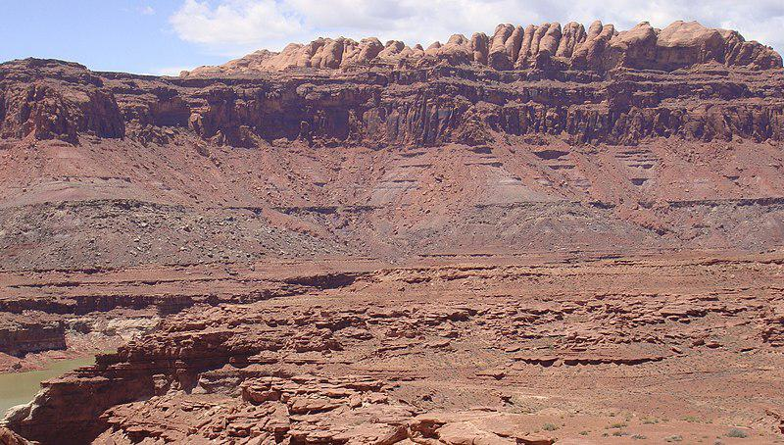

Generated Question - How do the fossil ages in the Cambrian Sawatch Formation compare to the marine fossils in the Carboniferous Deseret Limestone and the rock layers shown in Utah's Colorado Plateau?

Generated Answer - Sawatch fossils are oldest (Cambrian), Deseret Limestone fossils are younger (Carboniferous), and the Colorado Plateau layers span Permian to Jurassic ages.

--- Entry for custom_id: d5cad0420dba11ecb1e81171463288e9 ---

Image Source 1 -

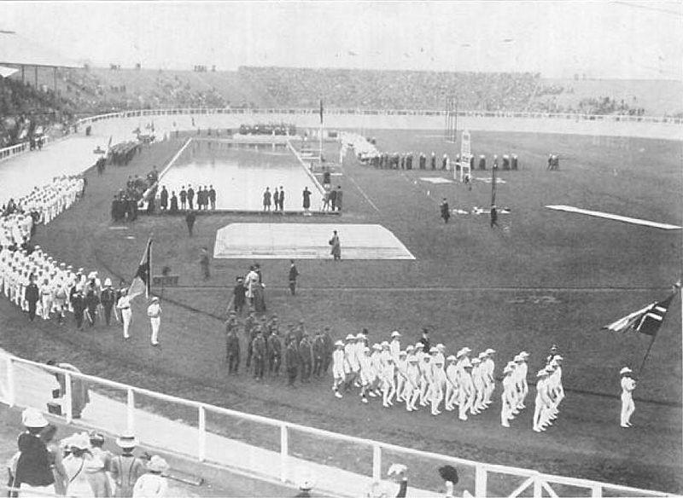

Caption for image source 1: Nations at 1908 Olympics *Cook, Theodore Andrea (1909-May) The Fourth Olympiad London 1908 Official Report (PDF), London: British Olympic Association, pp.p. 49 Retrieved on 4 February 2008. (Cook died in 1929.).

Image Source 2 -

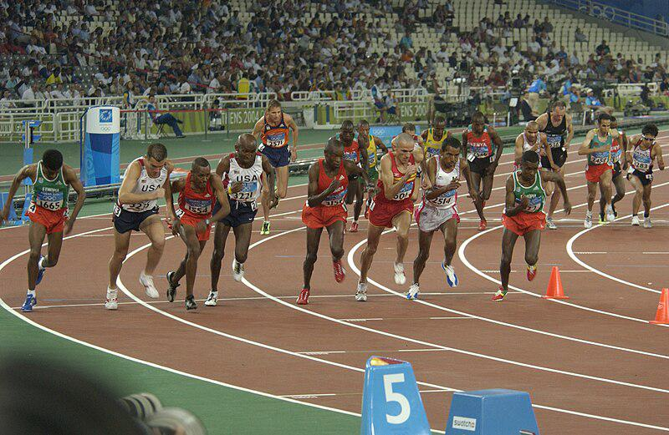

Caption for image source 2: 10,000-meter final during the 2004 Olympics Oregon National Guard Capt. Dan Browne (2nd from the left) takes off at the start of the men's 10,000-meter final during the 2004 Olympics in Athens, Greece, on August 20, 2004. Browne finished 12th in a field of 26 competitors..

Example Question - "Did the track have painted white lines in both the 2004 and 1908 Olympic games?"

Example Answer - "No, the track did not have painted white lines in both the 2004 and 1908 Olympic games."

Additional Text Source 1 - Some of the lyrics in "White Lines" ("something like a phenomenon") echoed lyrics from the song "Cavern" by Liquid Liquid ("slip in and out of phenomenon"), in addition to the note-by-note appropriation of the bass line from "Cavern" with a rapping track overlaid. (from: White Lines (Don't Don't Do It))

Generated Question - Considering the presence of white lines on the tracks, how do the 1908 and 2004 Olympic running tracks differ in their design?

Generated Answer - The 1908 Olympic track did not have painted white lines, while the 2004 Olympic track had clearly painted white lines.

--- Entry for custom_id: d5ccb4020dba11ecb1e81171463288e9 ---

Image Source 1 -

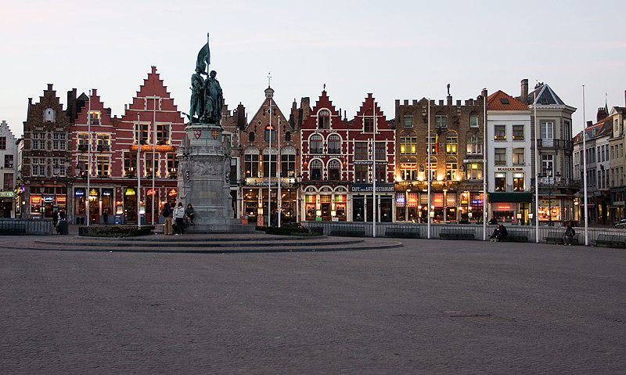

Caption for image source 1: Market Square - Bruges, Belgium - panoramio - Sergey Ashmarin.

Example Question - "What sits in the middle of the human figure statues in the middle of the Market Square - Bruges, Belgium?"

Example Answer - "There is a flag in the middle of the human figure statues in the middle of the Market Square."

Additional Text Source 1 - The Italian historian Lodovico Guicciardini described how, in late 13th-century Bruges, commodity traders gathered outdoors at a market square containing an inn owned by a family called Van der Beurze, and in 1409 they became the "Brugse Beurse", institutionalizing what had been, until then, an informal meeting. (from: Stock market)

Generated Question - How does the historical origin of the Market Square in Bruges relate to the current presence of statues and buildings around it?

Generated Answer - The Market Square originated as a traders' meeting place, now marked by statues and surrounded by historic buildings.

--- Entry for custom_id: d5d751d20dba11ecb1e81171463288e9 ---

Example Question - What can be traced to a demonstration at the Crufts dog show in the late 1970s in the United Kingdom that is a dog sport in which a handler directs a dog through an obstacle course in a race for both time and accuracy?

Example Answer - Dog Agility

Image Source 1 -



Generated Question - In the dog sport demonstrated at Crufts in the 1970s, how does the Papillon in the image complete the obstacle course without incentives or physical contact from the handler?

Generated Answer - The Papillon runs off leash and jumps over obstacles guided only by the handler's direction without incentives or contact.

--- Entry for custom_id: d5c99b8c0dba11ecb1e81171463288e9 ---

Image Source 1 -

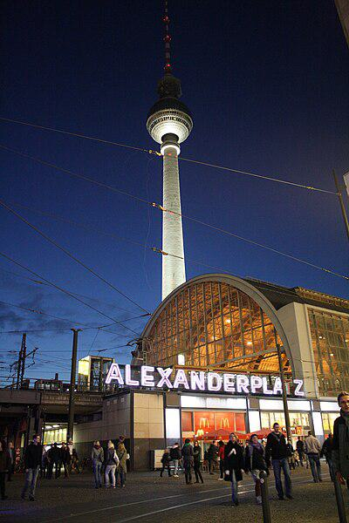

Caption for image source 1: Berlin Alexanderplatz abend Berlin Alexanderplatz at dawn.

Example Question - "Is the top or the bottom of the tower by Berlin Alexanderplatz more illuminated at night?"

Example Answer - "The bottom of the tower by Berlin Alexanderplatz is more illuminated at night than the top."

Additional Text Source 1 - With more than 360,000 visitors daily, Alexanderplatz is, according to one study, the most visited area of Berlin, beating Friedrichstrasse and City West. It is a popular starting point for tourists, with many attractions including the Fernsehturm (TV tower), the Nikolai Quarter and the Rotes Rathaus (Red city hall) situated nearby. (from: Alexanderplatz)

Generated Question - Is Alexanderplatz a popular tourist area because of the nearby Fernsehturm and other attractions?

Generated Answer - Yes, Alexanderplatz is popular due to the Fernsehturm and nearby attractions like the Nikolai Quarter.

--- Entry for custom_id: d5da12000dba11ecb1e81171463288e9 ---

Example Question - What kinds of feelings can women with a chronic, inflammatory skin disease of unknown cause, experience?

Example Answer - They may feel isolated, hopeless, have low self image, and become depressed, anxious, and angry.

Image Source 1 -



--- Entry for custom_id: d5c5b0d00dba11ecb1e81171463288e9 ---

Image Source 1 -

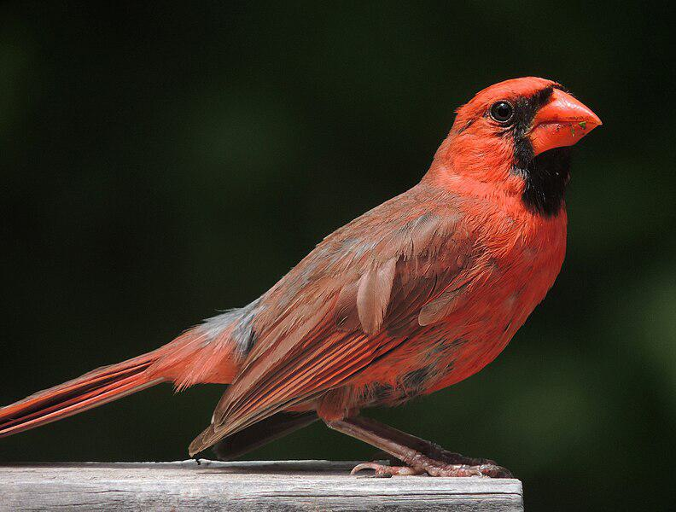

Caption for image source 1: Northern Cardinal Broadside A male northern cardinal.

Example Question - "Is the base of the northern cardinal's beak over half as tall as it's head?"

Example Answer - "Yes, the base of the northern cardinal's beak is over half as tall as it's head."

Additional Text Source 1 - The northern cardinal is a mid-sized songbird with a body length of 21–23.5 cm (8.3–9.3 in) and a wingspan of 25–31 cm (9.8–12.2 in). The adult weighs from 33.6–65 g (1.19–2.29 oz), with an average 44.8 g (1.58 oz). (from: Northern cardinal)

Generated Question - Considering the northern cardinal's body length and wingspan, is its wingspan generally longer than its body length?

Generated Answer - Yes, the northern cardinal's wingspan is generally longer than its body length.

--- Entry for custom_id: d5dbd84c0dba11ecb1e81171463288e9 ---

Example Question - What group of passerine birds in the family Meropidae are a predator of bees?

Example Answer - The bee-eaters are a group of non-passerine birds in the family Meropidae.

Image Source 1 -

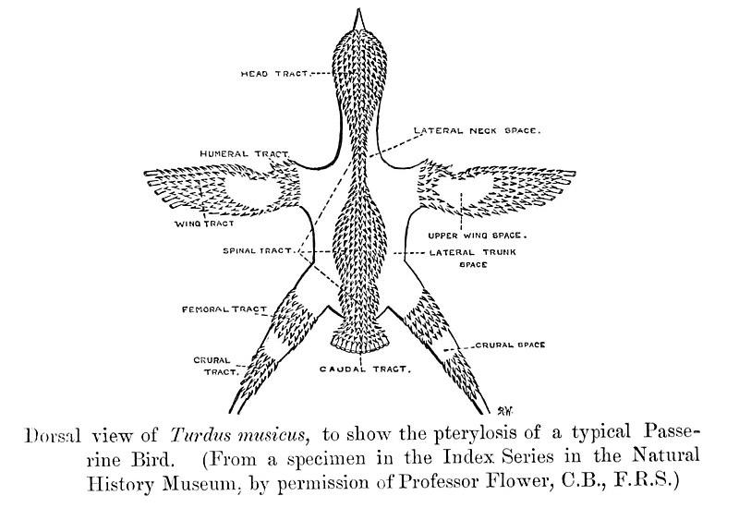

Generated Question - Are bee-eaters, predators of bees, classified as passerine birds like the one shown in the feather tract diagram?

Generated Answer - No, bee-eaters are non-passerine birds, unlike the typical passerine shown in the diagram.

--- Entry for custom_id: d5dc18160dba11ecb1e81171463288e9 ---

Example Question - Who formed the kingdom whose name begins with a K to the west of Panchala kingdom?

Example Answer - Tribes

Image Source 1 -

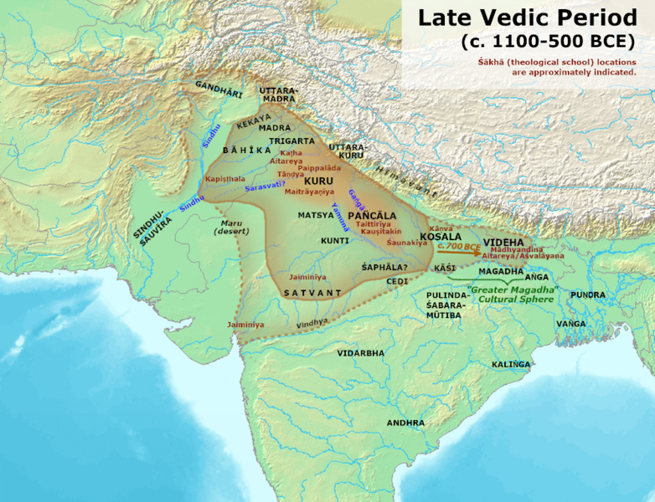

Generated Question - Which kingdom to the west of Panchala shifted from semi-nomadic tribes to settled farming of rice and barley?

Generated Answer - The Kuru Kingdom.

--- Entry for custom_id: d5d6b4160dba11ecb1e81171463288e9 ---

Example Question - DUSTOFF and Air Force One are both what?

Example Answer - Call sign.

Image Source 1 -

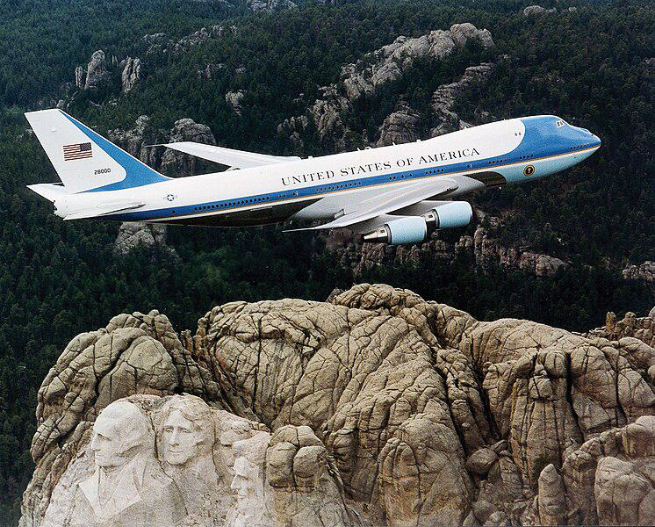

Generated Question - What call sign is used for the aircraft shown flying over Mount Rushmore when it is transporting the U.S. President?

Generated Answer - Air Force One.

--- Entry for custom_id: d5cb09400dba11ecb1e81171463288e9 ---

Image Source 1 -



Caption for image source 1: Stephanie Beckert - 5000m speed skating - Vancouver 2010 Stephanie Beckert at the Women's 5000m final..

Example Question - "When Stephanie Beckert competed in the finals of the 5000 meter speed skating race at the 2010 Olympics, what three letters were present on the sticker on the front of her leg?"

Example Answer - "When Stephanie Beckert competed in the finals of the 5000 meter speed skating race at the 2010 Olympics, the letters GER were present on the sticker on the front of her leg."

Additional Text Source 1 - At the 2010 Winter Olympics, Kramer was the favourite to win three gold medals, like his countryman Ard Schenk at the 1972 Olympics in Sapporo. At the 5000 meters race of the 2010 Winter Olympics in Vancouver, Kramer grabbed the gold medal with a new Olympic record of 6:14.60, beating the previous time of Jochem Uytdehaage by 0.06 seconds. (from: Sven Kramer)

Generated Question - Did Stephanie Beckert or Sven Kramer set a new Olympic record in the 5000m speed skating at the 2010 Winter Olympics?

Generated Answer - Sven Kramer set a new Olympic record in the 5000m speed skating at the 2010 Winter Olympics.

--- Entry for custom_id: d5d6b7d60dba11ecb1e81171463288e9 ---

Example Question - The bamboo xiao flute and the dizi transverse flute both have origins in what country?

Example Answer - China.

Image Source 1 -

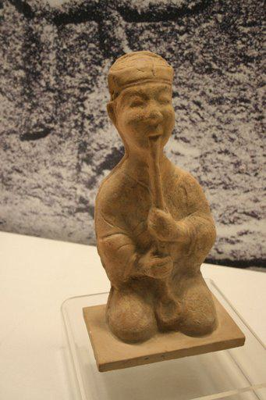

Generated Question - Considering the ceramic figure from the Eastern Han Dynasty, which type of Chinese flute is it likely depicting, the vertical xiao or the transverse dizi?

Generated Answer - The ceramic figure is likely depicting the vertical xiao flute.

--- Entry for custom_id: d5d373000dba11ecb1e81171463288e9 ---

Example Question - What type of materials are most commonly seen in the beds of the river that used to be called Rio de San Felipe or La Porciuncula?

Example Answer - Pale-yellow to light-brown sandstone and conglomerate are seen in the beds of this river.

Image Source 1 -

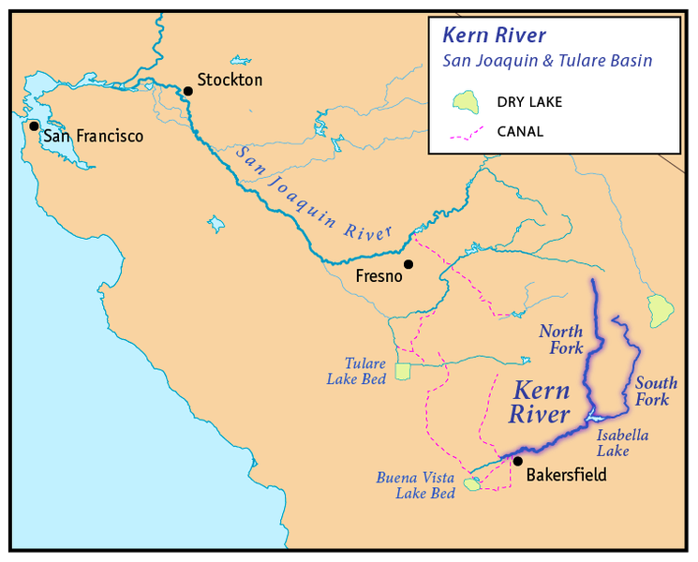

Generated Question - Does the Kern River flow near Bakersfield where the Kern River Beds formation with sandstone and conglomerate is located?

Generated Answer - Yes, the Kern River flows near Bakersfield where the Kern River Beds formation is found.

--- Entry for custom_id: d5c878d80dba11ecb1e81171463288e9 ---

Image Source 1 -



Caption for image source 1: ISS-50 Thomas Pesquet next to the airlock inside the Kibo lab ESA (European Space Agency) astronaut Thomas Pesquet floats next to the airlock inside the Japanese Experiment Module aboard the International Space Station..

Example Question - "Are there less than five countries represented on the International Space Station?"

Example Answer - "No, there are not less than five countries represented on the International Space Station."

Additional Text Source 1 - The International Space Station (ISS) is a modular space station (habitable artificial satellite) in low Earth orbit. It is a multinational collaborative project involving five participating space agencies: NASA (United States), Roscosmos (Russia), JAXA (Japan), ESA (Europe), and CSA (Canada). (from: International Space Station)

Generated Question - Does the presence of multiple flags in the Kibo lab image reflect the multinational collaboration of the ISS involving five space agencies?

Generated Answer - Yes, the flags represent the five space agencies collaborating on the ISS.

--- Entry for custom_id: d5c3ed2c0dba11ecb1e81171463288e9 ---

Image Source 1 -

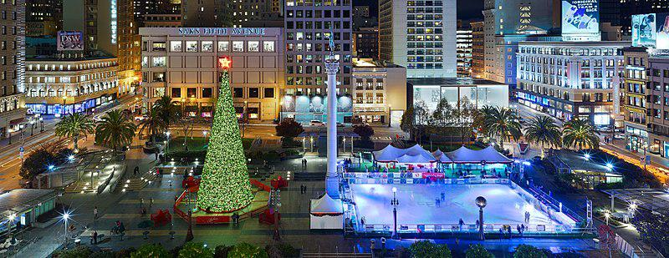

Caption for image source 1: Union Square, San Francisco December 2016 Union Square, San Francisco is a public plaza..

Example Question - "In 2016, was the Christmas tree in Union Square, San Francisco taller or shorter than the monument at the center of the square?"

Example Answer - "In 2016, the Christmas tree in Union Square, San Francisco was shorter than the monument at the center of the square."

Additional Text Source 1 - Union Square is a 2.6-acre (1.1-hectare) public plaza bordered by Geary, Powell, Post and Stockton Streets in downtown San Francisco, California. " Union Square" also refers to the central shopping, hotel, and theater district that surrounds the plaza for several blocks. (from: Union Square, San Francisco)

Generated Question - Is the ice skating rink in Union Square, San Francisco located closer to the Christmas tree or the monument in the center of the square?

Generated Answer - The ice skating rink is located closer to the monument than the Christmas tree.

--- Entry for custom_id: d5c40d8e0dba11ecb1e81171463288e9 ---

Image Source 1 -

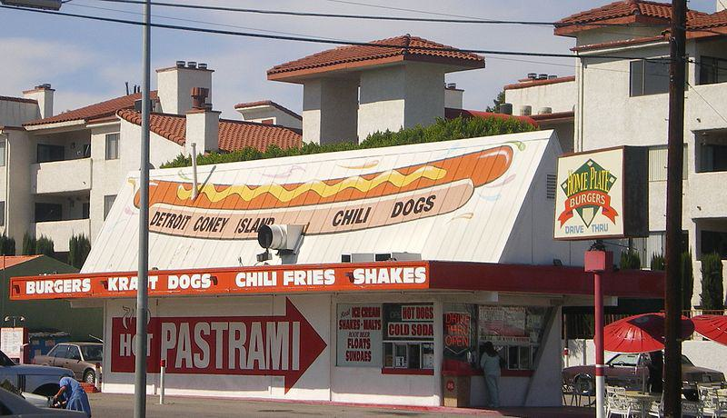

Caption for image source 1: Hot Dog Stand in Reseda Hot Dog Stand on Reseda Boulevard in Reseda in the western San Fernando Valley, Los Angeles, California..

Example Question - "Does the Hot Dog Stand on Reseda Boulevard in Reseda advertise the sale of both chili fries and chili dogs?"

Example Answer - "The Hot Dog Stand on Reseda Boulevard in Reseda advertises the sale of both chili fries and chili dogs."

Additional Text Source 1 - Hot dogs (Thai: ฮอตดอก; RTGS: hotdok; IPA: [hɔ́t dɔ̀ːk]) are very popular in Thailand and are also used in various ways in Thai cuisine. It can be sold inside a bun similar to a standard American hot dog but instead of tomato ketchup, they are also often eaten with a sweet tomato-chili sauce. (from: Hot dog variations)

Generated Question - Does the Hot Dog Stand on Reseda Boulevard sell hot dogs similar to those popular in Thailand with chili sauce?

Generated Answer - The stand sells chili dogs, which may be similar to Thai hot dogs with chili sauce.

--- Entry for custom_id: d5d4a9960dba11ecb1e81171463288e9 ---

Example Question - The cave that means 'cave of the mountain river' or 'cave of mountains behind Đoòng' in Vietnamese is made of stone formed during what geological period?

Example Answer - Hang Sơn Đoòng was formed by Carboniferous/Permian limestone.

Image Source 1 -



Generated Question - Is the cave with the largest known passage by volume formed in the same type of limestone as the cave with the underground river shown in the image?

Generated Answer - Yes, both caves are formed in soluble limestone.

--- Entry for custom_id: d5d0bb9c0dba11ecb1e81171463288e9 ---

Example Question - Were the Gnessin Institute and the Institute of Oriental Studies of the USSR Academy of Sciences both former names of research institutions?

Example Answer - Yes, both institutions have different names contemporaneously.

Image Source 1 -

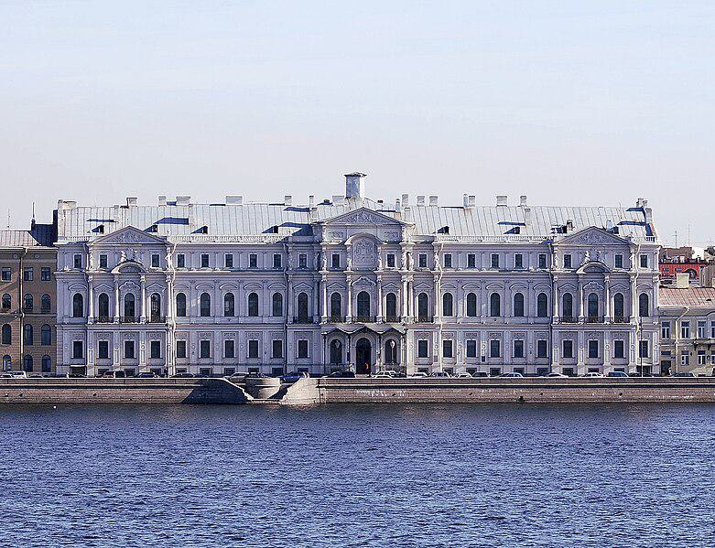

Generated Question - Is the Institute of Oriental Studies currently housed in the Novo-Mikhailovsky Palace, and was it formerly known as the Institute of Oriental Studies of the USSR Academy of Sciences?

Generated Answer - Yes, it is housed in the Novo-Mikhailovsky Palace and was formerly known as the Institute of Oriental Studies of the USSR Academy of Sciences.

--- Entry for custom_id: d5d44a780dba11ecb1e81171463288e9 ---

Example Question - Is the locally known "Routes 5 and 20" able to go to Crater Lake National Park, Oregon?

Example Answer - No, that route only goes around New York.

Image Source 1 -



Generated Question - Can Oregon Route 138 connect travelers from Elkton to Crater Lake National Park within Oregon?

Generated Answer - Yes, Oregon Route 138 provides access to Crater Lake National Park from the north.

--- Entry for custom_id: d5d66ccc0dba11ecb1e81171463288e9 ---

Example Question - Coregonus oxyrinchus is an allegedly extinct species of what, 99% of which belong to the class Actinopterygii?

Example Answer - Fish

Image Source 1 -

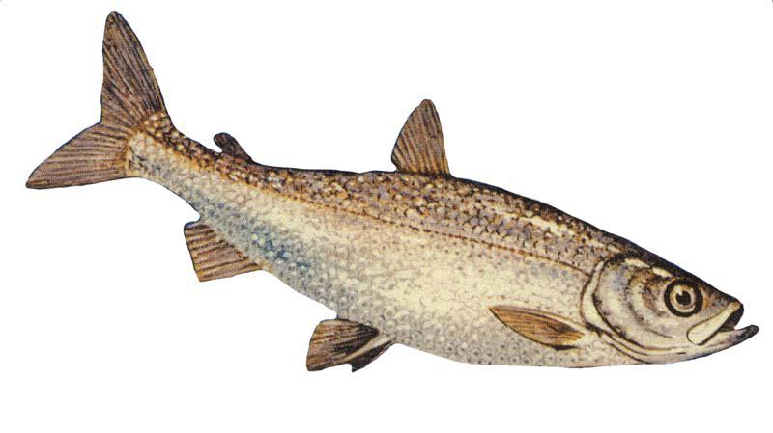

Generated Question - Are the houting and the bloater both species within the same genus of fish that belong to the class Actinopterygii?

Generated Answer - Yes, both houting and bloater belong to the genus Coregonus in the class Actinopterygii.

--- Entry for custom_id: d5c1a0ee0dba11ecb1e81171463288e9 ---

Image Source 1 -

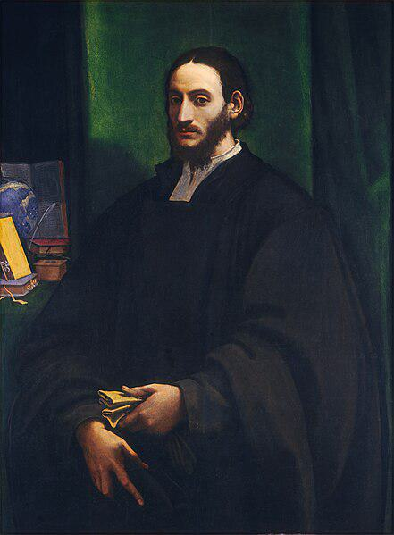

Caption for image source 1: Sebastiano del Piombo Portrait of a Humanist.

Example Question - "What is the color of the cloth worn by the man in Sebastiano del Piombo's painting " Portrait of a Humanist"?"

Example Answer - "The cloth worn by the man in Sebastiano del Piombo's painting " Portrait of a Humanist" is black."

Additional Text Source 1 - " ("Sebastian the Venetian made this") on the stone platform below Christ. Born Sebastiano Luciani, after coming to Rome he had become "Sebastiano Veneziano", until in 1531 he became the Keeper of the Seal to the Papacy, and so got the nickname del Piombo thereafter, meaning "of the lead", from his new job title. (from: The Raising of Lazarus (Sebastiano del Piombo))

Generated Question - Does the man in Sebastiano del Piombo's "Portrait of a Humanist" wear black clothing similar to the dark tones associated with Sebastiano del Piombo's later papal role?

Generated Answer - Yes, the man wears black clothing, reflecting the dark tones linked to Sebastiano del Piombo's papal role.

--- Entry for custom_id: d5c41e5a0dba11ecb1e81171463288e9 ---

Image Source 1 -

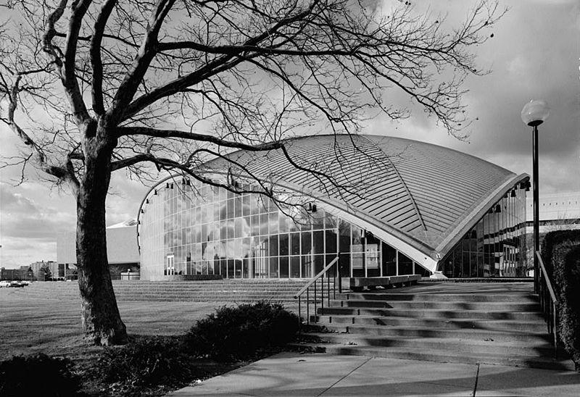

Caption for image source 1: Kresge audi, mit 1953 Kresge Auditorium, MIT Campus.

Image Source 2 -

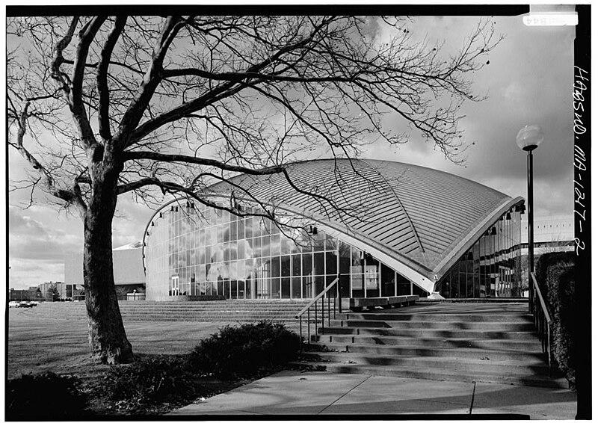

Caption for image source 2: Kresge Auditorium - 080149pv.

Example Question - "Are the smallest windows of the Kresge Auditorium triangular in shape?"

Example Answer - "The smallest windows of the Kresge Auditorium are not triangular in shape."

Additional Text Source 1 - It offers bignum precision for basic operations (addition, subtraction, multiplication, division) and 32 digits of precision for advanced operations (square root, transcendental functions). The largest value that can be represented on the Windows Calculator is currently <1010,000 and the smallest is 10−9,999. (from: Windows Calculator)

Generated Question - Does the Kresge Auditorium have triangular windows like the precision limits in Windows Calculator?

Generated Answer - No, the Kresge Auditorium's windows are not triangular.

--- Entry for custom_id: d5c204d00dba11ecb1e81171463288e9 ---

Image Source 1 -

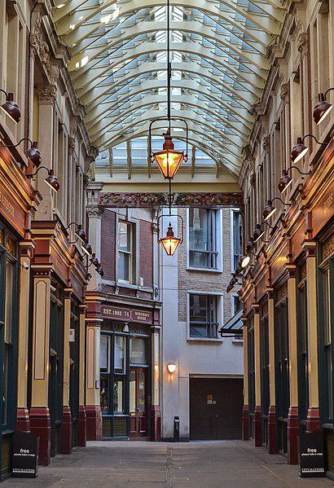

Caption for image source 1: Leadenhall Market, London B Leadenhall Market Wikidata has entry Q961148 with data related to this item..

Image Source 2 -

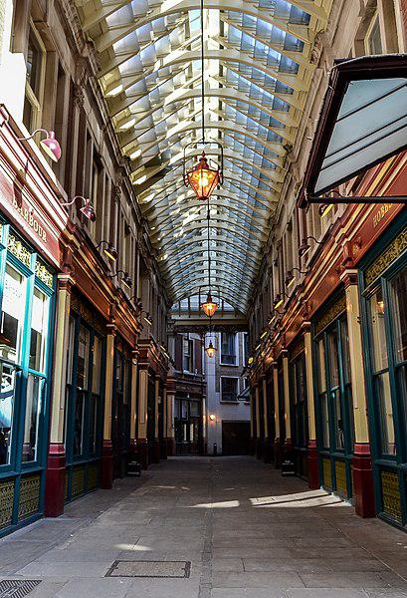

Caption for image source 2: Leadenhall Market, London A Leadenhall Market Wikidata has entry Q961148 with data related to this item..

Example Question - "Can I find lights hanging more than one foot down from at least 2 different Street covering ceilings at leadenhall Market in London?"

Example Answer - "Yes, there are lights hanging more than one foot down from at least two Street coverings at Leadenhall Market in London."

Additional Text Source 1 - Produce markets included Covent Garden, which Knight considered to be the 'pre-eminent' vegetable market; Farringdon Market between Holborn Hill and Fleet Street; Spitalfields - the largest potato market in London; Portman Market, Hungerford Market and Leadenhall Market- a mixed produce and meat market. (from: Marketplace)

Generated Question - Does Leadenhall Market in London have a covered walkway with hanging lights and shops on both sides?

Generated Answer - Yes, Leadenhall Market has a covered walkway with hanging lights and shops on both sides.

--- Entry for custom_id: d5d305640dba11ecb1e81171463288e9 ---

Example Question - Was the traditional pit house at the OKIB Cultural Arbor constructed before or after the death of Okanagan Nation Chief Nkwala?

Example Answer - after

Image Source 1 -

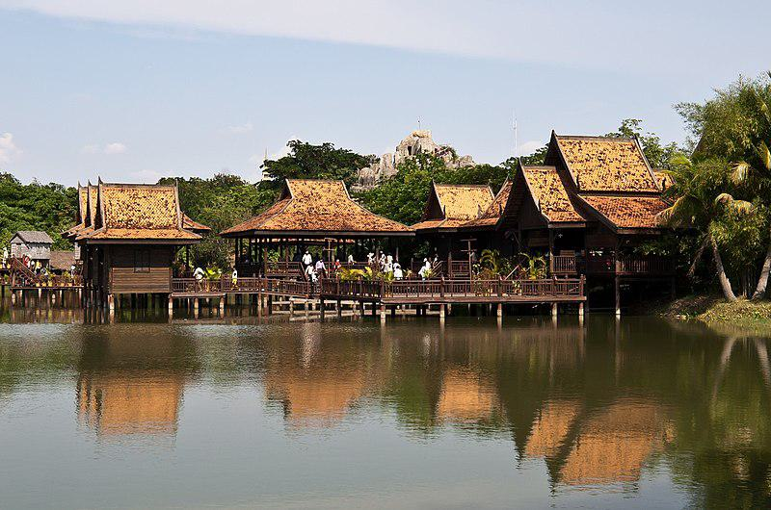

Generated Question - Is the traditional pit house at the OKIB Cultural Arbor similar in structure to the traditional Khmer houses built over water in the Cambodian Cultural Village?

Generated Answer - No, the pit house is not built over water like the Khmer houses.

--- Entry for custom_id: d5cfd6640dba11ecb1e81171463288e9 ---

Example Question - Were Ingrid Roscoe and William Roscoe born in the same month?

Example Answer - No, Ingrid Roscoe was born in May while William Roscoe was born in March.

Image Source 1 -

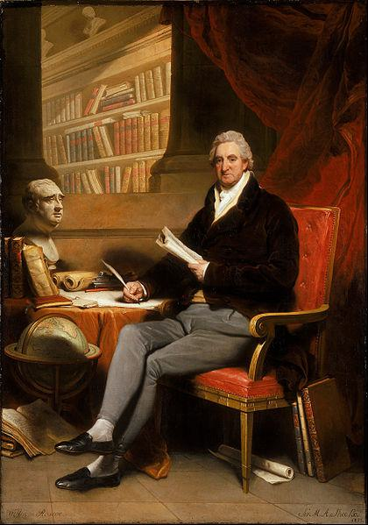

Generated Question - Did William Roscoe, shown in the painting, have a career in politics like Ingrid Roscoe?

Generated Answer - William Roscoe was briefly a Member of Parliament, so yes, he had a political career like Ingrid Roscoe.

--- Entry for custom_id: d5c49eb60dba11ecb1e81171463288e9 ---

Image Source 1 -

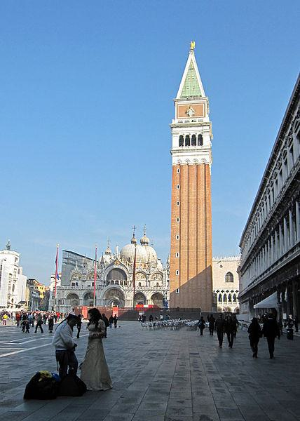

Caption for image source 1: Piazza San Marco, Venezia (8196039310).

Image Source 2 -

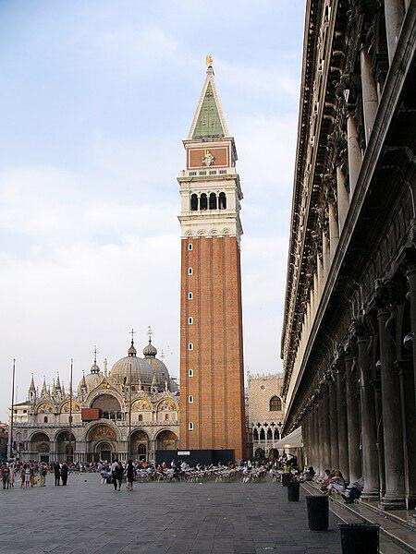

Caption for image source 2: Piazza San Marco in Venice, with St Mark's Campanile and Basilica in the background St. Mark's Square in Venice, Italy..

Example Question - "Is the Campanile taller than St. Mark's Basilica in Venice?"

Example Answer - "Yes, the Campanile is taller than St. Mark's Basilica."

Additional Text Source 1 - During the reign of duke Agnello Particiaco (811–827) the ducal seat moved from Malamocco to the more protected Rialto, within present-day Venice. The monastery of St. Zachary and the first ducal palace and basilica of St. Mark, as well as a walled defense (civitatis murus) between Olivolo and Rialto, were subsequently built here. (from: Venice)

Generated Question - Considering the historical move of the ducal seat to Rialto, is St. Mark's Campanile located in the same area as the original basilica and ducal palace?

Generated Answer - Yes, St. Mark's Campanile is located in the same area as the original basilica and ducal palace at Rialto.

--- Entry for custom_id: d5cb4c480dba11ecb1e81171463288e9 ---

Image Source 1 -

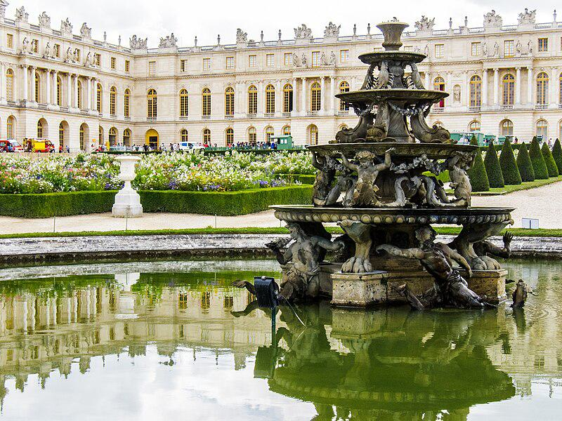

Caption for image source 1: Palace of Versailles 20130810 - fountain 2.

Example Question - "How many bowls does the statue in the middle of the fountain at the Palace of Versailles have?"

Example Answer - "There are four bowls on the statue in the middle of the fountain at the Palace of Versailles."

Additional Text Source 1 - For many years the palace was seldom used, even neglected. In 1864, a note was found pinned to the fence of Buckingham Palace, saying: "These commanding premises to be let or sold, in consequence of the late occupant's declining business." (from: Buckingham Palace)

Generated Question - Considering the neglect mentioned in the additional text, does the fountain at the Palace of Versailles appear well-maintained or neglected?

Generated Answer - The fountain at the Palace of Versailles appears well-maintained despite the neglect mentioned in the additional text.

--- Entry for custom_id: d5c886de0dba11ecb1e81171463288e9 ---

Image Source 1 -



Caption for image source 1: 'Echinops ritro' southern globethistle in Walled Garden of Parham House, West Sussex, England Echinops ritro, otherwise southern globethistle, in the Walled Garden of Parham House, in West Sussex, England..

Example Question - "Are the buds of the Echinops ritro wider than the stems?"

Example Answer - "The buds of the Echinops ritro are wider than the stems."

Additional Text Source 1 - Echinops adenocaulos is a species of flowering plant in the sunflower family, Asteraceae. It is native to Israel, Palestine, Jordan, Syria, and Lebanon. (from: Echinops adenocaulos)

Generated Question - Are the flower buds of Echinops ritro and Echinops adenocaulos similar in shape and size compared to their stems?

Generated Answer - Yes, both have round flower buds that are wider than their stems.

--- Entry for custom_id: d5c876da0dba11ecb1e81171463288e9 ---

Image Source 1 -

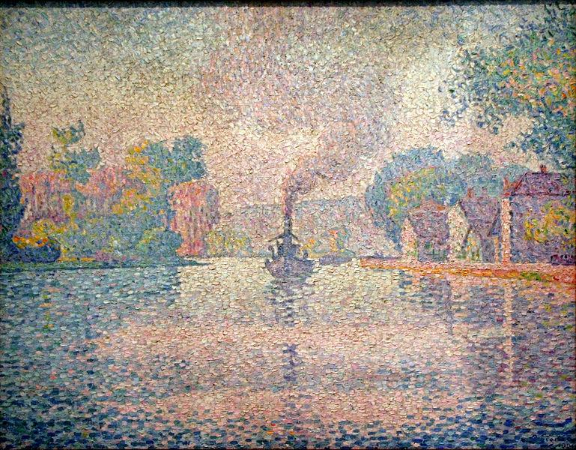

Caption for image source 1: Paul Signac - L'Hirondelle Steamer on the Seine.

Image Source 2 -



Caption for image source 2: Georges Seurat 027.

Example Question - "Which painting shows the darkest and clearest trees; Seine River in Courbevoie or L'Hirondelle Steamer on the Seine?"

Example Answer - "The Seine River in Courbevoie has the darkest and clearest trees."

Additional Text Source 1 - Courbevoie (French pronunciation: [kuʁbəvwa] (listen)) is a commune located in the Hauts-de-Seine Department of the Île-de-France region of France. It is in the suburbs of the city of Paris, 8.2 km (5.1 mi) from the center of Paris. (from: Courbevoie)

Generated Question - Which painting likely depicts a scene closer to Paris, L'Hirondelle Steamer on the Seine or Seine River in Courbevoie?

Generated Answer - Seine River in Courbevoie likely depicts a scene closer to Paris since Courbevoie is a suburb of Paris.

--- Entry for custom_id: d5d9ee1a0dba11ecb1e81171463288e9 ---

Example Question - Those who speak the modern language of Assyrian Neo-Aramaic can trace their descendants back to the which ancient civilization?

Example Answer - Speakers of the Turoyo language, of which Assyrian Neo-Aramaic stems from, are descendants of peoples from ancient Mesopotamia.

Image Source 1 -

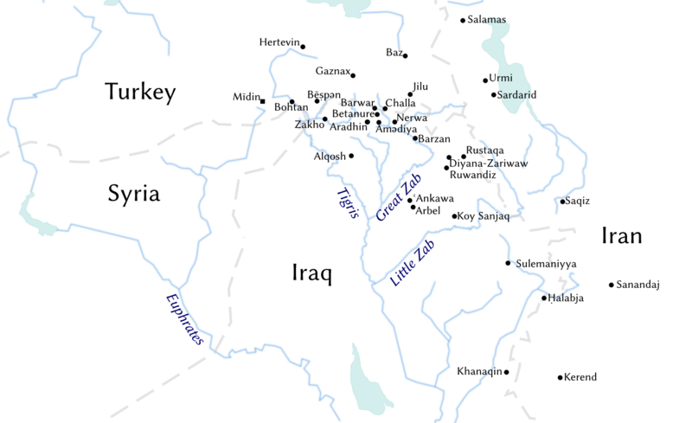

Generated Question - Are the speakers of Assyrian Neo-Aramaic and Turoyo languages from the same ancient region shown on the map where North-Eastern Neo-Aramaic varieties are spoken?

Generated Answer - Yes, both languages' speakers descend from ancient Mesopotamia, the region shown on the map.

--- Entry for custom_id: d5d582ee0dba11ecb1e81171463288e9 ---

Example Question - Who was the paternal grandfather of King Diomedes of Thrace?

Example Answer - Zeus was the paternal grandfather of King Diomedes of Thrace.

Image Source 1 -

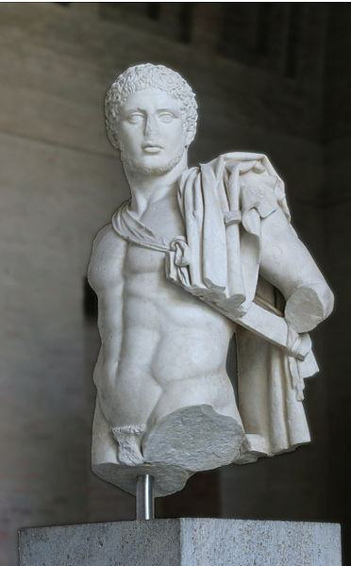

Generated Question - Was the King Diomedes of Thrace depicted in the statue the same as the King Diomedes of Argos in Greek mythology?

Generated Answer - No, King Diomedes of Thrace and King Diomedes of Argos are different figures in Greek mythology.

--- Entry for custom_id: d5c60db40dba11ecb1e81171463288e9 ---

Image Source 1 -

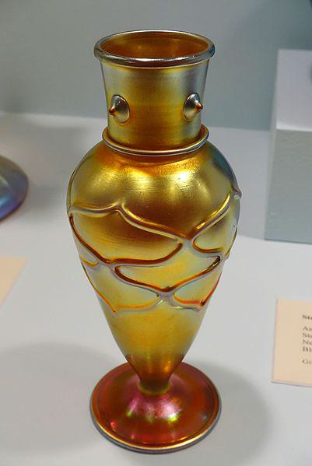

Caption for image source 1: Aurene vase, Steuben Division of Corning Glass Works, New York, 1900-1925, blown iridescent glass - Krannert Art Museum, UIUC - DSC06575 Exhibit in the Krannert Art Museum, University of Illinois at Urbana-Champaign - Urbana-Champaign, Illinois, USA. This work is old enough so that it is in the public domain..

Example Question - "Is the Aurene vase at the Exhibit in the Krannert Art Museum, University of Illinois at Urbana-Champaign - Urbana-Champaign, Illinois, USA completely smooth or textured?"

Example Answer - "The Aurene vase at the Exhibit in the Krannert Art Museum is textured."

Additional Text Source 1 - The Krannert Art Museum is a fine art museum located at the University of Illinois at Urbana-Champaign in Champaign, Illinois, United States. It has 48,000 square feet (4,500 m2) of space devoted to all periods of art, dating from ancient Egypt to contemporary photography. (from: Krannert Art Museum)

Generated Question - Is the Aurene vase at the Krannert Art Museum part of a collection that includes art from ancient Egypt to contemporary photography?

Generated Answer - Yes, the Krannert Art Museum's collection spans from ancient Egypt to contemporary photography.

--- Entry for custom_id: d5d4342a0dba11ecb1e81171463288e9 ---

Example Question - In which document could you find both the Due process clause and Article Five of the Constitution?

Example Answer - US Constitution

Image Source 1 -



Generated Question - How does the failure of the European Constitution relate to the amendment process described in Article Five of the US Constitution?

Generated Answer - The European Constitution failed due to negative votes, unlike the US Constitution which requires proposal and ratification for amendments.

--- Entry for custom_id: d5c81a820dba11ecb1e81171463288e9 ---

Image Source 1 -

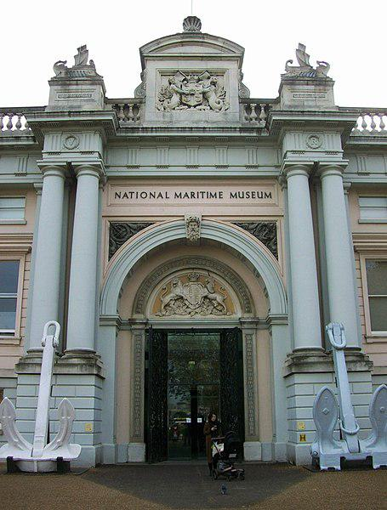

Caption for image source 1: National Maritime Museum, main entrance National Maritime Museum, Greenwich, main entrance.

Example Question - "How many large anchors are visible just outside the entrance of the National Maritime Museum?"

Example Answer - "There are two large anchors visible just outside the entrance of the National Maritime Museum."

Additional Text Source 1 - The Australian National Maritime Museum (ANMM) is a federally operated maritime museum in Darling Harbour, Sydney. After considering the idea of establishing a maritime museum, the federal government announced that a national maritime museum would be constructed at Darling Harbour, tied into the New South Wales state government's redevelopment of the area for the Australian bicentenary in 1988. (from: Australian National Maritime Museum)

Generated Question - Are the National Maritime Museum in Greenwich and the Australian National Maritime Museum located in the same country?

Generated Answer - No, the National Maritime Museum in Greenwich is in the UK, and the Australian National Maritime Museum is in Australia.

--- Entry for custom_id: d5ccb4d40dba11ecb1e81171463288e9 ---

Image Source 1 -

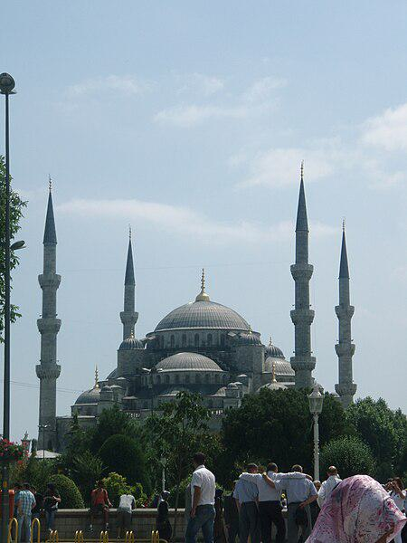

Caption for image source 1: Blue Mosque, Istanbul Turkey Blue Mosque, Istanbul Turkey.

Image Source 2 -

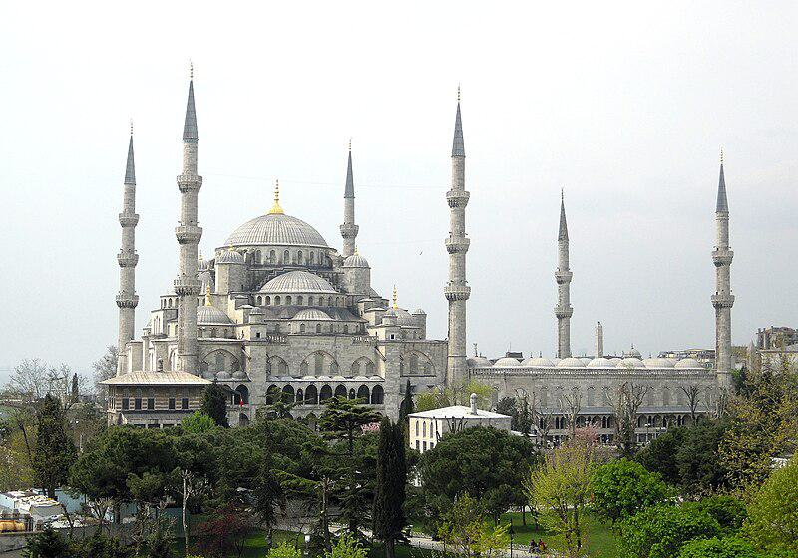

Caption for image source 2: The Blue Mosque The Sultan Ahmed Mosque or Sultan Ahmet Camii or the Blue Mosque in Istanbu, Turkey.

Example Question - "Are there more than four spires on the Blue mosque Istanbul?"

Example Answer - "Yes, there are more than four spires on the Blue Mosque in Istanbul."

Additional Text Source 1 - The New Mosque (Turkish: Yeni Cami, pronounced [jeni dʒami], originally named the Valide Sultan Mosque, Turkish: Valide Sultan Camii) and later New Valide Sultan Mosque (Turkish: Yeni Valide Sultan Camii) after its partial reconstruction and completion between 1660 and 1665, is an Ottoman imperial mosque located in the Eminönü quarter of Istanbul, Turkey. (from: New Mosque, Istanbul)

Generated Question - Does the New Mosque in Istanbul have more or fewer spires compared to the Blue Mosque shown in the images?

Generated Answer - The New Mosque has fewer spires than the Blue Mosque, which has six spires.

--- Entry for custom_id: d5d6341e0dba11ecb1e81171463288e9 ---

Example Question - Bayezid II was the son of who that defeated the crusade led by John Hunyadi after the Hungarian incursions into his country broke the conditions of the truce Peace of Szeged?

Example Answer - Mehmed.

Image Source 1 -

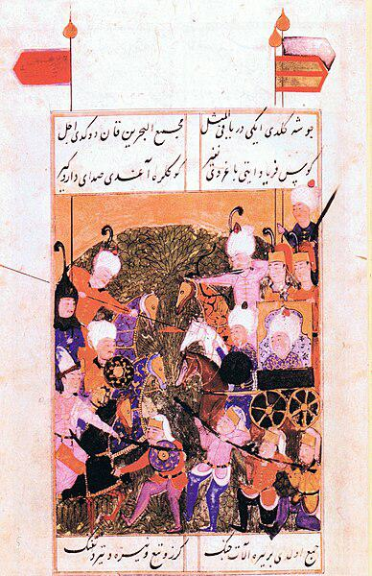

--- Entry for custom_id: d5cb5a260dba11ecb1e81171463288e9 ---

Image Source 1 -

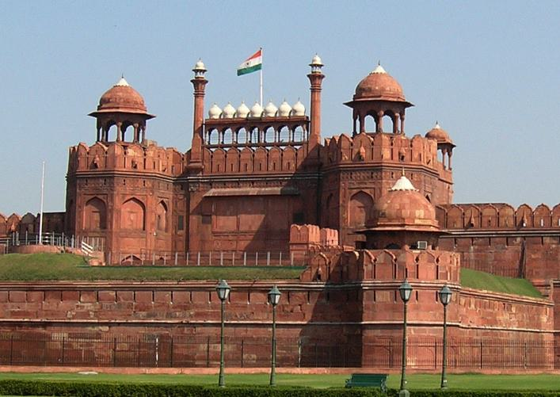

Caption for image source 1: Red Fort, Delhi by alexfurr (2).

Example Question - "What is the tallest object at the Red Fort in Delhi?"

Example Answer - "A flagpole flying the Indian flag is the tallest object at the Red Fort in Delhi."

Additional Text Source 1 - Likewise, the postmortem also ascertained the cause of death as "shock and hemorrhage due to antemortem injuries". A section of the farmers reached and entered the historic Red Fort of Delhi and hoisted religious flags from the ramparts and climbed up the domes of the fort. (from: 2021 Farmers' Republic Day protest)

Generated Question - Did the farmers who entered the Red Fort during the 2021 protest hoist the Indian flag or religious flags on the fort?

Generated Answer - The farmers hoisted religious flags, not the Indian flag, on the Red Fort during the protest.

--- Entry for custom_id: d5c2f66a0dba11ecb1e81171463288e9 ---

Image Source 1 -

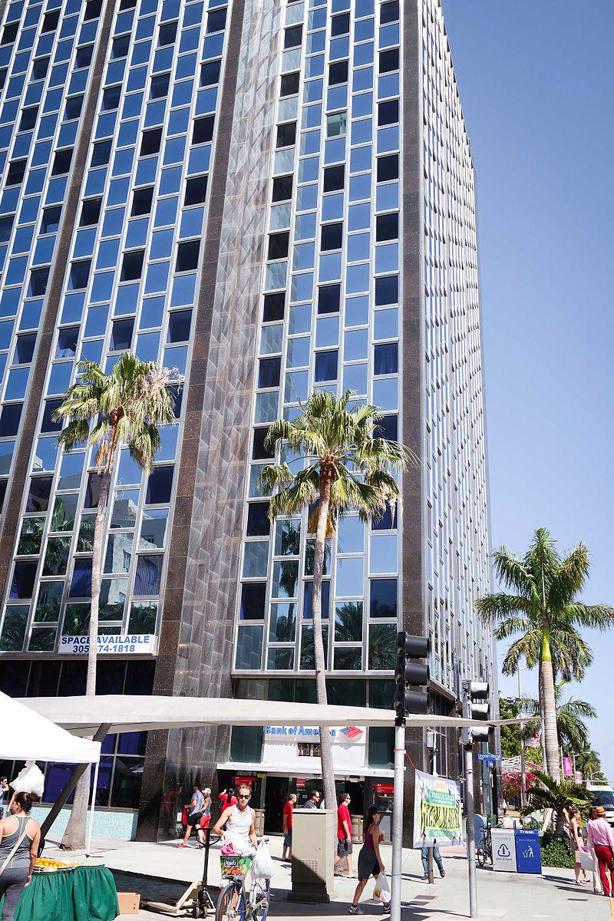

Caption for image source 1: 407 Lincoln Road (Miami Beach) 02 407 Lincoln Road on Lincoln Road Mall in Miami Beach, Florida.

Example Question - "Can you spot at least three palm trees at 407 Lincoln Rd in Miami?"

Example Answer - "You can spot at least three palm trees at 407 Lincoln Rd in Miami."

Additional Text Source 1 - Palm oil is obtained from the fruits of the oil palm (Elaeis guineensis). The fruits of the cocoa tree (Theobroma cacao) are used to make cocoa and chocolate and the berries of coffee trees, Coffea arabica and Coffea canephora, are processed to extract the coffee beans. (from: Tree)

Generated Question - Are the palm trees visible at 407 Lincoln Road related to the trees that produce palm oil, cocoa, or coffee?

Generated Answer - The palm trees at 407 Lincoln Road are related to the oil palm that produces palm oil, not cocoa or coffee trees.

--- Entry for custom_id: d5d53fc80dba11ecb1e81171463288e9 ---

Example Question - Where are the inedible mushrooms held by thin pinkish-white stems and has four-spored basidia found in?

Example Answer - Asia, Europe, and North America.

Image Source 1 -



Generated Question - Are the waxy, creamy white gills of the mushroom consistent with the inedible Mycena adonis found in acidic environments?

Generated Answer - Yes, the waxy, creamy white gills match the Mycena adonis characteristics.

--- Entry for custom_id: d5c419280dba11ecb1e81171463288e9 ---

Image Source 1 -

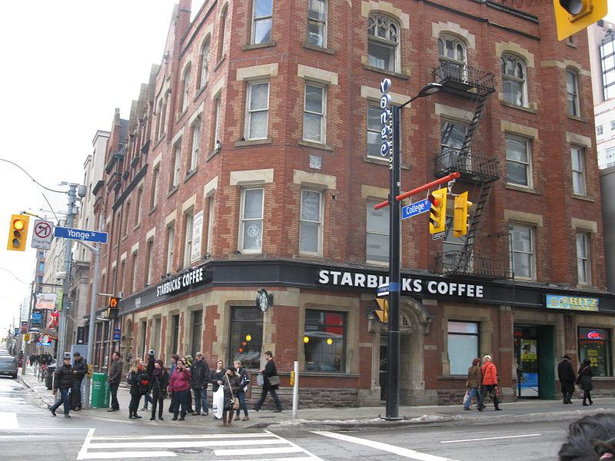

Caption for image source 1: Starbucks NW corner of Yonge and College, 2013 02 23 -a.

Example Question - "Are the window trim colors of the Starbucks in the building at the NW corner of Young and College in Toronto the same as the window trim colors in the rest of the building?"

Example Answer - "No, the window trim colors of the Starbucks in the building at the northwest corner of Young and College in Toronto are not the same as the window trim colors in the rest of the building."

Additional Text Source 1 - McElroy CommonsLocated on the Southwest Corner of middle campus, McElroy is referred to by students as 'Mac', reflecting the common, but incorrect, pronunciation of the building's name. McElroy Commons holds a variety of offices and contains Carney's Dining Hall which serves the majority of students living on College Road and Upper Campus. (from: Boston College)

Generated Question - Is the Starbucks at the NW corner of Yonge and College in Toronto located on the same corner as McElroy Commons at Boston College?

Generated Answer - No, Starbucks is at Yonge and College in Toronto, while McElroy Commons is at Boston College's southwest middle campus.

--- Entry for custom_id: d5c1644e0dba11ecb1e81171463288e9 ---

Image Source 1 -



Caption for image source 1: Wood Warbler - Pantelleria - Italy 3521 (19079866170) (2).

Image Source 2 -

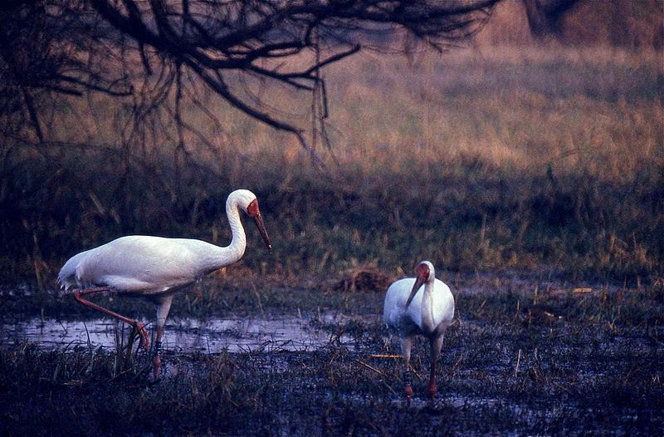

Caption for image source 2: Siberian Cranes (Grus leucogeranus) (19810170143).

Example Question - "Which bird's long legs make it more suited to marshes and hunting for food there; Grus leucogeranus or Wood Warbler?"

Example Answer - "Grus leucogeranus's long legs make it more suited to marshes and hunting for food there."

Additional Text Source 1 - The Siberian crane (Leucogeranus leucogeranus), also known as the Siberian white crane or the snow crane, is a bird of the family Gruidae, the cranes. (from: Siberian crane)

Generated Question - Which bird belongs to the Gruidae family and is better adapted to marshy environments, the Wood Warbler or the Siberian crane?

Generated Answer - The Siberian crane belongs to the Gruidae family and is better adapted to marshy environments.

--- Entry for custom_id: d5da23300dba11ecb1e81171463288e9 ---

Example Question - Besides Shuangcheng District, Daowai District and Xiangfang District, how many other districts are in the capital of Heilongjiang Province?

Example Answer - 6

Image Source 1 -

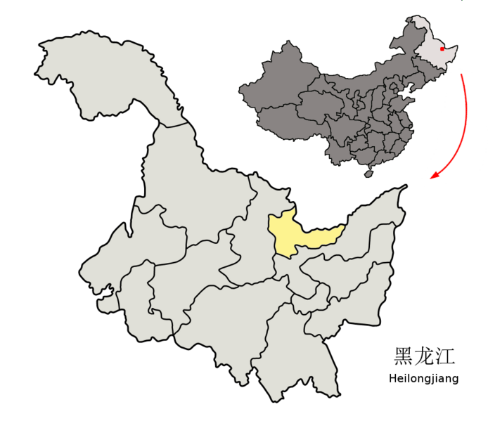

--- Entry for custom_id: d5bdf4080dba11ecb1e81171463288e9 ---

Image Source 1 -

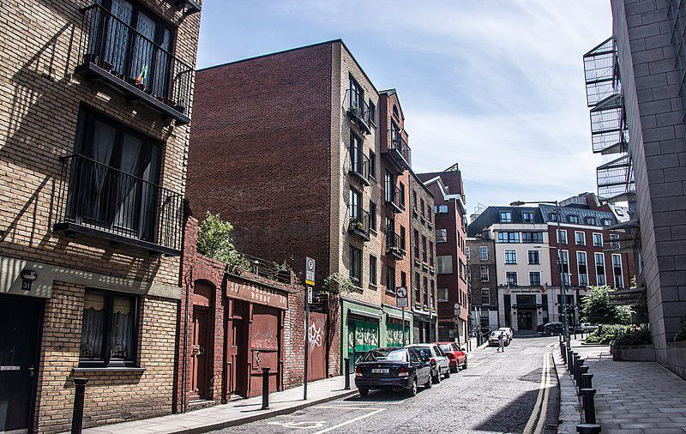

Caption for image source 1: Fishamble Street is a street in Dublin within the old city walls. - panoramio.

Image Source 2 -

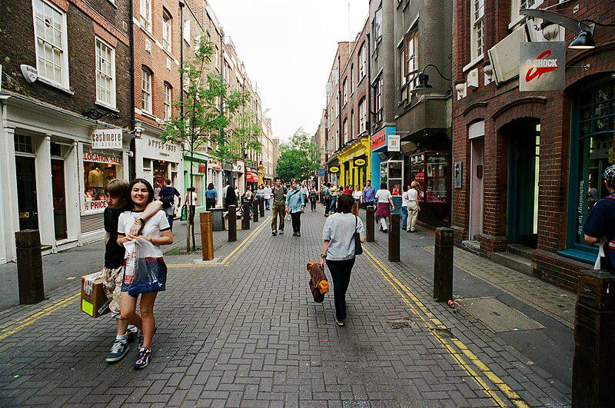

Caption for image source 2: Neal Street, Covent Garden London 1998 Neal Street, Covent Garden, London1998, looking south. Shot on film..

Example Question - "Do both Neal Street in Covent Garden London and Fishamble Street in Dublin have short poles along the sidewalk?"

Example Answer - "Yes, both Neal Street in Covent Garden London and Fishamble Street in Dublin have short poles along the sidewalk."

Additional Text Source 1 - Fishamble Street is also home to Darkey Kelly's, a well known Dublin music pub. It was named after Dorcas Kelly, who ran a popular brothel in the street in the 1750s and was executed for murder in 1761. (from: Fishamble Street)

Generated Question - Do both Fishamble Street in Dublin and Neal Street in Covent Garden London have shops or businesses along the street?

Generated Answer - Yes, both streets have shops or businesses lining the street.

--- Entry for custom_id: d5c3dd140dba11ecb1e81171463288e9 ---

Image Source 1 -

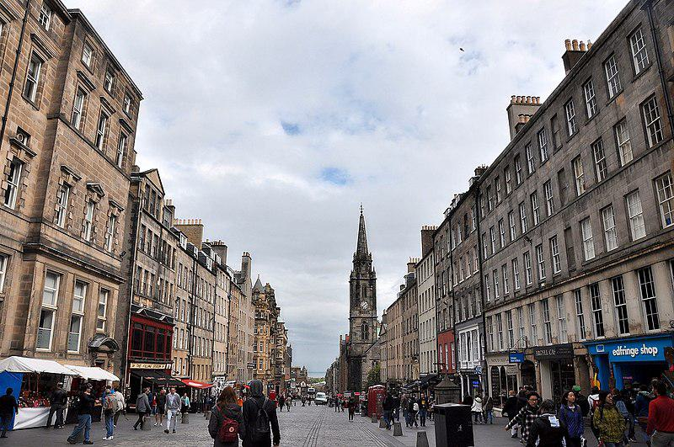

Caption for image source 1: Edinburgh, Royal Mile (38560568346).

Example Question - "Is there an edfringe shop on Royal Mile, Edinburgh, Scotland?"

Example Answer - "Yes, there is an edfringe shop on Royal Mile, Edinburgh, Scotland."

Additional Text Source 1 - The term was first used descriptively in W M Gilbert's Edinburgh in the Nineteenth Century (1901), "...with its Castle and Palace and the royal mile between", and was further popularised as the title of a guidebook by R T Skinner published in 1920, "The Royal Mile (Edinburgh) (from: Royal Mile)

Generated Question - Does the Royal Mile in Edinburgh have historic buildings lining both sides of the street?

Generated Answer - Yes, the Royal Mile in Edinburgh has historic buildings on both sides of the street.

--- Entry for custom_id: d5cabbb60dba11ecb1e81171463288e9 ---

Image Source 1 -

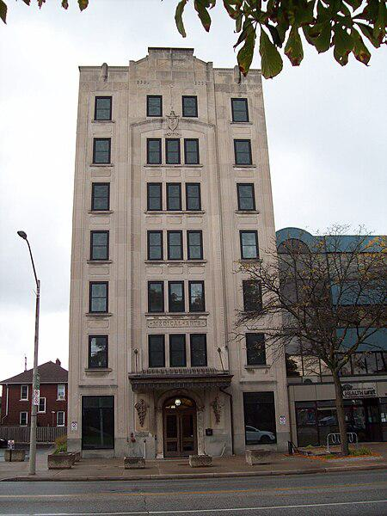

Caption for image source 1: Medical Arts Building 1011, Ouellette Avenue (2).

Image Source 2 -

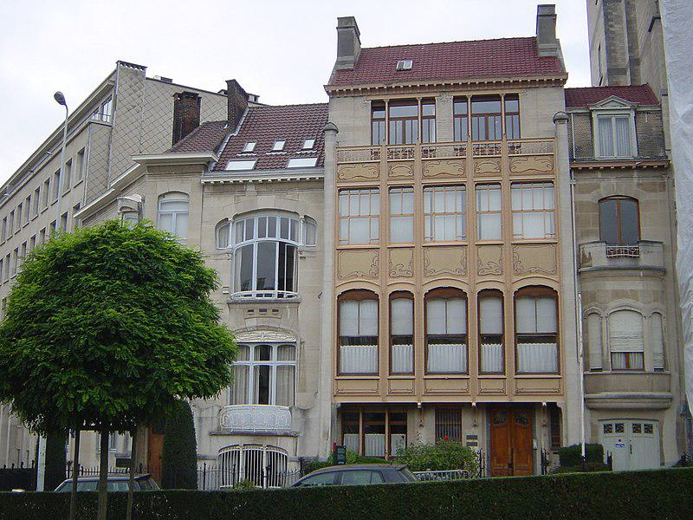

Caption for image source 2: Art Nouveau houses, Avenue Palmerston Hotel Edmond Van Eetvelde and extension.

Example Question - "Does the door on the Medical Arts Building have more glass in it than the front door on the Hôtel Edmond Van Eetvelde?"

Example Answer - "The door on the Medical Arts Building has more glass in it than the front door on the Hôtel Edmond Van Eetvelde."

Additional Text Source 1 - The Hôtel van Eetvelde (French: Hôtel van Eetvelde, Dutch: Hotel van Eetvelde) is a town house designed in 1895 by Victor Horta for Edmond van Eetvelde, administrator of Congo Free State. It is located at 4, avenue Palmerston/Palmerstonlaan in Brussels, Belgium. (from: Hôtel van Eetvelde)

Generated Question - Are both the Medical Arts Building and Hôtel van Eetvelde designed primarily for residential or professional use?

Generated Answer - The Medical Arts Building is for professional use, while Hôtel van Eetvelde is a residential town house.

--- Entry for custom_id: d5c750a20dba11ecb1e81171463288e9 ---

Image Source 1 -

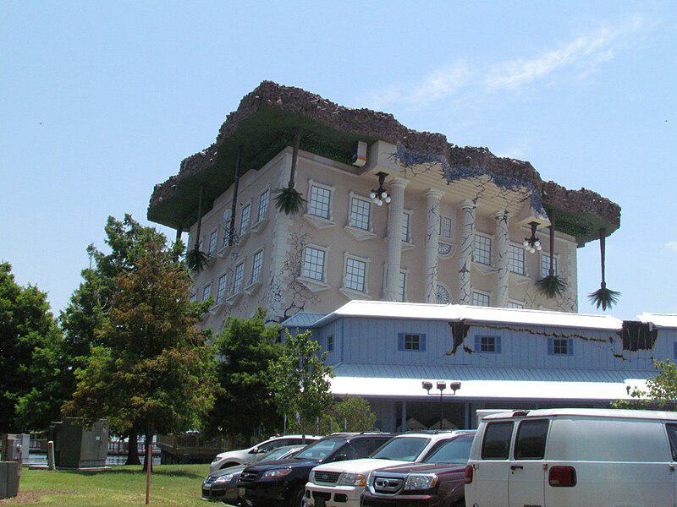

Caption for image source 1: WonderWorks Myrtle Beach, USA WonderWorks at Broadway at the Beach in Myrtle Beach, USA.

Example Question - "Are there any trees near the WonderWorks building at Broadway at the Beach in Myrtle Beach that are taller than the building?"

Example Answer - "No, there aren't any trees nearby that are taller than the WonderWorks building."

Additional Text Source 1 - Burroughs died in 1897, but his sons completed the railroad's expansion to the beach and opened the Seaside Inn in 1901.Around 1900, a contest was held to name the area, and Burroughs's wife suggested honoring the locally abundant shrub, the southern wax myrtle (Myrica cerifera). The Withers post office changed its name to "Myrtle Beach" soon afterward. (from: Myrtle Beach, South Carolina)

Generated Question - Is the WonderWorks building at Broadway at the Beach surrounded by natural vegetation similar to the southern wax myrtle that gave Myrtle Beach its name?

Generated Answer - Yes, the WonderWorks building is surrounded by trees and greenery like the southern wax myrtle.

--- Entry for custom_id: d5d368240dba11ecb1e81171463288e9 ---

Example Question - What is the common sizing between Chicoreus Cervicornis and Chicoreus Miyokoae?

Example Answer - Chicoreus Cervicornis and Chicoreus Miyokoae both grow to be between 45-75mm.

Image Source 1 -

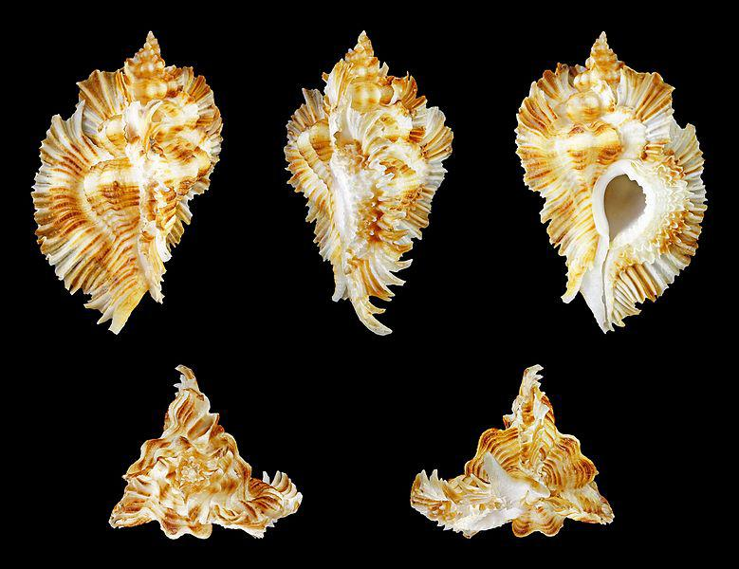

Generated Question - Do Chicoreus miyokoae and Chicoreus cervicornis share similar shell size ranges and family classification?

Generated Answer - Yes, both belong to the Muricidae family and have shell sizes ranging from about 40-78 mm.

--- Entry for custom_id: d5d754980dba11ecb1e81171463288e9 ---

Example Question - In which administrative region of Canada are both the rivière aux Anglais and the lac de la Rivière aux Anglais located?

Example Answer - They are both located in the administrative region of Côte-Nord.

Image Source 1 -

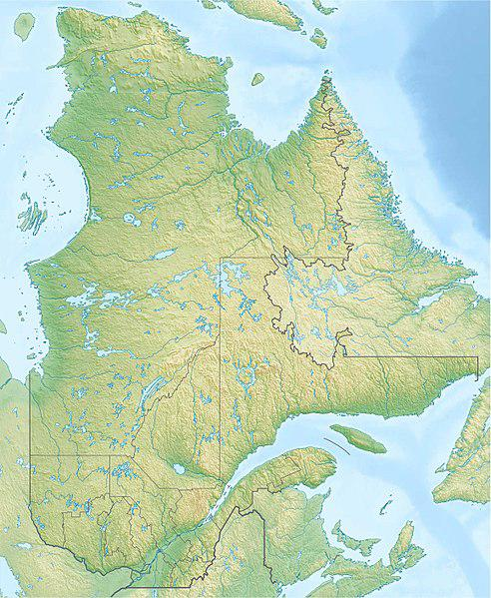

Generated Question - Are both the rivière aux Anglais and lac de la Rivière aux Anglais located within the same regional county municipality in Quebec?

Generated Answer - Yes, both are located in the Manicouagan Regional County Municipality.

--- Entry for custom_id: d5d71f5a0dba11ecb1e81171463288e9 ---

Example Question - Who maintains MS 1?

Example Answer - Mississippi Department of Transportation

Image Source 1 -

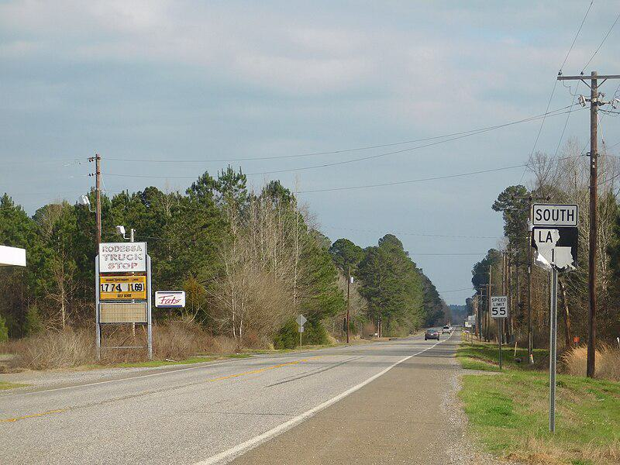

Generated Question - Does Mississippi Highway 1 connect directly to Louisiana Highway 1 as shown in the image?

Generated Answer - Yes, MS 1 continues south and connects to LA 1 at the state border.

--- Entry for custom_id: d5c995ba0dba11ecb1e81171463288e9 ---

Image Source 1 -

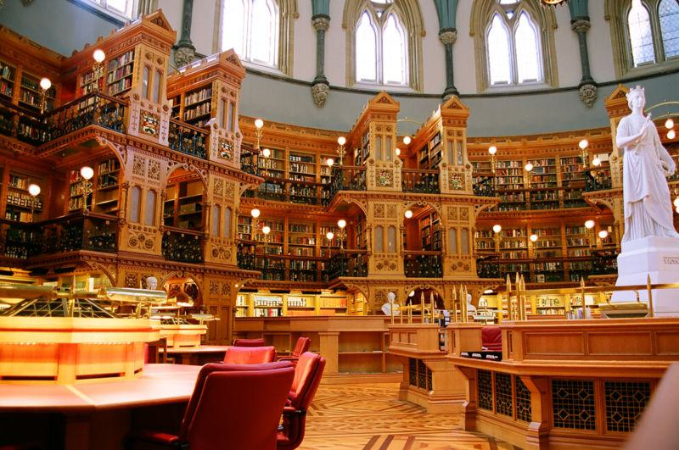

Caption for image source 1: LibraryReadingRoom.

Example Question - "Are the bookcases of the Library of Parliament reading room in Canada located only on ground floor or multiple floors?"

Example Answer - "The bookcases are on multiple floors."

Additional Text Source 1 - Therefore, the words "ground floor" and "first floor" are interchangeable. The "Lower" and "Upper Ground Floor" tagging may also be used by malls and some office buildings that have one partially-lowered and another partially-raised ground level, both of which are accessible to the actual ground level by stairs or escalators. (from: Storey)

Generated Question - Are the bookcases in the Library of Parliament reading room arranged on multiple levels similar to how some buildings have multiple ground floors?

Generated Answer - Yes, the bookcases are arranged on multiple levels, like buildings with multiple accessible ground floors.

--- Entry for custom_id: d5d2eda40dba11ecb1e81171463288e9 ---

Example Question - In 1992 was George Bush's popular vote margin of victory over Bill Clinton larger in the state of Idaho or Arizona?

Example Answer - Bush's margin of victory was larger in Idaho.

Image Source 1 -

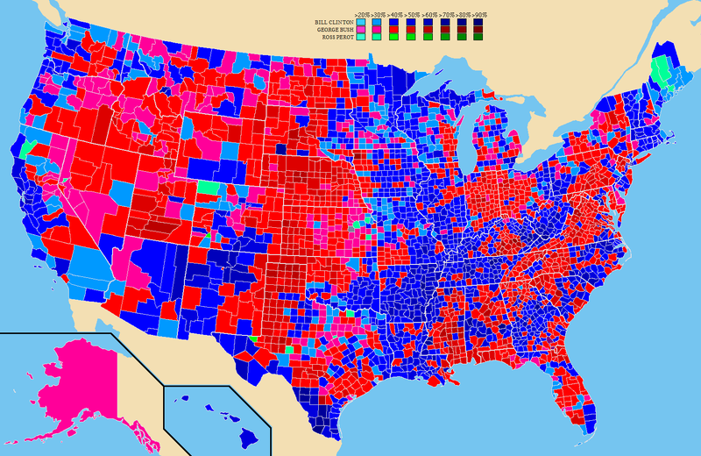

Generated Question - Based on the 1992 election map, did Ross Perot win any counties in Arizona or Idaho?

Generated Answer - Ross Perot did not win any counties in Arizona or Idaho.

--- Entry for custom_id: d5c1e7340dba11ecb1e81171463288e9 ---

Image Source 1 -

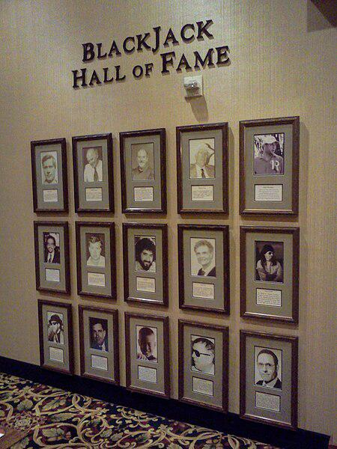

Caption for image source 1: Blackjack Hall of Fame The Blackjack Hall of Fame at the Barona Casino.

Example Question - "How many photographs are on the wall at the The Blackjack Hall of Fame at the Barona Casino?"

Example Answer - "There are fifteen photographs on the wall."

Additional Text Source 1 - The Hall of Fame is at the Barona Casino in San Diego. Members include Edward O. Thorp, author of the 1960s book Beat the Dealer; Ken Uston, who popularized the concept of team play; Arnold Snyder, author and editor of the Blackjack Forum trade journal; and Stanford Wong, author and popularizer of "Wonging". (from: Blackjack)

Generated Question - Are any members of the Blackjack Hall of Fame at Barona Casino known for authoring influential blackjack books?

Generated Answer - Yes, members like Edward O. Thorp and Stanford Wong are known for authoring influential blackjack books.

--- Entry for custom_id: d5c73d4c0dba11ecb1e81171463288e9 ---

Image Source 1 -



Caption for image source 1: Schoolsign-ishr-2 Sign at the entrance of the International School Hannover Region.

Example Question - "Is the top or the bottom line of text on the sign at the entrance of the International School Hannover Region written in the bolder font?"

Example Answer - "The top line of text on the sign at the entrance of the International School Hannover Region is written in a bolder font."

Additional Text Source 1 - The phrase "triple bottom line" was articulated more fully by John Elkington in his 1997 book Cannibals with Forks: the Triple Bottom Line of 21st Century Business, where he adopted a question asked by the Polish poet Stanisław Lec, "Is it progress if a cannibal uses a fork?" as the opening line of his foreword. (from: Triple bottom line)

Generated Question - Does the sign at the International School Hannover Region emphasize the top or bottom line more, similar to how the "triple bottom line" concept highlights multiple aspects?

Generated Answer - The sign emphasizes the top line more, similar to how the "triple bottom line" highlights distinct key elements.

--- Entry for custom_id: d5d1e62a0dba11ecb1e81171463288e9 ---

Example Question - Who performed Philippe Étienne's current job in 2015?

Example Answer - Gérard Araud performed this job in 2015.

Image Source 1 -

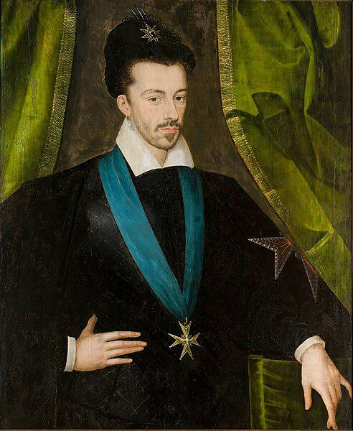

Generated Question - Could Henry III have served as the French Ambassador to the United States like Philippe Étienne and Gérard Araud?

Generated Answer - No, Henry III lived centuries before the United States existed.

--- Entry for custom_id: d5bbfc660dba11ecb1e81171463288e9 ---

Image Source 1 -

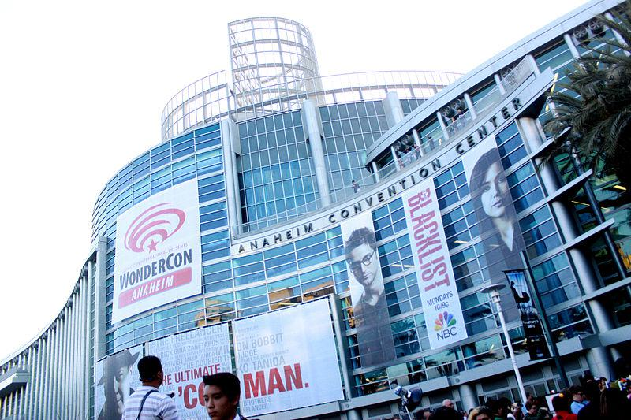

Caption for image source 1: Anaheim Convention Center (13909340482).

Image Source 2 -

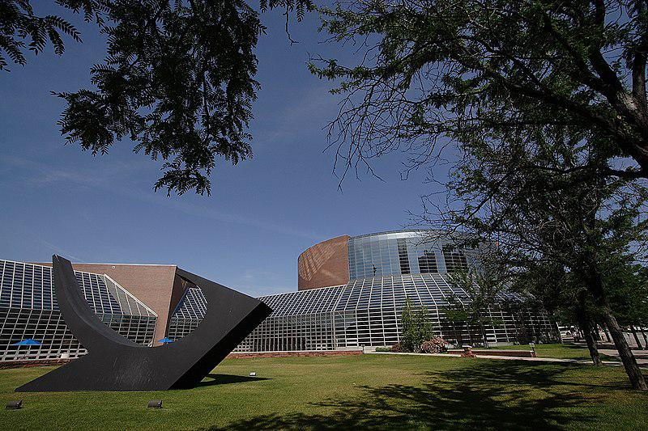

Caption for image source 2: Peoria Civic Center.

Example Question - "Are both the Peoria Civic Center and the Anaheim Convention Center made up of mostly windows?"

Example Answer - "Yes, the outsides of both buildings are largely made up of glass windows."

Additional Text Source 1 - This music-equipment convention (trade only, not open to the general public) had 1,560 exhibitors and a record-breaking 88,100 attendees during the 2008 show. The NAMM Show has been running at the Anaheim Center since 1977, except for a three-year break in 1998–2000 while the Convention Center underwent major renovations. (from: Anaheim Convention Center)

Generated Question - Has the Anaheim Convention Center hosted large events like the NAMM Show while the Peoria Civic Center is known for its distinctive outdoor sculpture?

Generated Answer - Yes, Anaheim hosts large events like NAMM, while Peoria Civic Center features a notable outdoor sculpture.

--- Entry for custom_id: d5d26d480dba11ecb1e81171463288e9 ---

Example Question - Aristarchus and Couder are both what?

Example Answer - Lunar impact craters

Image Source 1 -

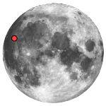

Generated Question - Which crater is located in the northwest near side of the Moon and is known for its brightness compared to the other crater in eastern Oceanus Procellarum?

Generated Answer - Aristarchus is located in the northwest near side and is known for its brightness.

--- Entry for custom_id: d5cc15740dba11ecb1e81171463288e9 ---

Image Source 1 -

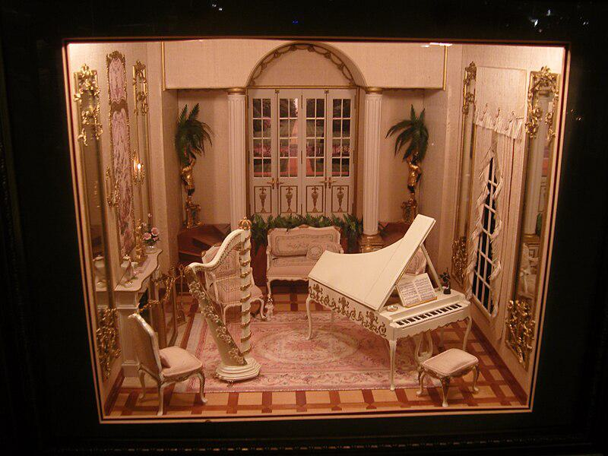

Caption for image source 1: Miniatures Museum of Taiwan Miniatures Museum of Taiwan.

Example Question - "Is the top of the piano next to the harp in the display at the Miniatures Museum of Taiwan open or closed?"

Example Answer - "The top of the piano in the display at the Miniatures Museum of Taiwan is open."

Additional Text Source 1 - Taiwan's museum is the first to specialize in contemporary miniatures and features two formats: "doll house" and room box with cut away views. (from: Miniatures Museum of Taiwan)

Generated Question - Does the Miniatures Museum of Taiwan display miniature rooms with cut-away views or fully enclosed dollhouse styles?

Generated Answer - It features both cut-away room boxes and fully enclosed dollhouse styles.

--- Entry for custom_id: d5d5cdf80dba11ecb1e81171463288e9 ---

Example Question - The most accepted theory says that disorders that disrupt the formation of neurons and their migration happens during what months of fetal life?

Example Answer - Second to fifth months

Image Source 1 -



Generated Question - How does the neuronal migration disorder shown in the MRI relate to the enlargement of occipital horns in colpocephaly?

Generated Answer - The disorder disrupts neuron migration, causing occipital horn enlargement in colpocephaly.

--- Entry for custom_id: d5cd273e0dba11ecb1e81171463288e9 ---

Image Source 1 -

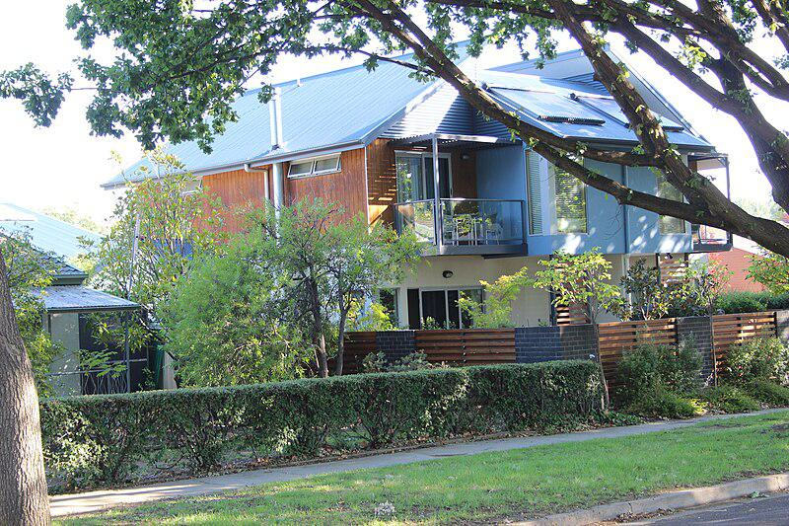

Caption for image source 1: Dooring st, Dickson New flats in Dooring St, Dickson.

Image Source 2 -

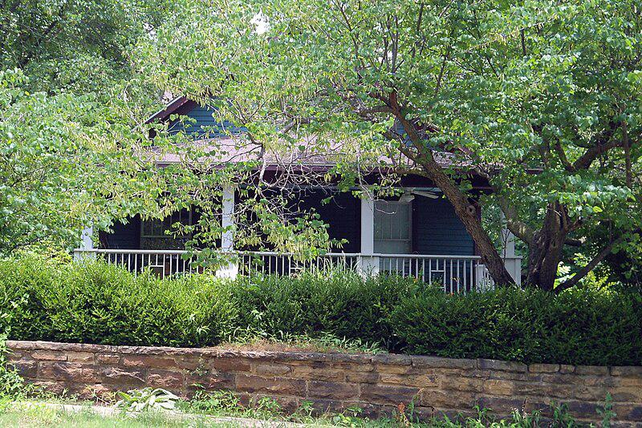

Caption for image source 2: 218 E Dickson Street, Washington-Willow Historic District, Fayetteville, Arkansas House at 218 E Dickson Street, Washington-Willow Historic District, Fayetteville, Arkansas.

Example Question - "What obscures the view from the street of both the House at 218 E Dickson Street and the New flats in Dooring St, Dickson?"

Example Answer - "Trees obscure the view from the street of both the House at 218 E Dickson Street and the New flats in Dooring St, Dickson."

Additional Text Source 1 - Following the funeral across the street from his house at Christ Episcopal Church of Riverdale, Gehrig's remains were cremated on June 4 at Kensico Cemetery in Valhalla, New York, which is 21 miles (34 km) north of Yankee Stadium in suburban Westchester County. Gehrig's ashes were locked into a crypt in the stone monument marking his grave. (from: Lou Gehrig)

Generated Question - Are the houses in Dooring St, Dickson and 218 E Dickson Street both surrounded by natural elements, unlike Lou Gehrig's final resting place?

Generated Answer - Yes, both houses are surrounded by trees and greenery, unlike Gehrig's crypt in a cemetery.

--- Entry for custom_id: d5d4438e0dba11ecb1e81171463288e9 ---

Example Question - Are Opioid receptors and the G cell located in the same part of the body?

Example Answer - No, Opioid receptors are part of the central nervous system and the G cell is part of the stomach and duodenum.

Image Source 1 -



Generated Question - Do opioid antagonists like 5'-Guanidinonaltrindole target the same cells that secrete gastrin in the stomach?

Generated Answer - No, opioid antagonists target opioid receptors in the nervous system, not G cells in the stomach.

--- Entry for custom_id: d5dafabc0dba11ecb1e81171463288e9 ---

Example Question - Which one of the two fundamental particles having integral spinclasses of particles can change the type of the particle – for example changing a strange quark into an up quark?

Example Answer - Bosons

Image Source 1 -

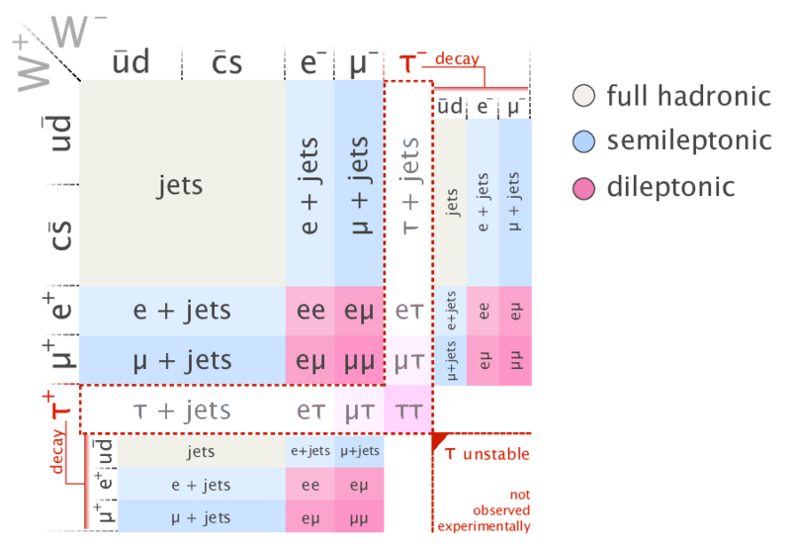

Generated Question - Can the neutral Z boson change a top quark into a different type of quark as shown in the top-quark pair decay final states?

Generated Answer - No, the neutral Z boson cannot change the type of quark.

--- Entry for custom_id: d5d7614a0dba11ecb1e81171463288e9 ---

Example Question - In what research involves such fields as electrical engineering and electromagnetics and has a cloaking process based on transformation optics?

Example Answer - Metamaterial research.

Image Source 1 -

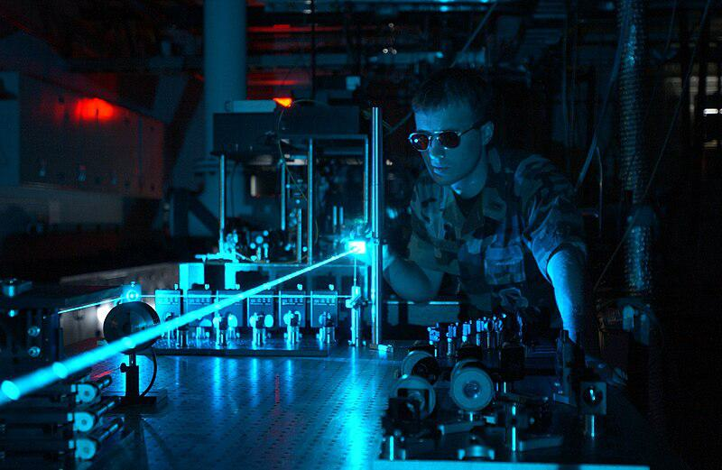

Generated Question - Which interdisciplinary research involving fields like electromagnetics and optics uses high-power laser experiments to control light propagation and achieve cloaking?

Generated Answer - Metamaterial research.

--- Entry for custom_id: d5c6c5100dba11ecb1e81171463288e9 ---

Image Source 1 -

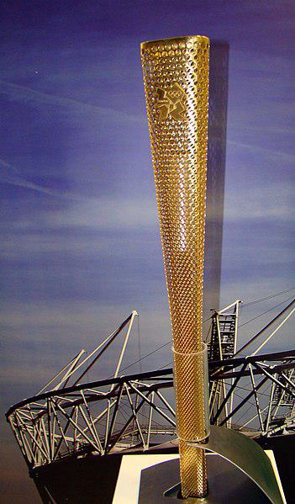

Caption for image source 1: 2012 Summer Olympics torch @ Cardiff.

Image Source 2 -

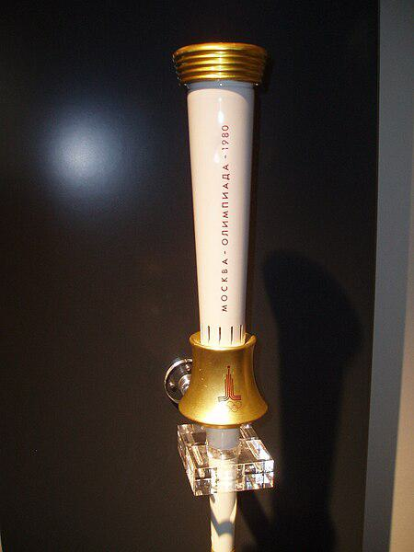

Caption for image source 2: Moscow torch.

Example Question - "Are the 2012 Summer Olympics torch and the Moscow Olympics torch both narrower at the top or the bottom?"

Example Answer - "The 2012 Summer Olympics and the Moscow Olympics torches are narrower at the bottom."

Additional Text Source 1 - The 1980 Summer Olympics, officially known as the Games of the XXII Olympiad (Russian: И́гры XXII Олимпиа́ды, tr. Igry XXII Olimpiady) and commonly known as Moscow 1980 (Russian: Москва 1980, tr. (from: 1980 Summer Olympics)

Generated Question - Do both the 2012 Summer Olympics torch and the Moscow 1980 Olympics torch have gold-colored elements?

Generated Answer - Yes, both torches have gold-colored elements.

--- Entry for custom_id: d5c873100dba11ecb1e81171463288e9 ---

Image Source 1 -

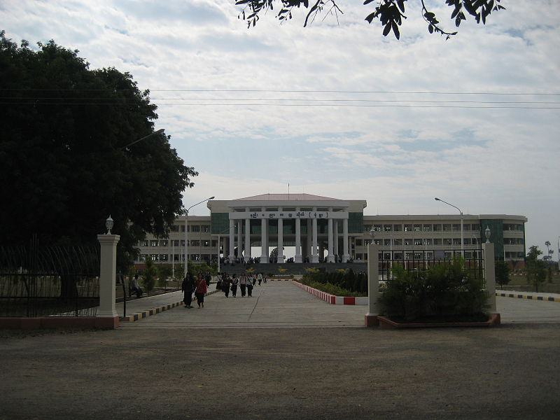

Caption for image source 1: Monywa Tech College Monywa Government Technical College.

Example Question - "Does the Monywa Tech College building have less than 2 floors?"

Example Answer - "No, the Monywa Tech College building does not have less than 2 floors."

Additional Text Source 1 - The Festival Walk mall in Hong Kong has floors labelled LG2 and LG1 ("Lower Ground 2" and "1"), G ("Ground") and UG ("Upper Ground"). In The Landmark Annex of TriNoma, DSn (n=floor) denotes the floor label of the department store area. (from: Storey)

Generated Question - Does the Monywa Tech College building have floor labels similar to those used in Festival Walk mall in Hong Kong?

Generated Answer - No, the Monywa Tech College building does not display floor labels like Festival Walk mall.

--- Entry for custom_id: d5cd9fa20dba11ecb1e81171463288e9 ---

Image Source 1 -

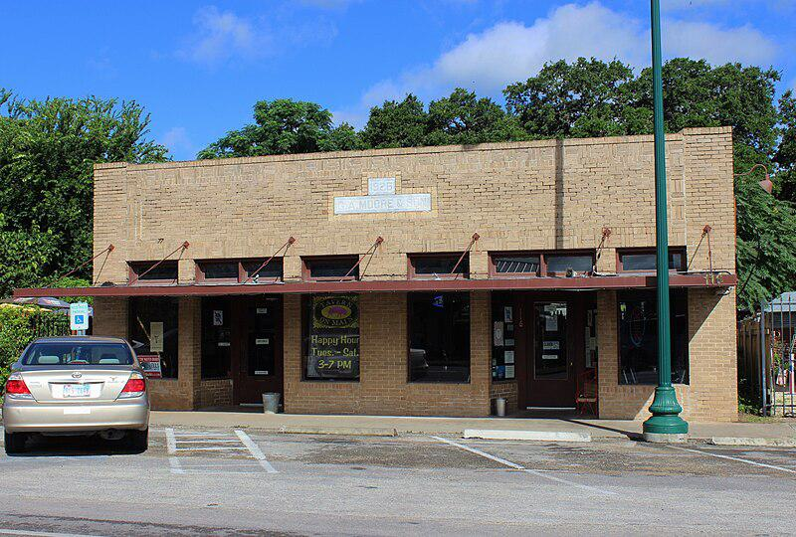

Caption for image source 1: G.A. Moore & Son Building 1926 Buda, Texas G.A. Moore & Son Building constructed in 1926. Buda, Texas..

Image Source 2 -

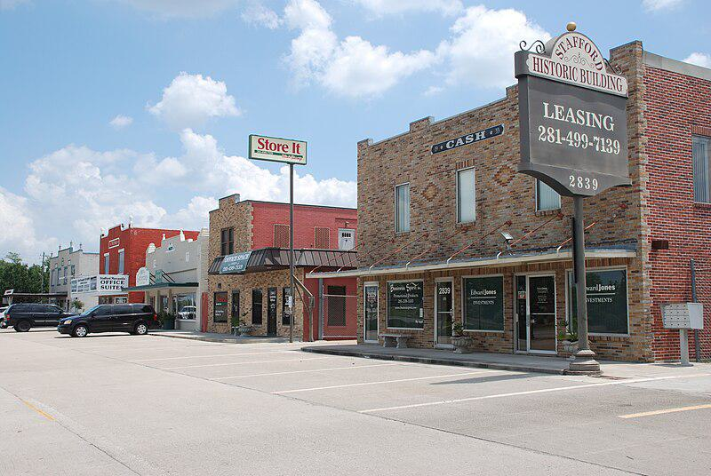

Caption for image source 2: Historic Buildings Stafford Texas DSC 3268 ad Historic buildings in Stafford, Texas, USA.

Example Question - "Do the Historic Building in Stafford, Texas and the G.A. Moore & Son Building in Buda, Texas both have parking spaces in front of them?"

Example Answer - "Yes, they both have parking spaces in front of them."

Additional Text Source 1 - Its distinctive "lily pad" columns and other innovations revived Wright's career at a point when he was losing influence. Also known as the Johnson Wax Administration Building, it and the nearby 14-story Johnson Wax Research Tower (built 1944–1950) were designated as a National Historic Landmark in 1976 as Administration Building and Research Tower, S.C. Johnson and Son. (from: Johnson Wax Headquarters)

Generated Question - Do the G.A. Moore & Son Building and the Historic Buildings in Stafford, Texas both have brick exteriors like the Johnson Wax Administration Building?

Generated Answer - Yes, both have brick exteriors, similar to the brick construction of the Johnson Wax Administration Building.

--- Entry for custom_id: d5c9c7560dba11ecb1e81171463288e9 ---

Image Source 1 -



Caption for image source 1: Peugeot 3008 20090712 front.

Image Source 2 -

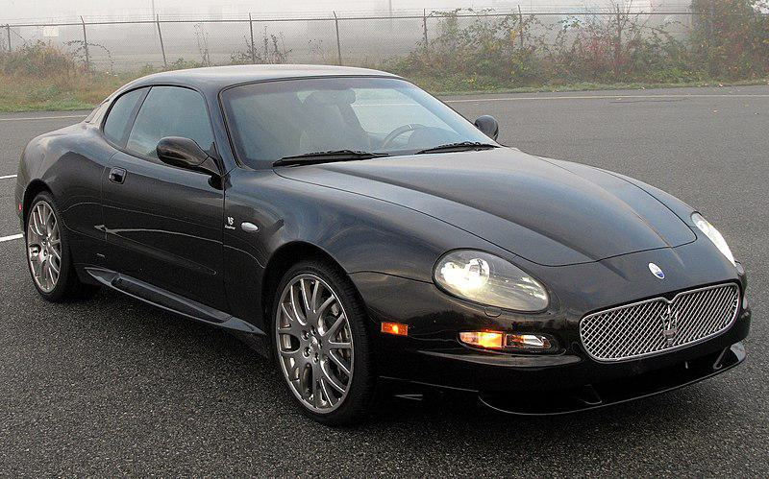

Caption for image source 2: Maserati Coupé GranSport Maserati Coupe GranSport.

Example Question - "Does a Peugeot 3008 have fewer doors than a Maserati Coupé Gran Sport?"

Example Answer - "No, the Peugeot 3008 does not have fewer doors than a Maserati Coupé Gran Sport."

Additional Text Source 1 - The last links to the de Tomaso era were cut in 2002, when the 3200 GT was replaced by the Maserati Coupé and Spyder; evolved from the 3200, these cars used an all-new, naturally aspirated, dry sump 4.2-litre V8 with a transaxle gearbox. In turn Coupé and Spyder were replaced by the GranTurismo and GranCabrio. (from: Maserati)

Generated Question - Considering the Maserati Coupé GranSport evolved from the 3200 GT with a V8 engine, does the Peugeot 3008 have a similar engine type?

Generated Answer - No, the Peugeot 3008 does not have a V8 engine like the Maserati Coupé GranSport.

--- Entry for custom_id: d5c1e4f00dba11ecb1e81171463288e9 ---

Image Source 1 -

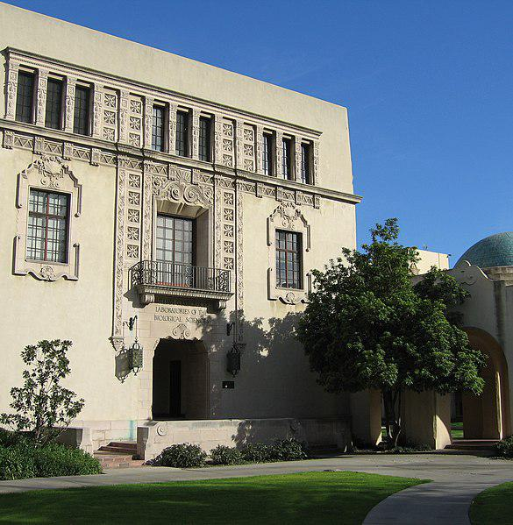

Caption for image source 1: Laboratories of the Biological Sciences, Caltech 2 (cropped).

Example Question - "Where is the sign for the Laboratories of the Biological Sciences on the campus of Caltech?"

Example Answer - "The sign for the Laboratories of the Biological Sciences on the campus of Caltech is above the entrance."

Additional Text Source 1 - In 2005, Caltech had 739,000 square feet (68,700 m2) dedicated to research: 330,000 square feet (30,700 m2) to physical sciences, 163,000 square feet (15,100 m2) to engineering, and 160,000 square feet (14,900 m2) to biological sciences. (from: California Institute of Technology)

Generated Question - Does the Laboratories of the Biological Sciences building at Caltech likely occupy part of the 160,000 square feet dedicated to biological sciences research?

Generated Answer - Yes, it likely occupies part of the 160,000 square feet for biological sciences research at Caltech.

--- Entry for custom_id: d5dc47460dba11ecb1e81171463288e9 ---

Example Question - Is the thickness of the mesocarp on an acai palm more or less than the circumference of an acai berry?

Example Answer - It is less.

Image Source 1 -



Generated Question - Considering the size and color of açaí fruits, could the dark purple berries on the acai bowl be açaí berries?

Generated Answer - Yes, the dark purple berries likely are açaí berries due to their color and size.

--- Entry for custom_id: d5da37b20dba11ecb1e81171463288e9 ---

Example Question - Who is Dr. Winston Zeddemore and what is his first on-screen appearance?

Example Answer - Dr. Winston Zeddemore is a fictional character appearing in the Ghostbusters films, TV series, and video games. His first on-screen appearance is in the movie Ghostbusters, when he responds to a help-wanted advertisement the team has posted in an attempt to deal with their sizable workload.

Image Source 1 -

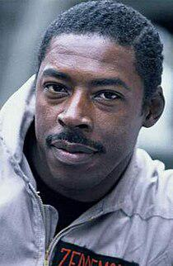

Generated Question - Who portrayed Winston Zeddemore in the Ghostbusters films and who voiced him in the first three seasons of The Real Ghostbusters?

Generated Answer - Ernie Hudson portrayed Winston Zeddemore in the films, and Arsenio Hall voiced him in the first three seasons of The Real Ghostbusters.

--- Entry for custom_id: d5c20da40dba11ecb1e81171463288e9 ---

Image Source 1 -

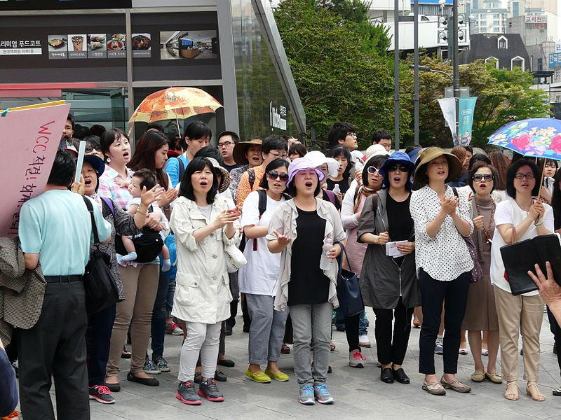

Caption for image source 1: Korea Queer Culture Festival 2014 24.

Example Question - "How many open umbrellas are in the group of people at the Korea Queer Culture Festival 2014?"

Example Answer - "There are 2 open umbrellas in the group of people at the Korea Queer Culture Festival 2014."

Additional Text Source 1 - The eleventh annual Korea Queer Film Festival was held in 2011 from June 2 to 8 at the “Seoul Art Cinema (Hollywood Theater)” (서울아트시네마 (허리우드극장)) in Jongno-Gu in Seoul. The 2011 festival featured 2 films from 2 countries (Korea and USA). (from: Korea Queer Film Festival)

Generated Question - Are the Korea Queer Culture Festival 2014 and the Korea Queer Film Festival held in the same city?

Generated Answer - Yes, both festivals are held in Seoul.

--- Entry for custom_id: d5ce745e0dba11ecb1e81171463288e9 ---

Image Source 1 -



Caption for image source 1: Traditional dress of Tripura This photo was clicked on ethnic day in office..

Example Question - "For the Traditional dress of Tripura, does a woman wear a dress that goes above her knees or below them?"

Example Answer - "The Traditional dress of Tripura goes below the knees of the wearer."

Additional Text Source 1 - Former Solicitor General Elena Kagan, the only woman to hold the office to date, appeared before the Court in pantsuits in lieu of morning dress. The traditional female equivalent of morning dress, "softly flowing dresses with hats", is strictly for social purposes and would be inappropriate attire for appearances before the nation's highest court. (from: Court dress)

Generated Question - Considering the traditional dress of Tripura and the court dress described, which attire is more formal and covers more of the body?

Generated Answer - The court dress is more formal and covers more of the body than the traditional dress of Tripura.

--- Entry for custom_id: d5c1d08c0dba11ecb1e81171463288e9 ---

Image Source 1 -



Caption for image source 1: David De Gea Olympics 2012.

Example Question - "During the 2012 Olympics, did David de Gea wear plain socks or socks with stripes on them?"

Example Answer - "During the 2012 Olympics, David de Gea wore socks with stripes on them."

Additional Text Source 1 - Manager David Moyes agreed with Schmeichel's assessment, describing the save was a "turning point" in a match in which they were losing 1–0 at the time, and said De Gea "is improving all the time". On 1 December, De Gea made his 100th appearance for Manchester United in a 2–2 draw against Tottenham. (from: David de Gea)

Generated Question - Did David de Gea wear a goalkeeper jersey with the number 1 during the 2012 Olympics and later make his 100th Manchester United appearance in a match against Tottenham?

Generated Answer - Yes, he wore the number 1 jersey in the 2012 Olympics and made his 100th Manchester United appearance against Tottenham.

--- Entry for custom_id: d5c15df00dba11ecb1e81171463288e9 ---

Image Source 1 -

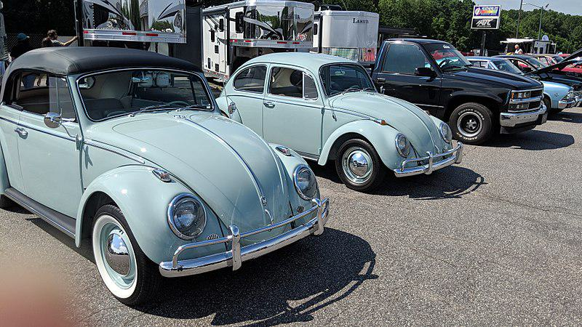

Caption for image source 1: 2018 DCHS Car Show - A Celebration of Classic Cars, Community… and Family! (41770340175).

Example Question - "Did the 2018 DCHS Car Show have a convertible VW Beetle or a hardtop VW Beetle at it?"

Example Answer - "The 2018 DCHS Car Show had both a convertible VW Beetle and a hardtop VW Beetle."

Additional Text Source 1 - Announced at the 2009 Los Angeles Auto Show, the 2010 Final Edition New Beetle features Aquarius Blue paintwork, with the hardtop receiving a black painted roof and the convertible sporting Campanella White painted side panels. In addition to unique 17-inch wheels, both models will be powered by a 2.5-liter engine mated to an automatic "Tiptronic" transmission. (from: Volkswagen New Beetle)

Generated Question - Are the VW Beetles at the 2018 DCHS Car Show painted in Aquarius Blue like the 2010 Final Edition New Beetle?

Generated Answer - No, the VW Beetles at the 2018 DCHS Car Show are a different light blue color, not Aquarius Blue.

--- Entry for custom_id: d5dcab820dba11ecb1e81171463288e9 ---

Example Question - In the practice that involves ascertaining the avasthas of planets at given times, what is the term that refers to one-third of the arc of the ecliptic intercepted between any two adjacent angles?

Example Answer - In Hindu astrology, bhava describes this portion of the arc.

Image Source 1 -

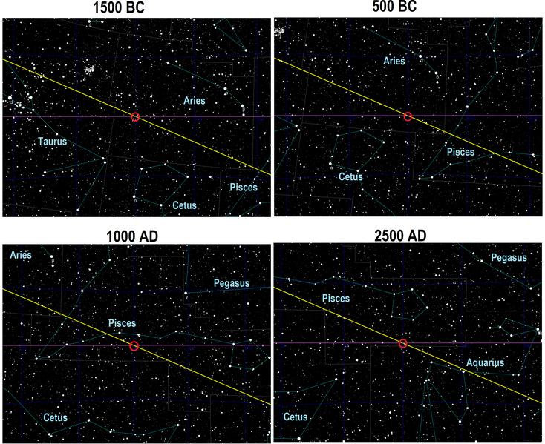

--- Entry for custom_id: d5d6e7100dba11ecb1e81171463288e9 ---

Example Question - The county in Pennsylvania named for the nation of Wales has how large a total area?

Example Answer - Cambria County has a total area of 694 square miles.

Image Source 1 -

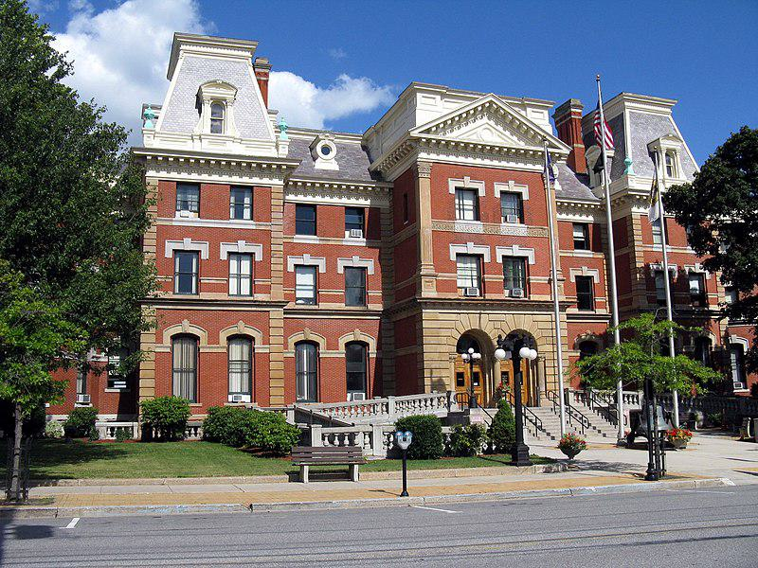

Generated Question - What is the county seat of the Pennsylvania county named after Wales, and what notable building is located there?

Generated Answer - The county seat is Ebensburg, which has the Cambria County Courthouse.

--- Entry for custom_id: d5d8493e0dba11ecb1e81171463288e9 ---

Example Question - The European pied flycatcher hybridizes to a limited extent with the collared flycatcher which are both which type of birds?

Example Answer - They are small passerine birds.

Image Source 1 -

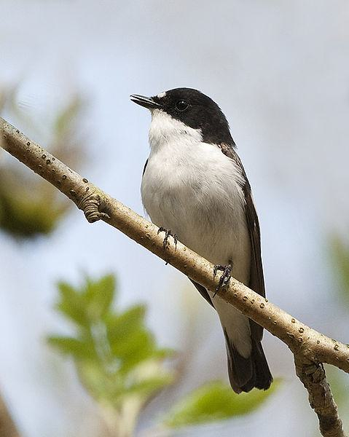

Generated Question - Do the European pied flycatcher and the collared flycatcher share the same migratory pattern and breeding region?

Generated Answer - No, the European pied flycatcher breeds in most of Europe and winters in tropical Africa, while the collared flycatcher's migratory pattern is not specified.

--- Entry for custom_id: d5d9ac340dba11ecb1e81171463288e9 ---

Example Question - What is a dog sport in which a handler directs a dog through an obstacle course in a race for both time and accuracy that can be traced to a demonstration at the Crufts dog show in the late 1970s in the United Kingdom?

Example Answer - Dog Agility

Image Source 1 -



Generated Question - In the dog sport that began as a demonstration at Crufts in the 1970s, what is the Papillon doing in the image without any incentives like food or toys?

Generated Answer - The Papillon is jumping over an obstacle as part of a dog agility course.

--- Entry for custom_id: d5c6ea040dba11ecb1e81171463288e9 ---

Image Source 1 -

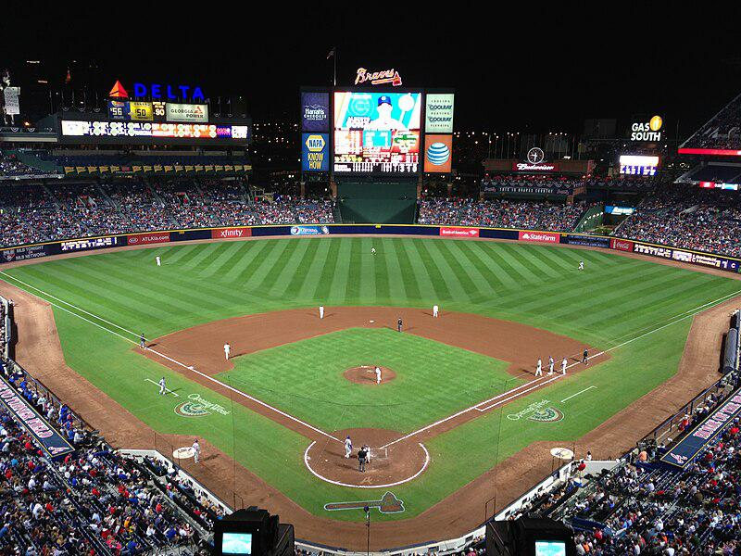

Caption for image source 1: Turner Field 2013 Photo of Turner Field during a night game on April 6, 2013 Taken with an iPhone 5.

Image Source 2 -

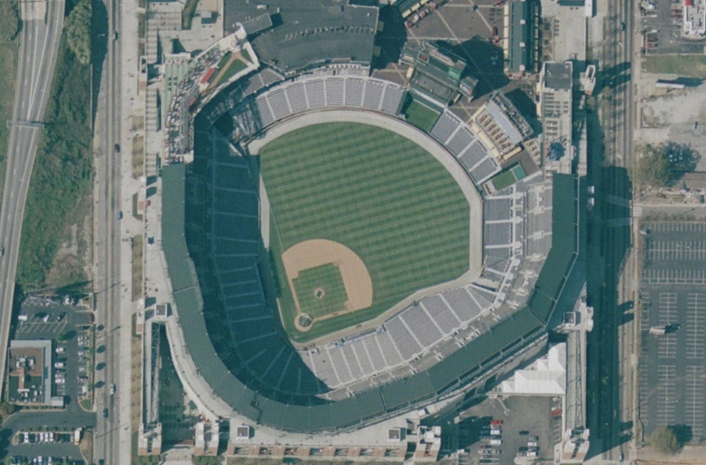

Caption for image source 2: Turner Field satellite view.png Turner Field satellite view, nasa world wind 1.3.5.

Example Question - "Are there any buildings taller than turner field in the immediate vicinity?"

Example Answer - "No, there are no buildings in the immediate vicinity of Turner Field that are taller than the field."

Additional Text Source 1 - The locality of Alice Arm and the Nisga'a community of Gits'oohl (formerly Gitzault Indian Reserve No. 24) are in the immediate vicinity. "Kitsault" is an adaptation of Gits'oohl, which means "a ways in behind". (from: Kitsault)

Generated Question - Considering the immediate vicinity of Turner Field and the nearby Nisga'a community, is Turner Field located in a densely urban or more remote area?

Generated Answer - Turner Field is located in a more urban area, unlike the remote vicinity of the Nisga'a community.

--- Entry for custom_id: d5c1cbf00dba11ecb1e81171463288e9 ---

Image Source 1 -



Caption for image source 1: Prunus pseudocerasus var. cantabrigiensis (Rosaceae) flower 2.

Image Source 2 -



Caption for image source 2: Iberis sempervirens.

Example Question - "Which plants bloom more in a sort of ring of flowers expanding and blooming atop a stem; Iberis sempervirens or Prunus pseudocerasus var. cantabrigiensis?"

Example Answer - "Iberis sempervirens blooms in more of a sort of ring of flowers expanding and blooming atop a stem than Prunus pseudocerasus var. cantabrigiensis does."

Additional Text Source 1 - Iberis is so named because many members of the genus come from the Iberian Peninsula in south west Europe. Sempervirens means "always green", referring to the evergreen foliage. (from: Iberis sempervirens)

Generated Question - Considering their flower structures and origins, which plant is more likely to have evergreen foliage, Iberis sempervirens or Prunus pseudocerasus var. cantabrigiensis?

Generated Answer - Iberis sempervirens is more likely to have evergreen foliage as its name means "always green."

--- Entry for custom_id: d5d885de0dba11ecb1e81171463288e9 ---

Example Question - What gene that encodes a member of the subtilisin -like proprotein convertase family is also known as subtilisin/kexin?

Example Answer - Membrane-bound transcription factor site-1 protease.

Image Source 1 -



Generated Question - How does the enzyme encoded by MBTPS1 differ from PCSK9 in terms of their protein family and function?

Generated Answer - MBTPS1 encodes a subtilisin-like proprotein convertase that cleaves SREBP, while PCSK9 is a different proprotein convertase with distinct functions.

--- Entry for custom_id: d5c3304e0dba11ecb1e81171463288e9 ---

Image Source 1 -

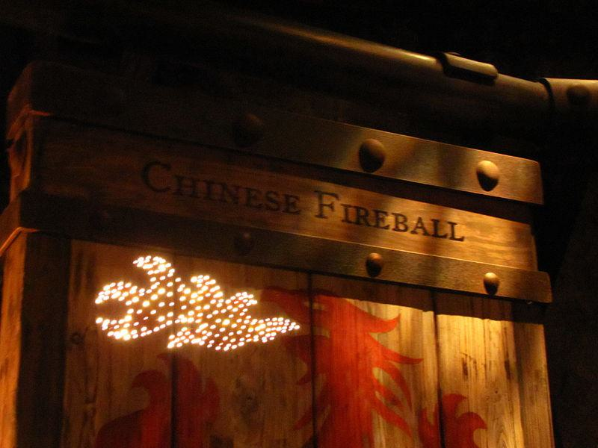

Caption for image source 1: Dragon Challenge 27.

Example Question - "One of the coasters for The Dragon Challenge was designated as the Chinese Fireball, and used what as its logo?"

Example Answer - "The coaster for The Dragon Challenge that was designated as the Chinese Fireball used a red dragon as its logo."

Additional Text Source 1 - Dragon Challenge (known as Dueling Dragons from 1999 to 2010) was a pair of intertwined, inverted roller coasters in the Wizarding World of Harry Potter area of Universal Studios' Islands of Adventure in Orlando, Florida, United States. The ride was themed to two chasing dragons, one side being a Chinese Fireball and the other a Hungarian Horntail. (from: Dragon Challenge)

Generated Question - Were the two intertwined roller coasters in Dragon Challenge themed after dragons from different cultures?

Generated Answer - Yes, one was a Chinese Fireball and the other a Hungarian Horntail.

--- Entry for custom_id: d5c836e80dba11ecb1e81171463288e9 ---

Image Source 1 -



Caption for image source 1: 2014.11.15.193354 Oriental Pearl Tower at night Pudong Shanghai View of Pudong from the Bund at night with the Oriental Pearl Tower - Shanghai, 15.11.2014.

Image Source 2 -

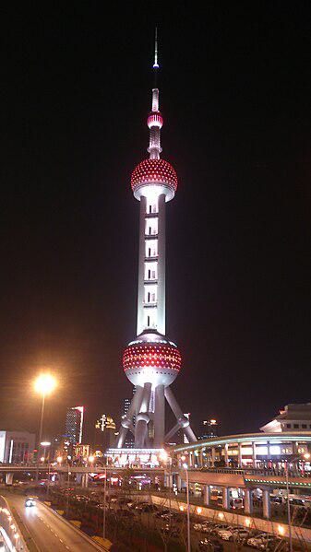

Caption for image source 2: Oriental Pearl Tower, Shanghai, at night Oriental Pearl Tower.

Example Question - "What are some examples of colors that the Oriental Pearl Tower can be lit up as at night?"

Example Answer - "The Oriental Pearl Tower may be lighted up in a variety of hues at night, including red and purple."

Additional Text Source 1 - The Oriental Pearl Radio & Television Tower (simplified Chinese: 东方明珠塔; traditional Chinese: 東方明珠塔; pinyin: Dōngfāng Míngzhūtǎ; Shanghainese: Tonfon Mintsyta, official name: 东方明珠广播电视塔) is a TV tower in Shanghai. (from: Oriental Pearl Tower)

Generated Question - Is the Oriental Pearl Tower in Shanghai primarily used for television broadcasting and does it feature multiple illuminated spheres at night?

Generated Answer - Yes, it is a TV tower with multiple illuminated spheres visible at night.

--- Entry for custom_id: d5c29ddc0dba11ecb1e81171463288e9 ---

Image Source 1 -



Caption for image source 1: MTA Issues Update on Precautions Against Coronavirus (49724829531).

Example Question - "Does the MTA promote social distancing?"

Example Answer - "Yes, the MTA promotes social distancing."

Additional Text Source 1 - Although the term "social distancing" was not introduced until the 21st century, social-distancing measures date back to at least the 5th century BC. (from: Social distancing)

Generated Question - Does the MTA's advice to keep six feet apart align with historical social-distancing practices?

Generated Answer - Yes, the MTA's six feet rule aligns with long-standing social-distancing measures.

--- Entry for custom_id: d5dd66300dba11ecb1e81171463288e9 ---

Example Question - How did the Iroise Sea get its name?

Example Answer - Its name appears to have been fixed not by local seafarers but rather by staff at the naval base at Brest.

Image Source 1 -

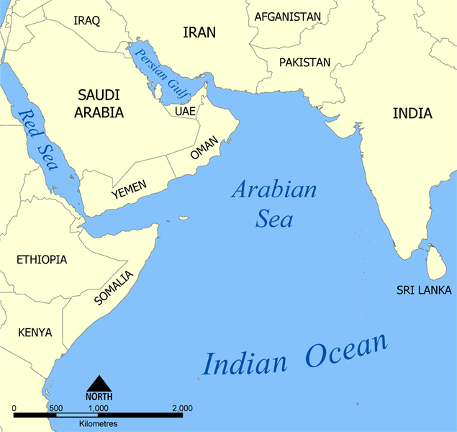

Generated Question - How do the Iroise Sea and Arabian Sea differ in their oceanic locations and bordering regions?

Generated Answer - The Iroise Sea is part of the Atlantic Ocean near France, while the Arabian Sea is a marginal sea of the Indian Ocean near South Asia.

--- Entry for custom_id: d5c296de0dba11ecb1e81171463288e9 ---

Image Source 1 -

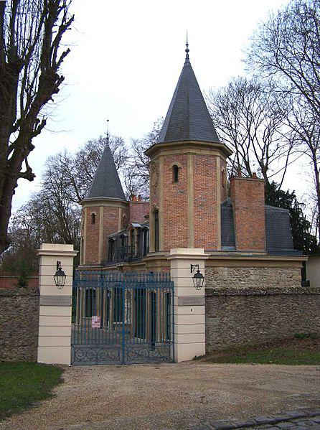

Caption for image source 1: Louveciennes Pavillon entrée Barry Little pavilion at the entrance of the domain of Madame du Barry in the path of the Machine in the village of Voisins in Louveciennes (Yvelines, France).

Image Source 2 -

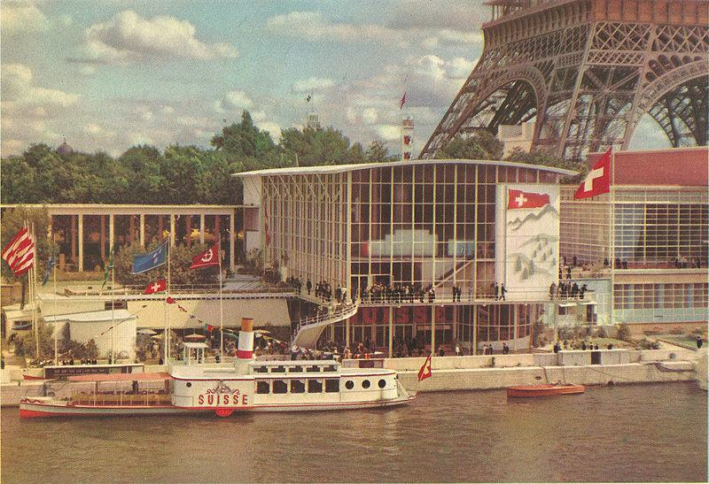

Caption for image source 2: Paris-expo-1937-pavillon de la Suisse-12.

Example Question - "What grows near both the Little pavilion at the entrance of the domain of Madame du Barry in the path of the Machine in the village of Voisins and the Paris expo 1937 pavillon de la Suisse?"

Example Answer - "Trees grow near both the Little pavilion at the entrance of the domain of Madame du Barry in the path of the Machine in the village of Voisins and the Paris expo 1937 pavillon de la Suisse."

Additional Text Source 1 - The King constructed a set of luxurious rooms for Madame du Barry on the floor above his offices; Madame du Barry also reigned in the Petit Trianon, which the King had built for Madame de Pompadour, and in the Pavillon de Louveciennes, also built for Madame de Pompadour. (from: Louis XV)

Generated Question - Did Madame du Barry and Madame de Pompadour both have pavilions associated with their residences?

Generated Answer - Yes, Madame du Barry had the Louveciennes pavilion, and Madame de Pompadour had the Petit Trianon and Pavillon de Louveciennes.

--- Entry for custom_id: d5caadec0dba11ecb1e81171463288e9 ---

Image Source 1 -



Caption for image source 1: Amanita muscaria, Palmer, Alaska, Estados Unidos, 2017-08-22, DD 24 Amanita muscaria, Palmer, Alaska, United States.

Image Source 2 -



Caption for image source 2: Leucoagaricus leucothites 20101004wc Leucoagaricus carneifolius (synonym: Leucoagaricus leucothites var. carneifolius) on a lawn near Massy, France..

Example Question - "Which fungus' top is darker; Amanita muscaria or Leucoagaricus leucothites?"

Example Answer - "Amanita muscaria has a darker top than Leucoagaricus leucothites."

Additional Text Source 1 - Vernacular names for the mushroom include "destroying angel", "deadly amanita", "white death cap", "angel of death" and "eastern North American destroying angel". Amanita bisporigera belongs to section Phalloideae of the genus Amanita, which contains some of the deadliest Amanita species, including A. phalloides and A. virosa. (from: Amanita bisporigera)

Generated Question - Considering the deadly nature of Amanita bisporigera, which mushroom between Amanita muscaria and Leucoagaricus leucothites is more likely to be toxic?

Generated Answer - Amanita muscaria is more likely to be toxic as it belongs to the Amanita genus known for deadly species.

--- Entry for custom_id: d5d325da0dba11ecb1e81171463288e9 ---

Example Question - What title was frequently used by people holding the position that Wilfred held from 988 to 1035?

Example Answer - The counts of Cerdanya frequently used the title marchio.

Image Source 1 -

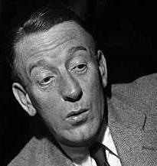

Generated Question - Did Wilfred Pickles hold the same title as Wilfred II, Count of Cerdanya, who used the title marchio?

Generated Answer - No, Wilfred Pickles did not hold the title marchio like Wilfred II, Count of Cerdanya.

--- Entry for custom_id: d5c51e540dba11ecb1e81171463288e9 ---

Image Source 1 -

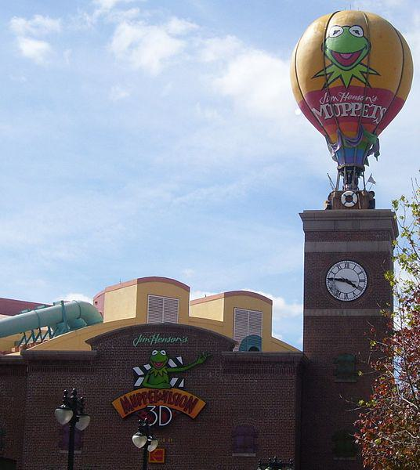

Caption for image source 1: MGMMuppetBuilding This is a picture I took, and I release it..

Example Question - "What is on top of the clocktower at the Muppet Vision 3D building?"

Example Answer - "A hot air balloon is on top of the clocktower at the Muppet Vision 3D building."

Additional Text Source 1 - They explain that they want the Fraggles to eat their work to create space for more building work to go up again. (from: Fraggle Rock)

Generated Question - Does the Muppet Vision 3D building have any features related to Fraggle Rock's idea of making space for more building work?

Generated Answer - No, the Muppet Vision 3D building features a hot air balloon, unrelated to Fraggle Rock's building concept.

--- Entry for custom_id: d5dbc9380dba11ecb1e81171463288e9 ---

Example Question - The tortoise plastrons from what dynasty are thought to have been unearthed periodically by local farmers since as early as the Sui and Tang dynasties?

Example Answer - Shang-dynasty.

Image Source 1 -

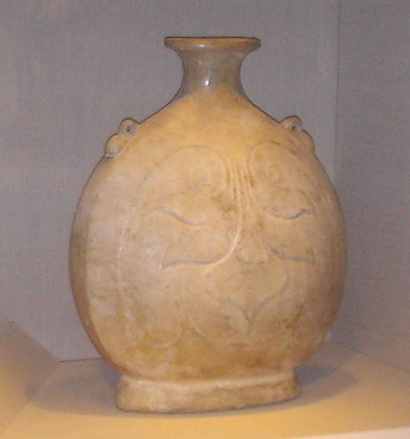

Generated Question - Were the Shang-dynasty oracle bones and the Sui dynasty pilgrim flask created during the same historical period?

Generated Answer - No, the Shang-dynasty oracle bones are much older than the Sui dynasty pilgrim flask.

--- Entry for custom_id: d5cb2d4e0dba11ecb1e81171463288e9 ---

Image Source 1 -

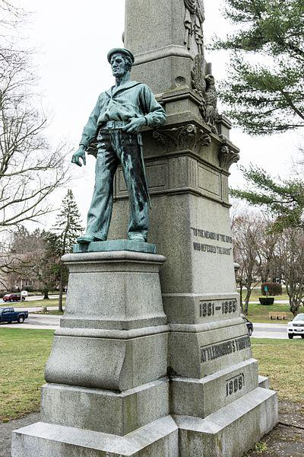

Caption for image source 1: Civil War memorial in Capron Park, Attleboro, MA Civil War Memorial, Capron Park, Attleboro, Massachusetts. "One Country. One Language. One Flag. 1861-1865. Attleborough's Tribute 1908.".

Example Question - "At the Civil War Memorial in Capron Park, which foot of the statue's is partially coming off the platform?"

Example Answer - "At the Civil War Memorial in Capron Park, the right foot of the statue's is partially coming off the platform."

Additional Text Source 1 - The American Civil War (April 12, 1861 – May 9, 1865, also known by other names) was a civil war in the United States fought between northern and Pacific states ("the Union" or "the North") and southern states that voted to secede and form the Confederate States of America ("the Confederacy" or "the South"). (from: American Civil War)

Generated Question - Does the Civil War Memorial in Capron Park honor the Union or the Confederacy based on the years inscribed?

Generated Answer - It honors the Union, as the years 1861-1865 correspond to the American Civil War period.

--- Entry for custom_id: d5dc42f00dba11ecb1e81171463288e9 ---

Example Question - What is the alphabet used for sign language in the country from which the braille alphabet originated?

Example Answer - The French manual alphabet

Image Source 1 -

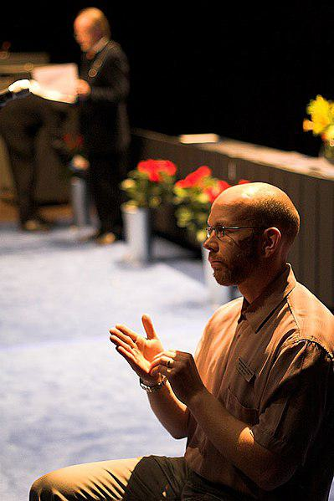

Generated Question - How does the French manual alphabet relate to the communication method shown in the image of the interpreter?

Generated Answer - The French manual alphabet is used in sign language, which the interpreter in the image is likely using.

--- Entry for custom_id: d5dd5b0e0dba11ecb1e81171463288e9 ---

Example Question - A compass rose, sometimes called a wind rose or rose of the winds, is a figure on what, on which in navigation directions are usually expressed with reference to geographical or true north?

Example Answer - Maps

Image Source 1 -

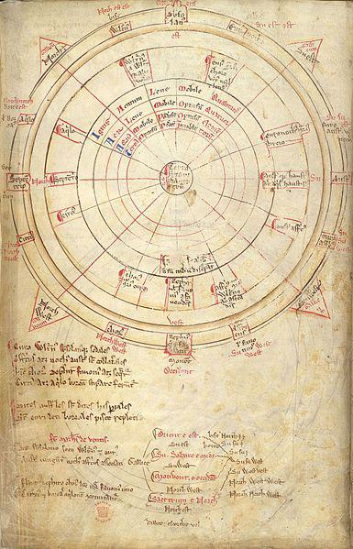

Generated Question - How does Matthew Paris's 16-wind compass rose attempt to represent the classical winds in relation to the cardinal directions used in navigation?

Generated Answer - It fits the 12 classical winds onto the 16-wind compass rose around cardinal directions.

--- Entry for custom_id: d5c0aca20dba11ecb1e81171463288e9 ---

Image Source 1 -

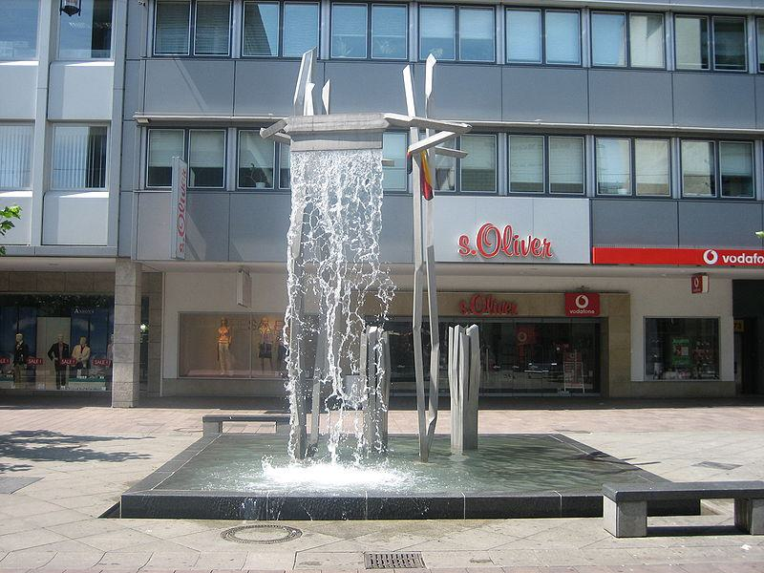

Caption for image source 1: Saarbrucken fountain 0119.

Example Question - "On the Saarbrucken fountain, does the water come in from below or from above?"

Example Answer - "The water for the Saarbrucken Fountain is projected from above."

Additional Text Source 1 - The Danish Australian Football League, based in Copenhagen is the largest Australian rules football competition outside of the English-speaking world. Copenhagen Marathon, Copenhagen's annual marathon event, was established in 1980.Round Christiansborg Open Water Swim Race is a 2-kilometre (1.2-mile) open water swimming competition taking place each year in late August. (from: Copenhagen)

Generated Question - Is the Saarbrucken fountain's water flow similar to the water activities featured in Copenhagen's open water swim race?

Generated Answer - No, the Saarbrucken fountain's water flows from above, unlike the open water swim race in Copenhagen.

--- Entry for custom_id: d5dede5c0dba11ecb1e81171463288e9 ---

Example Question - What sacred Aboriginal area is near Adelaide one of the fastest growing cities in Australia?

Example Answer - The Mount Barker Summit

Image Source 1 -

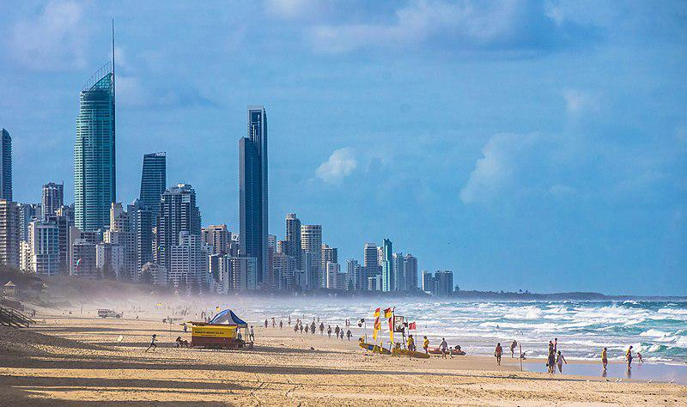

Generated Question - How does Mount Barker's growth compare to Australia's coastal metropolitan cities like Gold Coast?

Generated Answer - Mount Barker is one of the fastest growing areas near Adelaide, similar to growth in coastal metropolitan cities like Gold Coast.

--- Entry for custom_id: d5c346c40dba11ecb1e81171463288e9 ---

Image Source 1 -

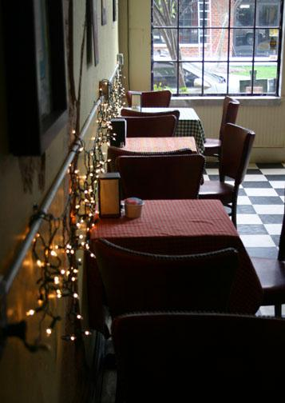

Caption for image source 1: Jake's eatery in Atlanta, Georgia Jake's: A shot I took at a local Atlanta neighborhood eatery. They kicked me out soon after this photo for taking pictures. They said it was against the rules... a 'copyright thing'. I didn't know environments could be copyrighted..

Example Question - "Are white tablecloths used in Jake’s Eatery in Atlanta?"

Example Answer - "No, white tablecloths are not used in Jake’s Eatery in Atlanta."

Additional Text Source 1 - Dîner en Blanc ("Dinner in White" in French) is a worldwide event spanning six continents in which people have a meal dressed in white in a temporary dining setup in a public space. Diners are required to provide their own food, tables, chairs and tablecloths. (from: Dîner en Blanc)

Generated Question - Would Jake’s Eatery in Atlanta fit the Dîner en Blanc event’s requirement for white tablecloths on its tables?

Generated Answer - No, Jake’s Eatery uses colored tablecloths, not white ones.

--- Entry for custom_id: d5d412240dba11ecb1e81171463288e9 ---

Example Question - What were a key tool in the proof by Bestvina, Feighn and Handel that can have a map which is a topological representative of φ?

Example Answer - A train track.

Image Source 1 -



--- Entry for custom_id: d5dca1be0dba11ecb1e81171463288e9 ---

Example Question - The general who conquered Egypt from the Romans had a father from what clan?

Example Answer - Amr ibn al-As's father, al-As ibn Wa'il, was from the Banu Sahm clan of the Quraysh tribe of Mecca.

Image Source 1 -

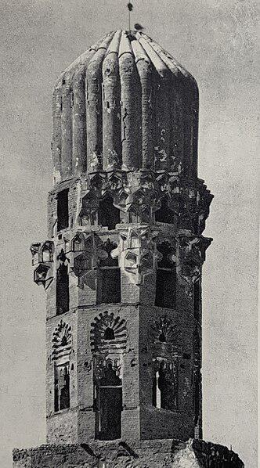

Generated Question - Was the mosque associated with the general who conquered Egypt from the Romans traditionally located based on a bird's choice?

Generated Answer - Yes, the original location of the mosque was traditionally chosen by a bird.

--- Entry for custom_id: d5db6ce00dba11ecb1e81171463288e9 ---

Example Question - Do the suborder of the housefly and the order of the fly start with the same letter or different letters?

Example Answer - They start with different letters.

Image Source 1 -



Generated Question - Does the housefly wing shown have the typical two flight wings and halteres characteristic of the fly order Diptera?

Generated Answer - Yes, the housefly wing shown has the typical two flight wings and halteres of Diptera.

--- Entry for custom_id: d5d943ac0dba11ecb1e81171463288e9 ---

Example Question - What is Thermally stimulated depolarization current (TSDC) and how can the depolarization be measured?

Example Answer - Thermally stimulated depolarization current (TSDC) is a scientific technique used to measure dielectric properties of materials. It can be used to measure the thermally stimulated depolarization of molecules within a material. This depolarization can be measured if the material is sandwiched between two ohmic electrodes and the current is measured on warming. As the material depolarizes, charges are pulled to (or pushed away from) the electrodes which causes a current through the measuring device.

--- Entry for custom_id: d5cea0820dba11ecb1e81171463288e9 ---

Image Source 1 -

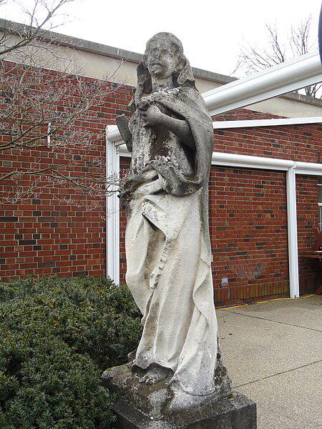

Caption for image source 1: Garden statue in Mellon Park - Pittsburgh, PA - DSC05013-001 Mellon Park - Pittsburgh, Pennsylvania, USA..

Example Question - "Which is more weathered: The top or the bottom of the Garden statue in Mellon Park - Pittsburgh, PA?"

Example Answer - "The top of the Garden statue in Mellon Park is more weathered."

Additional Text Source 1 - She saw a way to express her empathy for these refugees in terms of the statue. The resulting sonnet, "The New Colossus", including the lines: "Give me your tired, your poor/Your huddled masses yearning to breathe free", is uniquely identified with the Statue of Liberty in American culture and is inscribed on a plaque in its museum. (from: Statue of Liberty)

Generated Question - Is the garden statue in Mellon Park more weathered at the top like the Statue of Liberty's symbolic representation of enduring hardship?

Generated Answer - Yes, the garden statue is more weathered at the top, symbolizing exposure and endurance like the Statue of Liberty.

--- Entry for custom_id: d5cbde6a0dba11ecb1e81171463288e9 ---

Image Source 1 -

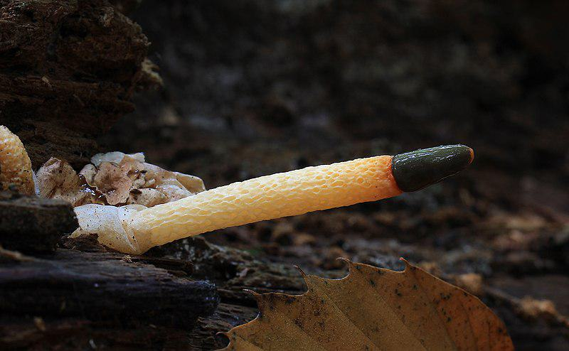

Caption for image source 1: Mutinus caninus, Dog Stinkhorn, UK Mutinus caninus, Dog Stinkhorn, in Trent Park, London Borough of Enfield, UK..

Example Question - "What color is the end of the Mutinus caninus?"

Example Answer - "The end of the Mutinus caninus is black."

Additional Text Source 1 - The "dog stinkhorn" (Mutinus caninus) is smaller, has a distinct oval or spindle-shaped tip on a slender stem and lacks the bright coloring of M. elegans; it has less of the stalk covered by gleba. The portion of the stalk below the spore mass is pitted in M. caninus, compared to "pebbly" in M. elegans. (from: Mutinus elegans)

Generated Question - How does the tip shape of Mutinus caninus compare to its stalk texture below the spore mass?

Generated Answer - The tip is oval or spindle-shaped, and the stalk below the spore mass is pitted.

--- Entry for custom_id: d5c921980dba11ecb1e81171463288e9 ---

Image Source 1 -



Caption for image source 1: Henriette Geertruida Knip - Flowers in a Vase, 1830 Roses, tulips, lady's purses, black irises and other flowers in a vase, and a stem of pink roses, on a stone ledge.

Image Source 2 -



Caption for image source 2: Nicolaes van Verendael - Still life of flowers in a crystal vase2 Still life of flowers in a crystal vase.

Example Question - "Are the butterflies flying in both A bouquet of Flowers in a Crystal Vase and Still Life of Flowers in a Crystal Vase?"

Example Answer - "No, there are not butterflies flying in both A bouquet of Flowers in a Crystal Vase and Still Life of Flowers in a Crystal Vase."

Additional Text Source 1 - Flowers in a Crystal Vase (French - Œillets et clématites dans un vase de cristal) is an 1882 painting by Édouard Manet, in the Musée d'Orsay in Paris since 1986. It shows clematis and 'oeillets', a French word used for several kinds of cut flowers, many from the Dianthus genus. (from: Flowers in a Crystal Vase)

Generated Question - Do all three paintings—Flowers in a Vase by Knip, Still Life of Flowers by Verendael, and Flowers in a Crystal Vase by Manet—depict flowers in a vase with butterflies present?

Generated Answer - No, only Knip's and Verendael's paintings show butterflies; Manet's does not.

--- Entry for custom_id: d5ce7da00dba11ecb1e81171463288e9 ---

Image Source 1 -

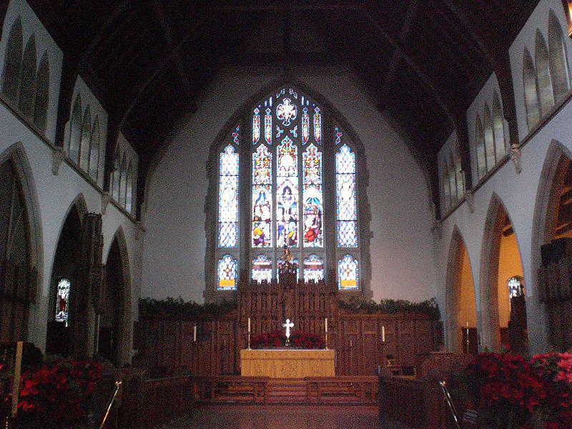

Caption for image source 1: Christ Church Cathedral interior, Ottawa View of the interior of Christ Church Cathedral, Ottawa.

Image Source 2 -

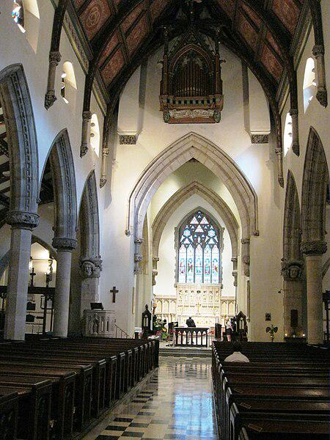

Caption for image source 2: Christ Church Cathedral Montreal 18.

Example Question - "Between the Christ Church Cathedral in Montreal and the Christ Church Cathedral in Ottawa, which one has a larger stained glass window behind the altar?"

Example Answer - "Christ Church Cathedral in Ottawa has a larger stained glass window behind the altar."

Additional Text Source 1 - In 1850, the second Christ Church was designated as the cathedral for the new Anglican Diocese of Montreal upon its separation from the Anglican Diocese of Quebec. The cathedral was destroyed by fire in 1856.The present cathedral, a Neo-gothic structure, was designed by architect Frank Wills (1822–1856), who also designed Christ Church Cathedral in Fredericton, New Brunswick. (from: Christ Church Cathedral (Montreal))

Generated Question - Considering the architectural styles and stained glass windows, which Christ Church Cathedral appears to have a more prominent Gothic influence?

Generated Answer - Christ Church Cathedral in Montreal shows a more prominent Gothic influence with pointed arches and detailed stonework.

--- Entry for custom_id: d5cad89e0dba11ecb1e81171463288e9 ---

Image Source 1 -



Caption for image source 1: Bohemian waxwing (Bombycilla garrulus), Uitkerke, Belgium (16364651620).

Image Source 2 -

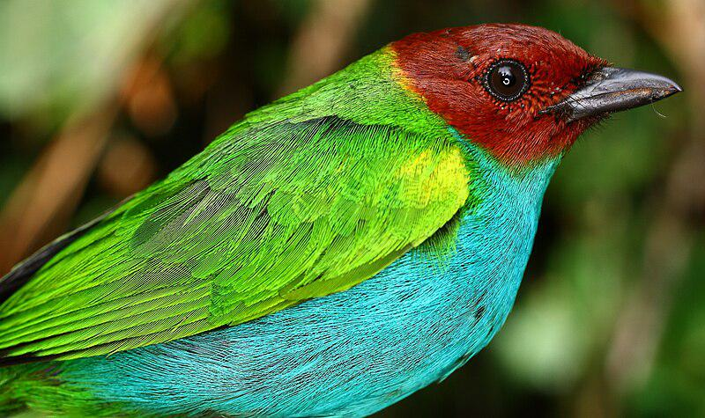

Caption for image source 2: Tangara gyrola (Bay-headed Tanager) (15148563221).

Example Question - "Does the bay-headed tanager or the bohemian waxwing have more vibrant colors?"

Example Answer - "The bay-headed tanager has more vibrant colors."

Additional Text Source 1 - The Bohemian waxwing is a starling-sized bird 19–23 cm (7.5–9.1 in) in length with a 32–35.5 cm (12.6–14.0 in) wingspan, and an average weight of 55 g (1.9 oz). (from: Bohemian waxwing)

Generated Question - Considering their size and color vibrancy, which bird is smaller and more colorful, the Bohemian waxwing or the bay-headed tanager?

Generated Answer - The bay-headed tanager is smaller and more colorful than the Bohemian waxwing.

--- Entry for custom_id: d5cc1a880dba11ecb1e81171463288e9 ---

Image Source 1 -

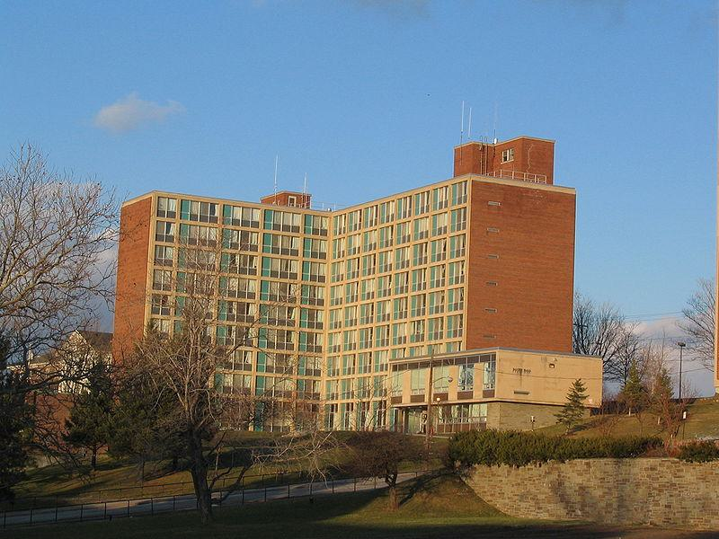

Caption for image source 1: Booth Hall, Syracuse University.

Example Question - "What alphabetical shape does Booth Hall at Syracuse University resemble?"

Example Answer - "Booth Hall at Syracuse University resembles the shape of the letter L."

Additional Text Source 1 - The Flexner Report hastened the demise of many medical schools in the United States and Canada, but, as Abraham Flexner wrote, "Of the eleven medical schools now existing in the state, only the bona-fide university departments can then expect to survive: outside of New York city, Syracuse University alone has just now a chance." (from: State University of New York Upstate Medical University)

Generated Question - Considering the Flexner Report's impact, why might Booth Hall at Syracuse University be significant in medical education?

Generated Answer - Booth Hall is significant because Syracuse University was one of the few medical schools likely to survive the Flexner Report reforms.

--- Entry for custom_id: d5d2ac0e0dba11ecb1e81171463288e9 ---

Example Question - Is U.S. Route 74 and the meridians of 41 North Latitude, 74 degrees West Longitude in the same state or different states?

Example Answer - Different states.

Image Source 1 -



Generated Question - Is the New Kituwah Academy located in the same state as U.S. Route 74?

Generated Answer - Yes, both are located in North Carolina.

--- Entry for custom_id: d5c5a0180dba11ecb1e81171463288e9 ---

Image Source 1 -



Caption for image source 1: U.S. Army Military Academy cadets march on Pennsylvania Avenue during the presidential inauguration parade in Washington, D.C 130121-D-DB155-007 U.S. Army Military Academy cadets march on Pennsylvania Avenue during the presidential inauguration parade in Washington, D.C., Jan. 21, 2013..

Example Question - "Did any of the U.S. Army Military Academy cadets who marched on Pennsylvania Avenue during the presidential inauguration parade in Washington, D.C. on Jan. 21, 2013 wear glasses?"

Example Answer - "Some of the U.S. Army Military Academy cadets who marched on Pennsylvania Avenue during the presidential inauguration parade in Washington, D.C. on Jan. 21, 2013 wore glasses."

Additional Text Source 1 - The event was the 58th presidential inauguration. Held in Washington, D.C., from January 17 to 21, 2017, inaugural events included concerts, the swearing-in ceremony, a congressional luncheon, parade, inaugural balls, and the interfaith inaugural prayer service. (from: Inauguration of Donald Trump)

Generated Question - Did the U.S. Army Military Academy cadets march in both the 2013 and 2017 presidential inauguration parades in Washington, D.C.?

Generated Answer - The cadets marched in the 2013 parade; the 2017 inauguration also included a parade in Washington, D.C.

--- Entry for custom_id: d5d5e7b60dba11ecb1e81171463288e9 ---

Example Question - The continent that is entirely within the Northern Hemisphere and almost all within the Western Hemisphere, is bordered to the north by what?

Example Answer - The Arctic ocean

Image Source 1 -

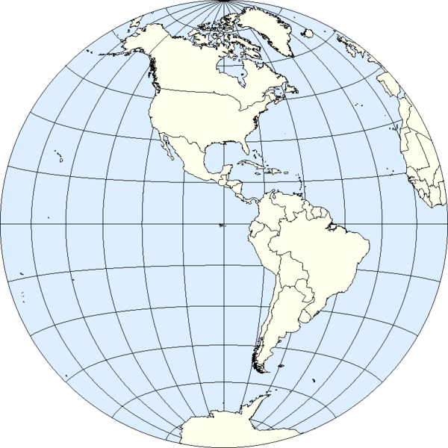

Generated Question - Which ocean borders the northern subcontinent of the Americas shown in the Western Hemisphere map?

Generated Answer - The Arctic Ocean.

--- Entry for custom_id: d5ce9d4e0dba11ecb1e81171463288e9 ---

Image Source 1 -

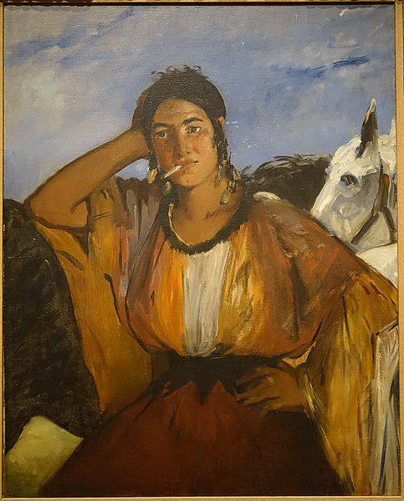

Caption for image source 1: Gypsy with a Cigarette, by Edouard Manet, French, undated, oil on canvas - Princeton University Art Museum - DSC07031 Exhibit in the Princeton University Art Museum - Princeton University, Princeton, New Jersey, USA..

Example Question - "What animal is behind the lady in Edouard Manet's painting "Gypsy with a Cigarette"?"

Example Answer - "In the painting, there is a horse seen behind the Gypsy."

Additional Text Source 1 - According to Maria Rutledge, "references to Blackness thus invaded the image of white Olympia, turning her into the caricatural and grotesque animal that Black people are frequently made to represent in the nineteenth century. "Many critics have applauded Manet in his use of white and black in the painting, an alternative to the tradition of chiaroscuro. (from: Olympia (Manet))

Generated Question - How does the use of color contrast in "Gypsy with a Cigarette" compare to Manet's technique in "Olympia"?

Generated Answer - Both paintings use strong contrasts of light and dark to highlight figures and challenge traditional chiaroscuro.

--- Entry for custom_id: d5c2d3100dba11ecb1e81171463288e9 ---

Image Source 1 -



Caption for image source 1: Ducks Lake Eola Orlando01.

Example Question - "Are there ducks at Lake Eola Park?"

Example Answer - "There are ducks at Lake Eola Park."

Additional Text Source 1 - The City of Orlando is nicknamed "the City Beautiful", and its symbol is the Linton E. Allen Memorial Fountain, commonly referred to as simply the "Lake Eola fountain" at Lake Eola Park. The Orlando International Airport (MCO) is the 13th-busiest airport in the United States and the 29th-busiest in the world. (from: Orlando, Florida)

Generated Question - Are the ducks at Lake Eola Park likely to be seen near the Lake Eola fountain, a symbol of Orlando?

Generated Answer - Yes, the ducks at Lake Eola Park are likely near the Lake Eola fountain, a symbol of Orlando.

--- Entry for custom_id: d5bd151a0dba11ecb1e81171463288e9 ---

Image Source 1 -

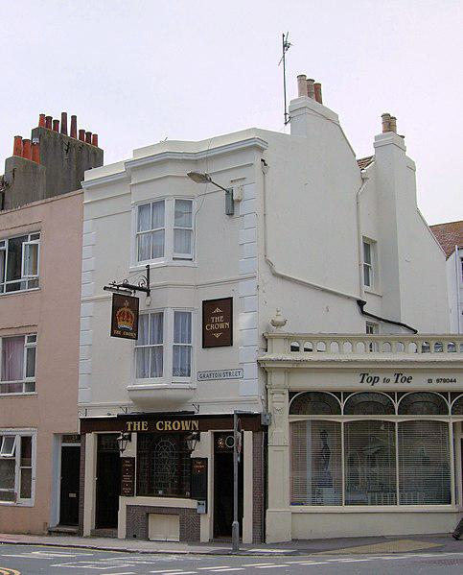

Caption for image source 1: The Crown Pub, Grafton Street, Brighton.

Example Question - "Do both small brown square signs hanging on the side of The Crown Pub, Grafton Street, Brighton have crowns on them?"

Example Answer - "No, only one of the small brown square signs has a crown on them."

Additional Text Source 1 - Disability Pride Brighton promotes acceptance and visibility for area residents who are disabled. The Kemptown area has its own small annual street festival, the Kemptown Carnival, and the Hanover area similarly has a "Hanover Day". (from: Brighton)

Generated Question - Is The Crown Pub located in an area of Brighton that hosts community events like Kemptown Carnival or Hanover Day?

Generated Answer - Yes, The Crown Pub is in Brighton, which has community events like Kemptown Carnival and Hanover Day.

--- Entry for custom_id: d5d5f4f40dba11ecb1e81171463288e9 ---

Example Question - What script was the earliest form of manuscript and Russian written in?

Example Answer - Cyrillic

Image Source 1 -

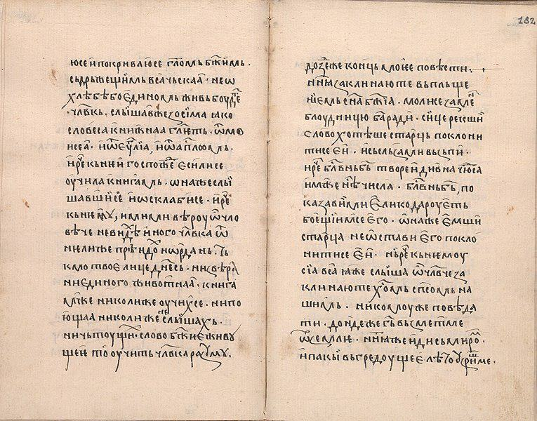

Generated Question - How does the earliest Cyrillic manuscript relate to the Russian language's use of soft and hard consonant sounds?

Generated Answer - The earliest Cyrillic manuscript laid the foundation for Russian, which uses Cyrillic to distinguish soft and hard consonants.

--- Entry for custom_id: d5def37e0dba11ecb1e81171463288e9 ---

Example Question - The episode "Billy and Mandy Moon the Moon" was part of the "Invaded" event of what network, which also made The Grim Adventures of Billy & Mandy?

Example Answer - Cartoon Network

Image Source 1 -

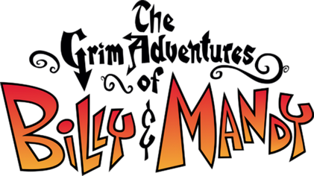

Generated Question - Which company developed the fighting video game based on the Cartoon Network show that aired the "Billy and Mandy Moon the Moon" episode?

Generated Answer - High Voltage Software developed the fighting video game based on The Grim Adventures of Billy & Mandy.

--- Entry for custom_id: d5db519c0dba11ecb1e81171463288e9 ---

Example Question - The Transmontano Mastiff is a breed of livestock guardian dog from what country that is the westernmost sovereign state in mainland Europe and the oldest nation-state on the Iberian Peninsula?

Example Answer - They are from Portugal.

Image Source 1 -

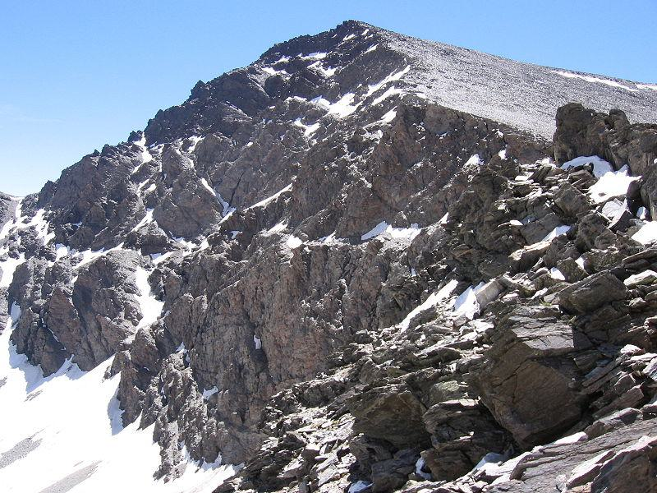

Generated Question - Is the Transmontano Mastiff breed from the same Iberian Peninsula where the Mulhacén, the highest peak, is located?

Generated Answer - Yes, both are from the Iberian Peninsula.

--- Entry for custom_id: d5c430ca0dba11ecb1e81171463288e9 ---

Image Source 1 -

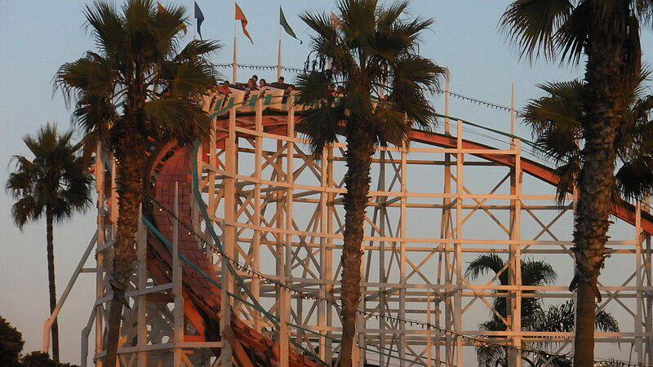

Caption for image source 1: Mission Beach Roller Coaster 001 The Giant Dipper, also known as the Mission Beach Roller Coaster, is a wooden roller coaster, built in 1925..

Example Question - "What kind of trees line the Giant Dipper roller coaster in Belmont Park, San Diego?"

Example Answer - "Palm trees line the Giant Dipper roller coaster in Belmont Park, San Diego."

Additional Text Source 1 - Newer attractions since 2016 include a Zip Line, a 3-level Sky Ropes obstacle course, a 7D Theater called Xanadu, and a 3-level Tron-themed Laser Tag arena. The park's rides, including the Giant Dipper, are operated by the San Diego Coaster Company. (from: Belmont Park (San Diego))

Generated Question - Are the Giant Dipper roller coaster and the newer attractions at Belmont Park operated by the same company?

Generated Answer - Yes, both are operated by the San Diego Coaster Company.

--- Entry for custom_id: d5c2dc3e0dba11ecb1e81171463288e9 ---

Image Source 1 -

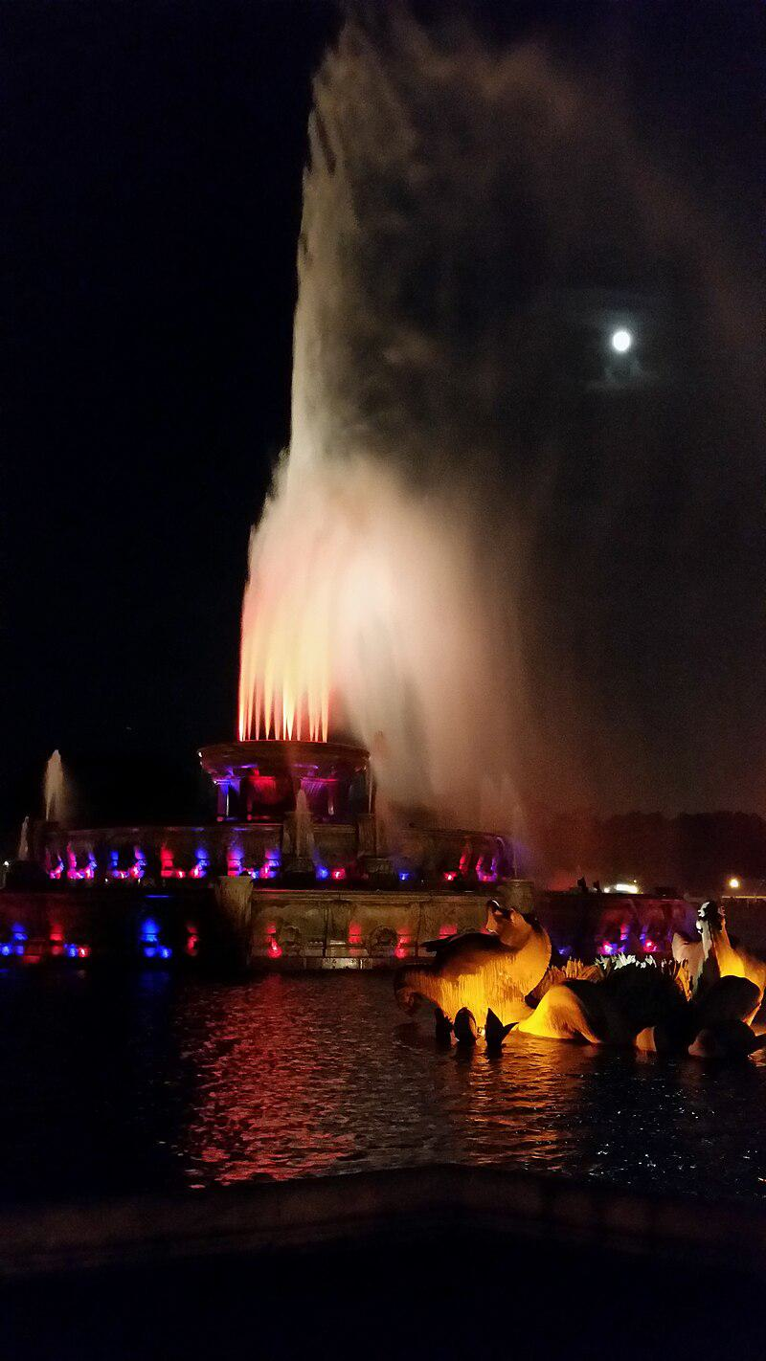

Caption for image source 1: Buckingham Fountain (14854830554).

Example Question - "Does the Buckingham Fountain light up at night?"

Example Answer - "Yes, the Buckingham Fountain lights up at night."

Additional Text Source 1 - Because of the colder winters common to the climate of Chicago, Plensa created a fountain that would remain vibrant when the water was inactive in the wintertime, so the fountain is an experience of light themes and the use of video technology. Plensa explores dualism with Crown Fountain, where he has two randomly selected faces "conversing" with each other. (from: Crown Fountain)

Generated Question - Does the Buckingham Fountain and Crown Fountain both use lighting to enhance their nighttime appearance?

Generated Answer - Yes, both fountains use lighting to create a vibrant nighttime display.

--- Entry for custom_id: d5d9fdce0dba11ecb1e81171463288e9 ---

Example Question - The Chicago Central and Pacific Railroad is part of a railroad named after what state in the the Central States?

Example Answer - Illinois

Image Source 1 -

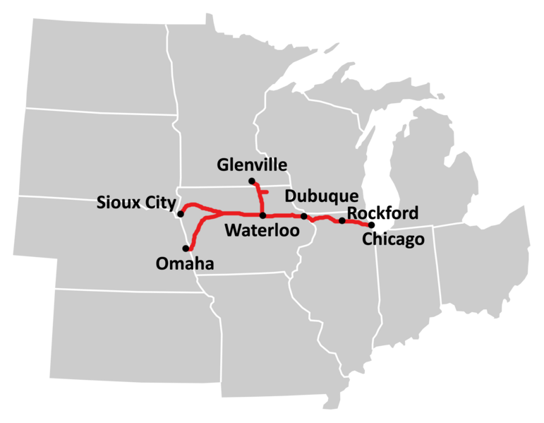

Generated Question - Does the Chicago Central and Pacific Railroad run through more than one state listed in the Central States?

Generated Answer - Yes, it runs through multiple Central States including Illinois, Iowa, and Nebraska.

--- Entry for custom_id: d5c98d7c0dba11ecb1e81171463288e9 ---

Image Source 1 -

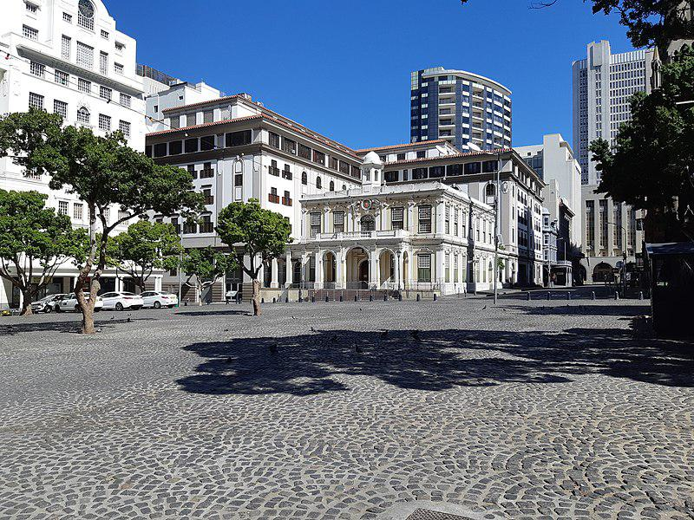

Caption for image source 1: Greenmarket Square lockdown 20200401 Greenmarket Square, Cape Town as it appeared during the COVID 19 lockdown in April 2020..

Example Question - "Are there trees growing in the Greenmarket Square ground?"

Example Answer - "Yes, there are trees growing in the Greenmarket Square ground."

Additional Text Source 1 - Also featured in the square are five bronze historical medallions, set flush into areas of the surrounding sidewalks, telling the history of the park and its surroundings, including one for the "Negro Burial Ground", an 18th-century African-American burial ground unearthed during construction of the square. This burial ground has been preserved as the African Burial Ground National Monument. (from: Foley Square)

Generated Question - Are there any visible historical medallions or monuments in the Greenmarket Square during the COVID-19 lockdown?

Generated Answer - No, there are no visible historical medallions or monuments in the Greenmarket Square in the image.

--- Entry for custom_id: d5d86f4a0dba11ecb1e81171463288e9 ---

Example Question - Is Mount Baldy or the southern flank of Bald Mountain taller?

Example Answer - Mount Baldy is taller.

Image Source 1 -



Generated Question - Considering the locations shown on the map, is Mount Baldy suitable for skiing compared to Bald Mountain in Mendocino National Forest?

Generated Answer - Yes, Mount Baldy is suitable for skiing as it has ski lifts, unlike Bald Mountain.

--- Entry for custom_id: d5c5b27e0dba11ecb1e81171463288e9 ---

Image Source 1 -

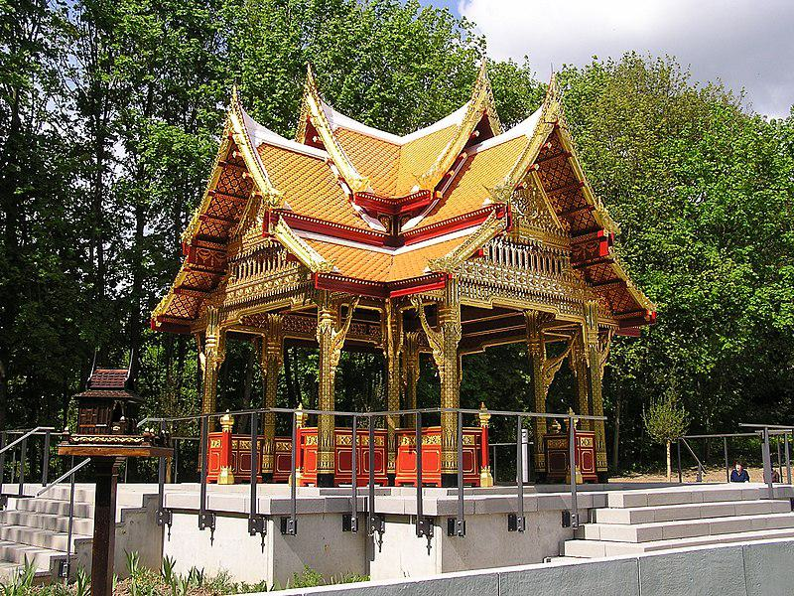

Caption for image source 1: Bad Homburg Sala-Thai II The new Sala-Thai II (pavilion) in the spa gardens Bad Homburg.

Image Source 2 -

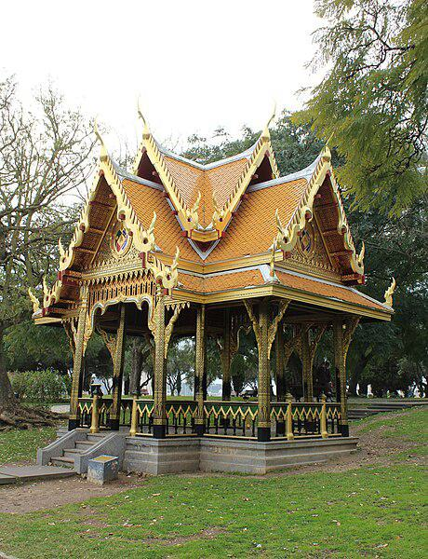

Caption for image source 2: Lissabon (Belém), Park Vasco da Gama, Thai Pavillon Lisbon (Belem), garden Vasco da Gama, Thai pavilion.

Example Question - "Do the Sala-Thai II pavilion and the Vasco da Gama, Thai pavilion have the same number of stairs leading up to them?"

Example Answer - "The Sala-Thai II pavilion and the Vasco da Gama, Thai pavilion have a different number of stairs leading up to them."

Additional Text Source 1 - Alexx O'Neill, who hails from Connecticut in the United States, was cast as Estêvão da Gama. "When I had signed Urumi, it was basically for a single character Estêvão Da Gama, but later I played [young] Vasco Da Gama's role, too, and had to speak only in Portuguese", O'Neill said. (from: Urumi (film))

Generated Question - Considering the historical figure Vasco Da Gama mentioned, which pavilion is located in a park named after him?

Generated Answer - The Vasco da Gama, Thai pavilion is located in the park named after Vasco Da Gama.

--- Entry for custom_id: d5d079700dba11ecb1e81171463288e9 ---

Example Question - Where was Audre Lorde's father from and what was her sexual orientation?

Example Answer - Audre Lorde's father was from Barbados, she was a lesbian.

Image Source 1 -

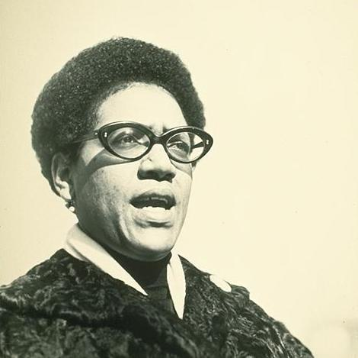

Generated Question - How did Audre Lorde describe her identity and what social issues did she address through her work?

Generated Answer - She described herself as a Black, lesbian, mother, warrior, poet and addressed racism, sexism, classism, capitalism, heterosexism, and homophobia.

--- Entry for custom_id: d5c2a0e80dba11ecb1e81171463288e9 ---

Image Source 1 -

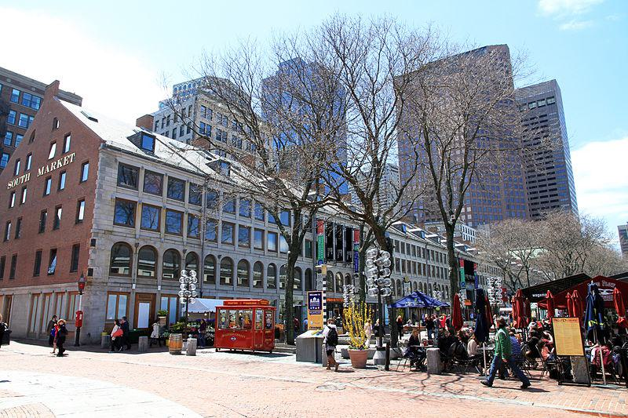

Caption for image source 1: USA-South Market South Market.

Example Question - "Are there any outdoor cafes near South Market?"

Example Answer - "Yes, South Market provides outdoor cafe options."

Additional Text Source 1 - The Wuhan Huanan Seafood Wholesale Market (Chinese: 武汉华南海鲜批发市场), simply known as the Huanan Seafood Market (Huanan means 'South China'), was a live animal and seafood market in Jianghan District, Wuhan City, the capital of Hubei Province in Central China. (from: Huanan Seafood Wholesale Market)

Generated Question - Are both South Market in the USA and Huanan Seafood Market in Wuhan associated with seafood trading?

Generated Answer - Yes, both markets are associated with seafood trading.

--- Entry for custom_id: d5cb16ce0dba11ecb1e81171463288e9 ---

Image Source 1 -

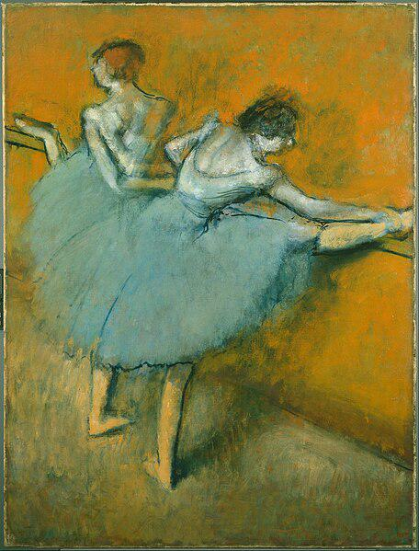

Caption for image source 1: Edgar Degas - Dancers at the Barre - Google Art Project.

Example Question - "In the Edgar Degas painting "Dancers at the Barre", how many feet do the dancers have on the ground?"

Example Answer - "In the Edgar Degas painting "Dancers at the Barre", the dancers have 2 feet on the ground."

Additional Text Source 1 - Hence, kethoneth passim, may be translated as "a full-sleeved robe", "a coat of many colours", "a coat reaching to his feet", "an ornamented tunic", "a silk robe", or "a fine woolen cloak". (from: Coat of many colors)

Generated Question - Do the dancers in Edgar Degas' "Dancers at the Barre" wear full-sleeved robes like the "coat of many colours"?

Generated Answer - No, the dancers wear sleeveless tutus, not full-sleeved robes.

--- Entry for custom_id: d5d176040dba11ecb1e81171463288e9 ---

Example Question - Which has a longer name it is referred to as: Black crappie or blackfish?

Example Answer - Black crappie.

Image Source 1 -

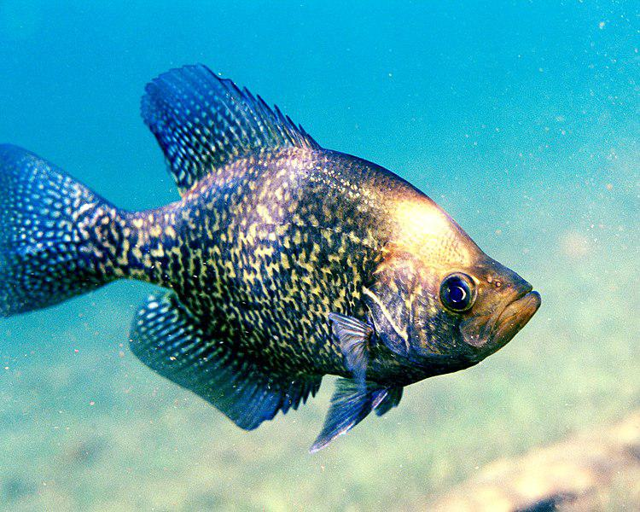

Generated Question - Which fish is more challenging to catch from shore, the blackfish or the black crappie shown in the image?

Generated Answer - The blackfish is more challenging to catch from shore.

--- Entry for custom_id: d5cd24000dba11ecb1e81171463288e9 ---

Image Source 1 -

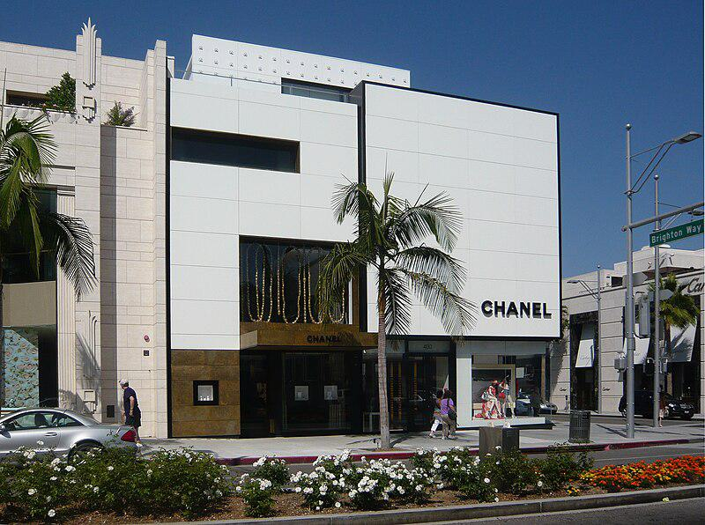

Caption for image source 1: Chanel boutique on Rodeo Drive Chanel boutique on Rodeo Drive (Beverly Hills, California).

Image Source 2 -

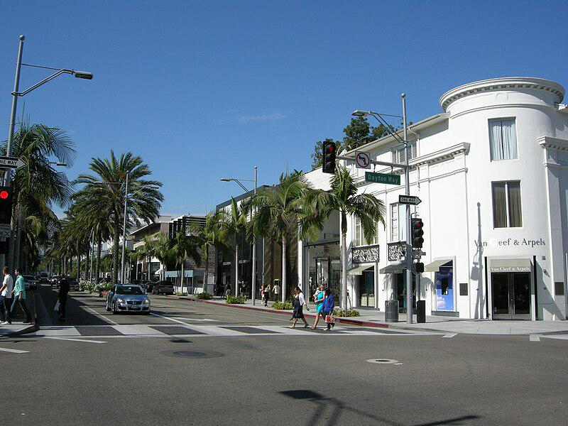

Caption for image source 2: Rodeo drive, 02.

Example Question - "Are both the Chanel and the Van Cleef & Arpels stores on Rodeo drive white?"

Example Answer - "Yes, both the Chanel and the Van Cleef & Arpels stores on Rodeo drive are white in color."

Additional Text Source 1 - The mall includes 150 specialty stores and restaurants including Balenciaga, Bruno Cucinelli, Burberry, Bvlgari, Cartier, Chanel, Dior, Christian Louboutin, Dolce and Gabbana, Fendi, Gucci, Hermès, Louis Vuitton, Jimmy Choo, Max Mara, Oliver Peoples, Prada, Saint Laurent, Salvatore Ferragamo, and Van Cleef & Arpels, it is anchored by Bloomingdale's, Macy's, Neiman Marcus, and Nordstrom. (from: The Mall at Short Hills)

Generated Question - Are the Chanel and Van Cleef & Arpels stores on Rodeo Drive similar in color to the luxury brands in The Mall at Short Hills?

Generated Answer - Yes, both stores on Rodeo Drive and the luxury brands in The Mall at Short Hills are predominantly white.

--- Entry for custom_id: d5c6ede20dba11ecb1e81171463288e9 ---

Image Source 1 -



Caption for image source 1: Mandrill portrait, Berlin Zoo Mandrill (Mandrillus sphinx) at the Berlin Zoo (Zoologischer Garten Berlin).

Example Question - "What bright color is found on a mandrill's nose?"

Example Answer - "A bright pink color is found on a mandrill's nose."

Additional Text Source 1 - Hyperbolic colors: these are impossibly highly saturated. For example, to see "hyperbolic orange": staring at bright cyan causes an orange afterimage, then on looking at orange, the resulting orange afterimage seen against the orange background may cause an orange color purer than the purest orange color that can be made by any normally-seen light. (from: Impossible color)

Generated Question - How does the bright pink on the mandrill's nose relate to the concept of hyperbolic colors described in the text?

Generated Answer - The mandrill's bright pink nose is a vivid natural color, but it is not an impossibly saturated hyperbolic color.

--- Entry for custom_id: d5d5015c0dba11ecb1e81171463288e9 ---

Example Question - Salute states as well as the Non-salute states qualify as true what, which the Pathans of Gujarat ruled a number of?

Example Answer - Princely states

Image Source 1 -

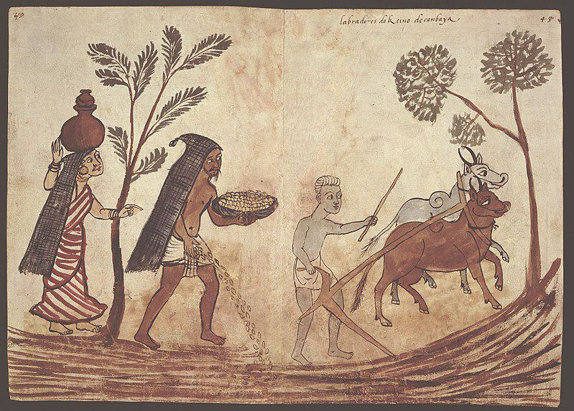

--- Entry for custom_id: d5da45040dba11ecb1e81171463288e9 ---

Example Question - What animal first appeared during the Oligocene epoch about 37 million years ago and was represented in literature, folklore, and myth?

Example Answer - Alligators.

Image Source 1 -

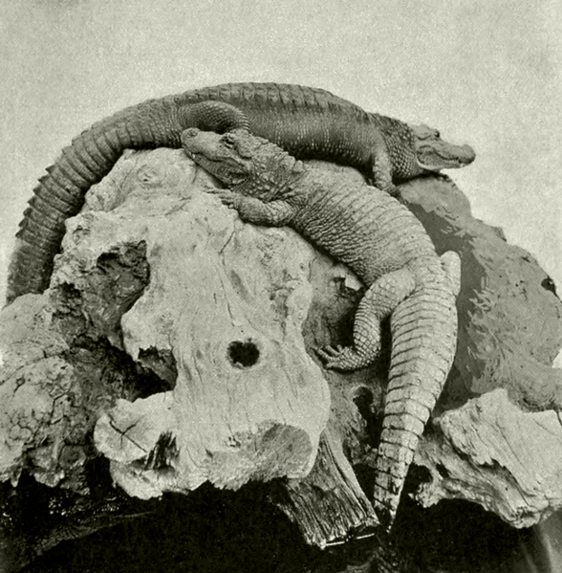

Generated Question - Which animal, first appearing in the Oligocene epoch, is depicted in the image and also features in notable fictional works?

Generated Answer - The alligator.

--- Entry for custom_id: d5cdd9360dba11ecb1e81171463288e9 ---

Image Source 1 -

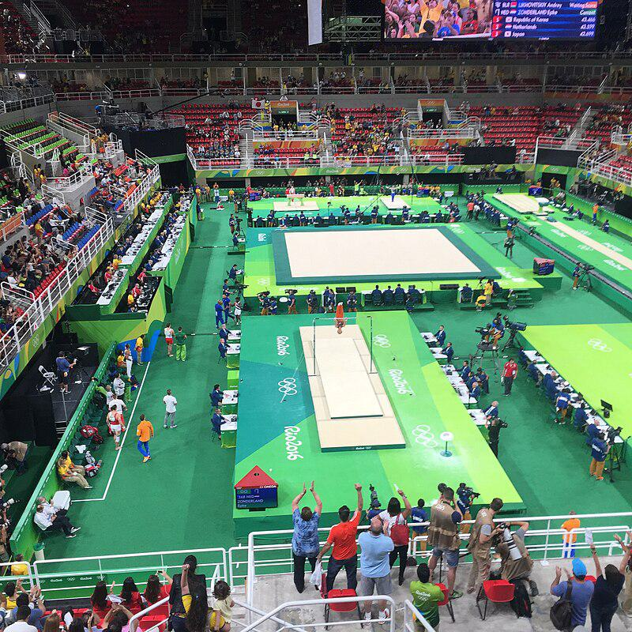

Caption for image source 1: Rio 2016 Olympic artistic gymnastics qualification men (29061917721).

Example Question - "Were spectators allowed to watch the gymnastics at the 2016 Summer Olympics?"

Example Answer - "Yes, spectators were allowed to watch the gymnastics at the 2016 Summer Olympics."

Additional Text Source 1 - Gymnastics at the 2016 Summer Olympics in Rio de Janeiro was held in three categories: artistic gymnastics, rhythmic gymnastics and trampolining. All gymnastics events were staged at the Arena Olímpica do Rio from 6 to 21 August 2016. (from: Gymnastics at the 2016 Summer Olympics)

Generated Question - Did the gymnastics events at the 2016 Summer Olympics take place in a single venue with multiple apparatus areas?

Generated Answer - Yes, all gymnastics events were held at one venue with multiple apparatus areas.

--- Entry for custom_id: d5de4bcc0dba11ecb1e81171463288e9 ---

Example Question - Dai Ön Ulus preceded what dynasty that annexed the areas of the southwest that had once been part of the Kingdom of Dali following the successful effort by Hui Muslim Ming armies to defeat Yuan -loyalist Mongol and Hui Muslim troops?

Example Answer - Ming.

Image Source 1 -

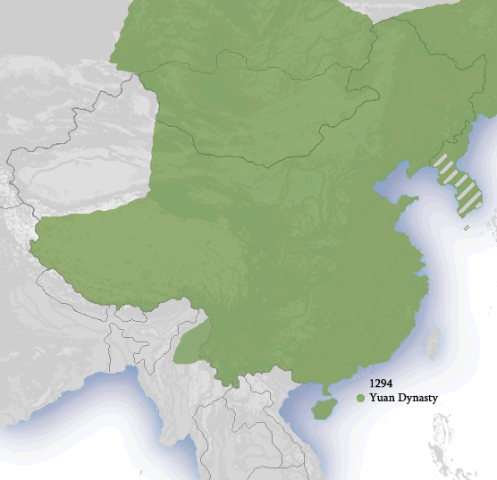

Generated Question - Which dynasty ruled China after the Yuan dynasty and annexed the southwest areas once part of the Kingdom of Dali?

Generated Answer - The Ming dynasty.

--- Entry for custom_id: d5d990be0dba11ecb1e81171463288e9 ---

Example Question - In the first presidential election after the end of World War I, who won the highest percentage of the vote in Alabama?

Example Answer - James Cox.

Image Source 1 -

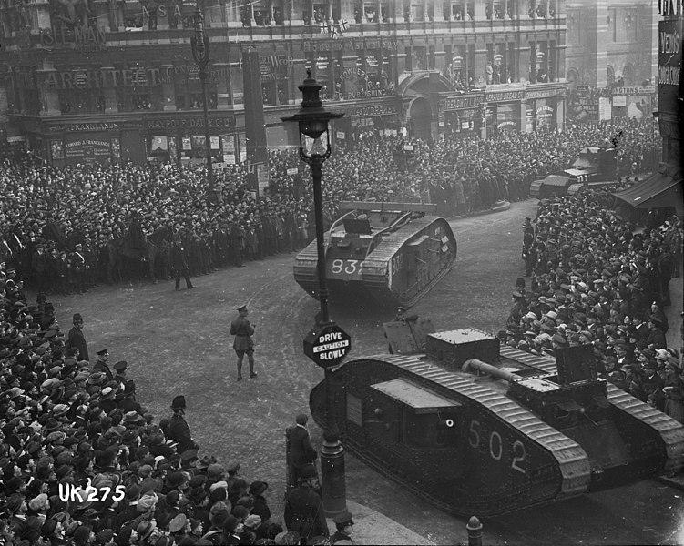

Generated Question - Did the presidential election after World War I occur before or after the tanks were paraded in London?

Generated Answer - The election occurred after the tanks were paraded in London.

--- Entry for custom_id: d5bcd53c0dba11ecb1e81171463288e9 ---

Image Source 1 -

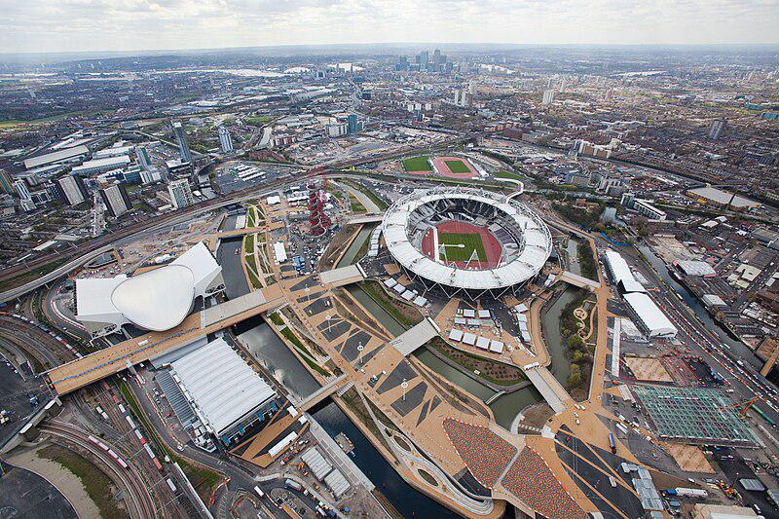

Caption for image source 1: Olympic Park, London, 16 April 2012 Final Construction of Olympic Park, London (April 2012). Aerial view of the Olympic Park looking south west towards London. Picture taken on 16 April 2012..

Example Question - "Is there only one football field surrounded by a track at Olympic Park London?"

Example Answer - "No, there is not only one football field surrounded by a track at Olympic Park London."

Additional Text Source 1 - A football pitch (also known as a football field) is the playing surface for the game of association football. Its dimensions and markings are defined by Law 1 of the Laws of the Game, "The Field of Play". (from: Football pitch)

Generated Question - Are the football fields surrounded by tracks at Olympic Park London consistent with the dimensions defined by Law 1 of the Laws of the Game?

Generated Answer - Yes, the football fields surrounded by tracks at Olympic Park London follow the standard dimensions defined by Law 1.

--- Entry for custom_id: d5daed560dba11ecb1e81171463288e9 ---

Example Question - Kementerian Kerja Raya is part of the government in which what person currently serves as Deputy Minister of Health?

Example Answer - Zahidi Zainul Abidin

Image Source 1 -

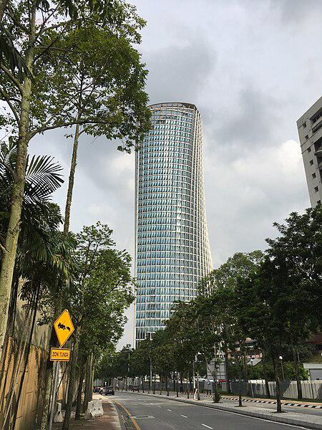

--- Entry for custom_id: d5cdb97e0dba11ecb1e81171463288e9 ---

Image Source 1 -

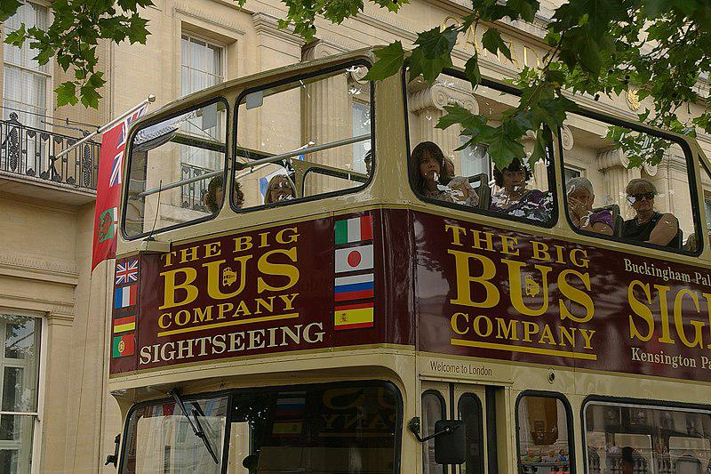

Caption for image source 1: London MMB 27 Trafalgar Square "The Big Bus Sightseeing Company" open top tour bus in Trafalgar Square, London..

Image Source 2 -

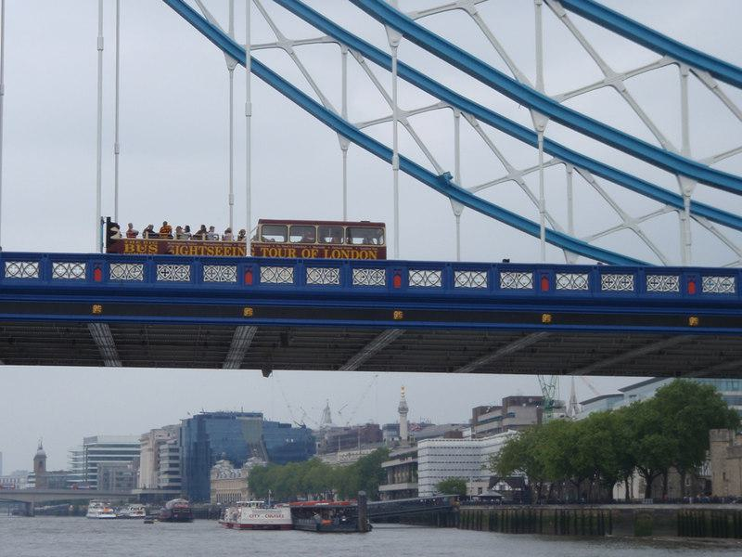

Caption for image source 2: Sights and sightseers - geograph.org.uk - 1903726 Sights and sightseers, Data from Geograph: Description: Sightseeing bus crossing the northern span of Tower bridge with a variety of sights to be seen on the other side of the bridge ICBM: 51.508626027384, -0.08680549616532 Location: (about 1 km from) near to City of London, Great Britain..

Example Question - "What colors are on both the The Big Bus Company bus and the Tower bridge in London?"

Example Answer - "Blue, red, yellow, and white appear on both the bus and bridge."

Additional Text Source 1 - A spokesman for Tower Bridge is quoted as saying: "We tried to contact the American Embassy, but they wouldn't answer the phone. "On 19 August 1999, Jef Smith, a Freeman of the City of London, drove a flock of two sheep across the bridge. (from: Tower Bridge)

Generated Question - Are the sightseeing bus and Tower Bridge in London both associated with popular tourist activities?

Generated Answer - Yes, both the sightseeing bus and Tower Bridge are popular tourist attractions in London.

--- Entry for custom_id: d5c45a5a0dba11ecb1e81171463288e9 ---

Image Source 1 -



Caption for image source 1: Athens academy Academy of Athens.

Image Source 2 -

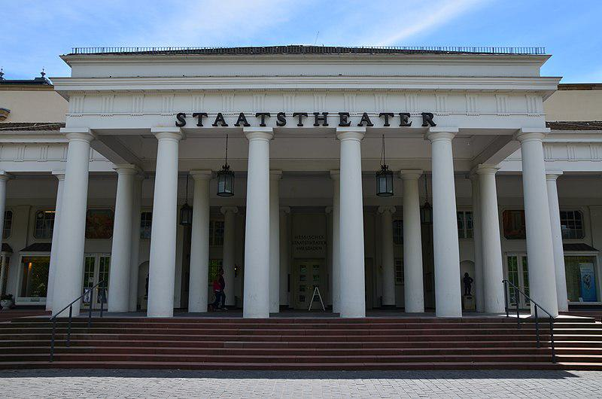

Caption for image source 2: Wiesbaden, Neoclassical architecture (9066890689).

Example Question - "What is the color of the pillars at the Staats Theater and the Athens Academy?"

Example Answer - "The color of the pillars at the Staats Theater and the Athens Academy is white."

Additional Text Source 1 - In 86 BC, Lucius Cornelius Sulla laid siege to Athens and conquered the city, causing much destruction. It was during the siege that he laid waste to the Academy, as Plutarch relates: "He laid hands upon the sacred groves and ravaged the Academy, which was the most wooded of the city's suburbs, as well as the Lyceum. (from: Platonic Academy)

Generated Question - Considering the destruction of the original Academy in Athens, how does the current Athens Academy's architecture compare to the neoclassical style of the Staats Theater?

Generated Answer - Both the Athens Academy and the Staats Theater feature neoclassical architecture with white pillars.

--- Entry for custom_id: d5c5c8180dba11ecb1e81171463288e9 ---

Image Source 1 -

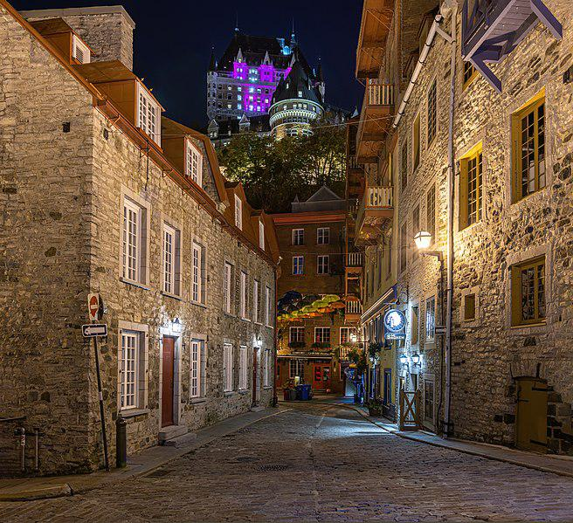

Caption for image source 1: Petit Champlain at night, Quebec city Quartier du Petit Champlain is a small commercial zone in Quebec City, Quebec, Canada..

Image Source 2 -

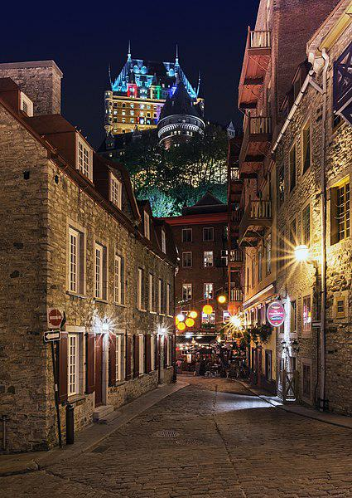

Caption for image source 2: Champlain Quebec city Champlain Quebec city, Canada.

Example Question - "Has the signage on Rue du Petit-Champlain always been the same?"

Example Answer - "No, the signage on Rue du Petit-Champlain has not always been the same."

Additional Text Source 1 - The mural painted on the side of the house 102 rue du Petit-Champlain (currently owned by Coopérative des artisans et commerçants du quartier Petit Champlain) is a trompe-l'œil measuring 100m2 (900 ft2). It represents the history of the district, the bombardments of 1759, the landslides, and the fires which have occurred in the district. (from: Petit Champlain)

Generated Question - Does the mural on 102 rue du Petit-Champlain reflect the historical events visible in the nighttime images of the district?

Generated Answer - Yes, the mural represents historical events of the district shown in the nighttime images.

--- Entry for custom_id: d5cc0c5a0dba11ecb1e81171463288e9 ---

Image Source 1 -

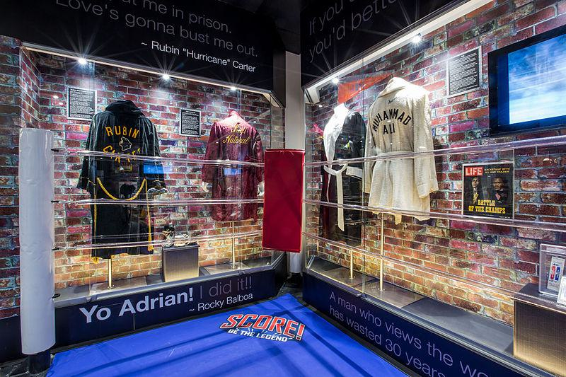

Caption for image source 1: BoxingHallOfFame 3 HollywoodAndAliExhibits Hollywood and Ali exhibits at Boxing Hall of Fame, Luxor Hotel, Las Vegas, Nevada.

Example Question - "What surface is behind the display at the Hollywood and Ali exhibits at Boxing Hall of Fame, Luxor Hotel, Las Vegas, Nevada?"

Example Answer - "Brick is behind the display at the Hollywood and Ali exhibits at Boxing Hall of Fame, Luxor Hotel, Las Vegas, Nevada."

Additional Text Source 1 - In 2021, the Pinball Hall of Fame moved near the "Fabulous Las Vegas" sign at the south end of the Strip. Also in 2021, Resorts World Las Vegas, the first new hotel-casino built in a decade, opened on the site of the former Stardust Resort and Casino (later the site of the unfinished Echelon Place). (from: Las Vegas Strip)

Generated Question - Are the Hollywood and Ali exhibits at the Boxing Hall of Fame located near the new Resorts World Las Vegas on the Strip?

Generated Answer - No, the exhibits are at Luxor Hotel, not near Resorts World Las Vegas.

--- Entry for custom_id: d5c4eac40dba11ecb1e81171463288e9 ---

Image Source 1 -

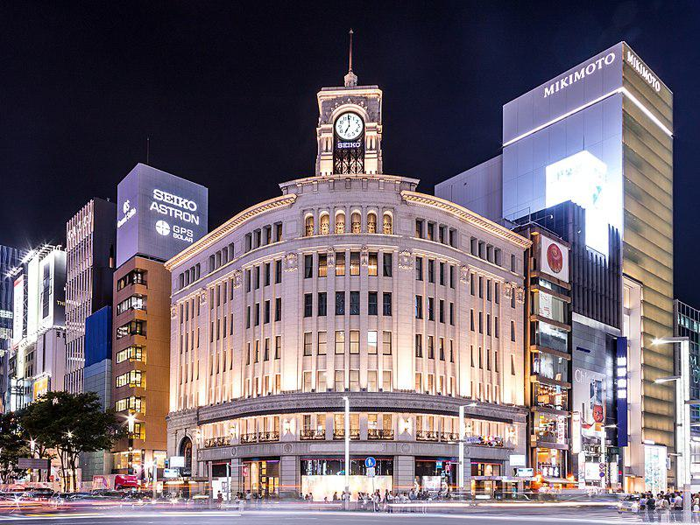

Caption for image source 1: Ginza-WAKO at night.

Example Question - "What is written below the clock at the top of Wako Ginza in Tokyo?"

Example Answer - "The word Seiko is written below the clock at the top of Wako Ginza in Tokyo."

Additional Text Source 1 - Ginza (銀座): Tokyo's most expensive shopping district, housing large stores such as Matsuya (松屋), Matsuzakaya (松坂屋), Mitsukoshi (三越), Wako (和光), and Printemps (プランタン), as well as the famous Kabuki-za (歌舞伎座) theater. At night, Ginza is ablaze with neon lights. (from: Chūō, Tokyo)

Generated Question - Is the Wako building in Ginza surrounded by other large stores and bright neon lights at night?

Generated Answer - Yes, the Wako building is surrounded by large stores and bright neon lights at night in Ginza.

--- Entry for custom_id: d5c483e00dba11ecb1e81171463288e9 ---

Image Source 1 -

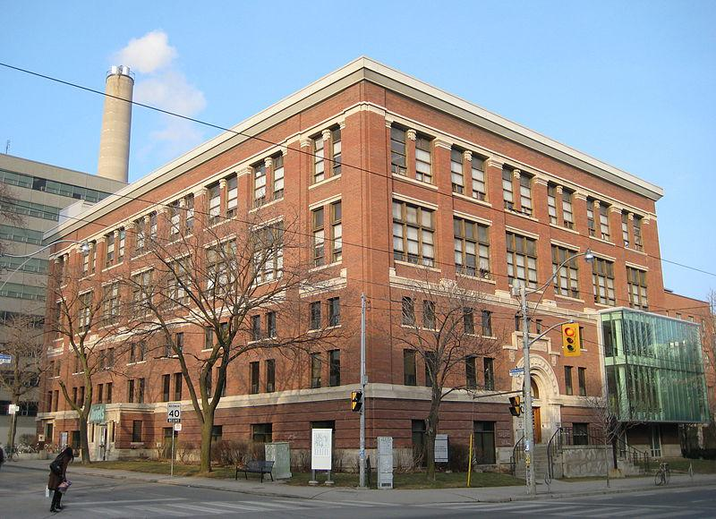

Caption for image source 1: Architecture Building, Toronto Architecture Building.

Example Question - "How many crosswalks lead to the Architecture Building in Toronto?"

Example Answer - "Two crosswalks lead to the Architecture Building in Toronto."

Additional Text Source 1 - Instead, zebra crossings are called "continental crosswalks" and are the preferred style in many states because of its enhanced visibility compared to the other marking styles. In most areas of Canada, standard parallel lines markings are the preferred crosswalk style, except in Toronto where zebra markings are widely used. (from: Zebra crossing)

Generated Question - Are the crosswalks leading to the Architecture Building in Toronto likely to be zebra or parallel line style?

Generated Answer - The crosswalks are likely zebra style, as Toronto widely uses zebra markings.

--- Entry for custom_id: d5c6cfba0dba11ecb1e81171463288e9 ---

Image Source 1 -

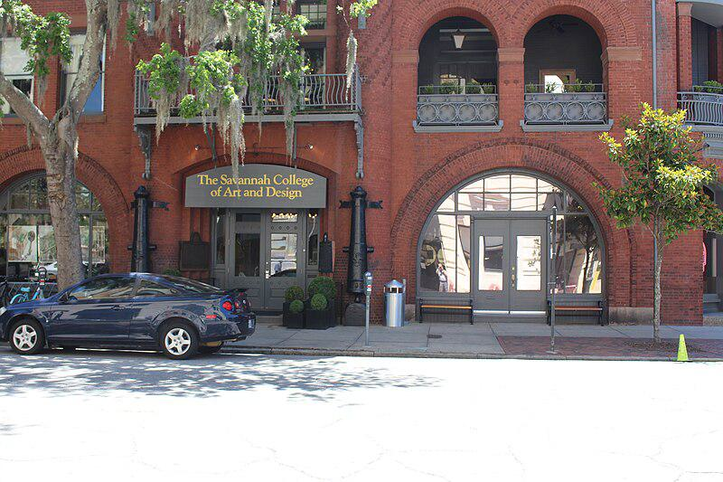

Caption for image source 1: Savannah College of Art and Design, Poetter Hall Savannah College of Art and Design, Poetter Hall, Savannah, Chatham County, Georgia.

Example Question - "Above the entrance to Savannah College of Art and Design, which line of text is longer: the bottom or top one?"

Example Answer - "Above the entrance to Savannah College of Art and Design the line of text is longer at the top."

Additional Text Source 1 - Businesses like LinkedIn, AIGA, Adweek, and Cooper-Hewitt, National Design Museum, and schools such as Art Center College of Design, Rhode Island School of Design (RISD), School of Visual Arts (SVA), Savannah College of Art and Design (SCAD), and the Maryland Institute College of Art (MICA) have used their services. (from: Behance)

Generated Question - Is the Savannah College of Art and Design building shown likely to be associated with other design schools mentioned in the additional text source?

Generated Answer - Yes, Savannah College of Art and Design is listed among the design schools in the additional text source.

--- Entry for custom_id: d5cc68c60dba11ecb1e81171463288e9 ---

Image Source 1 -

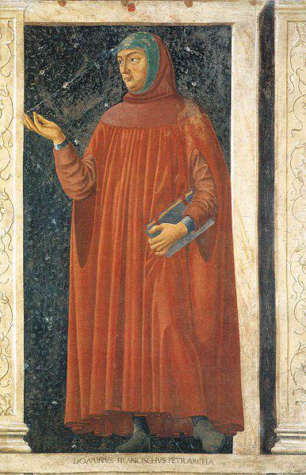

Caption for image source 1: Petrarch by Bargilla Famous Persons: Francesco Petrarca.

Example Question - "What is the man in Andrea del Castagno's painting "Famous Persons: Francesco Petrarca" holding?"

Example Answer - "The man in Andrea del Castagno's painting "Famous Persons: Francesco Petrarca" is holding a book."

Additional Text Source 1 - Corradini, Francisco, Africa Francisci Petrarchae nunc primum emendata, In Padova a Francesco Petrarca net Quinto Centenario dalla sua morte. Padova: Premiata Tipografia del Seminario, 1874. (from: Africa (Petrarch))

Generated Question - Does the figure in Andrea del Castagno's painting "Famous Persons: Francesco Petrarca" appear to be a scholar based on what he is holding and wearing?

Generated Answer - Yes, he appears to be a scholar as he is holding a book and wearing scholarly robes.

--- Entry for custom_id: d5ccdcb60dba11ecb1e81171463288e9 ---

Image Source 1 -

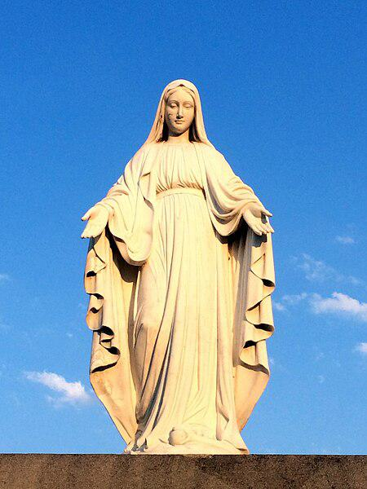

Caption for image source 1: Our Lady of Perpetual Help Catholic Church (Grove City, Ohio) - Blessed Virgin Mary statue Our Lady of Perpetual Help Catholic Church (Grove City, Ohio) - Blessed Virgin Mary statue.

Image Source 2 -

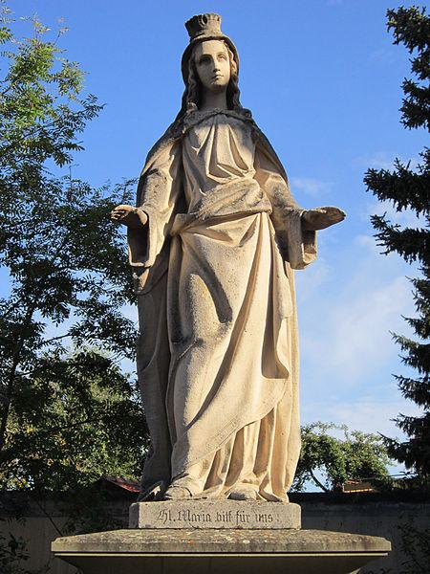

Caption for image source 2: Holy Mary Statue in Garitz (Bad Kissingen, Germany) – 20120722-013 Holy Mary Statue in Garitz, a quarter of the German spa town Bad Kissingen in Lower Franconia (Bavaria). The statue is the last work made by Franconian sculptor Michael Arnold..

Example Question - "What are both the Holy Mary Statue in Garitz and the Blessed Virgin Mary statue at Our Lady of Perpetual Help Catholic Church made of?"

Example Answer - "The Holy Mary Statue in Garitz and the Blessed Virgin Mary Statue at Our Lady of Perpetual Help Catholic Church are both made of stone."

Additional Text Source 1 - Our Lady of Guadalupe (Spanish: Nuestra Señora de Guadalupe), also known as the Virgin of Guadalupe (Spanish: Virgen de Guadalupe), is a Catholic title of the Blessed Virgin Mary associated with a series of five Marian apparitions in December 1531, and a venerated image on a cloak enshrined within the Basilica of Our Lady of Guadalupe in Mexico City. (from: Our Lady of Guadalupe)

Generated Question - Do the statues of the Blessed Virgin Mary in Ohio and Garitz represent the same religious figure as Our Lady of Guadalupe?

Generated Answer - Yes, all represent the Blessed Virgin Mary under different titles.

--- Entry for custom_id: d5ddefd80dba11ecb1e81171463288e9 ---

Example Question - What is the limited power of the Monarch in the Kingdom that has a Royal Government with Article 99 laying out the governmental duties?

Example Answer - The King's power is limited to that of a symbolic figurehead.

Image Source 1 -



Generated Question - How does the symbolic role of the Monarch relate to the Royal Government and military presence shown in Cambodia?

Generated Answer - The Monarch is a symbolic figurehead, while the Royal Government and military hold actual governing and defense roles.

--- Entry for custom_id: d5c96d420dba11ecb1e81171463288e9 ---

Image Source 1 -

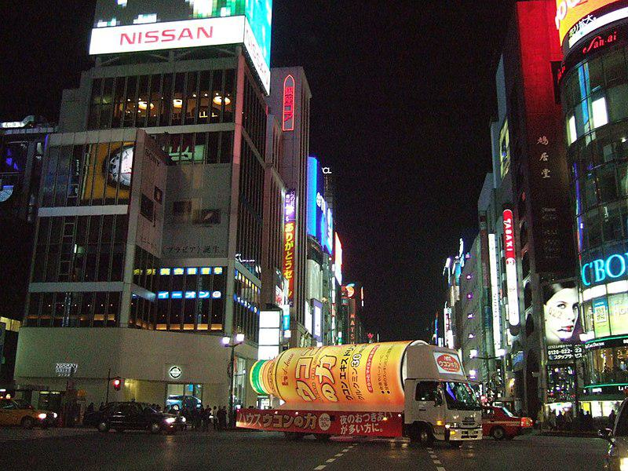

Caption for image source 1: Ginza 4, Chuo-dori St. 2005 (73602211).

Example Question - "What car company has an advertisement at Ginza 4?"

Example Answer - "Nissan has an advertisement at Ginza 4."

Additional Text Source 1 - Flagship electronic retail stores like the Sony showroom (which closed in 2017 and new building would open in 2022) and the first Apple Store outside the United States are also here (Ginza 2 chome). The electronics company, Ricoh is headquartered in the Ricoh Building in Ginza. (from: Ginza)

Generated Question - Which electronics companies have a presence in Ginza according to the image and text sources?

Generated Answer - Sony, Apple, and Ricoh have a presence in Ginza.

--- Entry for custom_id: d5d009a40dba11ecb1e81171463288e9 ---

Example Question - What tragic life event did both Herman Melville and Harold Harefoot experience?

Example Answer - The death of their fathers.

Image Source 1 -

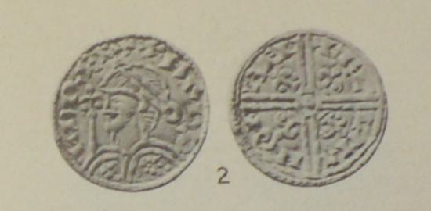

Generated Question - How does the coin image relate to Harold Harefoot's role described in the text?

Generated Answer - The coin represents Harold Harefoot's authority as regent of England after his father's death.

--- Entry for custom_id: d5c918f60dba11ecb1e81171463288e9 ---

Image Source 1 -

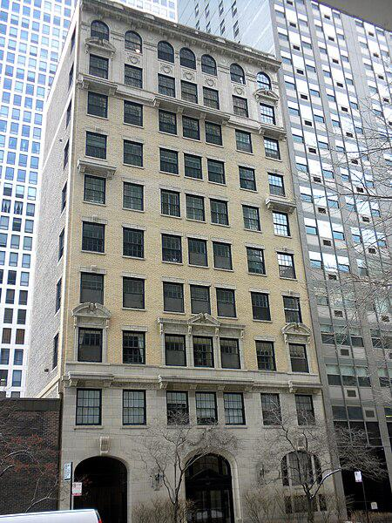

Caption for image source 1: 257 East Delaware Chicago 257 East Delaware Place, Chicago, on Near North Side. On the NRHP since June 26, 1987..

Example Question - "Are there any trees near the building at 257 East Delaware Place, Chicago which are taller than the building?"

Example Answer - "No, there are no trees near the building at 257 East Delaware Place, Chicago which are taller than the building."

Additional Text Source 1 - The Building at 257 East Delaware is a historic apartment building located at 257 East Delaware Place in the Near North Side neighborhood of Chicago, Illinois. (from: Building at 257 East Delaware)

Generated Question - Is the building at 257 East Delaware Place in Chicago surrounded by taller modern buildings?

Generated Answer - Yes, it is surrounded by taller modern buildings.

--- Entry for custom_id: d5df94e60dba11ecb1e81171463288e9 ---

Example Question - What first-line medication for the treatment of neuropathic pain caused by diabetic neuropathy was the eleventh most commonly prescribed medication in the United States in 2018?

Example Answer - Gabapentin was the eleventh most commonly prescribed medication in the United States in 2018.

Image Source 1 -

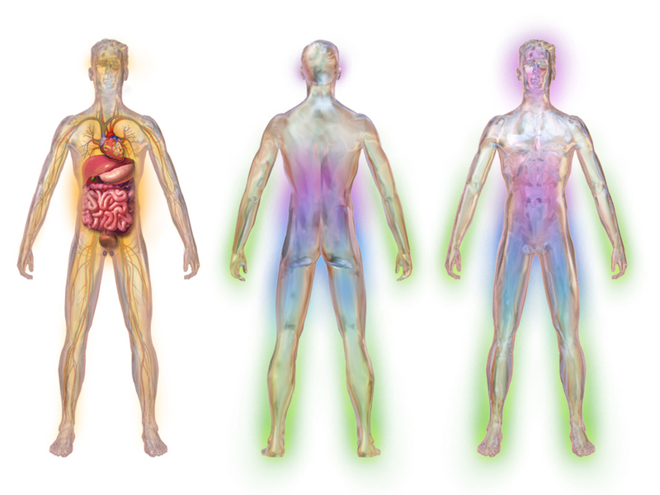

Generated Question - What medication approved in 1993 is moderately effective for treating the nerve pain shown in the diabetic neuropathy illustration?

Generated Answer - Gabapentin is moderately effective for treating diabetic neuropathy nerve pain and was approved in 1993.

--- Entry for custom_id: d5cc06600dba11ecb1e81171463288e9 ---

Image Source 1 -

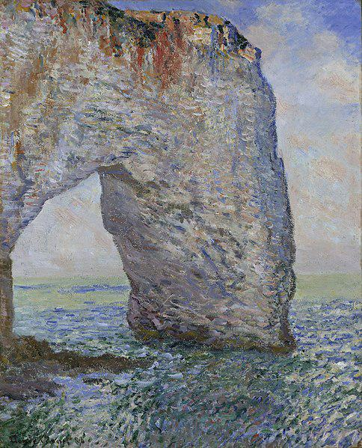

Caption for image source 1: Claude Monet - The Manneporte near Étretat.

Example Question - "What is the shape depicted in The Manneporte near Étretat?"

Example Answer - "In "The Manneporte near Étretat", an arch is depicted in it."

Additional Text Source 1 - In 1882 he wrote a short story for Le Gaulois entitled "The Englishman of Étretat" (L'Anglais d'Étretat), based on encounters in 1868, as a house guest of G. E. J. Powell, with the English poet Algernon Charles Swinburne, whom he had helped save from drowning. (from: Étretat)

Generated Question - Does the arch in Monet's painting relate to the English poet Algernon Charles Swinburne mentioned in the Étretat story?

Generated Answer - Yes, the arch is from Étretat, where Monet met Swinburne, inspiring the story.

--- Entry for custom_id: d5d869500dba11ecb1e81171463288e9 ---

Example Question - What pill that includes ethinylestradiol and levonorgestrela progestin would someone take to address the condition in which cells similar to those in the endometrium grow outside the uterus?

Example Answer - Someone could take Rigevidon to address this condition.

Image Source 1 -

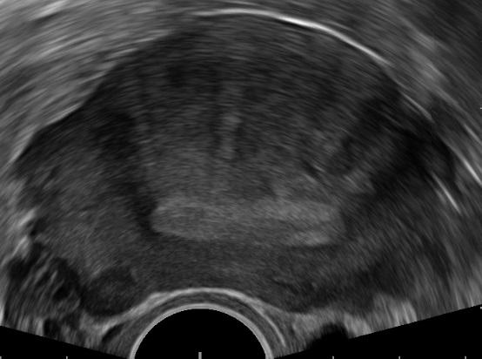

--- Entry for custom_id: d5d777fc0dba11ecb1e81171463288e9 ---

Example Question - Willie is a what, which Daley is a sympathetically presented as, ghost, and an diehard skateboarder?

Example Answer - Gay

Image Source 1 -



Generated Question - Which character from Kyo Kara Maoh! could be sympathetically presented like Daley, considering the themes of sexuality in the other sources?

Generated Answer - Yuri Shibuya.

--- Entry for custom_id: d5cb6a660dba11ecb1e81171463288e9 ---

Image Source 1 -

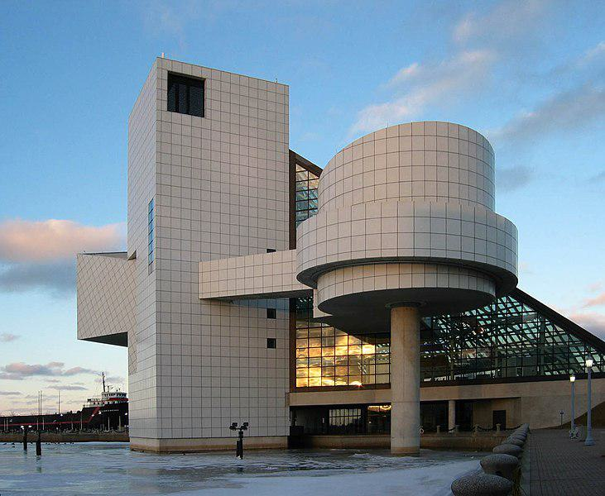

Caption for image source 1: Rock and Roll Hall of Fame The Rock and Roll Hall of Fame, Cleveland, Ohio; architect: I. M. Pei.

Example Question - "Is the section of the Rock and Roll Hall of Fame in Cleveland with glass walls the tallest part of the building?"

Example Answer - "No, the section of the Rock and Roll Hall of Fame in Cleveland with glass walls is not the tallest part of the building."

Additional Text Source 1 - Hall of Fame museum curator James Henke, along with "the museum's curatorial staff and numerous rock critics and music experts", created an unordered list of "500 Songs That Shaped Rock and Roll". The list is part of a permanent exhibit at the museum, and was envisioned as part of the museum from its opening in 1995. (from: Rock and Roll Hall of Fame)

Generated Question - Does the Rock and Roll Hall of Fame in Cleveland include exhibits that highlight influential rock songs as part of its permanent collection?

Generated Answer - Yes, it features a permanent exhibit of 500 Songs That Shaped Rock and Roll.

--- Entry for custom_id: d5c167a00dba11ecb1e81171463288e9 ---

Image Source 1 -

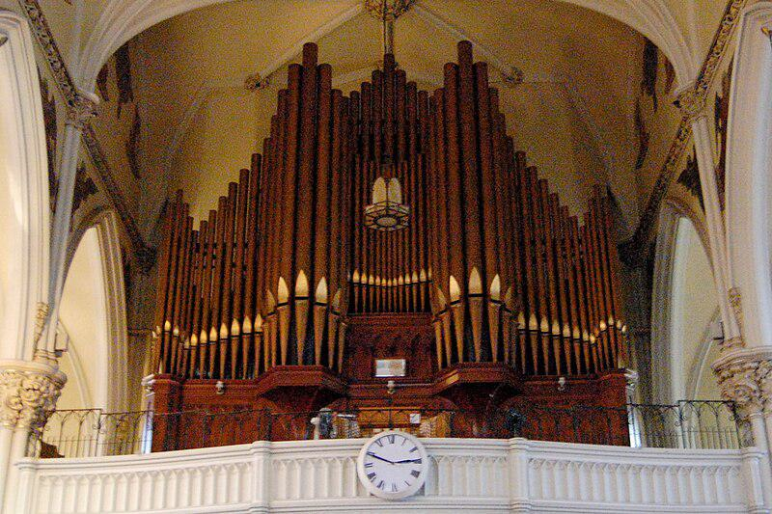

Caption for image source 1: St. Mary's Cathedral pipe organ.

Image Source 2 -

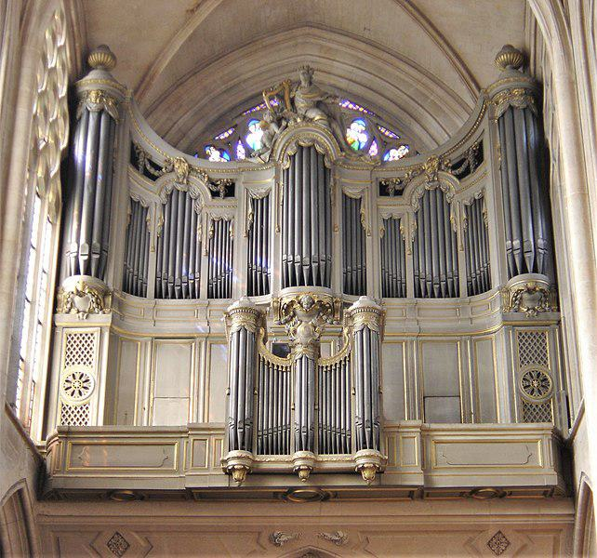

Caption for image source 2: StGermainAuxerrois1.

Example Question - "Are the pipes on the organ at St. Mary's Cathedral in Kingston a lighter or darker color than those on the Église Saint-Germain-l'Auxerrois church in Paris?"

Example Answer - "The pipes on the organ at St. Mary's Cathedral in Kingston are a darker color than those on the Église Saint-Germain-l'Auxerrois church in Paris."

Additional Text Source 1 - The Church of Saint-Roch (French: Église Saint-Roch) is a late Baroque 126 meter-long church in Paris, dedicated to Saint Roch. Located at 284 rue Saint-Honoré, in the 1st arrondissement, it was built between 1653 and 1740.The church is organized as a series of chapels. (from: Saint-Roch, Paris)

Generated Question - Considering the pipe organs in St. Mary's Cathedral and Église Saint-Germain-l'Auxerrois, which organ's pipes are darker, and how does this compare to the Baroque style of Saint-Roch church?

Generated Answer - St. Mary's Cathedral organ pipes are darker, contrasting with the lighter pipes of Église Saint-Germain-l'Auxerrois, while Saint-Roch church is a Baroque chapel series.

--- Entry for custom_id: d5c3ca9a0dba11ecb1e81171463288e9 ---

Image Source 1 -

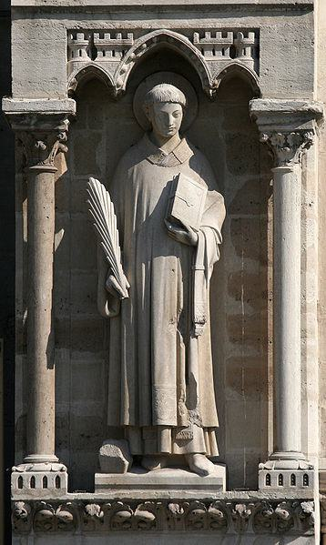

Caption for image source 1: Notre-dame-paris-1st-statue-west-side.

Image Source 2 -

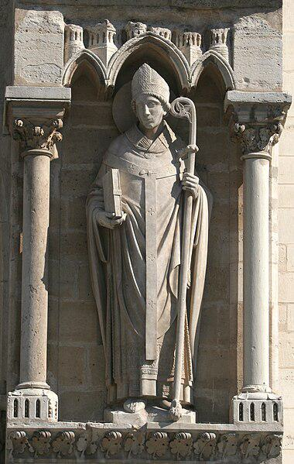

Caption for image source 2: Notre-dame-paris-4th-statue-west-side.

Example Question - "How many arches are above the Notre Dame Paris 1st and 4th statues on the west side?"

Example Answer - "There are three arches above the Notre Dame Paris 1st and 4th statues on the west side."

Additional Text Source 1 - A baptistery, the Church of Saint-John-le-Rond, built about 452, was located on the north side of the west front of Notre-Dame until the work of Jacques-Germain Soufflot in the 18th century. In 1160, the Bishop of Paris, Maurice de Sully, decided to build a new and much larger church. (from: Notre-Dame de Paris)

Generated Question - Were the statues on the west side of Notre-Dame likely added after the original 5th-century baptistery was replaced by the larger church built in 1160?

Generated Answer - Yes, the statues were likely added after the larger church was built in 1160.

--- Entry for custom_id: d5df95900dba11ecb1e81171463288e9 ---

Example Question - What is the name of the horse that has more wins in the King George VI Chase than Dessie?

Example Answer - Kauto Star

Image Source 1 -



Generated Question - Which horse has won the King George VI Chase more times than the number of people in the photo with King George VI, Queen Elizabeth, and Princess Elizabeth?

Generated Answer - Kauto Star, with five wins.

--- Entry for custom_id: d5cc9dbe0dba11ecb1e81171463288e9 ---

Image Source 1 -

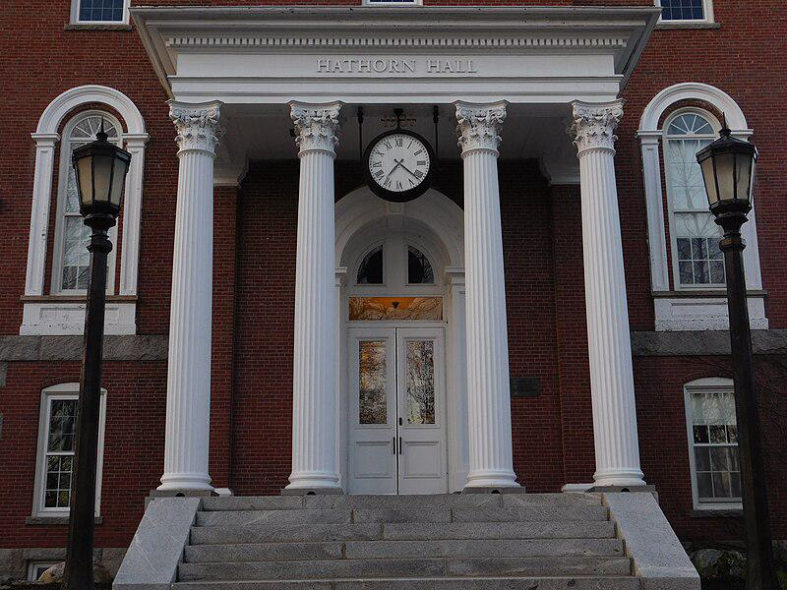

Caption for image source 1: Entrance to Hathorn Hall Entrance to Hathorn Hall.

Example Question - "How many columns are at the Entrance to Hathorn Hall?"

Example Answer - "There are 4 columns at the Entrance to Hathorn Hall."

Additional Text Source 1 - Most notably, Bates shares many architectural features with Dartmouth College and the Baker-Berry Library possesses numerous design aspects that parallel Hathorn Hall. (from: Campus of Bates College)

Generated Question - Do Hathorn Hall and the Baker-Berry Library share similar architectural features such as columns at their entrances?

Generated Answer - Yes, both Hathorn Hall and the Baker-Berry Library share similar architectural features including columns at their entrances.

--- Entry for custom_id: d5c0fe320dba11ecb1e81171463288e9 ---

Image Source 1 -

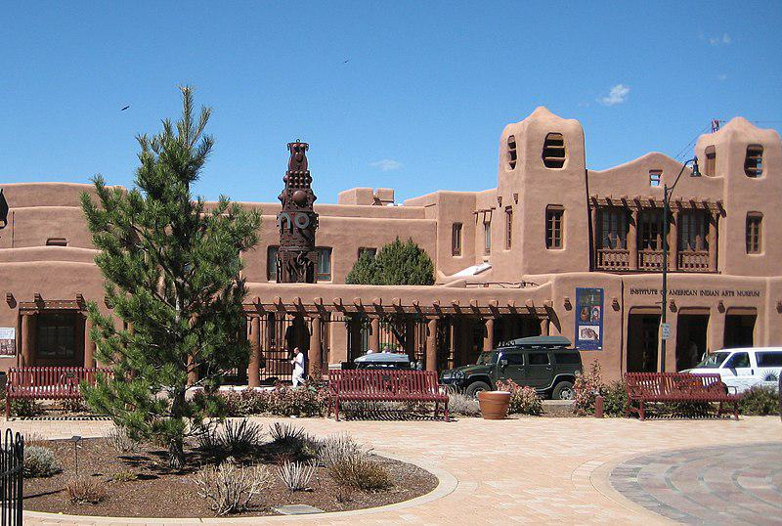

Caption for image source 1: IAIA Museum Institute Of American Indian Arts Museum, Santa Fe NM.

Example Question - "Is there only one bench to sit on in front of the Institute Of American Indian Arts Museum?"

Example Answer - "There is more than one bench to sit on in front of the Institute Of American Indian Arts Museum."

Additional Text Source 1 - In 1991 the college founded the Institute of American Indian Arts Museum, now the IAIA Museum of Contemporary Native Arts (MoCNA), in downtown Santa Fe, with a focus on contemporary intertribal Native American art (the C. N. Gorman Museum at the University of California, Davis, which also has a contemporary intertribal Native art focus, was founded in 1973.) (from: Institute of American Indian Arts)

Generated Question - Does the IAIA Museum of Contemporary Native Arts in Santa Fe focus on traditional or contemporary Native American art?

Generated Answer - It focuses on contemporary intertribal Native American art.

--- Entry for custom_id: d5bc218c0dba11ecb1e81171463288e9 ---

Image Source 1 -

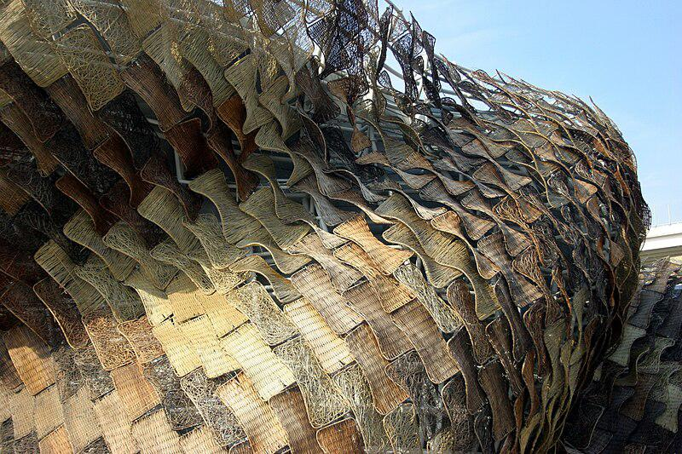

Caption for image source 1: Spain Pavilion of Expo 2010 Spain Pavilion of Expo 2010.

Example Question - "What does the exterior of the Spain Pavilion at Expo 2010 resemble?"

Example Answer - "The Spain Pavilion at Expo 2010's exterior resembles scales."

Additional Text Source 1 - Performers during the opening weeks of Expo 2010 included the Philadelphia Orchestra, Dee Dee Bridgewater and Herbie Hancock. The U.S. Pavilion, with its theme of "Rising to the Challenge", was a gray steel structure designed to resemble an eagle with its wings outstretched to welcome pavilion visitors. (from: Expo 2010 pavilions)

Generated Question - How do the exterior designs of the Spain Pavilion and the U.S. Pavilion at Expo 2010 differ in their animal inspirations?

Generated Answer - The Spain Pavilion resembles scales, while the U.S. Pavilion resembles an eagle with outstretched wings.

--- Entry for custom_id: d5cf8fec0dba11ecb1e81171463288e9 ---

Example Question - At minimum, how many cancers types would be classifiable as a reproductive system disease?

Example Answer - Six

Image Source 1 -

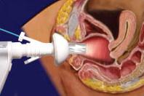

Generated Question - How does the use of a vaginal speculum relate to diagnosing diseases in the female reproductive system?

Generated Answer - A vaginal speculum allows examination of the vagina and cervix to help diagnose reproductive system diseases.

--- Entry for custom_id: d5c59f5a0dba11ecb1e81171463288e9 ---

Image Source 1 -

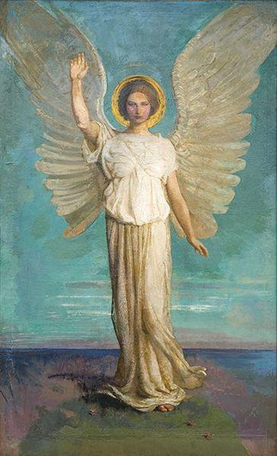

Caption for image source 1: 'Angel of the Dawn' by Abbott Handerson Thayer, 1919 Angel of the Dawn by Abbott Handerson Thayer, 1919, oil on canvas. St. Anselm Abbey School, Washington D.C..

Image Source 2 -

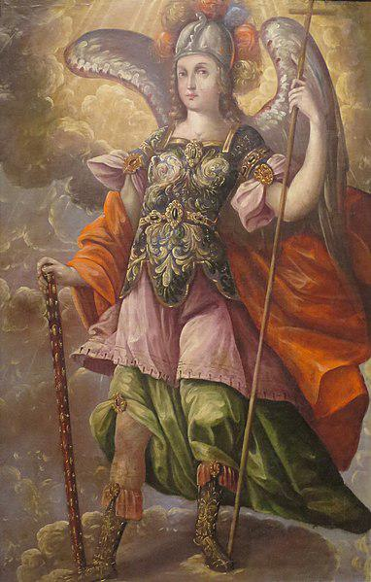

Caption for image source 2: 'Saint Michael the Archangel' anonymous Mexican painting, c. 1690, El Paso Museum of Art.

Example Question - "Do the figures in 'Angel of the Dawn' by Abbott Handerson Thayer and 'Saint Michael the Archangel' an anonymous Mexican painting both have wings?"

Example Answer - "Wings are on the figures of "Angel of the Dawn" by Abbott Handerson Thayer and "Saint Michael the Archangel", which is an anonymous Mexican painting."

Additional Text Source 1 - The Protestant Bible provides names for three angels: "Michael the archangel", the angel Gabriel, who is called "the man Gabriel" in Daniel 9:21 and third "Abaddon"/"Apollyon" in Revelation 9:11. Within Protestantism, the Anglican and Methodist tradition recognizes four angels as archangels: Michael the Archangel, Raphael the Archangel, Gabriel the Archangel, and Uriel the Archangel. (from: Archangel)

Generated Question - Are the figures in both paintings likely to be considered archangels based on their depiction and the Protestant recognition of archangels?

Generated Answer - Yes, both figures are likely archangels, as one is Michael and the other is depicted as an angelic figure with wings.

--- Entry for custom_id: d5cbed060dba11ecb1e81171463288e9 ---

Image Source 1 -

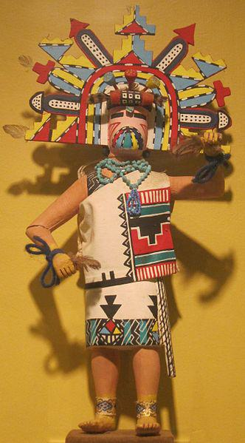

Caption for image source 1: Palhik mana (butterfly maiden) kachina, Arizona, Hopi people, Honolulu Museum of Art Palhik mana (butterfly maiden) kachina, Arizona, Hopi people, Honolulu Museum of Art.

Example Question - "What is in the hands of the Palhik mana kachina doll at the Honolulu Museum of Art?"

Example Answer - "Feathers are in the hands of the Palhik mana kachina doll at the Honolulu Museum of Art."

Additional Text Source 1 - It presents international caliber special exhibitions and features a collection that includes Hokusai, van Gogh, Gauguin, Monet, Picasso and Warhol, as well as traditional Asian and Hawaiian art. In 2011, The Contemporary Museum gifted its assets and collection to the Honolulu Academy of Arts; in 2012, the combined museum changed its name to the Honolulu Museum of Art. (from: Honolulu Museum of Art)

Generated Question - Does the Palhik mana kachina doll at the Honolulu Museum of Art represent traditional art like the museum's Asian and Hawaiian collections?

Generated Answer - Yes, the Palhik mana kachina doll represents traditional Hopi art like the museum's Asian and Hawaiian collections.

--- Entry for custom_id: d5c71ace0dba11ecb1e81171463288e9 ---

Image Source 1 -

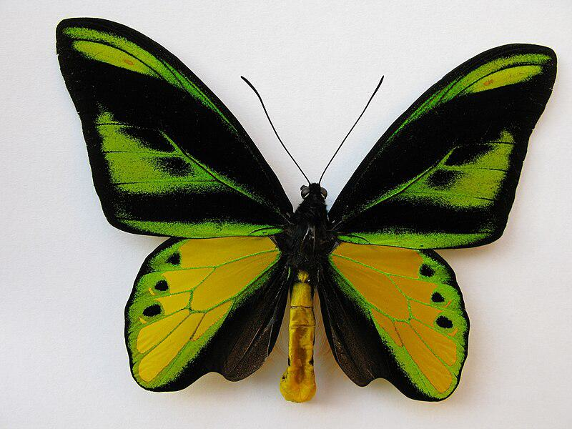

Caption for image source 1: Ornithoptera chimaera charybdis Ornithoptera chimaera charybdis Papua New Guinea, W.Irian, Mapia. 02/2012.

Image Source 2 -



Caption for image source 2: Dysphania percota - The Blue Tiger Moth 09 Dysphania percota - The Blue Tiger Moth.

Example Question - "Which insects main body is more zebra like; Dysphania percota or Ornithoptera chimaera?"

Example Answer - "The Dysphania percota has a body that is more zebra like, as it contains black stripes across a lighter colored body."

Additional Text Source 1 - Carallia brachiata is a large tree in the family Rhizophoraceae, that grows to a height of 25 metres and found from Australia, Malesia, Indochina through to the Western Ghats. It is the host plant of the moth Dysphania percota in India and Dysphania numana in Australia. (from: Carallia brachiata)

Generated Question - Which butterfly or moth is more likely to be found near Carallia brachiata trees based on their host plant relationship?

Generated Answer - Dysphania percota is more likely to be found near Carallia brachiata trees as it uses it as a host plant.

--- Entry for custom_id: d5d52dda0dba11ecb1e81171463288e9 ---

Example Question - What composes the tubes that lead from a female's ovaries to the uterus?

Example Answer - a single layer of column-shaped cells

Image Source 1 -

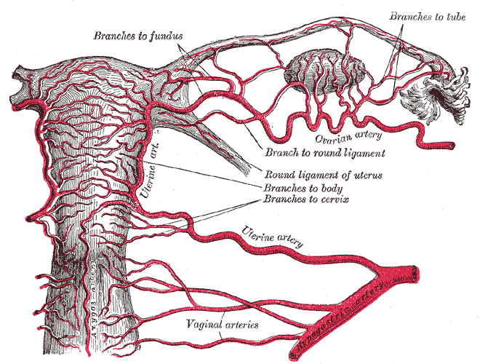

--- Entry for custom_id: d5dac8620dba11ecb1e81171463288e9 ---

Example Question - The up-island spider can reach lengths how much greater than a Galeodes arabs?

Example Answer - 2.1 inches

Image Source 1 -

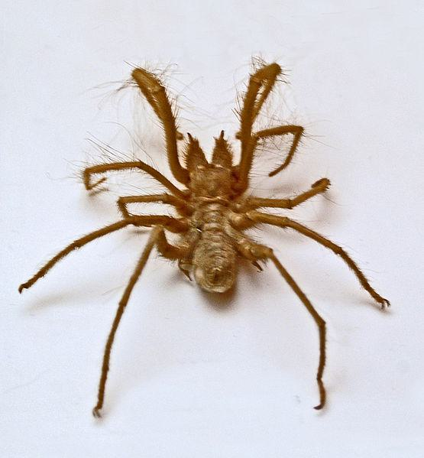

Generated Question - Which spider is faster, the up-island spider or Galeodes arabs, based on the given information?

Generated Answer - Galeodes arabs is faster, reaching speeds of 10 miles per hour; no speed is given for the up-island spider.

--- Entry for custom_id: d5db38420dba11ecb1e81171463288e9 ---

Example Question - A tumulus is a what, defined as a heaped pile of earth, gravel, sand, rocks, or debris, created over a tomb?

Example Answer - A mound

Image Source 1 -



Generated Question - Can the materials shown in the image, such as volcanic and quartz sand, be components of the earth heaped to form a tumulus or mound?

Generated Answer - Yes, these sands can be part of the earth used to create a tumulus or mound.

--- Entry for custom_id: d5bd22940dba11ecb1e81171463288e9 ---

Image Source 1 -



Caption for image source 1: 2020-01-21 Freestyle skiing – Snowboarding at the 2020 Winter Youth Olympics – Team Ski-Snowboard Cross – Quarterfinals – Quarterfinal 2 (Martin Rulsch) 12 Quarterfinal 2 of Freestyle skiing Snowboarding Team Ski-Snowboard Cross at the 2020 Winter Youth Olympics in Lausanne on 21 January 2020..

Image Source 2 -



Caption for image source 2: Anders Södergren at 2010 Winter Olympics cropped.

Example Question - "How many more skis were used by Anders Södergren during the 2010 Olympics than were used by Martin Rulsch during the 2020 Winter Youth Olympics?"

Example Answer - "Anders Södergren used two more skis during the 2010 Olympics."

Additional Text Source 1 - The Bulgarian Olympic Committee was also interested in the city potentially bidding for the 2020 Winter Youth Olympics but eventually declined. Ushuaia, ArgentinaBefore the 2018 Summer Youth Olympics, held in Buenos Aires, International Olympic Committee President Thomas Bach visited Ushuaia and talked about the possibility of holding the 2024 Winter Youth Olympics here. (from: Bids for the 2024 Winter Youth Olympics)

Generated Question - Did the 2020 Winter Youth Olympics snowboarding event and the potential 2024 Winter Youth Olympics in Ushuaia both involve winter sports on snow?

Generated Answer - Yes, both events involved winter sports on snow.

--- Entry for custom_id: d5c2f4e40dba11ecb1e81171463288e9 ---

Image Source 1 -

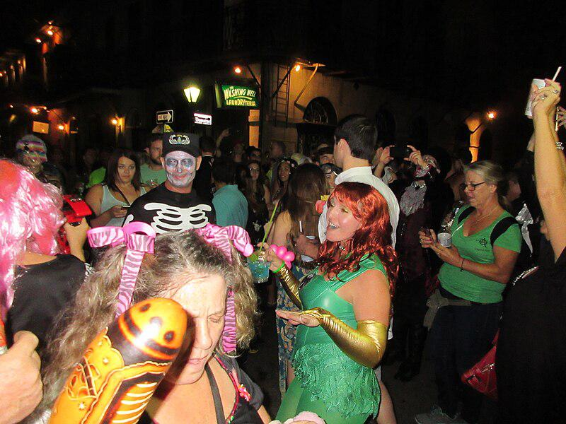

Caption for image source 1: Halloween Saturday Night in Lower French Quarter New Orleans 2016 18 New Orleans..

Example Question - "What color is the dress?"

Example Answer - "The dress is green."

Additional Text Source 1 - They may apply to the FAA to take a specialized test, administered by the FAA. Typically, this test is the "color vision light gun test". (from: Color blindness)

Generated Question - Can someone with color blindness easily identify the green dress in the Halloween crowd?

Generated Answer - No, color blindness may make it difficult to distinguish the green dress.

--- Entry for custom_id: d5c67e2a0dba11ecb1e81171463288e9 ---

Image Source 1 -



Caption for image source 1: Coprinopsis atramentaria 114645.

Image Source 2 -



Caption for image source 2: Lepista nuda sb777 fungi.

Example Question - "Does the Inky cap mushroom or the Clitocybe nuda mushroom have a thicker stem?"

Example Answer - "The Clitocybe nuda mushroom has a thicker stem."

Additional Text Source 1 - Many species originally described within Tricholoma have since been moved to other genera. These include the Wood blewit (Clitocybe nuda), previously Tricholoma nudum, blewit (Clitocybe saeva), previously Tricholoma personatum, and St George's mushroom (Calocybe gambosa) previously Tricholoma gambosum. (from: Tricholoma)

Generated Question - Considering the stem thickness and genus changes, which mushroom has a thicker stem, Coprinopsis atramentaria or the one formerly known as Tricholoma nudum?

Generated Answer - The mushroom formerly known as Tricholoma nudum (Clitocybe nuda) has a thicker stem.

--- Entry for custom_id: d5da63a40dba11ecb1e81171463288e9 ---

Example Question - What is the approximate Mohs hardness of the chemical element that was discovered in Cornwall by William Gregor in 1791?

Example Answer - This chemical element has an approximate Mohs hardness of six.

Image Source 1 -

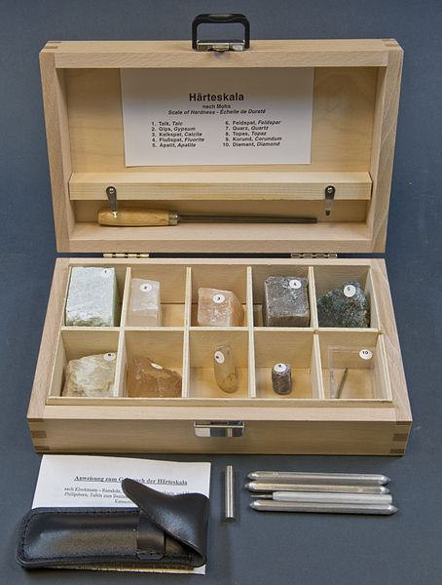

Generated Question - Which element, titanium or uranium, can scratch the minerals with Mohs hardness less than six in the kit shown?

Generated Answer - Both titanium and uranium can scratch minerals with Mohs hardness less than six.

--- Entry for custom_id: d5c03e660dba11ecb1e81171463288e9 ---

Image Source 1 -



Caption for image source 1: Team Canada at 2010 Winter Olympics opening ceremony 2.

Image Source 2 -

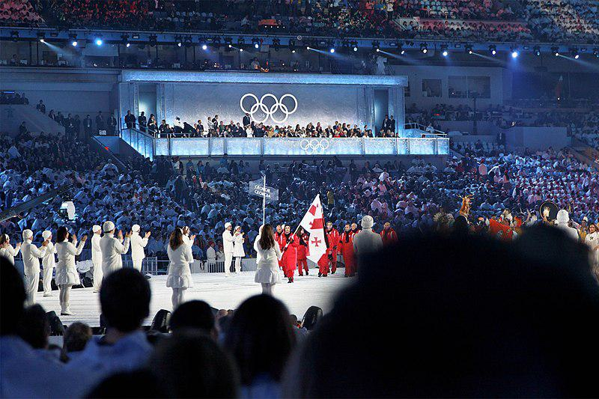

Caption for image source 2: 2010 Olympic Winter Games Opening Ceremony - Georgia entering In perhaps the most emotional moment of the Opening Ceremony of the 2010 Winter Olympics, the crowd rises to give the Georgian athletes, led by Alpine skier Iason Abramashvili, a standing ovation following the tragic death of 21-year-old luge athlete Nodar Kumaritashvili earlier in the day..

Example Question - "The uniforms of the Georgian and Canadian athletes at the 2010 winter Olympic ceremonies shared what as their primary color?"

Example Answer - "They both shared the color red."

Additional Text Source 1 - The production's director was David Atkins, who directed the Sydney 2000 Olympic and 2006 Doha Asian Games ceremonies. The Opening and Closing Ceremonies had a combined budget of $48.5 million (it received $20 million (CA$) funding from the Department of Canadian Heritage while VANOC contributed the rest). (from: 2010 Winter Olympics opening ceremony)

Generated Question - Did the 2010 Winter Olympics opening ceremony feature both Canadian and Georgian athletes wearing red uniforms while being directed by David Atkins?

Generated Answer - Yes, both teams wore red uniforms and the ceremony was directed by David Atkins.

--- Entry for custom_id: d5dc8af80dba11ecb1e81171463288e9 ---

Example Question - Katabatic and Long-duration are both types of what?

Example Answer - Winds

Image Source 1 -

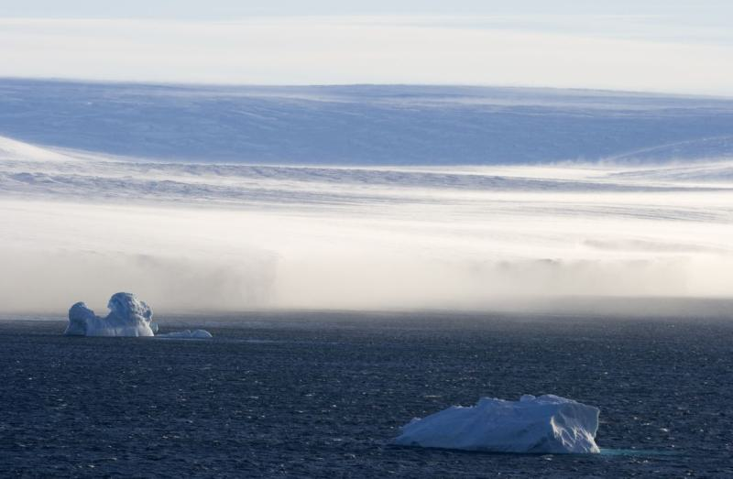

Generated Question - How do katabatic winds in Antarctica affect ice and snow compared to other long-duration winds?

Generated Answer - Katabatic winds heat as they descend, evaporating ice and snow, unlike typical long-duration winds.

--- Entry for custom_id: d5dad3f20dba11ecb1e81171463288e9 ---

Example Question - The what, of which The Arkansas Valley is a Level III version, that cover the main islands of Japan, Honshū, Hokkaidō, Kyūshū, and Shikoku, along with the nearby islands, are considered part of the Palearctic realm?

Example Answer - Ecoregions

Image Source 1 -

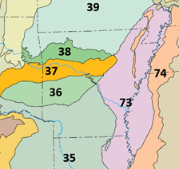

Generated Question - Which Level III ecoregion in Arkansas lies between the Ozark Highlands and the Boston Mountains according to the map?

Generated Answer - The Arkansas Valley (37) lies between the Ozark Highlands (39) and the Boston Mountains (38).

--- Entry for custom_id: d5c672180dba11ecb1e81171463288e9 ---

Image Source 1 -

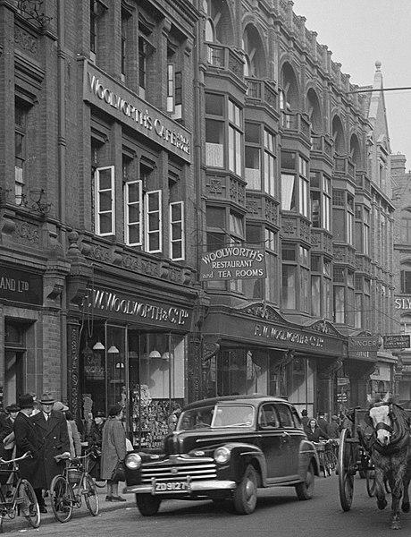

Caption for image source 1: Woolworths's Grafton Street, Dublin in 1946 (cropped) Several forms of transportation on Grafton Street, Dublin in 1946.

Example Question - "How many different signs did Woolworths's Cafe on Grafton Street in Dublin have bearing its name in 1946?"

Example Answer - "Woolworths's Cafe on Grafton Street in Dublin had three signs bearing its name in 1946."

Additional Text Source 1 - The company has operated a café on Dublin's Grafton Street since 1927. Sometimes described as a "Dublin landmark", this outlet was closed between November 2004 and May 2005 for refurbishment and restoration. (from: Bewley's)

Generated Question - How long had Woolworths's café on Grafton Street been operating by 1946?

Generated Answer - Woolworths's café had been operating for 19 years by 1946.

--- Entry for custom_id: d5d49a320dba11ecb1e81171463288e9 ---

Example Question - What is Dimethylaminoethyl acrylate (2-dimethylaminoethyl acrylate) and what are its chemical properties?

Example Answer - Dimethylaminoethyl acrylate (2-dimethylaminoethyl acrylate) or DMAEA is an unsaturated carboxylic acid ester having a tertiary amino group. It is miscible with water, reacts bases and hydrolyzes rapidly to acrylic acid and dimethylaminoethanol. It can form ignitable mixtures with air.

Generated Question - How does the odor and water miscibility of Dimethylaminoethyl acrylate relate to its chemical structure?

Generated Answer - Its tertiary amino group causes a pungent amine-like odor and makes it miscible with water.

--- Entry for custom_id: d5c5743a0dba11ecb1e81171463288e9 ---

Image Source 1 -

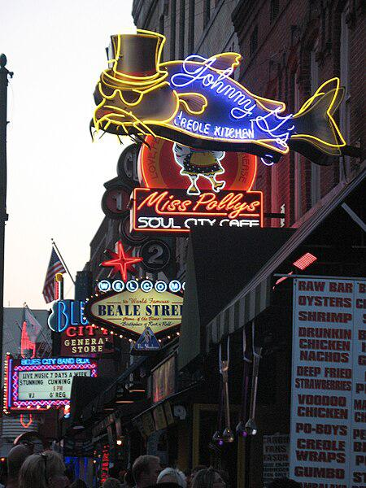

Caption for image source 1: Beale Street, Memphis.

Image Source 2 -

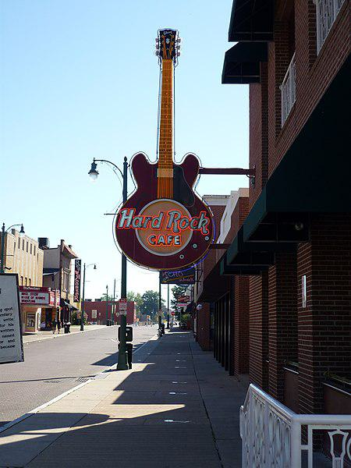

Caption for image source 2: HRC in der Beale St. (Memphis, TN) - panoramio.

Example Question - "Which business on Beale Street in Memphis have animals on their neon signs?"

Example Answer - "Johnny G's Creole Kitchen, Red Rooster, and Miss Polly's Soul City Cafe are all businesses on Beale Street in Memphis that have animals on their neon signs."

Additional Text Source 1 - In 1903, Mayor Thornton was looking for a music teacher for his Knights of Pythias Band and called Tuskegee Institute to talk to his friend, Booker T. Washington, who recommended a trumpet player in Clarksdale, Mississippi named W. C. Handy. Mayor Thornton contacted Handy, and Memphis became the home of the musician who created the "Blues on Beale Street". (from: Beale Street)

Generated Question - How does the musical history of Beale Street relate to the types of businesses shown in the images?

Generated Answer - Beale Street's musical history is reflected in businesses like Hard Rock Cafe and music-themed neon signs.

--- Entry for custom_id: d5c0dbe60dba11ecb1e81171463288e9 ---

Image Source 1 -

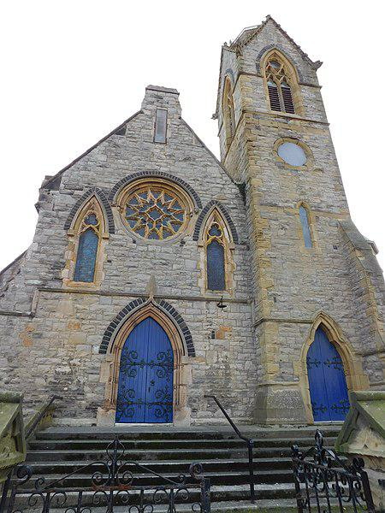

Caption for image source 1: Christ Church, Llandudno 3 United Reformed Church (Christ Church) including forecourt walls, piers and gates Wikidata has entry Q29485157 with data related to this item..

Example Question - "What is depicted in the circular window above the larger door of the United Reformed Church?"

Example Answer - "A sun is depicted in the large circular window of the United Reformed Church."

Additional Text Source 1 - The United Reformed Church has published Reform magazine since 1972, as a forum for "News, comment, inspiration debate". A digital edition of the magazine, accessed through an app or online, was launched in April 2015. (from: United Reformed Church)

Generated Question - How does the United Reformed Church in the image reflect its community engagement through its publications?

Generated Answer - The church engages its community by publishing Reform magazine since 1972, including a digital edition launched in 2015.

--- Entry for custom_id: d5ce1dd80dba11ecb1e81171463288e9 ---

Image Source 1 -

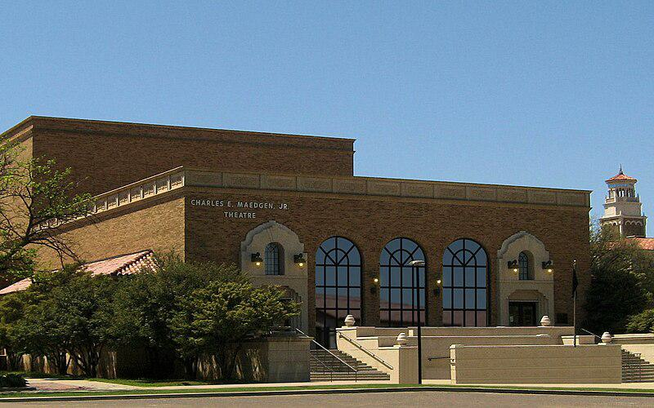

Caption for image source 1: TTtheat Charles E. Maedgen, Jr. Theatre at Texas Tech University in Lubbock, Texas, U.S..

Example Question - "When approaching the Charles E. Maedgen, Jr. Theatre, you can choose from how many flights of stairs to walk up of to reach the entrance?"

Example Answer - "You can choose between two flights of stairs to walk up to the entrance of the Charles E. Maedgen, Jr. Theatre."

Additional Text Source 1 - Human rights groups in Argentina often cite a figure of 30,000 disappeared; Amnesty International estimates 20,000. Many were killed in death flights, a practice initiated by Admiral Luis María Mendía, usually after detention and torture. (from: Death flights)

Generated Question - How many flights of stairs lead to the entrance of the Charles E. Maedgen, Jr. Theatre, and how does this compare to the number of disappeared cited by human rights groups in Argentina?

Generated Answer - There are two flights of stairs to the theatre entrance, far fewer than the thousands disappeared in Argentina.

--- Entry for custom_id: d5d13b080dba11ecb1e81171463288e9 ---

Example Question - What is the geographical commonality between Manaus and the Amazon basin?

Example Answer - They are both by the Amazon river.

Image Source 1 -

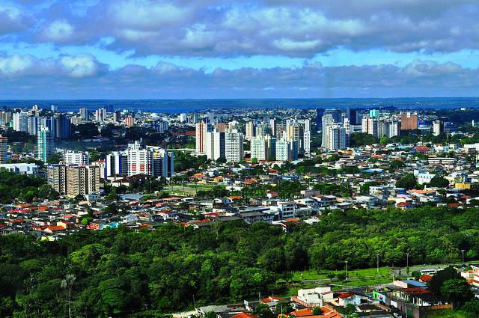

Generated Question - How does Manaus's population compare to the size of the Amazon basin it is located in?

Generated Answer - Manaus has 2.2 million people, while the Amazon basin covers about 7 million square kilometers.

--- Entry for custom_id: d5c0b0080dba11ecb1e81171463288e9 ---

Image Source 1 -

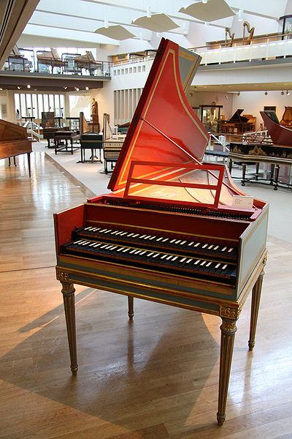

Caption for image source 1: MIM French Harpsichord CN5715 French harpsichord (by Benoit Stehlin Paris, 1767)..

Image Source 2 -

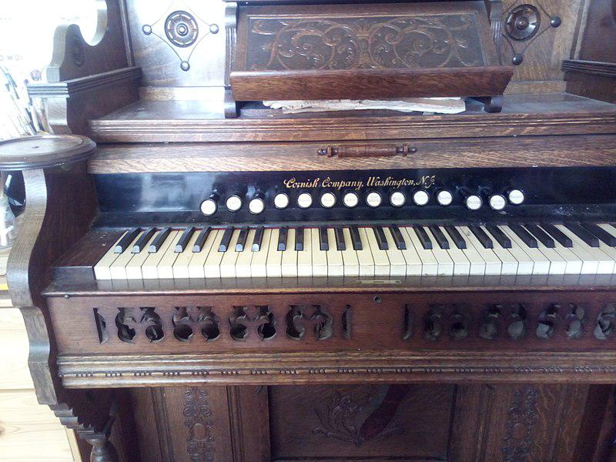

Caption for image source 2: 14 stops on Cornish pump organ.

Example Question - "Which instrument contains more black keys; MIM French Harpsichord or Cornish pump organ?"

Example Answer - "A MIM French Harpsichord contains more black keys than a Cornish pump organ."

Additional Text Source 1 - According to an interview on NPR's Fresh Air, the group's name "the Black Keys" came from an acquaintance diagnosed with schizophrenia, Alfred McMoore. He would leave incoherent messages on their answering machines referring to their fathers as "black keys" such as "D flat" when he was upset with them. (from: The Black Keys)

Generated Question - Considering the number of black keys on the MIM French Harpsichord and the Cornish pump organ, which instrument has more black keys?

Generated Answer - The MIM French Harpsichord has more black keys than the Cornish pump organ.

--- Entry for custom_id: d5d0e7340dba11ecb1e81171463288e9 ---

Example Question - What do the evergreen trees in some temperate broadleaf and mixed forests serve as?

Example Answer - As canopy component

Image Source 1 -

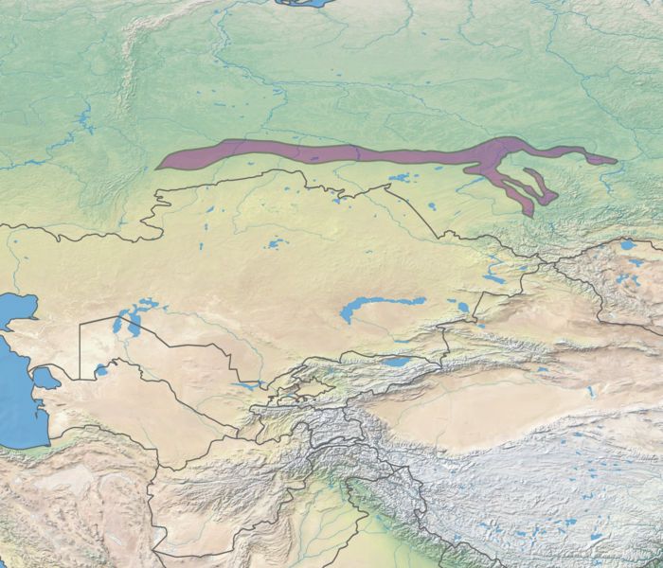

Generated Question - How do the dominant tree types in the Northeastern Himalayan subalpine conifer forests differ from those in the West Siberian broadleaf and mixed forests?

Generated Answer - Northeastern Himalayan forests are mainly coniferous, while West Siberian forests have dominant broadleaf trees like oaks and beeches.

--- Entry for custom_id: d5c966d00dba11ecb1e81171463288e9 ---

Image Source 1 -



Caption for image source 1: Collège Saint Marc - dorms - room in use.

Example Question - "What type of floor is inside the dorms of the Collège Saint Marc?"

Example Answer - "Tile floors are inside the dorms of the Collège Saint Mar."

Additional Text Source 1 - Today, the most important French schools in Alexandria run by Catholic missionaries include Collège de la Mère de Dieu, Collège Notre Dame de Sion, Collège Saint Marc, Ecoles des Soeurs Franciscaines (four different schools), École Girard, École Saint Gabriel, École Saint-Vincent de Paul, École Saint Joseph, École Sainte Catherine, and Institution Sainte Jeanne-Antide. (from: Alexandria)

Generated Question - Are the dorm rooms at Collège Saint Marc likely to have tile floors like other French missionary schools in Alexandria?

Generated Answer - Yes, the dorm rooms at Collège Saint Marc have tile floors, consistent with other French missionary schools.

--- Entry for custom_id: d5cb56ac0dba11ecb1e81171463288e9 ---

Image Source 1 -

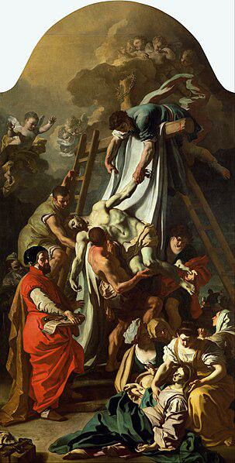

Caption for image source 1: Francesco Solimena - The Deposition - Google Art Project.

Example Question - "Is the deposition painting by Francesco solimena bereft of flying beings?"

Example Answer - "No, "The Deposition" by Francesco solimena includes flying angels."

Generated Question - Does the painting "The Deposition" by Francesco Solimena depict both human figures and supernatural beings?

Generated Answer - Yes, it depicts human figures and flying angels.

--- Entry for custom_id: d5c450780dba11ecb1e81171463288e9 ---

Image Source 1 -

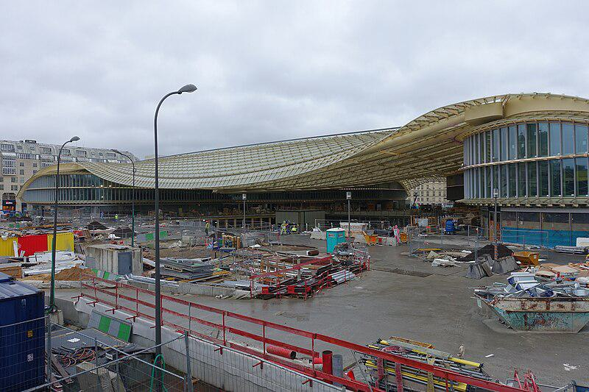

Caption for image source 1: Restructuration of Forum des Halles, Paris 30 January 2016 004.

Example Question - "What type of material is the primary component of the walls of the Forum des Halles?"

Example Answer - "The primary component of the walls of the Forum des Halles is glass."

Additional Text Source 1 - ESX/ESXi is the primary component in the VMware Infrastructure software suite. The name ESX originated as an abbreviation of Elastic Sky X. In September 2004, the replacement for ESX was internally called VMvisor, but later changed to ESXi (as the "i" in ESXi stood for "integrated"). (from: VMware ESXi)

Generated Question - Is the primary component of the Forum des Halles walls related to the software named ESX/ESXi?

Generated Answer - No, the Forum des Halles walls are primarily made of glass, unrelated to ESX/ESXi software.

--- Entry for custom_id: d5d0b4300dba11ecb1e81171463288e9 ---

Example Question - Which is more of a sort of poisoning caused by something manufactured; Organophosphate poisoning or Hyperkalemia?

Example Answer - Organophosphate poisoning is caused by insecticides, medications or nerve agents, things manufactured.

Image Source 1 -



Generated Question - Does the chemical structure shown relate to the poisoning caused by manufactured substances or to potassium imbalance in the blood?

Generated Answer - The chemical structure relates to poisoning caused by manufactured substances, specifically organophosphates.

--- Entry for custom_id: d5db2c6c0dba11ecb1e81171463288e9 ---

Example Question - a hydrogen internal combustion engine vehicle and Internal combustion engine cooling are both types of what?

Example Answer - Internal combustion engine

Image Source 1 -

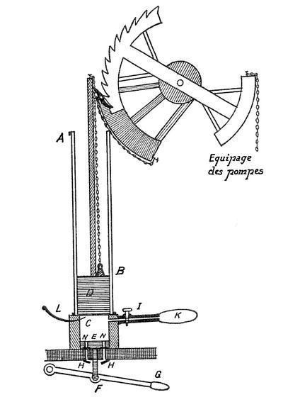

Generated Question - How does the early de Rivaz internal combustion pumping engine relate to hydrogen internal combustion engine vehicles in terms of engine type?

Generated Answer - Both use internal combustion engines to convert fuel into mechanical work.

--- Entry for custom_id: d5d367b60dba11ecb1e81171463288e9 ---

Example Question - What name is shared by a fictional English band played by the real American band Eight Bucks Experiment in the movie SLC Punk and is a physical punishment given by a parent?

Example Answer - Corporal punishment

Image Source 1 -



Generated Question - What term connects a fictional English band in SLC Punk! and a form of physical punishment by a parent?

Generated Answer - Corporal punishment

--- Entry for custom_id: d5deed3e0dba11ecb1e81171463288e9 ---

Example Question - The physiological reaction that occurs in response to a perceived harmful event, attack, or threat to survival is activated by what system in the body?

Example Answer - The fight-or-flight response is activated by the sympathetic nervous system.

Image Source 1 -



Generated Question - How does the sympathetic nervous system contribute to the physiological changes during a panic attack as shown in the image?

Generated Answer - It activates the fight-or-flight response by releasing norepinephrine, causing the physiological changes seen in a panic attack.

--- Entry for custom_id: d5c6c2180dba11ecb1e81171463288e9 ---

Image Source 1 -

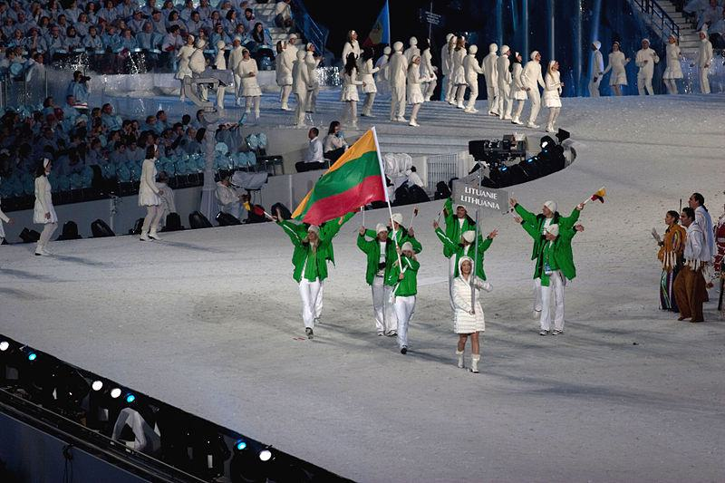

Caption for image source 1: 2010 Opening Ceremony - Lithuania entering.

Image Source 2 -

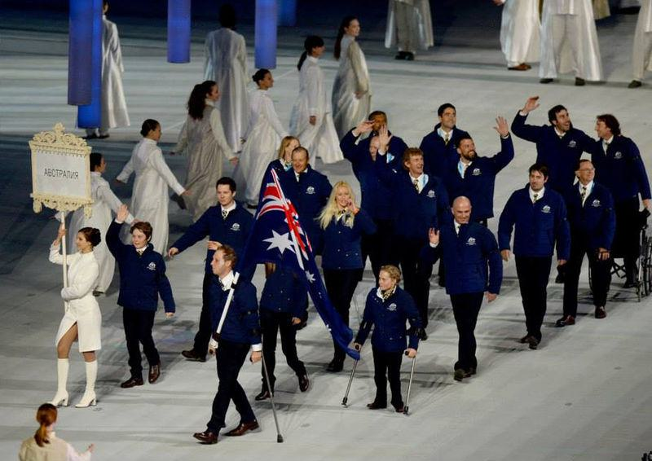

Caption for image source 2: 2014 Opening ceremony The Australian Team marches at the Opening Ceremony of the Sochi 2014 Paralympic Winter Games, led by flagbearer Cameron Rahles-Rahbula.

Example Question - "What is the color of the clothing worn by the leading participant in the 2010 Opening Ceremony and 2014 Opening Ceremony?"

Example Answer - "The leading participants in the 2010 Opening Ceremony and 2014 Opening Ceremony both wore white."

Additional Text Source 1 - A soundtrack, Sounds of Vancouver 2010: Opening Ceremony Commemorative Album (French: Musique de Vancouver 2010 : L'album commémoratif de la cérémonie d'ouverture des Jeux), was released through the iTunes Store on February 12, 2010, containing many studio recordings of the performances from the opening ceremony. (from: 2010 Winter Olympics opening ceremony)

Generated Question - Did the leading participants in the 2010 and 2014 Opening Ceremonies wear the same color clothing despite different event locations?

Generated Answer - Yes, both leading participants wore white clothing in the 2010 and 2014 Opening Ceremonies.

--- Entry for custom_id: d5cac0480dba11ecb1e81171463288e9 ---

Image Source 1 -

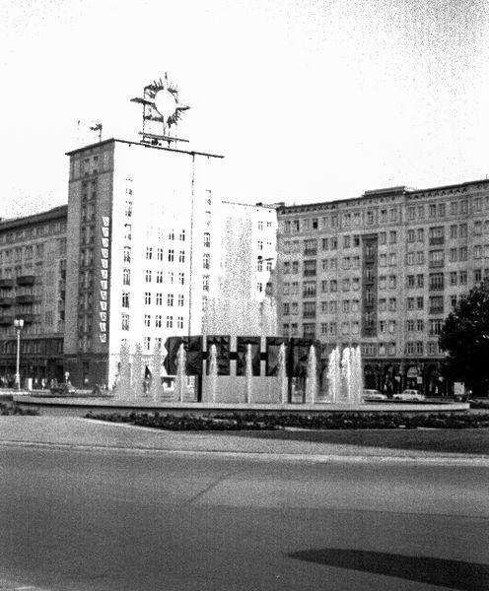

Caption for image source 1: East Berlin 1967, Alexanderplatz.

Example Question - "Does the fountain in East Berlin 1967, Alexanderplatz have only one jet?"

Example Answer - "The fountain does not have only one jet."

Additional Text Source 1 - The complex was built from 1967 to 1970 in the course of the redevelopment of Alexanderplatz when it was located in East Berlin. It was designed by the team of Roland Korn, Heinz Scharlipp and Hans Erich Bogatzky. (from: Park Inn by Radisson Berlin Alexanderplatz)

Generated Question - Was the fountain in Alexanderplatz present during the redevelopment of the area from 1967 to 1970 in East Berlin?

Generated Answer - Yes, the fountain was present during the redevelopment of Alexanderplatz from 1967 to 1970.

--- Entry for custom_id: d5c725aa0dba11ecb1e81171463288e9 ---

Image Source 1 -

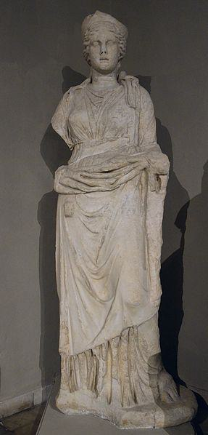

Caption for image source 1: Over life-size statue of Hera, from the Gymnasium of Salamis, 2nd century AD, Cyprus Museum, Nicosia, Cyprus (22497777355).

Image Source 2 -

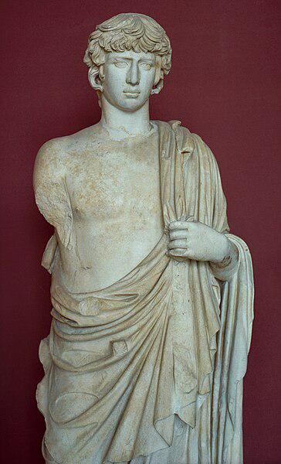

Caption for image source 2: Antinous, life-size marble statue, 130-135 AD, AM Eleusis, Elem704 Antinous, life-size marble statue, 130-135 AD. Archaeological Museum of Eleusis..

Example Question - "Which arm is missing from both the statue of Hera in the Cyprus Museum and the statue of Antinous in the Archaeological Museum of Eleusis?"

Example Answer - "The right arm is missing from both the statue of Hera in the Cyprus Museum and the statue of Antinous in the Archaeological Museum of Eleusis."

Additional Text Source 1 - The Cyprus Folk Art Museum (Μουσείο Λαικής Τέχνης Κύπρου) is a museum in Cyprus dedicated to the country's ethnographic history. The museum is located in Nicosia directly beside the Cathedral of Agios Ioannis Evangelistis, the Byzantine Museum of Cyprus, the National Struggle Museum, and the current Archbhishop's Palace. (from: Ethnographic Museum of Cyprus)

Generated Question - Are the statues of Hera and Antinous located in museums that are both in Nicosia, Cyprus?

Generated Answer - No, only the statue of Hera is in a museum in Nicosia, Cyprus; Antinous is in Eleusis.

--- Entry for custom_id: d5c7cc1c0dba11ecb1e81171463288e9 ---

Image Source 1 -

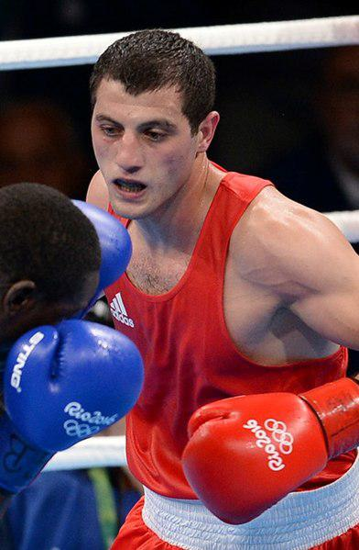

Caption for image source 1: Boxing at the 2016 Summer Olympics, Baghirov vs Cissokho 3 (cropped) Boxing at the 2016 Summer Olympics, Baghirov vs Cissokho.

Image Source 2 -

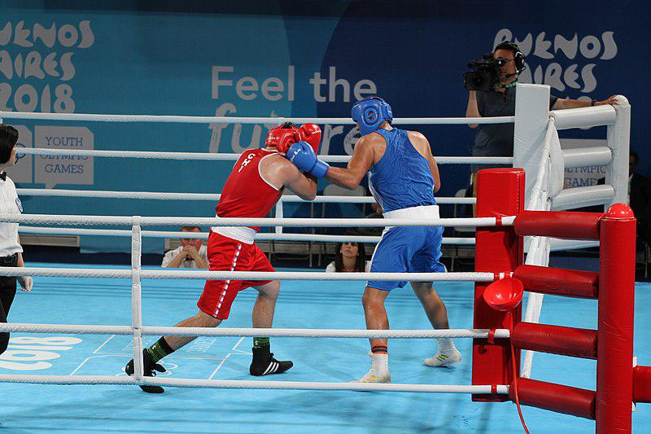

Caption for image source 2: Men's Heavy (91kg) Bout for 18th Place CHI vs SAM Boxing at the 2018 Summer Youth Olympics. Men's Heavy (91kg) Bout for 5th Place.

Example Question - "Were the boxing gloves used in the match between Baghirov and Cissokho at the 2016 Olympics a different color than the ones used in the 5th place boxing match in the 91kg division at the 2018 Youth Olympics?"

Example Answer - "No, the gloves between the boxing matches were the same color."

Additional Text Source 1 - The Parque Polideportivo Roca was fully renovated before the 2018 Summer Youth Olympics in order to be used as main Olympic Park. Six pavilions were built: Asia Pavilion (judo and wrestling), Africa Pavilion (fencing and modern pentathlon), Europe Pavilion (karate and weightlifting), Oceania Pavilion (boxing and taekwondo), America Pavilion (gymnastics) and natatorium. (from: 2018 Summer Youth Olympics)

Generated Question - Did both boxing matches at the 2016 Olympics and 2018 Youth Olympics take place in venues specifically renovated or built for their events?

Generated Answer - No, only the 2018 Youth Olympics boxing venue was renovated or newly built for the event.

--- Entry for custom_id: d5d3bc660dba11ecb1e81171463288e9 ---

Example Question - The province bordered on its south-east corner by Malawi and Mozambique has how many districts?

Example Answer - 14

Image Source 1 -

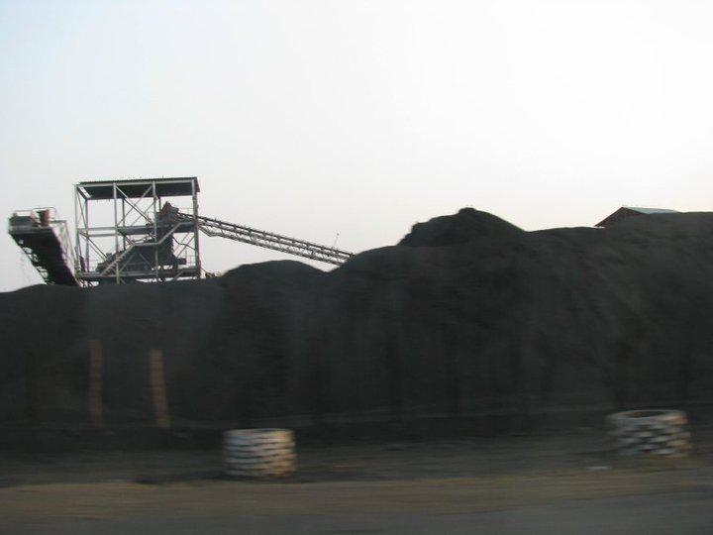

--- Entry for custom_id: d5bf31b00dba11ecb1e81171463288e9 ---

Image Source 1 -

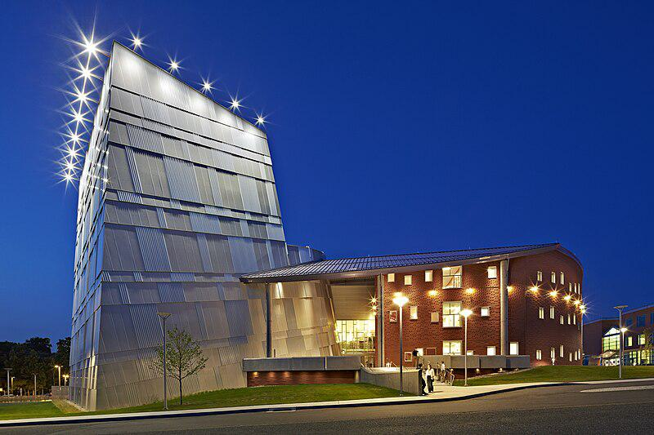

Caption for image source 1: Western Connecticut State University, Visual & Performing Arts Center Exterior Western Connecticut State University, Visual & Performing Arts Center.

Example Question - "How many lights are at the top of the tallest portion of the Western Connecticut State University, Visual & Performing Arts Center?"

Example Answer - "There are thirteen lights at the top of the tallest portion of the Western Connecticut State University, Visual & Performing Arts Center."

Additional Text Source 1 - Fiorello H. LaGuardia High School of Music & Art and Performing Arts, often referred to simply as LaGuardia, is a public magnet high school specializing in teaching visual arts and performing arts, located near Lincoln Center in the Lincoln Square neighborhood of the Upper West Side, Manhattan, New York City, in the U.S. state of New York. (from: Fiorello H. LaGuardia High School)

Generated Question - Which building, Western Connecticut State University or Fiorello H. LaGuardia High School, is specifically described as a public magnet school for visual and performing arts?

Generated Answer - Fiorello H. LaGuardia High School is described as a public magnet school for visual and performing arts.

--- Entry for custom_id: d5c7e7f60dba11ecb1e81171463288e9 ---

Image Source 1 -

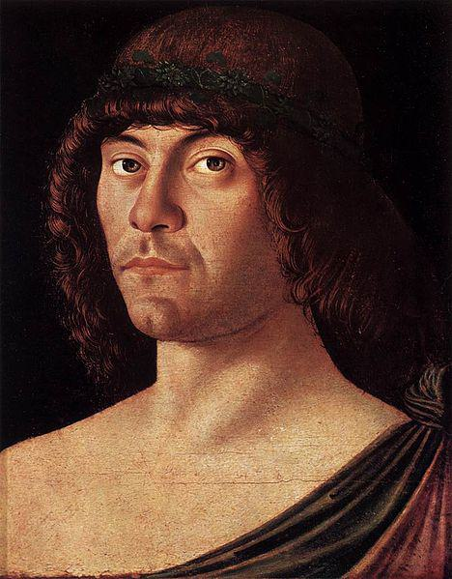

Caption for image source 1: Giovanni Bellini - Portrait of a Humanist - WGA01674.

Image Source 2 -

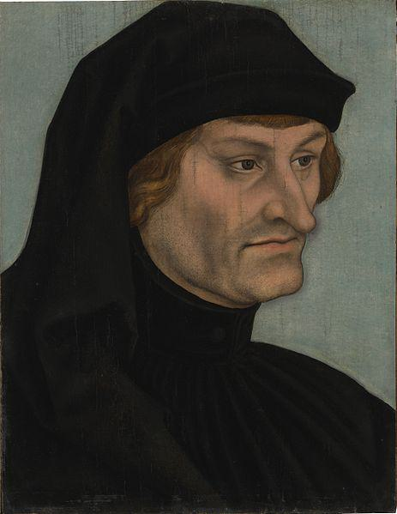

Caption for image source 2: Lucas Cranach d.Ä. - Bildnis des Rudolph Agricola (Alte Pinakothek).

Example Question - "In which painting is the head of the subject less covered, Portrait of a Humanist or Portrait of Rudolph Agricola?"

Example Answer - "The head of the subject less covered in Portrait of a Humanist."

Additional Text Source 1 - Thus, for Agricola, dialectic was an open field; the art of finding "whatever can be said with any degree of probability on any subject." (from: Rodolphus Agricola)

Generated Question - Which portrait shows a subject whose headwear might symbolize a more open intellectual approach, considering Agricola's view on dialectic?

Generated Answer - The Portrait of a Humanist shows less head covering, symbolizing a more open intellectual approach.

--- Entry for custom_id: d5cf7ffc0dba11ecb1e81171463288e9 ---

Example Question - Do England and China spell councilor the same way in government titles?

Example Answer - No, the former spells it Counsellors while the later spells it Councillor

Image Source 1 -

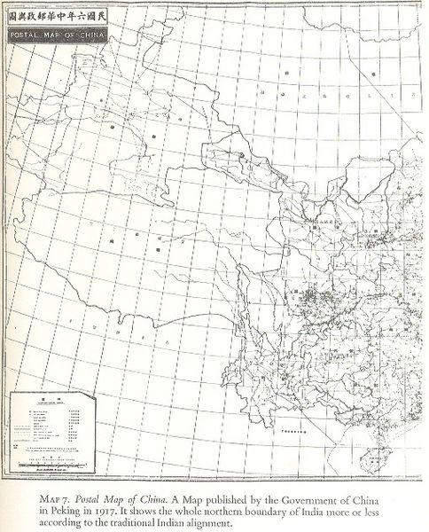

Generated Question - Are the Counsellors of State in England and the State Councillors in China part of the same government structure shown in the 1917 Postal Map of China?

Generated Answer - No, England's Counsellors of State and China's State Councillors belong to different governments; the map shows only China.

--- Entry for custom_id: d5d3b5ae0dba11ecb1e81171463288e9 ---

Example Question - What artistic practice did both Carol Lawrence and Lee Lawrence participate in?

Example Answer - Singing.

Image Source 1 -



Generated Question - Did Peter Lee Lawrence likely have formal training in the same artistic practice as Lee Lawrence and Carol Lawrence?

Generated Answer - Yes, Peter Lee Lawrence likely had formal training in acting, related to their artistic practices.

--- Entry for custom_id: d5cb450e0dba11ecb1e81171463288e9 ---

Image Source 1 -



Caption for image source 1: Calopteryx maculata on Palmetto Calopteryx maculata on Palmetto leaf at Francis Beidler Forest.

Example Question - "What is the predominant color of Calopteryx maculata?"

Example Answer - "The Calopteryx maculata is predominantly blue."

Additional Text Source 1 - Males in sympatric populations of the damselflies Calopteryx maculata and C. aequabilis are able to discriminate between females of different species better than those in allopatric populations; with females of C. aequabilis in sympatric populations exhibiting lighter wing colors compared to allopatric females—an illustration of reproductive character displacement. (from: Evidence for speciation by reinforcement)

--- Entry for custom_id: d5cc28660dba11ecb1e81171463288e9 ---

Image Source 1 -



Caption for image source 1: Myrmecobius fasciatus - Swedish Museum of Natural History - Stockholm, Sweden - DSC00656 Exhibit in the Swedish Museum of Natural History - Stockholm, Sweden. Photography was permitted in the museum without restriction..

Image Source 2 -



Caption for image source 2: Siberian Chipmunk (Tamias sibiricus), Parc du Rouge-Cloître, Forêt de Soignes, Brussels (26040359560).

Example Question - "Are the stripes on the back of Tamias sibiricus oriented in the same direction as those on the back of Myrmecobius fasciatus?"

Example Answer - "No, the stripes on the back of Tamias sibiricus are not oriented in the same direction as those on the back of Myrmecobius fasciatus."

Additional Text Source 1 - Subsequently recognized as a subspecies of the Siberian chipmunk Tamias sibiricus, first described (as Sciurus sibiricus) by explorer Erich Gustav Laxmann in 1769, Tamias (Eutamias) sibiricus lineatus is included in Mammal Species of the World as one of nine subspecies of Tamias (Eutamias) sibiricus. (from: Ezo chipmunk)

Generated Question - Are Myrmecobius fasciatus and Tamias sibiricus lineatus classified under the same genus despite their different stripe orientations?

Generated Answer - No, Myrmecobius fasciatus and Tamias sibiricus lineatus belong to different genera.

--- Entry for custom_id: d5c6fe5e0dba11ecb1e81171463288e9 ---

Image Source 1 -



Caption for image source 1: 090215-IMG 0702-WhistlerVillage Whistler Village from the Blackcomb Peak-2-Peak Gondola terminal..

Example Question - "Which is larger: the Whistler Village area or the uninhabited area surrounding Whistler Village?"

Example Answer - "The uninhabited area surrounded Whistler Village is larger than the Whistler Village area."

Additional Text Source 1 - The mountains are accessed via four gondolas and one high-speed quads: Blackcomb Excalibur Gondola, Whistler Mountain Village Gondola, and Fitzsimmons Express in the village, the Blackcomb Gondola in Blackcomb Base/Upper Village, and the Whistler Creekside Gondola to the south in the Creekside area. The primary skiing terrain starts about one-third up the mountains. (from: Whistler Blackcomb)

Generated Question - Are the gondolas and ski lifts in Whistler Village located closer to the inhabited area or the uninhabited mountain slopes?

Generated Answer - The gondolas and ski lifts are located closer to the inhabited Whistler Village area near the mountain bases.

--- Entry for custom_id: d5c490380dba11ecb1e81171463288e9 ---

Image Source 1 -

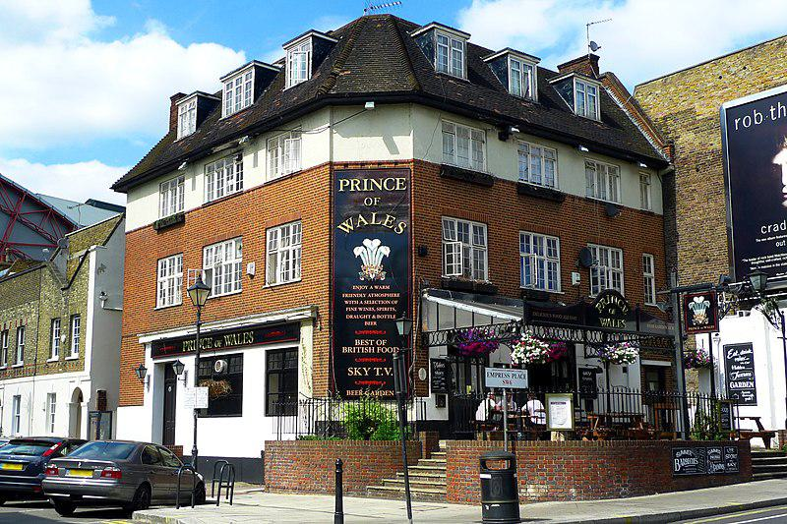

Caption for image source 1: Prince of Wales, Earls Court, SW6 (5306444465).

Example Question - "How many sidewalk patio entrances does the Prince of Wales pub in Earl's Court have?"

Example Answer - "The Prince of Wales pub in Earl's Court has two sidewalk patio entrances."

Additional Text Source 1 - Only a handful of native princes had their claim to the overlordship of Wales recognised by the English Crown; however Wales had many Princes during self rule. The first known to have used such a title was Owain Gwynedd, adopting the title Prince of the Welsh around 1165 after earlier using rex Waliae ("King of Wales"). (from: Prince of Wales)

Generated Question - Does the Prince of Wales pub in Earl's Court reflect the historical significance of Welsh princes mentioned in the additional text?

Generated Answer - No, the pub's name references Welsh princes but does not reflect their historical significance.

--- Entry for custom_id: d5d2108c0dba11ecb1e81171463288e9 ---

Example Question - Can you find the highest expanse of woodland on the slopes of the Himalayas in the Northeastern Himalayan subalpine conifer forest?

Example Answer - No.

Image Source 1 -

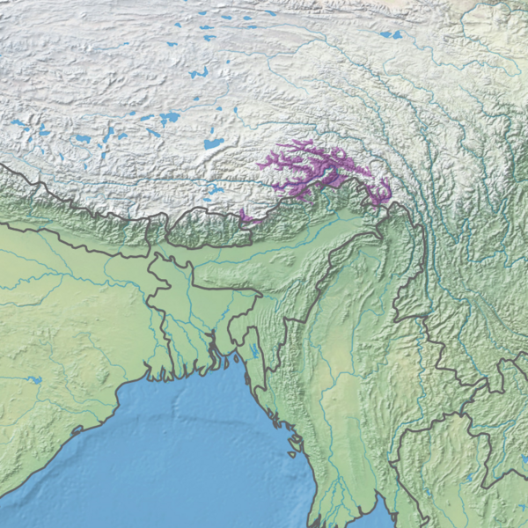

Generated Question - Do the Western Himalayan subalpine conifer forests and Northeastern Himalayan subalpine conifer forests overlap geographically?

Generated Answer - No, they occur in distinct regions separated by the central Himalayas.

--- Entry for custom_id: d5c092080dba11ecb1e81171463288e9 ---

Image Source 1 -

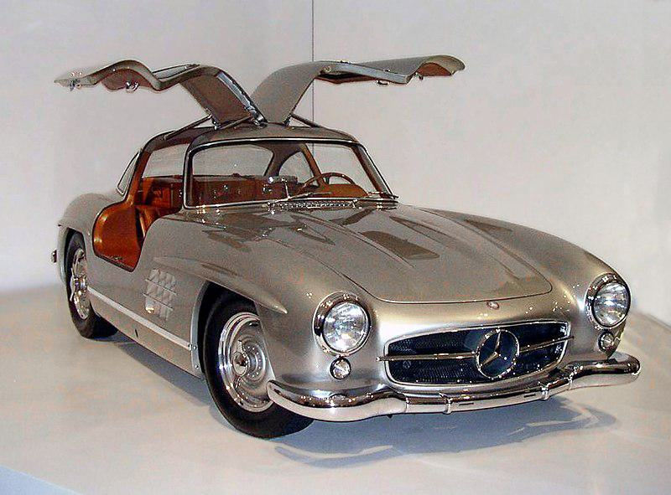

Caption for image source 1: 1955 Mercedes-Benz 300SL Gullwing Coupe 34 right.

Image Source 2 -



Caption for image source 2: Alfa Romeo SZ.

Example Question - "Do the doors of the 1955 Mercedes-Benz 300SL Gullwing Coupe and the Alfa Romeo SZ open the same way?"

Example Answer - "The doors of the 1955 Mercedes-Benz 300SL Gullwing Coupe and the Alfa Romeo SZ do not open the same way."

Additional Text Source 1 - Daimler-Benz's official importer in the USA, New York Mercedes distributor Max Hoffman, suggested to company management in Stuttgart that a street version of the W194 would be a commercial success, especially in America. The result was an icon, the 1954 Mercedes-Benz 300 SL Gullwing (W198). (from: Mercedes-Benz W194)

Generated Question - Was the 1955 Mercedes-Benz 300SL Gullwing Coupe designed with unique doors partly due to its racing heritage suggested for commercial success in America?

Generated Answer - Yes, its distinctive gullwing doors were inspired by the W194 racing car and aimed at American markets.

--- Entry for custom_id: d5d69ae40dba11ecb1e81171463288e9 ---

Example Question - How many universities are in the city that is near the place that where 350th Reconnaissance Aviation Squadron used to be active?

Example Answer - This city has two universities.

Image Source 1 -



Generated Question - Were the reconnaissance aircraft like the McDonnell RF-4C Phantoms similar to those used by the 350th Reconnaissance Aviation Squadron at Tuzla Air Base?

Generated Answer - Yes, both operated reconnaissance aircraft for military purposes.

--- Entry for custom_id: d5c9fe060dba11ecb1e81171463288e9 ---

Image Source 1 -

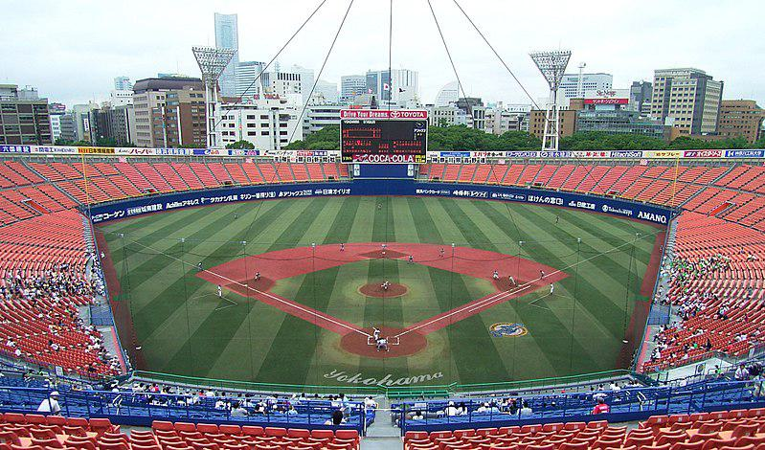

Caption for image source 1: Yokohama Stadium 2007 -3.

Example Question - "What soda brand has a sponsorship on the scoreboard at Yokohama Stadium?"

Example Answer - "Coca-Cola has a sponsorship on the scoreboard at Yokohama Stadium."

Additional Text Source 1 - Nissan Stadium (日産スタジアム, Nissan Sutajiamu), also known as International Stadium Yokohama (横浜国際総合競技場, Yokohama Kokusai Sōgō Kyōgi-jō), is a sports venue in Yokohama, Kanagawa Prefecture, Japan, which opened in March 1998. It is the home stadium of Yokohama F. Marinos of the J1 League. (from: Nissan Stadium (Yokohama))

Generated Question - Are both Yokohama Stadium and Nissan Stadium located in the same city?

Generated Answer - Yes, both Yokohama Stadium and Nissan Stadium are located in Yokohama.

--- Entry for custom_id: d5c8e82c0dba11ecb1e81171463288e9 ---

Image Source 1 -

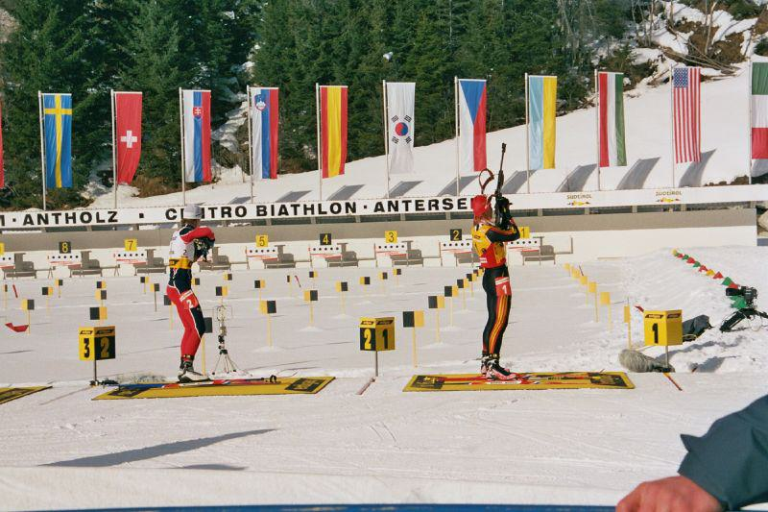

Caption for image source 1: Biathlon-Antholz-2006-Wilhelm-Bailly.

Example Question - "What shape are the National flags at the end of the range at the 2006 biathlon in Anholz?"

Example Answer - "The National flags at the end of the range at the 2006 biathlon in Anholz are rectangles."

Additional Text Source 1 - According to Article 15 of the Law on the National Flag, "the national flag, when raised or carried in a procession with another flag or flags, shall be in front of the other flag or flags." (from: Flag of China)

Generated Question - Are the national flags at the 2006 biathlon in Antholz arranged in front of or behind the shooting range?

Generated Answer - The national flags are arranged behind the shooting range.

--- Entry for custom_id: d5d616960dba11ecb1e81171463288e9 ---

Example Question - No women were transported by The British Government to what country for an act that is legal in the British Virgin Islands?

Example Answer - Australia

Image Source 1 -

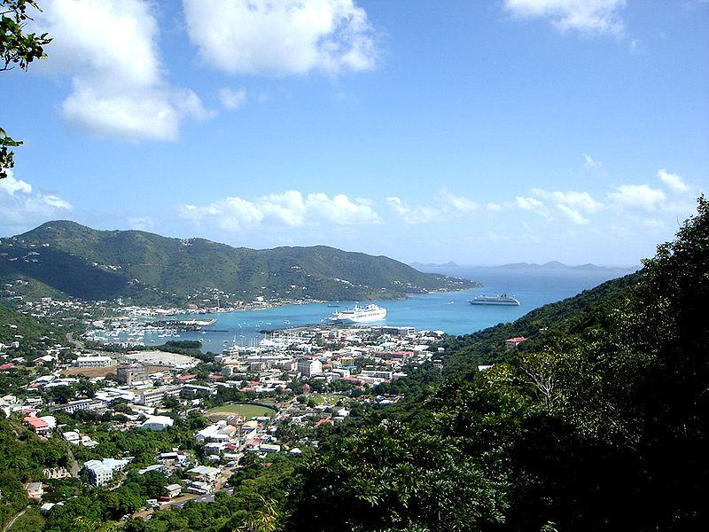

Generated Question - Which place shown in the image allows prostitution but restricts entry to known prostitutes, unlike the country where no women were transported for prostitution?

Generated Answer - The British Virgin Islands (Road Town) allows prostitution but restricts entry to known prostitutes, unlike Australia.

--- Entry for custom_id: d5d083700dba11ecb1e81171463288e9 ---

Example Question - What type of character were both the Well-Manicured Man and Alvin Kersh in the television show The X-Files?

Example Answer - They both were antagonists.

Image Source 1 -



Generated Question - Do Alvin Kersh and the Well-Manicured Man both oppose the main FBI agents in The X-Files series?

Generated Answer - Yes, both act as antagonists opposing the main FBI agents.

--- Entry for custom_id: d5cdf33a0dba11ecb1e81171463288e9 ---

Image Source 1 -

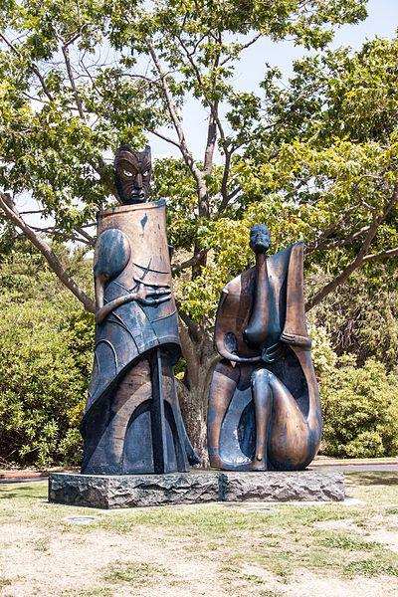

Caption for image source 1: Government Gardens, modern sculpture of a Maori artist, 2016-01-24.

Example Question - "What material is the Modern Sculpture of a Maori Artist in Government Gardens created from?"

Example Answer - "The Modern Sculpture of a Maori Artist in Government Gardens was created from metal."

Additional Text Source 1 - Sir Mirza Ismail, the Deewan of Mysore, a man with a penchant for gardens, founded the Brindavan Gardens (Krishnaraja Sagar Dam in particular) and built the Cauvery River high-level canal to irrigate 120,000 acres (490 km2) in modern Mandya district. (from: Brindavan Gardens)

Generated Question - Are the Government Gardens sculpture and Brindavan Gardens both associated with outdoor natural settings?

Generated Answer - Yes, both are located in outdoor natural garden settings.

--- Entry for custom_id: d5ca3a060dba11ecb1e81171463288e9 ---

Image Source 1 -

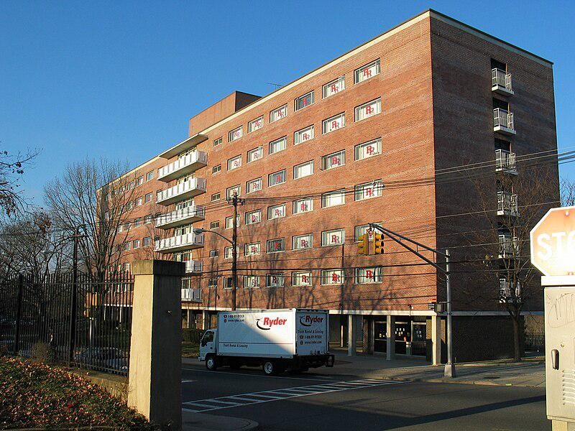

Caption for image source 1: Hardenbergh Hall Hardenbergh Hall, College Avenue Campus, Rutgers University.

Image Source 2 -

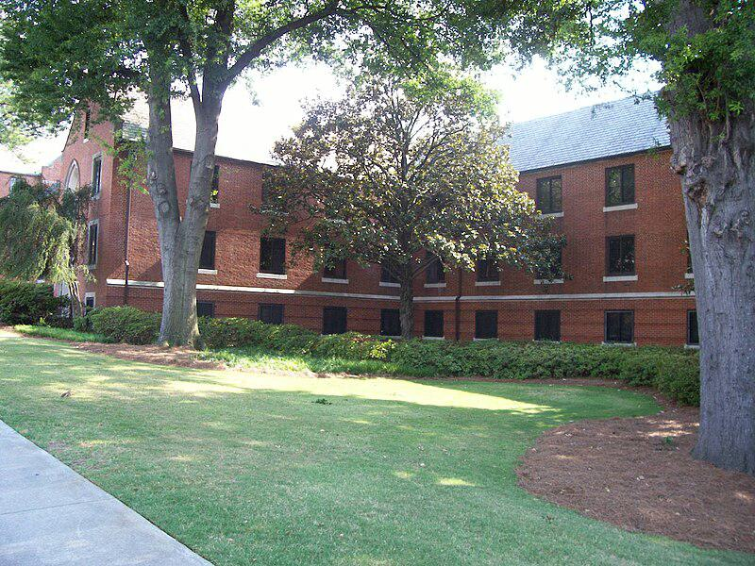

Caption for image source 2: TowersHallGeorgiaTech Towers Hall from the Williams St. and Interstate Connector side..

Example Question - "Which building has more rows of windows the Hardenbergh Hall or the Towers Hall?"

Example Answer - "Hardenbergh Hall has more rows of windows than the Towers Hall."

Additional Text Source 1 - Residence Halls: Brett, Campbell, Clothier, Demarest, Frelinghuysen, Hardenbergh, Hegeman, Leupp, Mettler, Pell, Stonier, Tinsley, Wessels, University Center Apartments, Sojourner Truth Apartments (formerly called College Avenue Apartments). Frelinghuysen Hall is an international residence hall and classroom building. (from: Rutgers University–New Brunswick)

Generated Question - Are Hardenbergh Hall and Towers Hall both part of university residence halls like those listed for Rutgers University?

Generated Answer - Hardenbergh Hall is a Rutgers residence hall, but Towers Hall is not listed among Rutgers residence halls.

--- Entry for custom_id: d5ca03f60dba11ecb1e81171463288e9 ---

Image Source 1 -

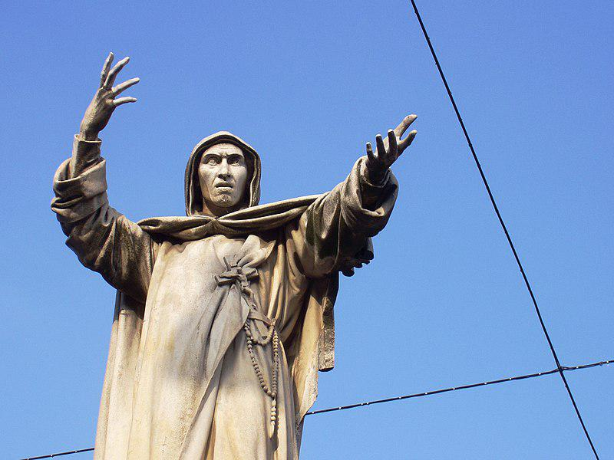

Caption for image source 1: Girolamo Savonarola statue - Ferrara, Italy Girolamo Savonarola statue - Ferrara, Italy. This statue is immediately proximate to the Castello Estense in the city center..

Example Question - "What is tucked in the belt of Girolamo Savonarola statue (in Ferrara, Italy)?"

Example Answer - "A rosary is tucked in the belt of the Girolamo Savonarola statue in Ferrara, Italy."

Additional Text Source 1 - The other statues were mostly executed by his pupils. Adolf von Donndorf contributed standing figures of Reuchlin and Frederick the Wise of Saxony, seated figures of Girolamo Savonarola, Peter Waldo and an allegorical statue (with mural crown) representing the town of Magdeburg grieving after the Sack of Magdeburg in 1631, as well as reliefs. (from: Luther Monument (Worms))

Generated Question - Are the statues of Girolamo Savonarola in Ferrara and Worms both standing figures?

Generated Answer - No, the Ferrara statue is standing, but the Worms statue is seated.

--- Entry for custom_id: d5bf17840dba11ecb1e81171463288e9 ---

Image Source 1 -



Caption for image source 1: WI Union activists protest outside McCain Town Hall in Racine, July 31, 2008 (2722173865).

Example Question - "Did more than four people attend the WI Union activists' protest outside McCain Town Hall on July 31, 2008?"

Example Answer - "Yes, more than four people attended the WI Union activists' protest outside McCain Town Hall on July 31, 2008."

Additional Text Source 1 - On 13 and 14 July a weekend of protest was held in East London, with a series of seven-minute Dalston traffic blockades, a mass bike ride through the A10, Olympic park traffic blocks, a people's assembly outside Hackney Town Hall, and all-day talks and panels in London Fields. (from: Timeline of Extinction Rebellion actions)

Generated Question - Did the WI Union activists' protest outside McCain Town Hall involve fewer participants than the multiple events held in East London on July 13 and 14?

Generated Answer - Yes, the WI Union protest had fewer participants than the multiple events in East London.

--- Entry for custom_id: d5c89a020dba11ecb1e81171463288e9 ---

Image Source 1 -

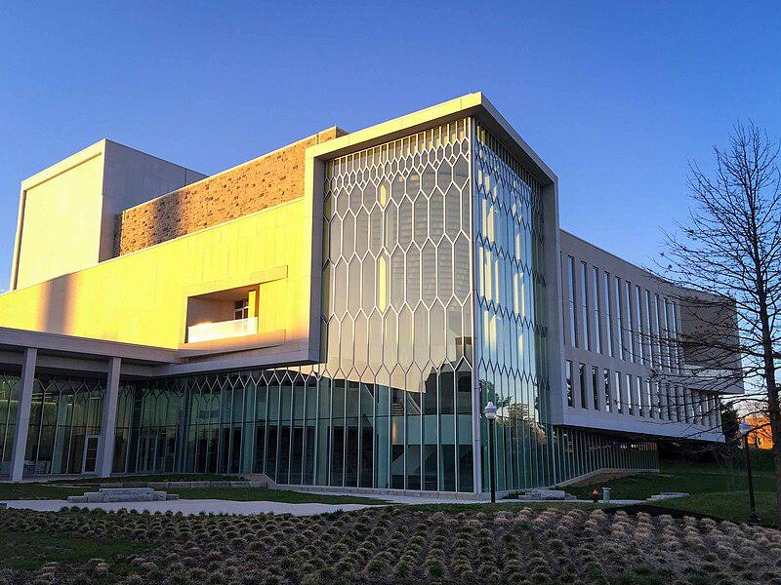

Caption for image source 1: Moss Arts Center-1 Moss Arts Center at Virginia Tech in Blacksburg, Virginia.

Example Question - "Does the Moss Arts Center at Virginia Tech in Blacksburg, Virginia have an oldschool or modern exterior architecture?"

Example Answer - "The Moss Arts Center at Virginia Tech has a modern exterior architecture."

Additional Text Source 1 - The center also hosts the West Virginia Dance Festival, which features classical and modern dance. Huntington's historic Keith-Albee Theatre, built by brothers A.B. and S.J. Hyman, was originally opened to the public on May 7, 1928, and hosts a variety of performing arts and music attractions. (from: West Virginia)

Generated Question - Does the Moss Arts Center at Virginia Tech and the Keith-Albee Theatre in West Virginia both host modern performing arts events?

Generated Answer - Yes, both venues host modern performing arts events.

--- Entry for custom_id: d5d2cc200dba11ecb1e81171463288e9 ---

Example Question - How many species of flowering plants come from the genus that the Iris Pallida belongs to?

Example Answer - 260-300

Image Source 1 -

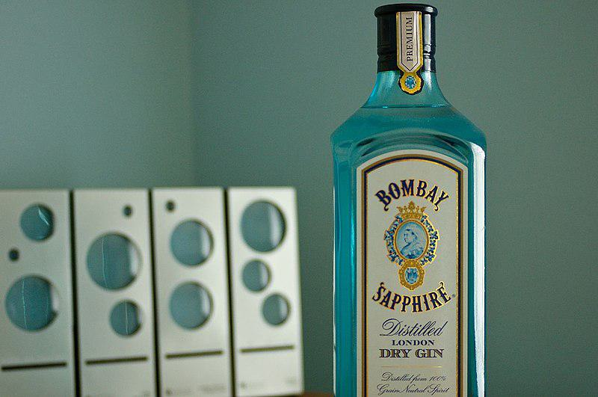

Generated Question - Which genus do the iris species used for flavoring Bombay Sapphire gin belong to, and how many species does this genus have?

Generated Answer - They belong to the genus Iris, which has 260-300 species.

--- Entry for custom_id: d5cf4be00dba11ecb1e81171463288e9 ---

Example Question - Are Afro-Germans and Mexicans concentrated in the same German states?

Example Answer - No, they are not. Mexican population is concentrated mostly in the federal states of Bavaria, Baden-Württemberg while Afro-Germans are in larger cities like Hamburg, Darmstadt, Frankfurt, Munich, Bremen, Cologne and Berlin

Image Source 1 -

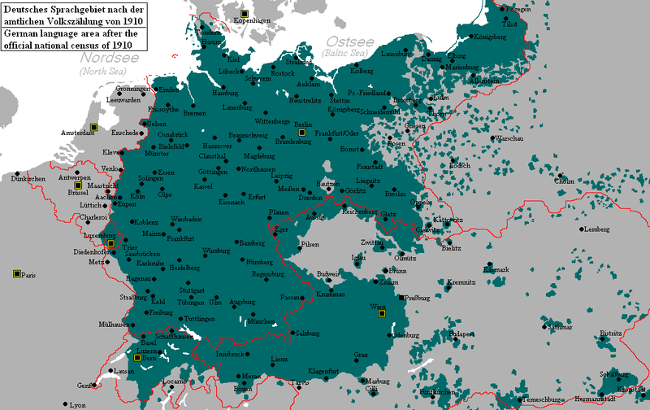

Generated Question - Do the current Afro-German and Mexican populations mainly live within the 1910 German language area shown on the map?

Generated Answer - Yes, both Afro-German and Mexican populations mostly live within the 1910 German language area boundaries.

--- Entry for custom_id: d5ccb5920dba11ecb1e81171463288e9 ---

Image Source 1 -

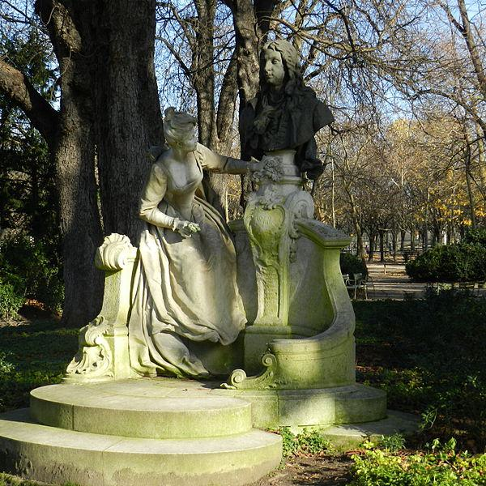

Caption for image source 1: Monument à Watteau by Henri Désiré Gauquié, 25 November 2012 01.

Example Question - "Do the people depicted in the Monument à Watteau by Henri Désiré both have complete bodies?"

Example Answer - "No, the people depicted in the Monument à Watteau by Henri Désiré do not both have complete bodies."

Additional Text Source 1 - Many people thought a simple obelisk, one without the colonnade, would be too bare. Architect Mills was reputed to have said omitting the colonnade would make the monument look like "a stalk of asparagus"; another critic said it offered "little ... to be proud of". (from: Washington Monument)

Generated Question - Does the Monument à Watteau by Henri Désiré have a complete colonnade like the Washington Monument?

Generated Answer - No, the Monument à Watteau does not have a colonnade like the Washington Monument.

--- Entry for custom_id: d5c2a9800dba11ecb1e81171463288e9 ---

Image Source 1 -

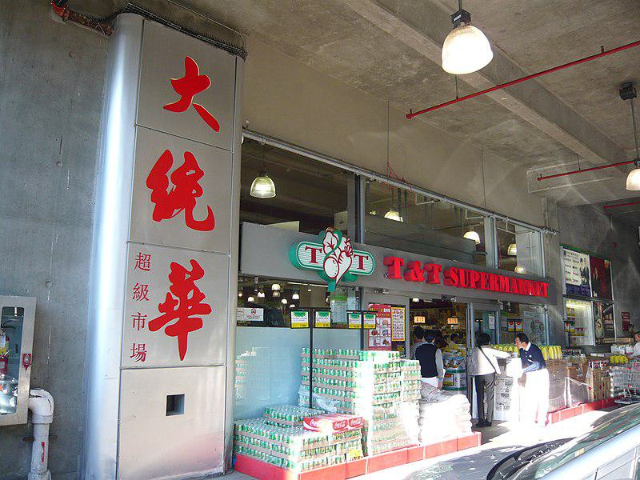

Caption for image source 1: Richmond T&T.

Example Question - "Does the T & T Supermarket in Richmond have a fire extinguisher that is at the front entrance to the left of large, red Chinese letters on a silver wall?"

Example Answer - "Yes, there is a fire extinguisher that is at the front entrance to the left of large, red Chinese letters on a silver wall."

Additional Text Source 1 - Red (Chinese: 紅中/红中; pinyin: hóngzhōng; Cantonese Jyutping: hung4zung1; also Chinese and Japanese: 中; pinyin: zhōng; Cantonese Jyutping: zung1; rōmaji: chun) - a tile with a red traditional Chinese character (中) meaning center or middle. (from: Mahjong tiles)

Generated Question - Is the large red Chinese character on the silver wall at the T&T Supermarket entrance similar in color to the red tile called "hóngzhōng" in Mahjong?

Generated Answer - Yes, both the character and the "hóngzhōng" tile are red in color.

--- Entry for custom_id: d5ccbc4a0dba11ecb1e81171463288e9 ---

Image Source 1 -



Caption for image source 1: Vaping stand Enfield shopping centre Vaping stand Enfield shopping centre.

Image Source 2 -

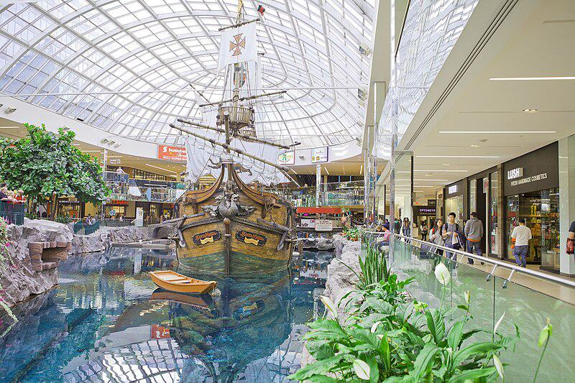

Caption for image source 2: West Edmonton Mall, Edmonton, Alberta (22080575776).

Example Question - "Is the main interior space of the West Edmonton Mall in Alberta more vertically spacious than that of the enfield shopping center?"

Example Answer - "The main interior space of the West Edmonton Mall in Alberta is more vertically spacious than that of the Enfield Shopping Center."

Additional Text Source 1 - The Dubai Mall (Arabic: دبي مول‎ "Dubai Mall") is a shopping mall in Dubai. It is the largest mall in the world by total land area, and the 26th-largest shopping mall in the world by gross leasable area, tying with West Edmonton Mall and Fashion Island (Thailand)—both of which are older than it. (from: The Dubai Mall)

Generated Question - Is the West Edmonton Mall more spacious and larger in area compared to the Enfield Shopping Centre?

Generated Answer - Yes, the West Edmonton Mall is larger and more spacious than the Enfield Shopping Centre.

--- Entry for custom_id: d5d0952c0dba11ecb1e81171463288e9 ---

Example Question - Which Argentine footballer was born later: Diego Peralta or Diego Trotta?

Example Answer - Diego Peralta was born later.

Image Source 1 -

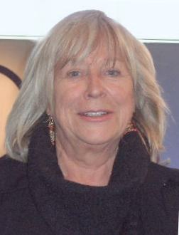

Generated Question - Which Diego shares a last name with the person in the image, and who is older between the two Diegos?

Generated Answer - Diego Trotta shares the last name with Margarethe von Trotta and is older than Diego Peralta.

--- Entry for custom_id: d5d8997a0dba11ecb1e81171463288e9 ---

Example Question - RAT and NS1 are both what type of test, which are are often immunoassays (IAs) of one kind or another?

Example Answer - Antigen tests

Image Source 1 -



--- Entry for custom_id: d5d2da9e0dba11ecb1e81171463288e9 ---

Example Question - Wha common body of water will you find the giant freshwater stingray and the thorny freshwater stingray?

Example Answer - rivers

Image Source 1 -

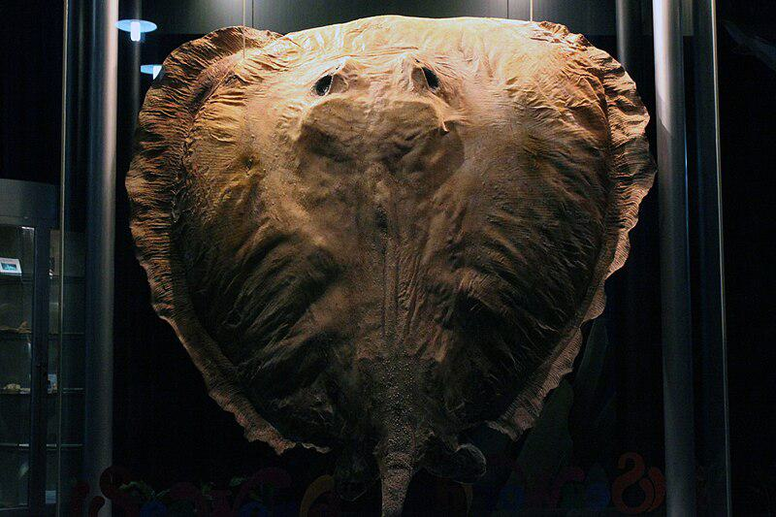

Generated Question - Do both the pincushion ray and the giant freshwater stingray belong to the same family and inhabit freshwater environments?

Generated Answer - Yes, both belong to the family Dasyatidae and live in freshwater rivers and lakes.

--- Entry for custom_id: d5d9ed480dba11ecb1e81171463288e9 ---

Example Question - What 1963 revisionist Western movie directed by Martin Ritt stars Paul Newman as the reworked title character that is also an antihero

Example Answer - Hud

Image Source 1 -



Generated Question - How does the antihero role of Paul Newman's character in Hud compare to Clint Eastwood's "Man with No Name" in revisionist Westerns?

Generated Answer - Both are morally ambiguous antiheroes leading revisionist Western films.

--- Entry for custom_id: d5cf73860dba11ecb1e81171463288e9 ---

Example Question - What is the synthetic pregnane steroid hormone derived from hydrocortisone and prednisolone that has a fat-soluble ester called Depo-Medrol?

Example Answer - Methylprednisolone.

Image Source 1 -



Generated Question - How does the steroid structure of methylprednisolone compare to the four-ring structure shown in 5α-dihydroprogesterone?

Generated Answer - Both have the characteristic four-ring steroid structure with polar groups at opposite ends.

--- Entry for custom_id: d5bf75620dba11ecb1e81171463288e9 ---

Image Source 1 -

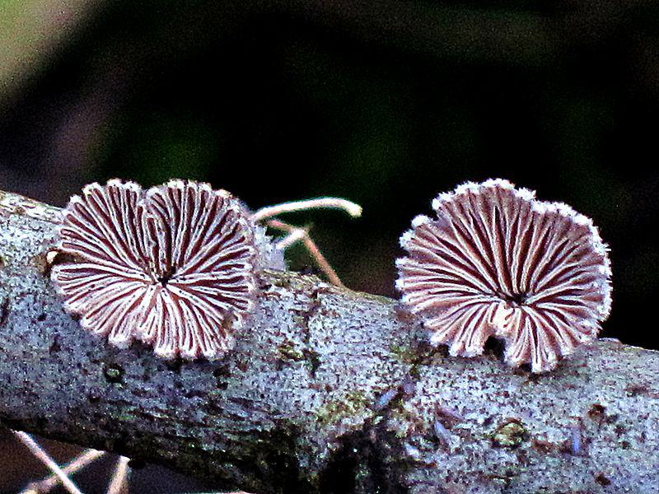

Caption for image source 1: Schizophyllum commune (Split Gill) , Arnhem, the Netherlands Schizophyllum commune (Split Gill), Arnhem, the Netherlands.

Image Source 2 -

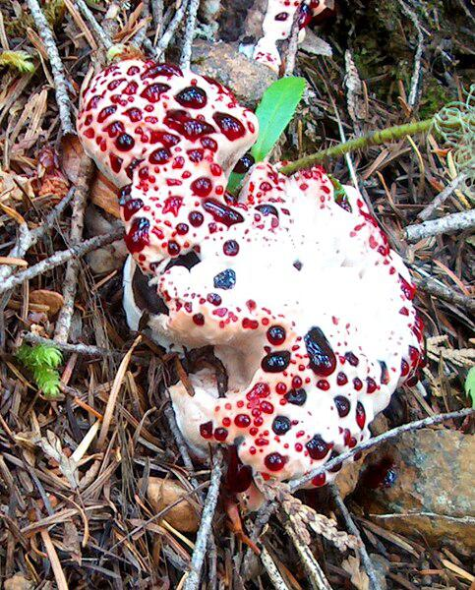

Caption for image source 2: Red-Juice Tooth Fungus (1294299445).

Example Question - "Does the Schizophyllum commune and the Red-Juice Tooth Fungus both have stripes?"

Example Answer - "No, stripes are not present in both the Schizophyllum commune and the Red-Juice Tooth Fungus."

Additional Text Source 1 - Examples of tetrapolar organisms are the smuts Ustilago maydis and U. longissima, and the mushrooms Coprinopsis cinerea, Schizophyllum commune, Pleurotus djamor and Laccaria bicolor. It is believed that multi-allelic systems favor outcrossing in Basidiomycota. (from: Mating in fungi)

Generated Question - Are both Schizophyllum commune and Red-Juice Tooth Fungus examples of tetrapolar organisms in Basidiomycota?

Generated Answer - Schizophyllum commune is a tetrapolar organism, but it is not stated for Red-Juice Tooth Fungus.

--- Entry for custom_id: d5c4e9c00dba11ecb1e81171463288e9 ---

Image Source 1 -



Caption for image source 1: Purchawka olbrzymia i widelec.

Example Question - "What color is the center of the Purchawka olbrzymia i widelec?"

Example Answer - "The center is white."

Generated Question - New Is the fork placed on the Purchawka olbrzymia i widelec resting on the left or right half of the mushroom?  
  
New

Generated Answer - The fork is resting on the right half of the mushroom.

--- Entry for custom_id: d5cbe3b00dba11ecb1e81171463288e9 ---

Image Source 1 -



Caption for image source 1: Miga (mascot) Winter Olympic 2010 mascot Miga..

Image Source 2 -

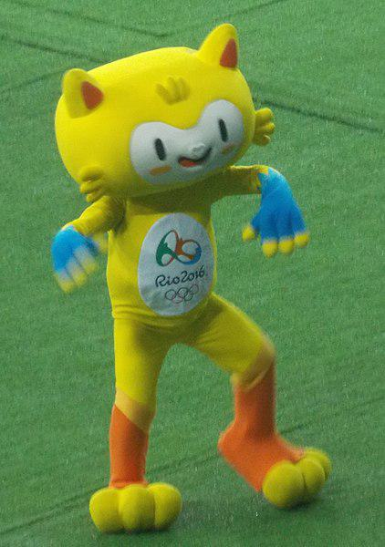

Caption for image source 2: 2016 Summer Olympic Mascot Vinicius Vinicius, the 2016 Summer Olympic Mascot during the Women's tournament of football for Gold medal match (2016.08.19 2016).

Example Question - "Which mascot has a better chance of getting a typist job; Vinicius or miga?"

Example Answer - "Vinicius has a better chance of getting a typist job than Miga because Vinicius has fingers."

Additional Text Source 1 - Vinicius's mission is "to spread joy throughout the world and celebrate the friendship that flourishes between people from all over the world" at the Olympic Games. Tom, named after Brazilian musician Tom Jobim, is the Paralympic mascot. (from: Vinicius and Tom)

Generated Question - Which mascot is more likely to symbolize winter sports, Miga or Vinicius?

Generated Answer - Miga is more likely to symbolize winter sports as the Winter Olympic 2010 mascot.

--- Entry for custom_id: d5c7df0e0dba11ecb1e81171463288e9 ---

Image Source 1 -

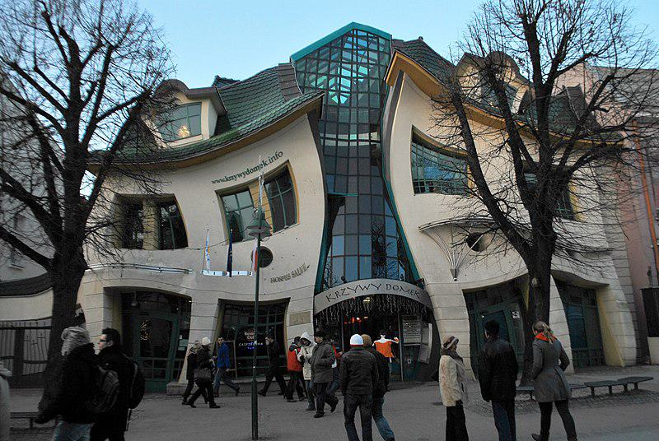

Caption for image source 1: The Crooked House of Sopot, Poland (3173810231).

Example Question - "Is the center of the The Crooked House of Sopot, Poland made of a reflective material?"

Example Answer - "Yes, it is made of a reflective material."

Additional Text Source 1 - Hayward returns home and reads a death notice in The Times: Sophia's grandfather, the wealthy entrepreneur Aristide Leonides, has died, aged 85. Due to the war, the whole family has been living with him in a sumptuous but ill-proportioned house called "Three Gables," the 'crooked house' of the title. (from: Crooked House)

Generated Question - Does the Crooked House of Sopot, Poland resemble the "Three Gables" house described as ill-proportioned in the additional text source?

Generated Answer - Yes, both are described as crooked or ill-proportioned houses.

--- Entry for custom_id: d5dc647e0dba11ecb1e81171463288e9 ---

Example Question - There were six major officers of what kingdom which was established during the First Crusade and first ruled by Godfrey of Bouillon?

Example Answer - Kingdom of Jerusalem

Image Source 1 -

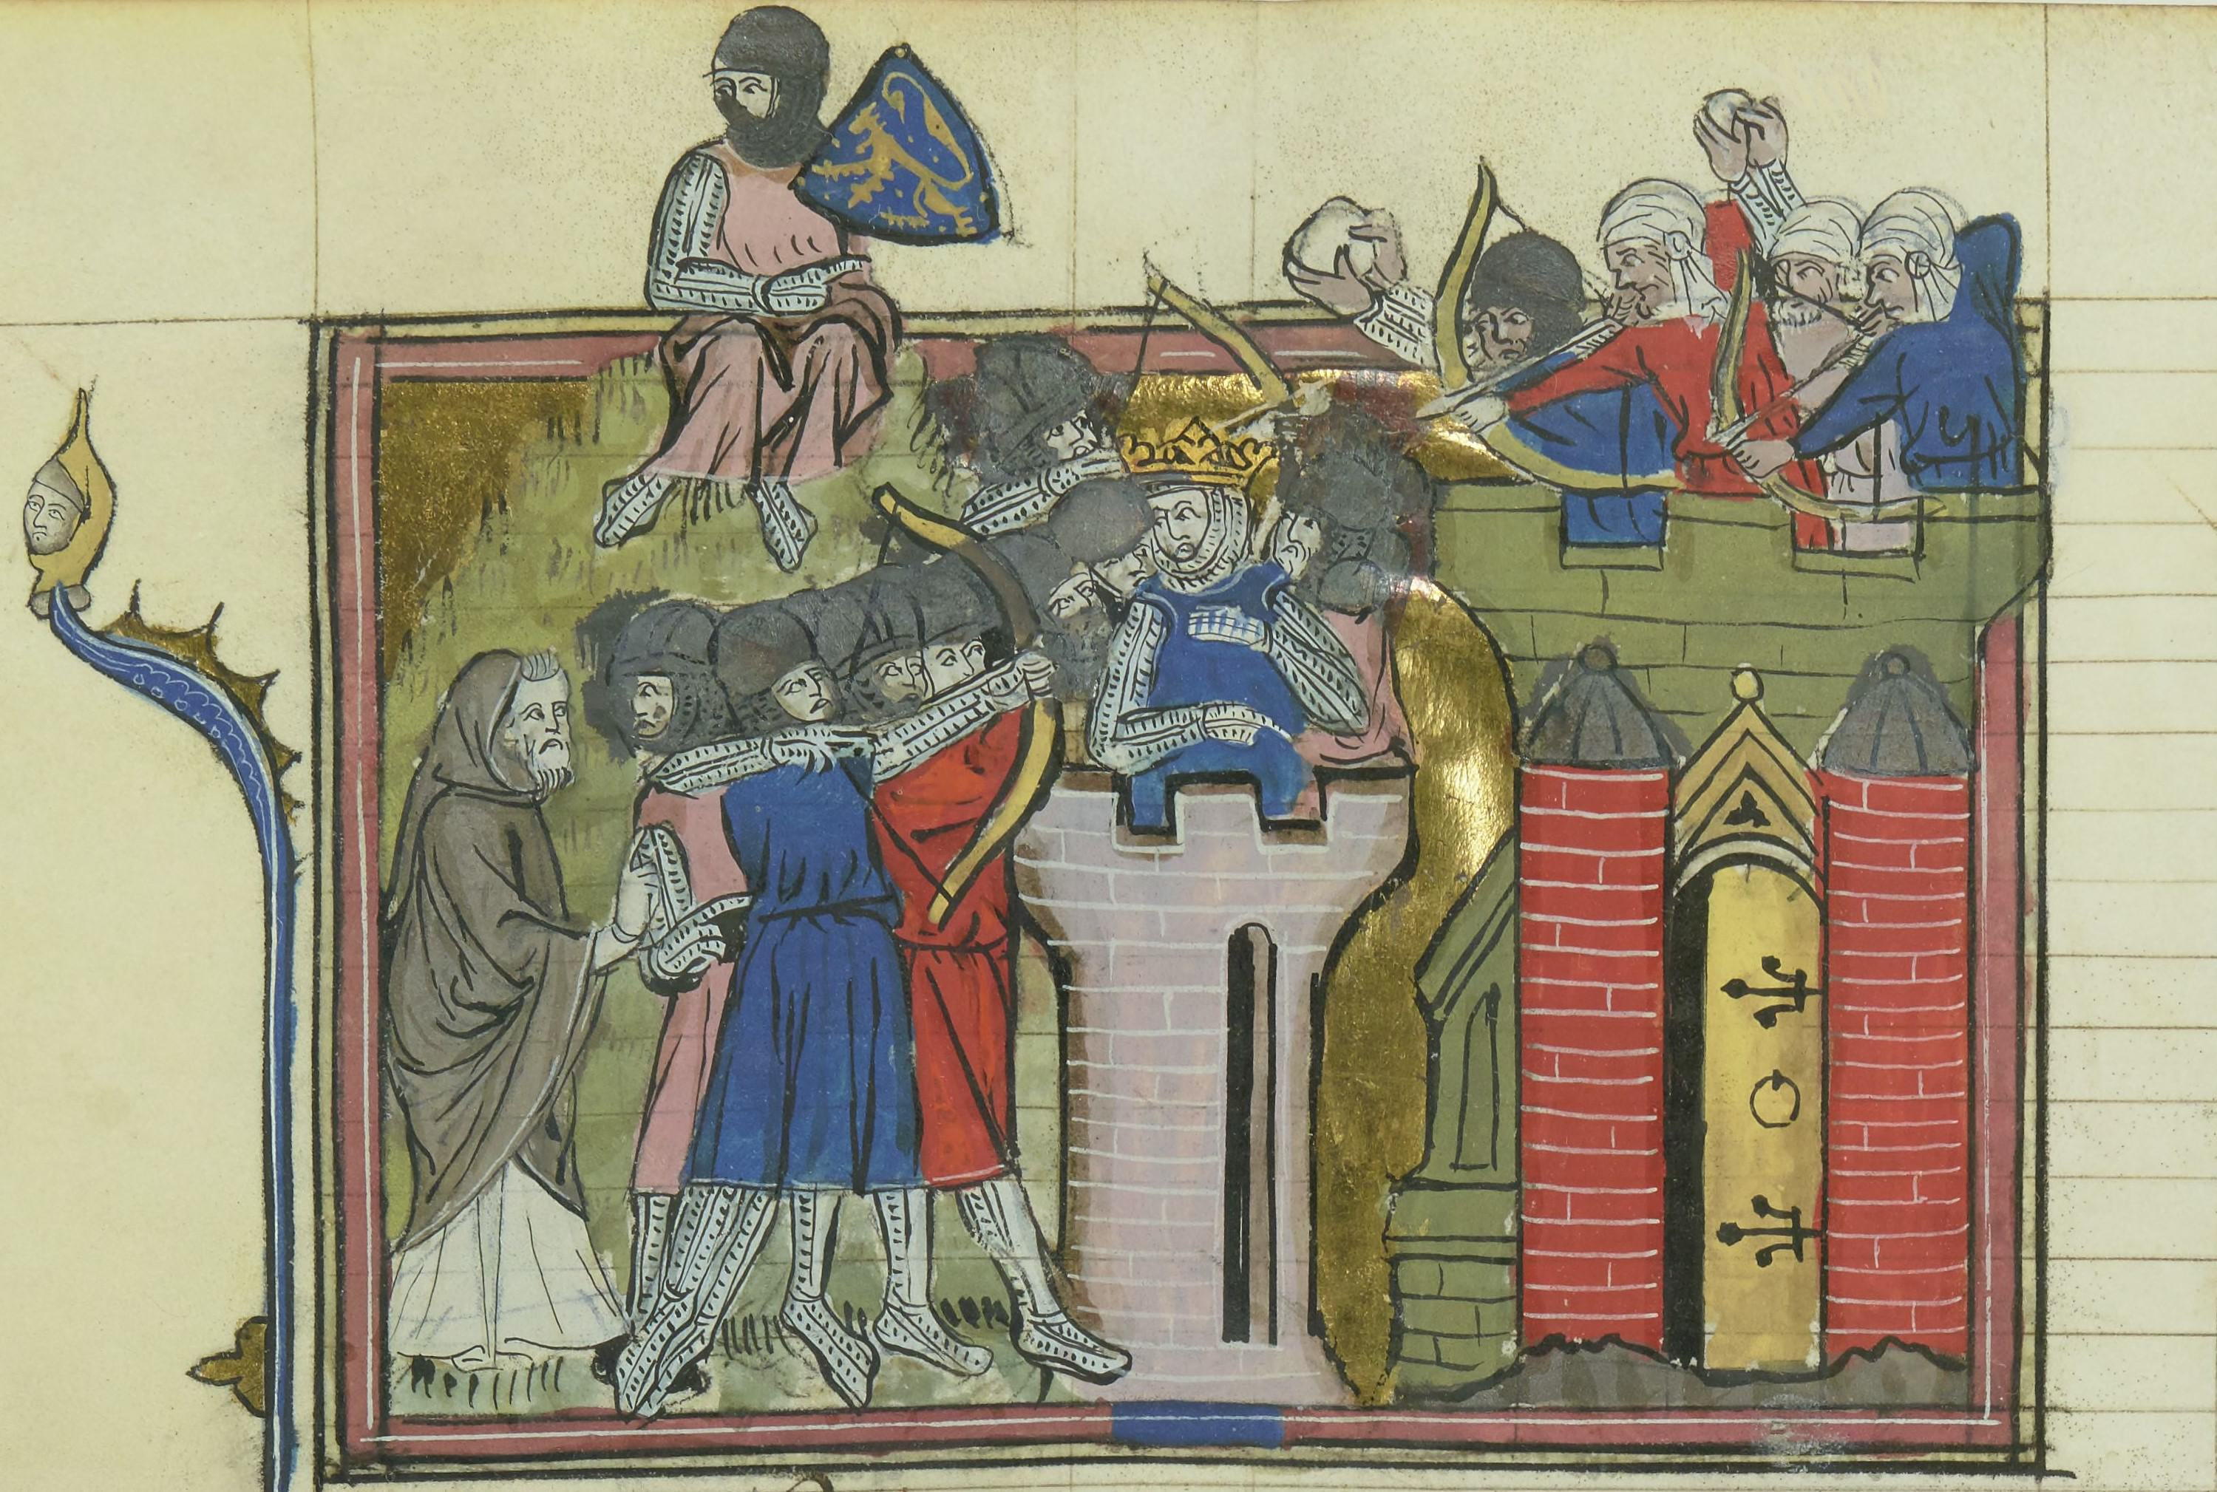

Generated Question - Who was the first ruler of the kingdom established during the First Crusade, which had six major officers including the constable and marshal?

Generated Answer - Godfrey of Bouillon

--- Entry for custom_id: d5cc188a0dba11ecb1e81171463288e9 ---

Image Source 1 -

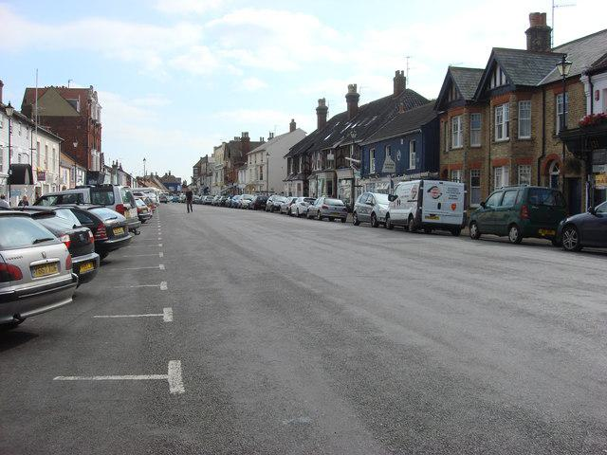

Caption for image source 1: High Street, Aldeburgh - geograph.org.uk - 982239 High Street, Aldeburgh.

Example Question - "Does High Street in Aldeburgh have slant parking, or parallel parking?"

Example Answer - "The High Street in Aldeburgh has slant parking and parallel parking."

Additional Text Source 1 - The term "High Street" is used to describe stores found on a typical high street to differentiate them from more specialised, exclusive and expensive outlets (often independent stores) – for example, "High Street banks" (instead of the less-common private or investment banks) or "High Street shops" (instead of boutiques). (from: High Street)

Generated Question - Does the High Street in Aldeburgh primarily feature typical "High Street shops" as described in the additional text source?

Generated Answer - Yes, the High Street in Aldeburgh likely features typical "High Street shops" as described.

--- Entry for custom_id: d5c086640dba11ecb1e81171463288e9 ---

Image Source 1 -



Caption for image source 1: Nemoptera-bipennis-20130711-recorte.

Example Question - "Are the tails of Nemoptera Bipennis longer than it's body?"

Example Answer - "Yes, the tail of the Nemoptera Bipennis is longer than its body."

Additional Text Source 1 - Nemoptera bipennis is a species of slow flying insect in the spoonwing family, Nemopteridae. It is found in Spain, Turkey, Portugal, and France. (from: Nemoptera bipennis)

Generated Question - Is the Nemoptera bipennis found in countries located on the Iberian Peninsula?

Generated Answer - Yes, it is found in Spain and Portugal, which are on the Iberian Peninsula.

--- Entry for custom_id: d5c494020dba11ecb1e81171463288e9 ---

Image Source 1 -

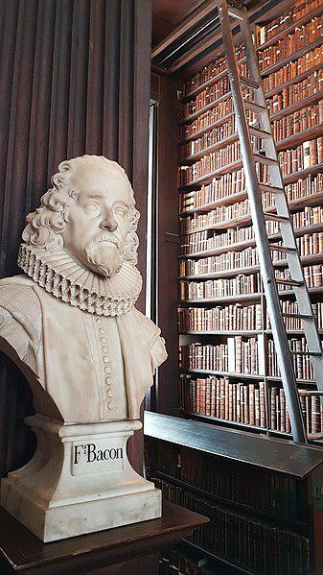

Caption for image source 1: The Old Library, Trinity College - Dublin 04 The Old Library, Trinity College - Dublin.

Example Question - "What body part of F.Bacon is depicted in his statue in The Old Library of Trinity College?"

Example Answer - "The head of F.Bacon is depicted in his statue in The Old Library of Trinity College."

Additional Text Source 1 - The buildings referred to as the college's BLU (Berkeley Lecky Ussher) Arts library complex consist of the Berkeley Library in Fellow's Square, built in 1956, the Lecky Library, attached to the Arts building, and the James Ussher Library which, opening officially in 2003, overlooks College Park and houses the Glucksman Map Library. (from: Trinity College Dublin)

Generated Question - Is the F. Bacon statue located in the same library complex as the Berkeley, Lecky, and James Ussher Libraries at Trinity College Dublin?

Generated Answer - No, the F. Bacon statue is in the Old Library, separate from the Berkeley, Lecky, and James Ussher Libraries.

--- Entry for custom_id: d5dd7c380dba11ecb1e81171463288e9 ---

Example Question - The motor and sensory supply of the upper limb is provided by the what, which the dorsal scapular nerve is a collateral branch of?

Example Answer - Brachial plexus

Image Source 1 -

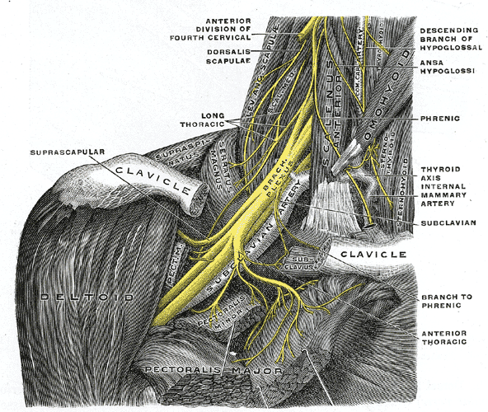

Generated Question - Which nerve shown in the image innervates the rhomboid muscles and is a collateral branch of the brachial plexus?

Generated Answer - The dorsal scapular nerve.

--- Entry for custom_id: d5d4d4160dba11ecb1e81171463288e9 ---

Example Question - Who are the historic heads of the court that certifies many Osem products?

Example Answer - This court is historically headed by a Chief Rabbi and by the Head of Rabbinical Court.

Image Source 1 -

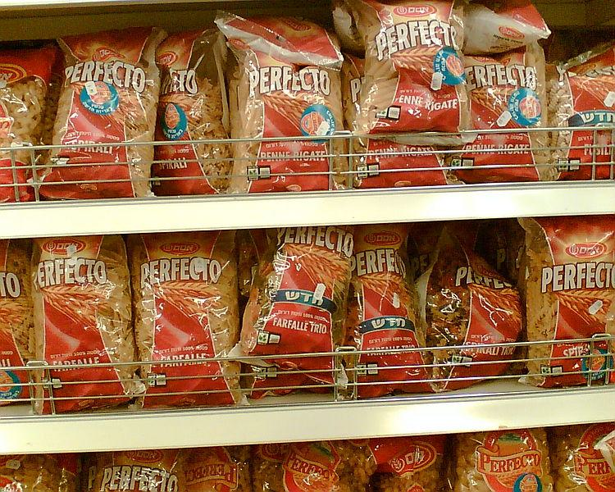

--- Entry for custom_id: d5d047d40dba11ecb1e81171463288e9 ---

Example Question - What is the meaning of the name of the city where the Steve Hoyle Rehabilitation Center is located?

Example Answer - The city's name, Tallulah, means leaping water.

Image Source 1 -

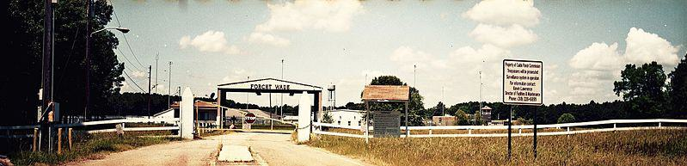

Generated Question - Is the Forcht-Wade Correctional Center located in the city whose name means "leaping water"?

Generated Answer - Yes, it is located in Tallulah, which means "leaping water."

--- Entry for custom_id: d5ce75940dba11ecb1e81171463288e9 ---

Image Source 1 -

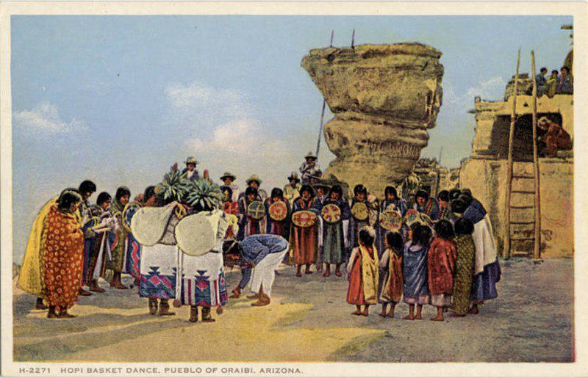

Caption for image source 1: Hopi Basket dance, Pueblo of Oraibi, Arizona. Fred Harvey series. (NBY 22531) Hopi Basket dance, Pueblo of Oraibi, Arizona. Fred Harvey series..

Image Source 2 -

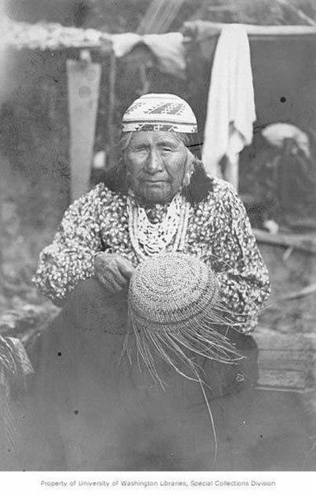

Caption for image source 2: Native American woman weaving a basket, Oregon, circa 1900 (AL+CA 2629) Native American woman weaving a basket, Oregon, circa 1900 PH Coll 17 Album 2.17.

Example Question - "Which image depicts more people, Hopi Basket dance or Native American woman weaving a basket?"

Example Answer - "Hopi Basket dance depicts more people."

Additional Text Source 1 - Many Native American tribes believed that they originated from a woman, with many of their legends and creation stories depict a "mother earth." Women were entrusted with overseeing a tribe's agricultural systems, and were responsible for harvesting and cultivating the vegetables and plants for their people. (from: Native American women in Colonial America)

Generated Question - How do the roles of women in the Hopi Basket dance and basket weaving reflect their cultural importance in Native American tribes?

Generated Answer - Both show women as central to cultural traditions and agricultural responsibilities.

--- Entry for custom_id: d5d4eaaa0dba11ecb1e81171463288e9 ---

Example Question - The Glagolev-Shipunov-Gryazev GShG-7.62 is a gas operated, self-powered weapon, which is in contrast with most other what, an example of which would be the M61 Vulcan?

Example Answer - Rotary guns

Image Source 1 -



--- Entry for custom_id: d5de01080dba11ecb1e81171463288e9 ---

Example Question - What is the area known for where Chhatrapati Shivaji Terminus was built as a replacement station?

Example Answer - imports and exports

Image Source 1 -

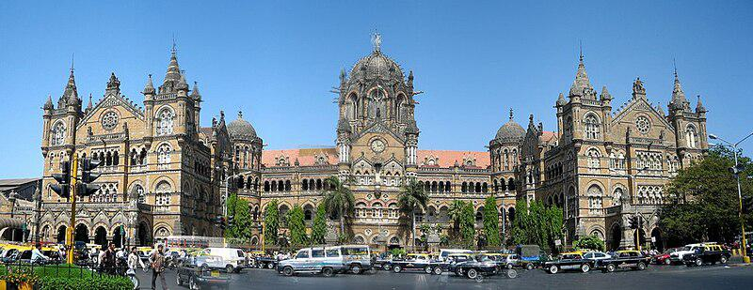

Generated Question - Was the Chhatrapati Shivaji Terminus built before or after Queen Victoria's 50 years of rule ended?

Generated Answer - It was completed in the year marking 50 years of Queen Victoria's rule.

--- Entry for custom_id: d5d8b27a0dba11ecb1e81171463288e9 ---

Example Question - Serbia is home to both the Patriarchate of Peć, and the Holy Synod which consists of what five members?

Example Answer - Four bishops and the Patriarch who serves as the Chairman.

Image Source 1 -

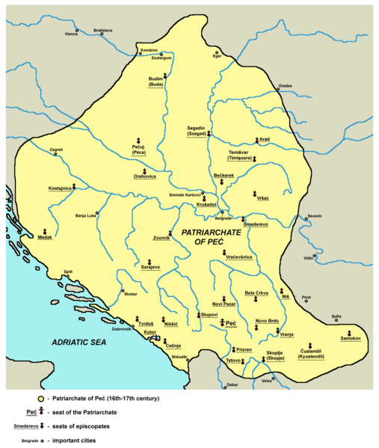

Generated Question - How does the historical Serbian Patriarchate of Peć relate to the current Holy Synod's leadership structure?

Generated Answer - The Patriarchate of Peć was the historic seat of the Serbian Patriarch, who now chairs the Holy Synod with four bishops.

--- Entry for custom_id: d5c4ed580dba11ecb1e81171463288e9 ---

Image Source 1 -

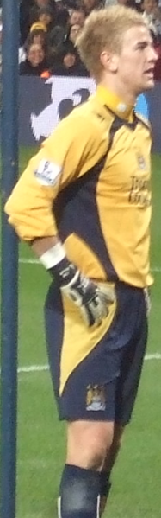

Caption for image source 1: Joe Hart Manchester City v. Arsenal 1.png Joe Hart.

Example Question - "Did the shirt of Joe Hart Manchester City's uniform have more yellow or black on it?"

Example Answer - "Joe Hart Manchester City's jersey was more yellow than black."

Additional Text Source 1 - "Blue Moon" is a popular music standard, written by Richard Rodgers and Lorenz Hart in 1934, and one of the best known football chants, used since the '90s by Manchester City and Crewe Alexandra. (from: Blue moon)

Generated Question - Does Joe Hart's Manchester City uniform share any color with the "Blue Moon" chant's team colors?

Generated Answer - No, Joe Hart's uniform is yellow and black, while "Blue Moon" is associated with blue.

--- Entry for custom_id: d5d230f80dba11ecb1e81171463288e9 ---

Example Question - Out of Metro Manila, Metro Davao, and Metro Cebu, which is the smaller metropolitan area?

Example Answer - Metro Davao

Image Source 1 -

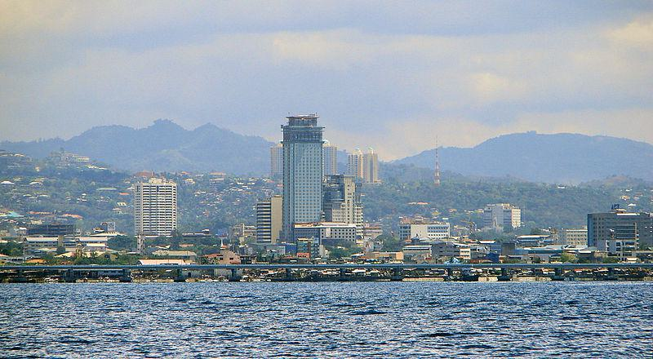

Generated Question - Which metropolitan area is the second largest in the Philippines, located in the Visayas, and includes Cebu City as its center?

Generated Answer - Metro Cebu is the second largest metropolitan area in the Philippines, located in the Visayas with Cebu City as its center.

--- Entry for custom_id: d5dc1d700dba11ecb1e81171463288e9 ---

Example Question - What varies in thickness over the surface of the tooth and is often thickest at the cusp, up to 2.5mm, and thinnest at its border and includes striae of Retzius?

Example Answer - Tooth enamel.

Image Source 1 -

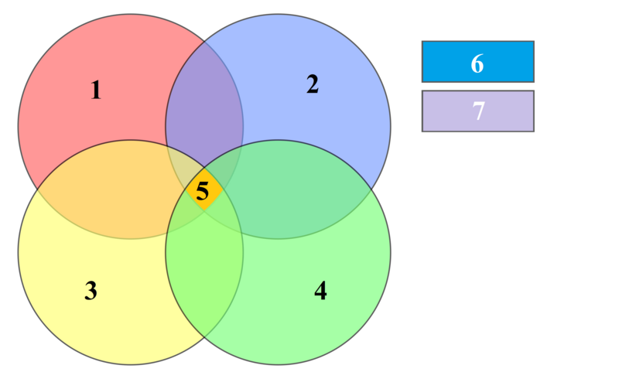

--- Entry for custom_id: d5c8757c0dba11ecb1e81171463288e9 ---

Image Source 1 -

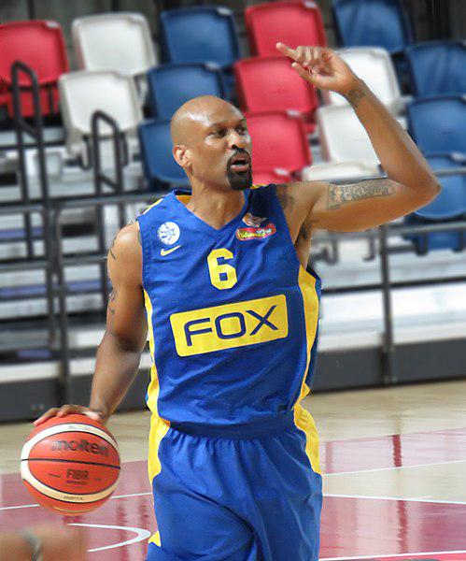

Caption for image source 1: Devin Smith Maccabi (2) Maccabi Rishon LeZion vs. Maccabi Tel Aviv B.C., 26 September, 2015.

Image Source 2 -



Caption for image source 2: Tarik Phillip Team GB Tarik Phillip playing for the British national team against Estonia in the European 2019 FIBA Basketball World Cup qualification round.

Example Question - "Did the British national team against Estonia game in the European 2019 FIBA Basketball World Cup qualification round and the Maccabi Rishon LeZion vs. Maccabi Tel Aviv B.C., 26 September, 2015 game both have a similarly striped basketball?"

Example Answer - "Yes, both games used a similarly striped basketball."

Additional Text Source 1 - On May 13, 2019, Ariel recorded a season-high 19 points, shooting 5-of-6 from three-point range, in a 102–105 loss to Hapoel Holon. Ariel won the 2018 Israeli League Cup title with Rishon LeZion, as well as reaching the 2019 Israeli League Finals, where they eventually fell short to Maccabi Tel Aviv. (from: Adam Ariel)

Generated Question - Did the player from Maccabi Rishon LeZion in 2015 and the British national team player in 2019 both play in games involving Maccabi Tel Aviv or Estonia?

Generated Answer - No, the 2015 game involved Maccabi Tel Aviv, while the 2019 game was against Estonia.

--- Entry for custom_id: d5cb95220dba11ecb1e81171463288e9 ---

Image Source 1 -

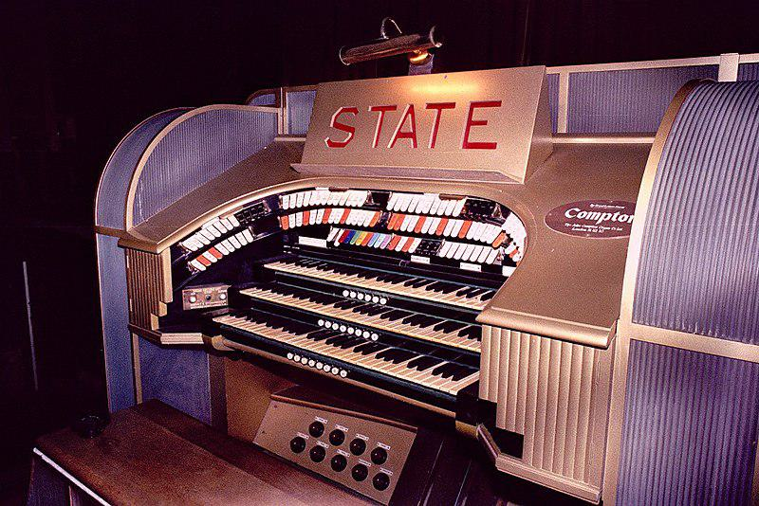

Caption for image source 1: State organ close.

Example Question - "What word is engraved on a plate that sits on the Compton Organ in the State Cinema, Grays, England?"

Example Answer - "STATE is the word engraved on the plate sitting on the Compton Organ in the State Cinema in Grays, England."

Additional Text Source 1 - After the closure the cinema was handed over to a small independent operator who in 1989 rebadged the building "The Grays State Theatre". Films continued to be shown and organ concerts were once again a feature of the programme as was the £1 entry ticket. (from: State Cinema)

Generated Question - Was the Compton Organ still used for concerts after the cinema was renamed "The Grays State Theatre"?

Generated Answer - Yes, organ concerts continued after the cinema was renamed "The Grays State Theatre".

--- Entry for custom_id: d5c103f00dba11ecb1e81171463288e9 ---

Image Source 1 -

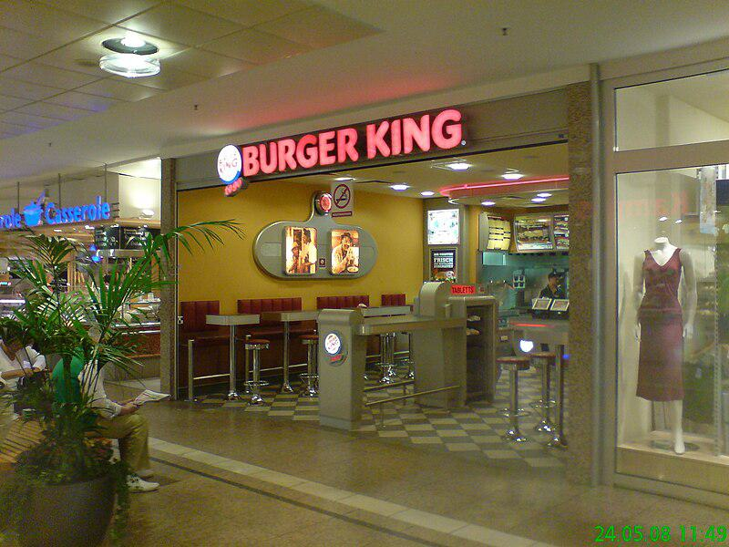

Caption for image source 1: Burger King RCW Cologne Author: Toni S. Source: Own Taken: 5/24/2008 Summary: Pic showing the Burger King location in the RheinCenter RheinCenter Koln, Burger King location ref Cologne-Weiden, Germany..

Example Question - "What kind of shop is there on the right side of Burger King RCW Cologne?"

Example Answer - "There is a clothing shop on the right side of Burger King RCW Cologne."

Additional Text Source 1 - On the right side the subclavian artery arises from the brachiocephalic (innominate) artery behind the right sternoclavicular articulation; on the left side it springs from the arch of the aorta. The two vessels, therefore, in the first part of their course, differ in length, direction, and relation with neighboring structures. (from: Subclavian artery)

Generated Question - Is the subclavian artery on the right side closer to the Burger King RCW Cologne than the clothing shop next to it?

Generated Answer - No, the subclavian artery is an internal body vessel and not physically near the Burger King or clothing shop.

--- Entry for custom_id: d5d4e6ae0dba11ecb1e81171463288e9 ---

Example Question - What is a disease that often gets worse over time and can damage all organ systems with the use of the most common drug in the world?

Example Answer - Alcoholism.

Generated Question - Which organs are especially affected by the disease caused by excessive use of the most common drug worldwide?

Generated Answer - The brain, heart, liver, pancreas, and immune system.

--- Entry for custom_id: d5bbf0f40dba11ecb1e81171463288e9 ---

Image Source 1 -

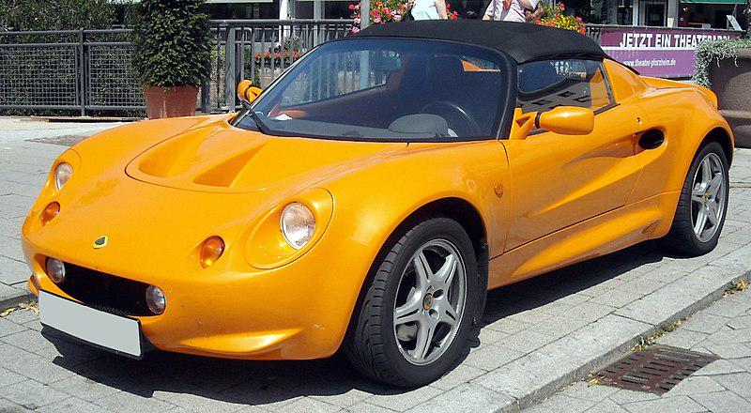

Caption for image source 1: Lotus Elise front 20090806.

Image Source 2 -

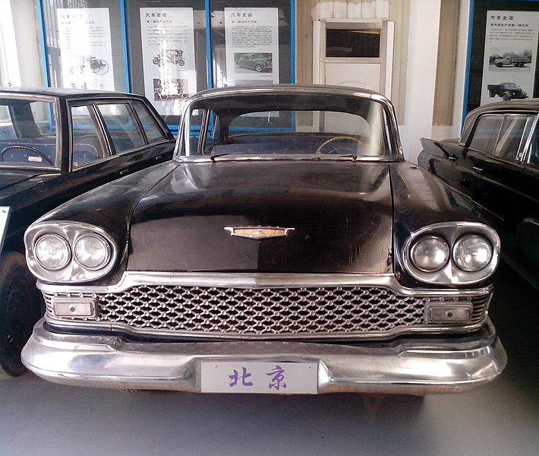

Caption for image source 2: 1960 Beijing luxury car The 1960 Beijing CB4 luxury car, its style copied from a 1956 Buick with a Cadillac-inspired front end..

Example Question - "Would a driver sit higher off the road in a 1960 Beijing luxury car or a Lotus Elise?"

Example Answer - "A driver would sit higher off the road in a 1960 Beijing luxury car than in a Lotus Elise."

Additional Text Source 1 - They said the Roadster felt like "an over-ballasted Lotus Elise", but the weight was well-distributed, so the car remained responsive. " Fit and finish of our Tesla were exemplary", which Road & Track thought fit the target market. (from: Tesla Roadster (first generation))

Generated Question - Considering the Lotus Elise's low weight and the 1960 Beijing luxury car's design, which car likely offers a more responsive driving experience?

Generated Answer - The Lotus Elise likely offers a more responsive driving experience due to its low weight and well-distributed balance.

--- Entry for custom_id: d5d91ea40dba11ecb1e81171463288e9 ---

Example Question - The section of paper removed by the office tool used for the purpose of collecting the sheets in a binder or folder does to paper would be known as a what?

Example Answer - A chad

Image Source 1 -

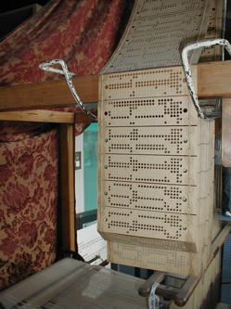

--- Entry for custom_id: d5da08320dba11ecb1e81171463288e9 ---

Example Question - Landline and Videophones are both types of what?

Example Answer - telephones

Image Source 1 -



Generated Question - Does the Siemens telephone in the image use the same twisted pair wiring system as traditional landline telephones?

Generated Answer - Yes, it uses the same twisted pair wiring system as traditional landline telephones.

--- Entry for custom_id: d5c8c9280dba11ecb1e81171463288e9 ---

Image Source 1 -

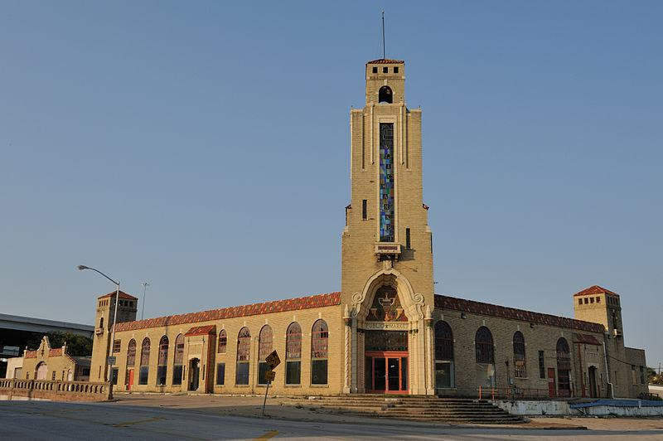

Caption for image source 1: 0011Public Market Full NE Fort Worth Texas Fort Worth Public MarketView of the Fort Worth Public Market from the Northeast. NRHP Ref 84001981..

Example Question - "What kind of glass is used in the Fort Worth Public Market Building's entrance tower?"

Example Answer - "Stained glass was used in the Fort Worth Public Market Building's entrance tower."

Additional Text Source 1 - The "Panther City" tradition is also preserved in the names and design of some of the city's geographical/architectural features, such as Panther Island (in the Trinity River), the Flat Iron Building, Fort Worth Central Station, and in two or three "Sleeping Panther" statues. (from: Fort Worth, Texas)

Generated Question - Does the Fort Worth Public Market building reflect the "Panther City" tradition seen in Fort Worth's landmarks?

Generated Answer - No, the Fort Worth Public Market building does not reflect the "Panther City" tradition.

--- Entry for custom_id: d5d1359a0dba11ecb1e81171463288e9 ---

Example Question - Taoists make charms of what, on which Chinese calligraphy was used?

Example Answer - Coins

Image Source 1 -

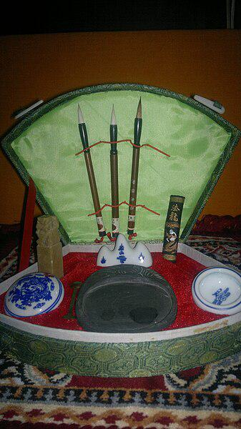

--- Entry for custom_id: d5d4acc00dba11ecb1e81171463288e9 ---

Example Question - What can be defined by elemental geometry that was introduced by Leonhard Euler to describe the orientation of a rigid body with respect to a fixed coordinate system?

Example Answer - Euler angles

Image Source 1 -

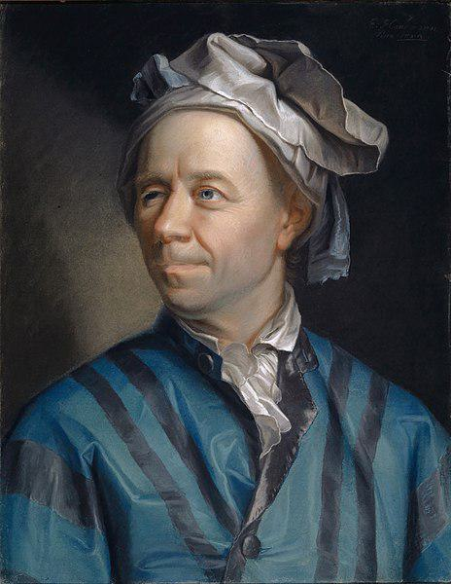

Generated Question - Who introduced the three angles used to describe the orientation of a rigid body, as shown in the portrait?

Generated Answer - Leonhard Euler introduced the three angles known as Euler angles.

--- Entry for custom_id: d5c2afd40dba11ecb1e81171463288e9 ---

Image Source 1 -



Caption for image source 1: Pomme Salade supermarket 04 Pomme Salade supermarket, Quebec city, Canada.

Example Question - "Is there a veggie isle in pomme salade stores?"

Example Answer - "There is a veggie isle in Pomme Salade stores."

Additional Text Source 1 - Within a few years he had founded what was to be one of California's largest department stores. Later he helped found the well-known Bohemian Club, which still exists. (from: List of foods named after people)

Generated Question - Does the Pomme Salade supermarket in Quebec City sell vegetables like ginger and plantains?

Generated Answer - Yes, the Pomme Salade supermarket sells vegetables including ginger and plantains.

--- Entry for custom_id: d5cf67ce0dba11ecb1e81171463288e9 ---

Example Question - The ancient Greek pantheon of major deities consisted of how many more deities than The Ennead?

Example Answer - The Ancient Greeks recognized 3 more deities than were in The Ennead.

Image Source 1 -

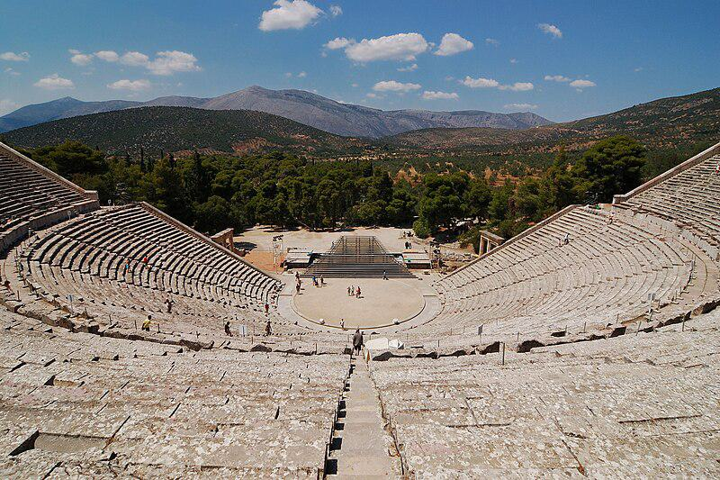

Generated Question - Considering the ancient theatre of Epidaurus was used for Greek plays, how many more major deities did the Greeks have compared to the Egyptian Ennead?

Generated Answer - The Greeks had 3 more major deities than the Egyptian Ennead.

--- Entry for custom_id: d5df0c9c0dba11ecb1e81171463288e9 ---

Example Question - What is the voiced palatal nasal and how is it commonly described?

Example Answer - The voiced palatal nasal is a type of consonant used in some spoken languages. It is commonly described as palatal; it is often unclear whether a language has a true palatal or not.

Generated Question - How does the alveolo-palatal nasal differ from the voiced palatal nasal in terms of language classification?

Generated Answer - The alveolo-palatal nasal is often mistaken for the voiced palatal nasal, but many languages have the alveolo-palatal instead of a true palatal nasal.

--- Entry for custom_id: d5c553060dba11ecb1e81171463288e9 ---

Image Source 1 -

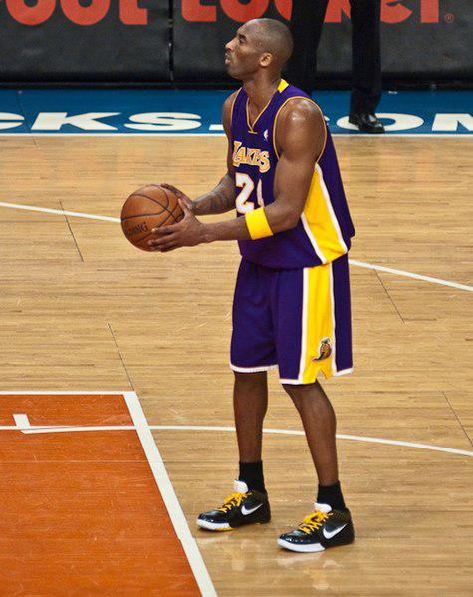

Caption for image source 1: Kobe Bryant 61 NYK4 Kobe Bryant 61 point game against the New York Knicks.

Image Source 2 -

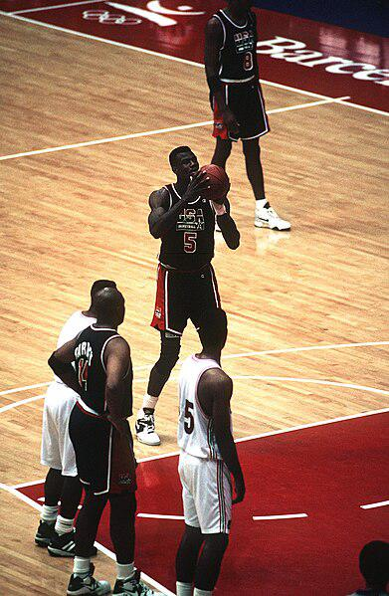

Caption for image source 2: Dream Team at the 1992 Summer Olympics.JPEG At the 25th Olympic games David Robinson, at that time US Navy Reserves, makes a free throw during the game between the "Dream Team" and Puerto Rico. Robinson scored 14 points and played 21.51 minutes of the game..

Example Question - "Were there white border stripes on the uniform shorts of both the 1992 Olympics USA Men's basketball team and those of the modern Los Angeles Lakers?"

Example Answer - "Uniform shorts for both the 1992 Olympics USA men's basketball team and those of the modern Los Angeles Lakers have white border stripes."

Additional Text Source 1 - The Phoenix Suns with point guard Steve Nash were a running team under Mike D'Antoni, and The New York Times called them "this decade’s incarnation of the Los Angeles Lakers’ Showtime". When D'Antoni joined with the Lakers and Nash in 2012, he declared, "We would love to be able to play 'Showtime' basketball." (from: Showtime (basketball))

Generated Question - Did both the 1992 Olympics USA team and the Showtime Lakers emphasize fast-paced basketball styles?

Generated Answer - Yes, both teams emphasized fast-paced, running basketball styles.

--- Entry for custom_id: d5cdc27a0dba11ecb1e81171463288e9 ---

Image Source 1 -

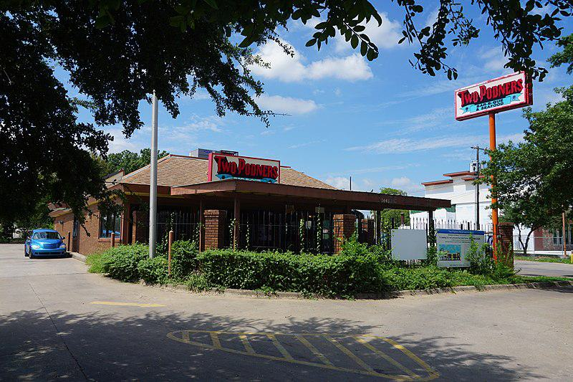

Caption for image source 1: South Dallas August 2016 1 (Two Podners Bar-B-Que & Seafood) Two Podners Bar-B-Que & Seafood (current location) in the South Dallas neighborhood in Dallas, Texas (United States)..

Image Source 2 -

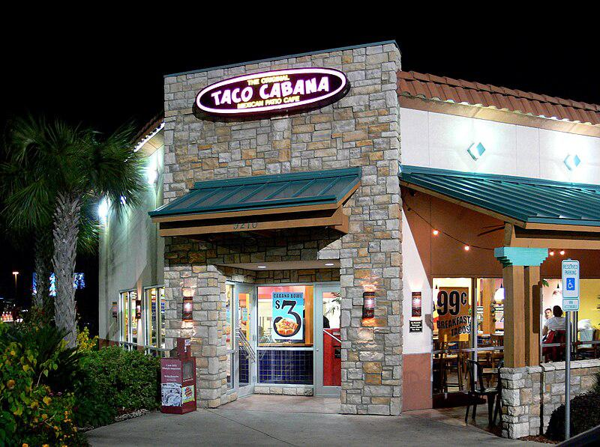

Caption for image source 2: Taco Cabana Dallas.

Example Question - "Does the illuminated sign at the Taco Cabana in Dallas have the same shape as the sign for the Two Podners Bar-B-Que & Seafood restaurant?"

Example Answer - "No, the illuminated sign at the Taco Cabana in Dallas does not have the same shape as the sign for the Two Podners Bar-B-Que & Seafood restaurant."

Additional Text Source 1 - In 1992 Taco Cabana went public with its first stock offering, and ended the year with 17 restaurants. In January 1993 Taco Cabana announced that it was purchasing cash-strapped Two Pesos' restaurant assets in exchange for 940,000 shares of Taco Cabana stock, valued at approximately $22 million. (from: Taco Cabana)

Generated Question - Did Taco Cabana expand its business by acquiring assets from another restaurant around the time it had 17 locations?

Generated Answer - Yes, Taco Cabana acquired Two Pesos' assets after having 17 restaurants.

--- Entry for custom_id: d5d87d8c0dba11ecb1e81171463288e9 ---

Example Question - As a result of colonialism and imperialism, a majority of what, which Carthage controlled most of the North of, lost sovereignty and control of natural resources such as gold and rubber?

Example Answer - Africa

Image Source 1 -

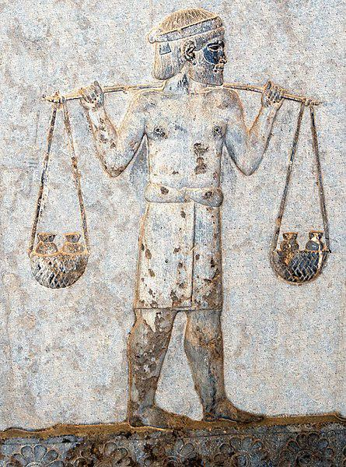

Generated Question - How does the tribute-bearer carrying gold in the Achaemenid satrapy relate to the control of natural resources lost by Africa due to colonialism, which Carthage once dominated?

Generated Answer - Both show control and transfer of valuable resources like gold, with Africa losing such control during colonialism.

--- Entry for custom_id: d5ce2e5e0dba11ecb1e81171463288e9 ---

Image Source 1 -

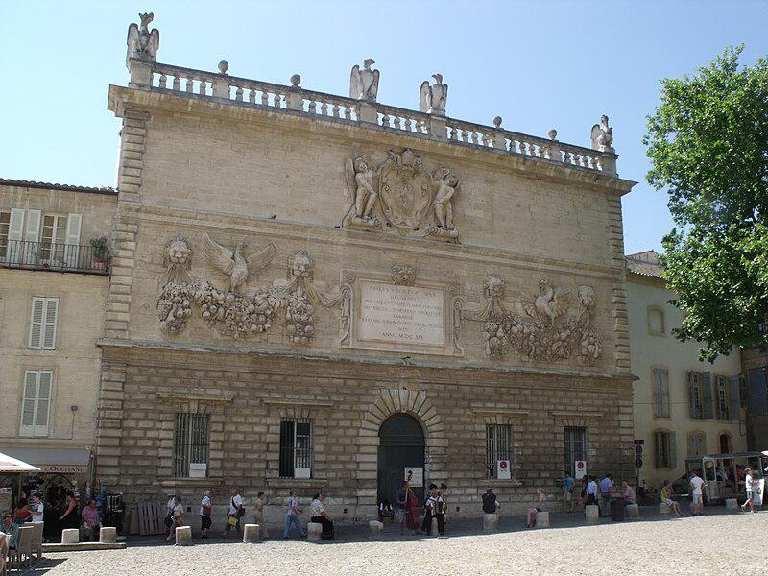

Caption for image source 1: Avignon - Place du Palais - The Old Mint.

Example Question - "What animal is carved in a statue on the roof of the Place du Palais?"

Example Answer - "A bird is carved in a statue on the roof of the Place du Palais."

Additional Text Source 1 - The Palais de Justice (French pronunciation: ​[palɛ də ʒystis]; '"Palace of Justice"), formerly the Palais de la Cité ("Palace of the City"), is a courthouse in Paris, located on the Boulevard du Palais on the Île de la Cité. (from: Palais de Justice, Paris)

Generated Question - Are there any bird sculptures on the Place du Palais and the Palais de Justice in Paris?

Generated Answer - Yes, both have bird sculptures on their roofs or facades.

--- Entry for custom_id: d5d3849e0dba11ecb1e81171463288e9 ---

Example Question - Of Iowa, Utah, and California, which held its Democratic primary on Super Tuesday?

Example Answer - Utah and California.

Image Source 1 -



Generated Question - Did the Iowa Democratic caucuses in 1984 and 2020 both occur before Super Tuesday?

Generated Answer - Yes, both Iowa caucuses occurred before Super Tuesday.

--- Entry for custom_id: d5cf2ea80dba11ecb1e81171463288e9 ---

Image Source 1 -

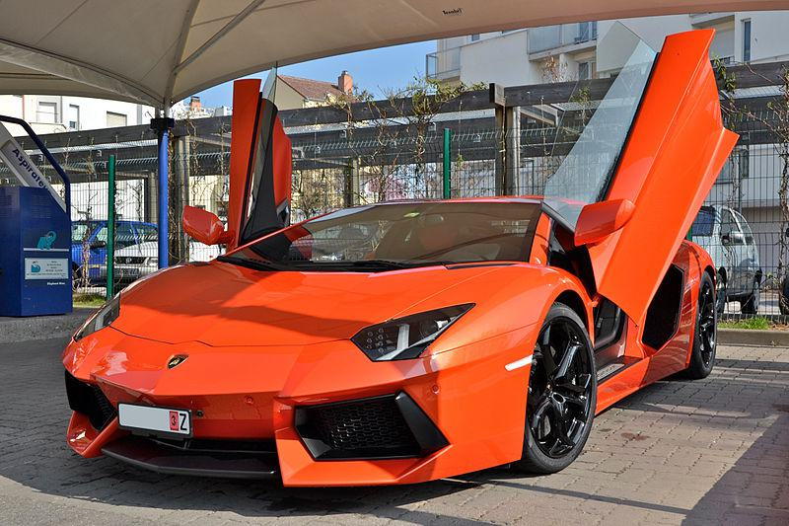

Caption for image source 1: Lamborghini Aventador LP 700-4 - Flickr - Alexandre Prévot (13).

Image Source 2 -



Caption for image source 2: Suzuki Grand Escudo L-Edition 0268.

Example Question - "Which vehicle has a taller roof, the Lamborghini Aventador LP 700-4 or the Suzuki Grand Escudo L-Edition 0268?"

Example Answer - "The Suzuki Grand Escudo L-Edition 0268 has a taller roof than the Lamborghini Aventador LP 700-4."

Additional Text Source 1 - The Aventador LP700–4 uses Lamborghini's new 700 PS (515 kW; 690 hp) 6,498 cc (6.5 L; 396.5 cu in) 60° V12 engine weighing 235 kg. Known internally as the L539, the new engine is Lamborghini's fifth in-house engine and second V12 design. (from: Lamborghini Aventador)

Generated Question - Does the Lamborghini Aventador LP 700-4 have a more powerful engine than the Suzuki Grand Escudo L-Edition 0268?

Generated Answer - Yes, the Lamborghini Aventador LP 700-4 has a much more powerful engine than the Suzuki Grand Escudo L-Edition 0268.

--- Entry for custom_id: d5d300fa0dba11ecb1e81171463288e9 ---

Example Question - Are the GM C car platform and the Chrysler C car platform both front wheel drive, both rear wheel drive or one of each style drivetrain?

Example Answer - one of each style drivetrain

Image Source 1 -



Generated Question - Considering the Chrysler C platform is rear wheel drive and the GM C platform is front wheel drive, how does the 1934 Citroën Traction Avant relate to these drivetrain types?

Generated Answer - The 1934 Citroën Traction Avant is an early example of front wheel drive like the GM C platform.

--- Entry for custom_id: d5cd95660dba11ecb1e81171463288e9 ---

Image Source 1 -

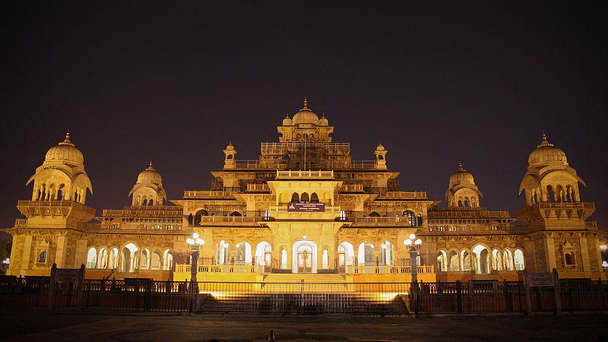

Caption for image source 1: Albert Hall Museum (Night).

Example Question - "How many cupolas are visible from the front of the Albert Hall Museum?"

Example Answer - "Seven cupolas are visible from the front of the Albert Hall Museum."

Additional Text Source 1 - The Victoria & Albert Museum is split into four Collections departments: 1) Asia; 2) Furniture, Textiles and Fashion; 3) Sculpture, Metalwork, Ceramics & Glass; and, 4) Word & Image. The museum curators care for the objects in the collection and provide access to objects that are not currently on display to the public and scholars. (from: Victoria and Albert Museum)

Generated Question - Does the Albert Hall Museum share any architectural features with the Victoria & Albert Museum's focus on Asian collections?

Generated Answer - Yes, the Albert Hall Museum's architecture reflects Asian influences, aligning with the Victoria & Albert Museum's Asian collection focus.

--- Entry for custom_id: d5daeb1c0dba11ecb1e81171463288e9 ---

Example Question - The Driver and éX-Driver were both titles of what?

Example Answer - Movies

Image Source 1 -



Generated Question - Did Walter Hill, the writer-director of The Driver, influence filmmakers like Quentin Tarantino with his movie?

Generated Answer - Yes, Walter Hill's movie The Driver influenced filmmakers like Quentin Tarantino.

--- Entry for custom_id: d5c572500dba11ecb1e81171463288e9 ---

Image Source 1 -

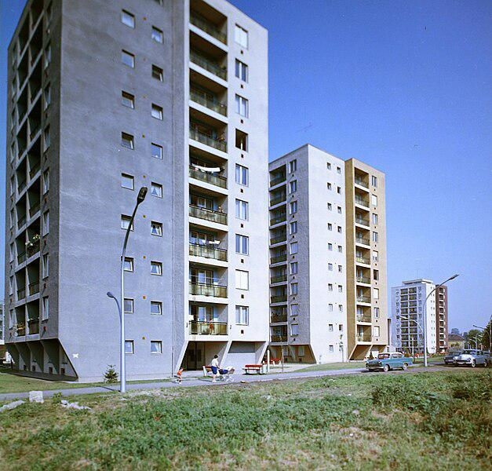

Caption for image source 1: Eger, Hadnagy úti lakótelep a Kertész utca felől nézve. Fortepan 20954.

Example Question - "On the largest building at Eger, Hadnagy úti lakótelep a Kertész utca felől nézve, on which side of the structure can I find the color grey?"

Example Answer - "On the largest building at Eger, Hadnagy úti lakótelep a Kertész utca felől nézve, on the left side of the structure you can find the color grey."

Additional Text Source 1 - Following the war, the building was sold to the Eger city council, which used it as a warehouse. It was destroyed in 1967 and no longer exists. (from: Eger Synagogue)

--- Entry for custom_id: d5c88a080dba11ecb1e81171463288e9 ---

Image Source 1 -

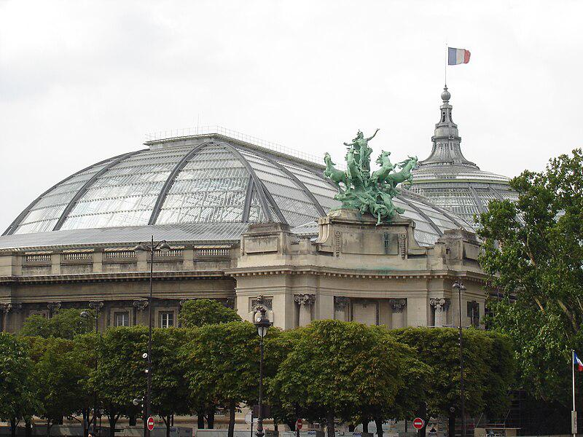

Caption for image source 1: Paris Grand Palais, 18 July 2005.

Example Question - "Outside the Grand Palais structure in Paris, how many of the horse statues have their front hooves in the air?"

Example Answer - "Four of the horse statues outside the Grand Palais structure in Paris have their front hooves in the air."

Additional Text Source 1 - It is named for Gilbert du Motier, Marquis de Lafayette, a French aristocrat and hero of the American Revolutionary War (1775–1783) and includes several statues of revolutionary heroes from Europe, including Lafayette, and at its center a famous statue of early 19th century U.S. President and general Andrew Jackson on horseback with both of the horse's front hooves raised. (from: Lafayette Square, Washington, D.C.)

Generated Question - How many horses in the Lafayette statue have their front hooves raised compared to the horse statues outside the Grand Palais in Paris?

Generated Answer - The Lafayette statue has one horse with both front hooves raised, while four horses outside the Grand Palais have their front hooves in the air.

--- Entry for custom_id: d5d4225a0dba11ecb1e81171463288e9 ---

Example Question - Was William Childs Westmoreland serving in the military during a war where the C-124 was extensively in use?

Example Answer - Yes, Westmoreland was a general during the Vietnam War where the C-124 was used extensively.

Image Source 1 -



Generated Question - Did William Westmoreland's tenure as Chief of Staff overlap with the operational period of the C-124 in the Vietnam War?

Generated Answer - Yes, Westmoreland was Chief of Staff from 1968 to 1972, during the C-124's use in Vietnam.

--- Entry for custom_id: d5c7a9da0dba11ecb1e81171463288e9 ---

Image Source 1 -

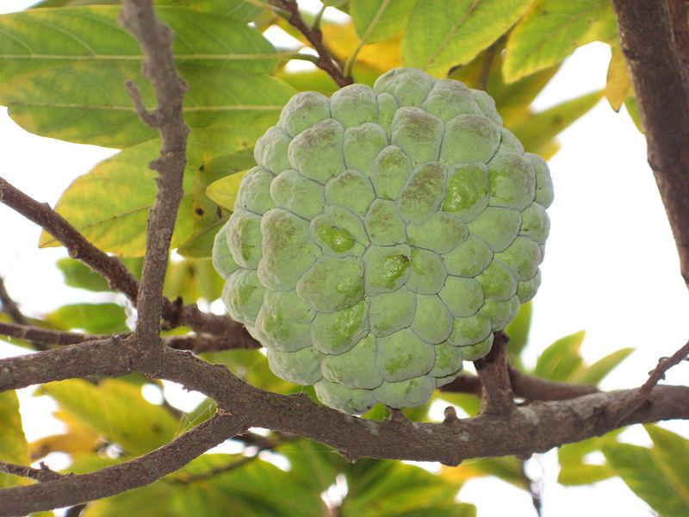

Caption for image source 1: Sugar-apple fruit Sugar-apple fruit.

Image Source 2 -



Caption for image source 2: Echeveria elegans0.

Example Question - "Do both the Sugar-apple fruit and Echeveria elegans grow in a tree?"

Example Answer - "No, the the Sugar-apple fruit and Echeveria elegans do not both grow in a tree."

Additional Text Source 1 - Echeveria elegans is cultivated as an ornamental plant for rock gardens planting, or as a potted plant. It thrives in subtropical climates, such as Southern California (from: Echeveria elegans)

Generated Question - Can both the Sugar-apple fruit and Echeveria elegans be found growing naturally on trees?

Generated Answer - No, only the Sugar-apple fruit grows on a tree; Echeveria elegans grows on the ground or in pots.

--- Entry for custom_id: d5dea8240dba11ecb1e81171463288e9 ---

Example Question - Would you find the Edge of Appalachia Preserve and Backbone Mountain in the same state or different states?

Example Answer - They would be found in different states.

Image Source 1 -

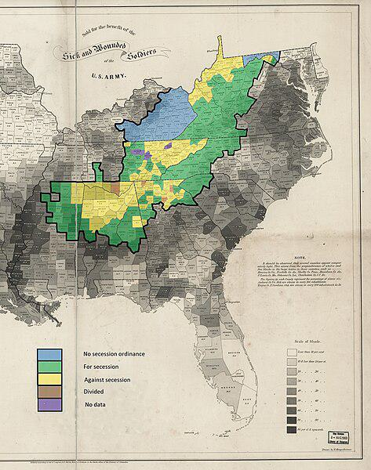

Generated Question - Based on the 1860–1861 secession votes map, would the Edge of Appalachia Preserve and Backbone Mountain have been in counties voting similarly on secession?

Generated Answer - No, they would have been in counties with different secession vote stances.

--- Entry for custom_id: d5dbc2bc0dba11ecb1e81171463288e9 ---

Example Question - Engineered tissue of the oral mucosa which is the lining of the mouth can be used to replace what kind of tissue defects in the oral cavity?

Example Answer - Soft tissue

Image Source 1 -

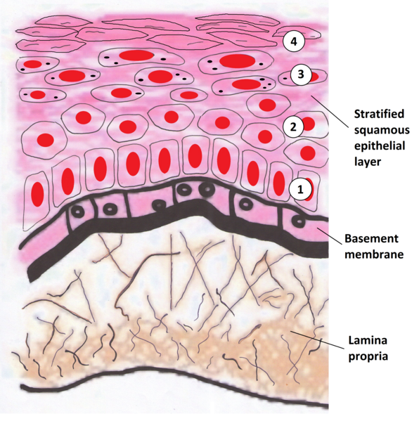

--- Entry for custom_id: d5cdc8ba0dba11ecb1e81171463288e9 ---

Image Source 1 -

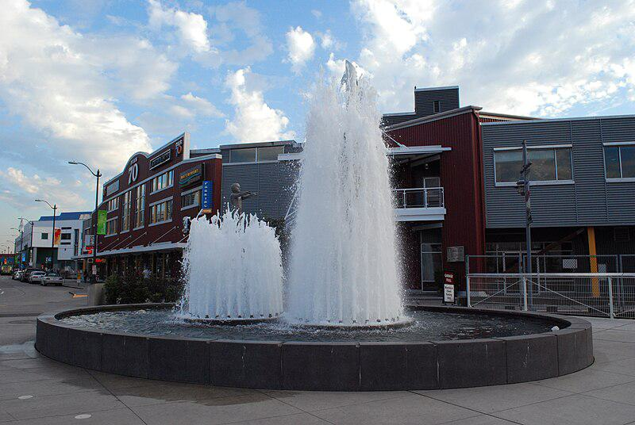

Caption for image source 1: Father and son fountain 0441 Father and Son Fountain Olympic Sculpture Park Seattle, WA 09.2008.

Example Question - "Are the two fountains in the Father and Son fountain in Olympic Sculpture Park in Seattle the same height?"

Example Answer - "No, the two fountains in the Father and Son fountain in the Olympic Sculpture Park in Seattle are not the same height."

Additional Text Source 1 - The Olympic Sculpture Park is a free-admission outdoor sculpture park with both permanent outdoor sculpture, temporary works, and site-specific installations. The Seattle Art Museum regularly rotates a major artwork at the Olympic Sculpture Park, including installations by Victoria Haven from 2016 - 2017, Spencer Finch from 2017 - 2019, and Regina Silveira from 2019 - 2020. (from: Olympic Sculpture Park)

Generated Question - Does the Father and Son Fountain in the Olympic Sculpture Park have permanent sculptures or rotating art installations nearby?

Generated Answer - The Olympic Sculpture Park features both permanent sculptures and regularly rotating art installations.

--- Entry for custom_id: d5d3631a0dba11ecb1e81171463288e9 ---

Example Question - Do any of the administrative districts in the city of Manila share a name with any of the four district centers of the Metro Manila region?

Example Answer - No

Image Source 1 -

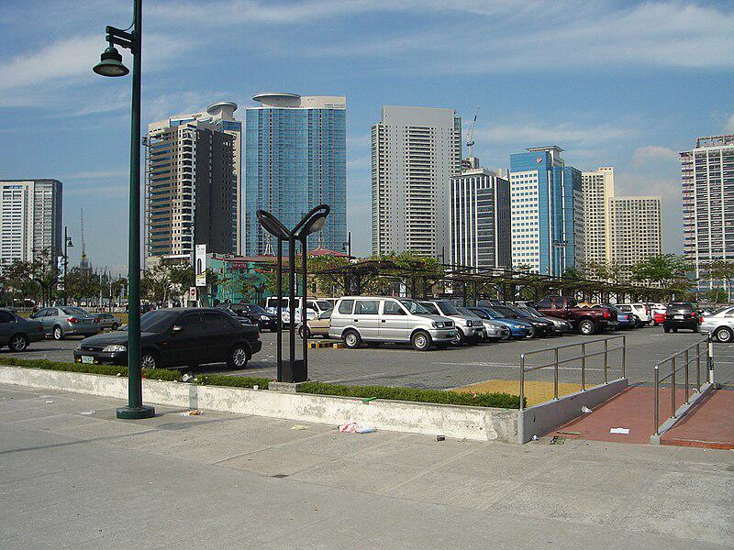

--- Entry for custom_id: d5da81d60dba11ecb1e81171463288e9 ---

Example Question - La Villeneuve and Bonnat are communes located in what area of France in common?

Example Answer - They're in the in the Creuse department in the Nouvelle-Aquitaine region in France.

Image Source 1 -

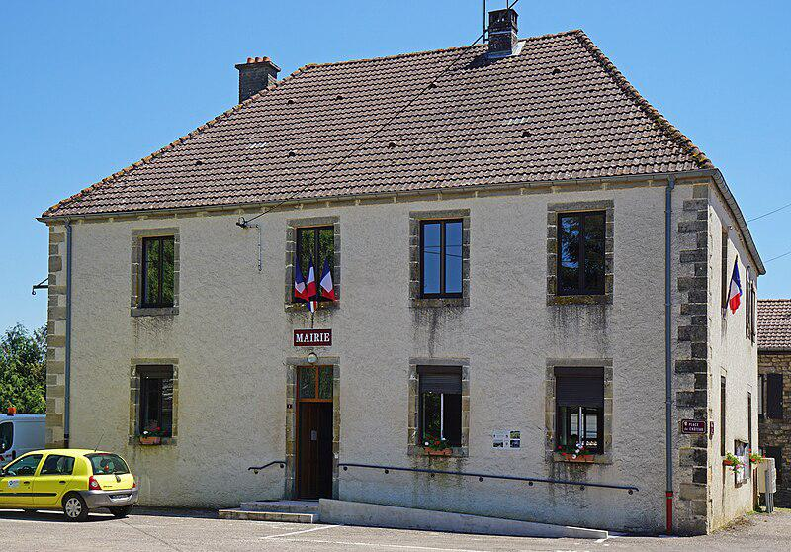

Generated Question - Are Bonnat and La Villeneuve-Bellenoye-et-la-Maize both located in the same French department and region?

Generated Answer - Yes, both are in the Creuse department in the Nouvelle-Aquitaine region of France.

--- Entry for custom_id: d5bbd13c0dba11ecb1e81171463288e9 ---

Image Source 1 -

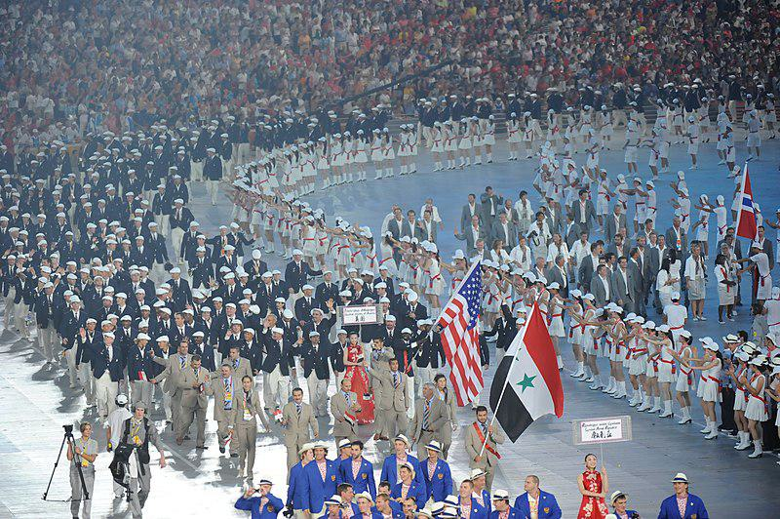

Caption for image source 1: 2008 Summer Olympics - Opening Ceremony - Beijing, China 同一个世界 同一个梦想 - U.S. Army World Class Athlete Program - FMWRC (4928870644).

Example Question - "What color hat did American athletes wear while walking in the 2008 Summer Olympics opening ceremony?"

Example Answer - "The American athletes wore white while walking in the 2008 Summer Olympics opening ceremony."

Additional Text Source 1 - The 2008 Games also set numerous world and Olympics records, and were also the most expensive Summer Olympics of all time and second most expensive overall after the 2014 Winter Games in Sochi. The opening ceremony was lauded by spectators and numerous international presses as spectacular, spellbinding and, by many accounts, "the greatest ever in the history of Olympics". (from: 2008 Summer Olympics)

Generated Question - Did the U.S. Army World Class Athlete Program participants wear the same color suits as the other American athletes during the 2008 Olympics opening ceremony?

Generated Answer - No, the U.S. Army World Class Athlete Program participants wore beige suits, while other American athletes wore blue suits.

--- Entry for custom_id: d5cde66a0dba11ecb1e81171463288e9 ---

Image Source 1 -

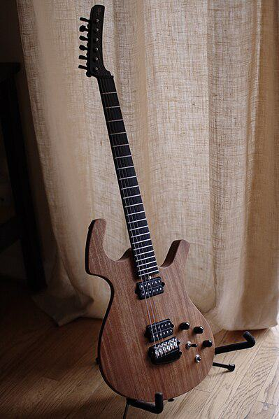

Caption for image source 1: Parker NiteFly-M (2008).

Example Question - "What color is the fret board on the Parker NiteFly-M guitar?"

Example Answer - "The Parker NiteFly-M guitar has a black fret board."

Additional Text Source 1 - MIDI FlyBased on a Nite Fly body and made between 1999–2002, the MIDIFly has a mahogany body and Parker's TurboTone neck (also constructed of mahogany) with Virtual DSP Corp.'s MidiAxe guitar-to-MIDI converter system. It has custom DiMarzio pickups plus an active Fishman piezo system. (from: Parker Fly)

Generated Question - Does the Parker NiteFly-M guitar have a mahogany body like the MIDIFly model?

Generated Answer - Yes, both have a mahogany body.

--- Entry for custom_id: d5cd3ac60dba11ecb1e81171463288e9 ---

Image Source 1 -

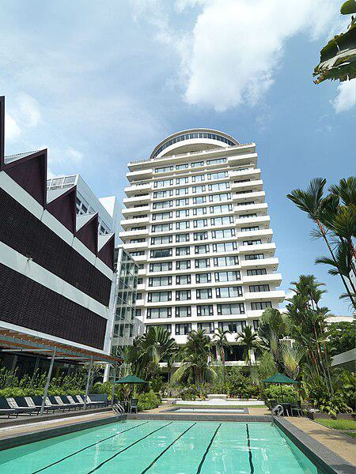

Caption for image source 1: Federal Hotel Facade The Federal Kuala Lumpur.

Image Source 2 -

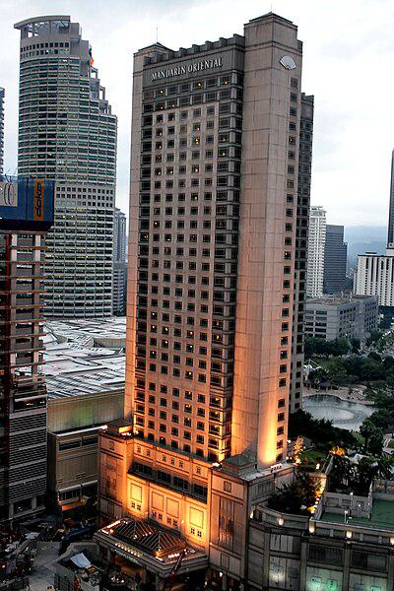

Caption for image source 2: Mandarin Oriental, Kuala Lumpur, June 2010 A view of Mandarin Oriental, Kuala Lumpur in June 2010..

Example Question - "Between the Federal Hotel and the Mandarin Oriental in Kuala Lumpur, which has an outdoor swimming pool?"

Example Answer - "The Federal Hotel has an outdoor swimming pool."

Additional Text Source 1 - Mandarin Oriental, Hong Kong is a five-star hotel located on Connaught Road Central in Central, Hong Kong, owned and managed by Mandarin Oriental Hotel Group. The hotel opened in 1963 as "The Mandarin" (Most old generations of Hong Kong socialites and tycoons still refers the hotel as "The Mandarin" despite the name change). (from: Mandarin Oriental, Hong Kong)

Generated Question - Considering the outdoor amenities, which hotel in Kuala Lumpur is more likely to offer a poolside garden experience?

Generated Answer - The Federal Hotel is more likely to offer a poolside garden experience due to visible greenery around its outdoor pool.

--- Entry for custom_id: d5c967de0dba11ecb1e81171463288e9 ---

Image Source 1 -

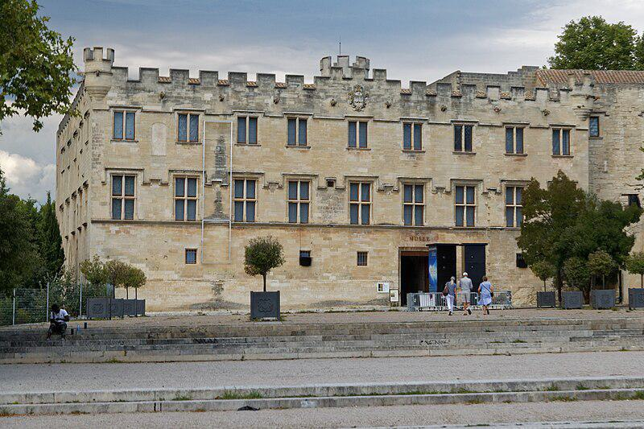

Caption for image source 1: Avignon-Petit Palais-bjs180817-01.

Image Source 2 -

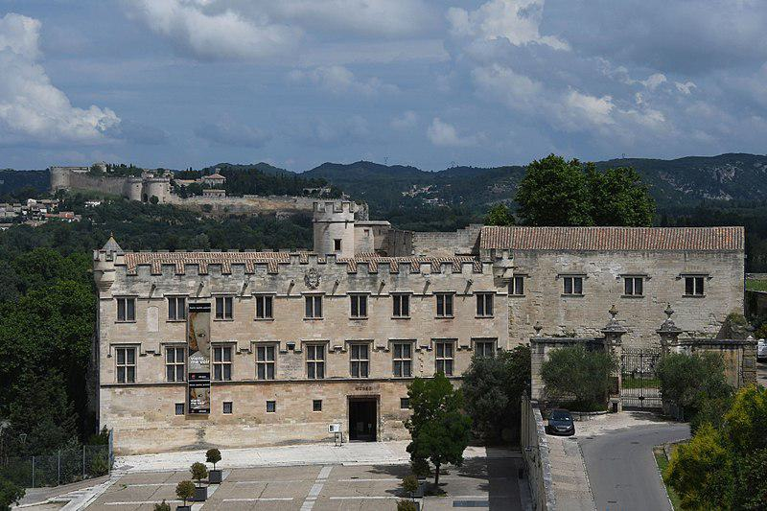

Caption for image source 2: Avignon, Palais des Papes (14.), Ausblick vom Tour l'Audience ou de la Gâche (41814209355).

Example Question - "What can you find growing in front of the Petit Palais in Avignon and the Palais des Papes in Avignon?"

Example Answer - "You can find trees growing in front of both places."

Additional Text Source 1 - Musée du Petit Palais (opened 1976) at the end of the square overlooked by the Palais des Papes, has an exceptional collection of Renaissance paintings of the Avignon school as well as from Italy, which reunites many "primitives" from the collection of Giampietro Campana. (from: Avignon)

Generated Question - Are both the Petit Palais and the Palais des Papes in Avignon located near open spaces with trees visible?

Generated Answer - Yes, both are near open spaces with trees visible in front.

--- Entry for custom_id: d5d49b4a0dba11ecb1e81171463288e9 ---

Example Question - Shinty and Camogie are both played with what?

Example Answer - Sticks and a ball

Image Source 1 -

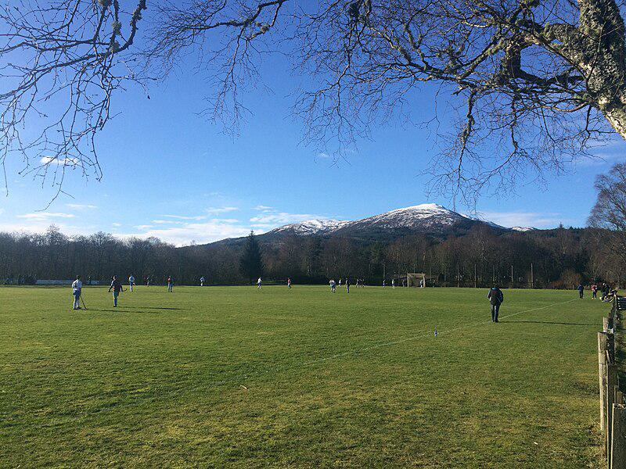

--- Entry for custom_id: d5dc589e0dba11ecb1e81171463288e9 ---

Example Question - Rhodopsin-like is a family of what thing of which Prostaglandin F is a type of?

Example Answer - Receptor

Image Source 1 -



Generated Question - Are the prostacyclin receptor and rhodopsin structurally related as types of G protein-coupled receptors?

Generated Answer - Yes, both are G protein-coupled receptors in the rhodopsin-like family.

--- Entry for custom_id: d5de07160dba11ecb1e81171463288e9 ---

Example Question - Are there any abbreviations where Charleston Air Force Base would come after Grand Strand Airport, or are they all first alphabetically?

Example Answer - Charleston Air Force Base would always come first.

Image Source 1 -



Generated Question - Considering the IATA codes, which airport's code would appear first alphabetically, Charleston Air Force Base or Grand Strand Airport?

Generated Answer - Charleston Air Force Base's code (CHS) would appear first alphabetically before Grand Strand Airport's code (CRE).

--- Entry for custom_id: d5cef44c0dba11ecb1e81171463288e9 ---

Image Source 1 -

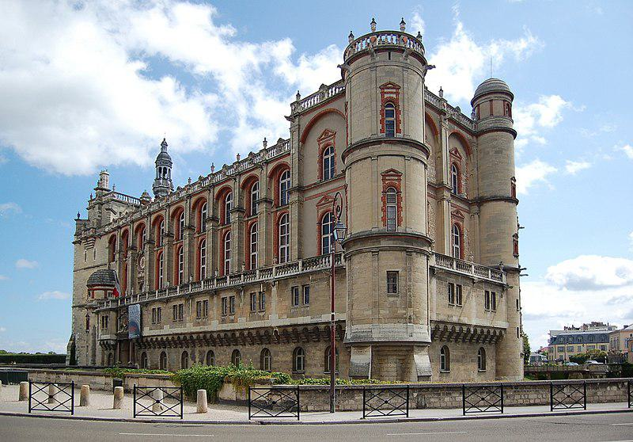

Caption for image source 1: Chateau de St Germain-en-laye Saint-Germain-en-Laye castle, France..

Example Question - "How many stories of windows are on the side of the Chateau de St Germain in France?"

Example Answer - "The Chateau de St Germain in France has four stories of windows are on the side."

Additional Text Source 1 - Notable historic monuments in the Region outside of Paris include the Palace of Versailles (7,700,000 visitors), the Palace of Fontainebleau (500,000 visitors), the chateau of Vaux-le-Vicomte (300,000 visitors), and the Château de Malmaison, Napoleon's former country house; and the Basilica of Saint-Denis, where the Kings of France were interred before the French Revolution. (from: Île-de-France)

Generated Question - Is the Chateau de St Germain-en-Laye likely to attract more visitors than the Palace of Fontainebleau based on its historic significance in the Île-de-France region?

Generated Answer - No, the Palace of Fontainebleau attracts more visitors than the Chateau de St Germain-en-Laye.

--- Entry for custom_id: d5d652d20dba11ecb1e81171463288e9 ---

Example Question - The first North Indian temple had a prominent feature of Kadamba architecture called what?

Example Answer - It is called a shikhara, or tower.

Image Source 1 -

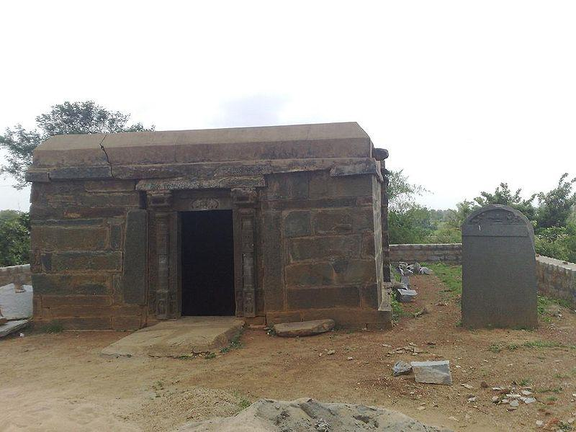

Generated Question - Does the Praneshvara temple at Talagunda likely feature the Kadamba shikhara style seen in early Karnataka temples?

Generated Answer - Yes, it likely features the Kadamba shikhara style from the late fourth century Kadamba rule.

--- Entry for custom_id: d5d52d080dba11ecb1e81171463288e9 ---

Example Question - What is an example of a muscle that responds to pressure by relaxing and also inhibits the release of urine?

Example Answer - internal sphincter muscles

Image Source 1 -



Generated Question - How do autonomic neurons control involuntary sphincter muscles compared to voluntary sphincter muscles?

Generated Answer - Autonomic neurons use varicosities to control involuntary smooth muscle sphincters, while voluntary sphincters are controlled by somatic nerves.

--- Entry for custom_id: d5d531ae0dba11ecb1e81171463288e9 ---

Example Question - Where do the large collections of autonomic nerve fibers form in the gastrocnemius muscle?

Example Answer - The gastrocnemius muscle is in the lower leg. The autonomic nerve fibers only form large clusters in the thorax, abdomen, and pelvis outside the spinal cord.

Image Source 1 -

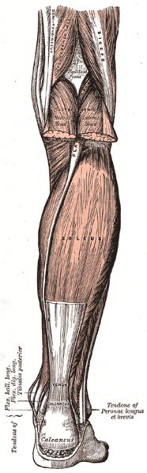

Generated Question - Considering the location of the soleus and gastrocnemius muscles in the lower leg, do autonomic nerve fibers form large collections near these muscles?

Generated Answer - No, autonomic nerve fibers form large collections only in the thorax, abdomen, and pelvis, not near the soleus or gastrocnemius muscles.